Florida
Public Hurricane Loss Model 6.0
Submitted in compliance with the 2013 Standards of the
Florida Commission on Hurricane Loss Projection Methodology
Revision Submitted on July 12, 2013

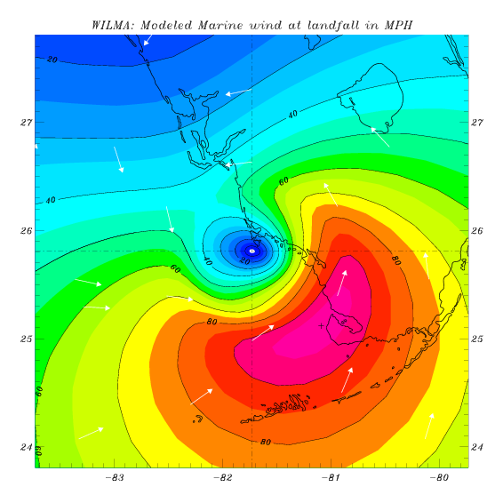

Model Identification

Name of Model: Florida Public Hurricane Loss Model 6.0

Model Version Identification:

Software Program Version Identification:

Interim Software Program Version Update Identification:

Software Platform Name and Identifications:

Interim Data Update Designation:

Name of Modeling Organization: Florida International University

Street Address: International Hurricane Research Center, MARC 360

City, State, ZIP Code: Miami, Florida 33199

Mailing Address, if different from above: Same as above

Contact Person: Shahid S. Hamid

Phone Number: 305-348-2727 Fax: 305-348-1761

E-mail Address: hamids@fiu.edu

Date:

July 12, 2013

Chair, Florida Commission on Hurricane Loss Projection Methodology
c/o Donna Sirmons
Florida State Board of Administration
1801 Hermitage Boulevard, Suite 100
Tallahassee, FL 32308

Dear Commission Chairman:

I am pleased to inform you that the final version of 5.0 of Florida Public Hurricane Loss Model is ready for review by the Commission. The FPHLM model has been reviewed by professionals having credentials and/or experience in the areas of meteorology, engineering, actuarial science, statistics and computer science; for compliance with the Standards, as documented by the expert certification forms G1-G7.

Enclosed are 7 bound copies of our submission, which includes the summary statement of compliance with the standards, the forms, and the submission checklist.

Please contact me if you have any questions regarding this submission.

Sincerely,

Shahid Hamid, Ph.D., CFA
Professor of Finance, and
Director, Laboratory for Insurance, Economic and Financial Research
International Hurricane Research Center
RB 202B, Department of Finance, College of Business
Florida International University
Miami, FL 33199
tel: 305 348 2727 fax: 305 348 4245

Cc: Kevin M. McCarty, Insurance Commissioner
Statement of Compliance and Trade Secret Disclosure Items

The Florida Public Hurricane Loss Model v5.0 is intended to comply with each Standard of the 2011 Report of Activities released by the Florida Commission on Hurricane Loss Projection Methodology. The required disclosures, forms, and analysis are contained herein.

The source code for the loss model will be available for review by the Professional Team.

Model Submission Checklist

- Please indicate by checking below that the following has been included in your submission documentation to the Florida Commission on Hurricane Loss Projection Methodology.

Yes | No | Item
X |  | 1. Letter to the Commission
X |  | - Refers to the certification forms and states that professionals having credentials and/or experience in the areas of meteorology, engineering, actuarial science, statistics, and computer science have reviewed the model for compliance with the standards
X |  | b. States model is ready to be reviewed by the Professional Team
X |  | c. Any caveats to the above statements noted with a complete explanation
X |  | 2. Summary statement of compliance with each individual standard and the data and analyses required in the disclosures and forms
X |  | 3. General description of any trade secret information the modeling organization intends to present to the Professional Team
X |  | 4. Model Identification
X |  | 5. Seven (7) Bound Copies (duplexed)
X |  | 6. Link containing:
X |  | a. Submission text in PDF format
X |  | b. PDF file highlightable and bookmarked by standard, form, and section
X |  | c. Data file names include abbreviated name of modeling organization, standards year, and form name (when applicable)
X |  | d. Form S-6 (if required) in ASCII and PDF format
X |  | e. Forms M-1, M-3, V-2, A-1, A-2, A-3, A-4, A-5, A-7, and A-8 in Excel format
X |  | 7. Table of Contents
X |  | 8. Materials consecutively numbered from beginning to end starting with the first page (including cover) using a single numbering system
X |  | 9. All tables, graphs, and other non-text items consecutively numbered using whole numbers
X |  | 10. All tables, graphs, and other non-text items specifically listed in Table of Contents
X |  | 11. All tables, graphs, and other non-text items clearly labeled with abbreviations defined
X |  | 12. All column headings shown and repeated at the top of every subsequent page for forms and tables
X |  | 13. Standards, disclosures, and forms in italics, modeling organization responses in non-italics
X |  | 14. Graphs accompanied by legends and labels for all elements
X |  | 15. All units of measurement clearly identified with appropriate units used
X |  | 16. Hard copy of all forms included in a submission document Appendix except  Forms V-3, A-6, and S-6

- Explanation of “No” responses indicated above. (Attach additional pages if needed.)

Florida Public Hurricane Loss Model 5.0 |  |  |  | July 12, 2013
Model Name |  | Modeler Signature |  | Date

Table of Contents

GENERAL STANDARDS 16
G-1 Scope of the Computer Model and Its Implementation 16
G-2 Qualifications of Modeling Organization Personnel and Consultants 118
G-3 Risk Location 126
G-4 Independence of Model Components 128
G-5 Editorial Compliance 129
Form G-1 130
Form G-2 131
Form G-3 132
Form G-4 133
Form G-5 134
Form G-6 135
Form G-7 136
METEOROLOGICAL STANDARDS 137
M-1 Base Hurricane Storm Set 137
M-2 Hurricane Parameters and Characteristics 139
M-3 Hurricane Probabilities 147
M-4 Hurricane Windfield Structure 149
M-5 Landfall and Over-Land Weakening Methodologies 157
M-6 Logical Relationships of Hurricane Characteristics 162
Form M-1: Annual Occurrence Rates 164
Form M-2: Maps of Maximum Winds 169
Form M-3: Radius of Maximum Winds and Radii of Standard Wind Thresholds 175
VULNERABILITY STANDARDS 180
V-1 Derivation of Vulnerability Functions 180
V-2 Derivation of Contents and Time Element Vulnerability Functions 238
V-3 Mitigation Measures 242
Form V-1: One Hypothetical Event 246
Form V-2: Mitigation Measures – Range of Changes in Damage 253
Form V-3: Mitigation Measures – Mean Damage Ratio 256
ACTUARIAL STANDARDS 267
A-1 Modeling Input Data 267
A-2 Event Definition 275
A-3 Modeled Loss Cost and Probable Maximum Loss Considerations 276
A-4 Policy Conditions 280
A-5 Coverages 283
A-6 Loss Output 286
Form A-1: Zero Deductible Personal Residential Loss Costs by ZIP Code 290
Form A-2: Base Hurricane Storm Set Statewide Loss Costs 294
Form A-3: Cumulative Losses from the 2004 Hurricane Season 295
Form A-4: Output Ranges 301
Form A-5: Percentage Change in Output Ranges 302
Form A-6: Personal Residential Output Ranges 311
Form A-7: Percentage Change in Logical Relationship to Risk
Form A-8: Probable Maximum Loss for Florida 312
STATISTICAL STANDARDS 316
S-1 Modeled Results and Goodness-of-Fit 316
S-2 Sensitivity Analysis for Model Output 328
S-3 Uncertainty Analysis for Model Output 331
S-4 County Level Aggregation 334
S-5 Replication of Known Hurricane Losses 335
S-6 Comparison of Projected Hurricane Loss Costs 339
Form S-1: Probability and Frequency of Florida Landfalling Hurricanes per Year 340
Form S-2: Examples of Loss Exceedance Estimates 341
Form S-3: Distributions of Stochastic Hurricane Parameters 342
Form S-4: Validation Comparisons 343
Form S-5: Average Annual Zero Deductible Statewide Loss Costs – Historical versus Modeled 349
Form S-6: Hypothetical Events for Sensitivity and Uncertainty Analysis 351
COMPUTER STANDARDS 358
C-1 Documentation 358
C-2 Requirements 360
C-3 Model Architecture and Component Design 361
C-4 Implementation 362
C-5 Verification 364
C-6 Model Maintenance and Revision 367
C-7 Security 370
Appendix A – Expert Review Letters 410
Appendix B – Form A-2: Base Hurricane Storm Set Statewide Loss Costs 418Appendix C – Form A-3: Cumulative Losses from the 2004 Hurricane Season 421
Appendix D – Form A-4: Output Ranges 438
Appendix E – Form A-5: Percentage Change in Output Ranges 459
Appendix F – Form A-6: Logical Relationship to Risk 461
Appendix G – Form A-7: Percentage Change in Logical Relationship to Risk 506
Appendix H – Form A-8: Probable Maximum Loss for Florida 515

List of Figures

Figure 1. Process to assure continual agreement and correct correspondence. 17
Figure 2. Florida Public Hurricane Loss Model domain. Circles represent the threat zone. Blue color indicates water depth exceeding 656 ft (200 m). 19
Figure 3. Examples of simulated hurricane tracks. Numbers refer to the stochastic track number, and colors represent storm intensity based on central pressure. Dashed lines represent tropical storm strength winds, and Cat 1-5 winds are represented by black, blue, orange, red, and turquoise, respectively. 21
Figure 4. Comparison between the modeled and observed Willoughby and Rahn (2004) B dataset. 22
Figure 5. Observed and expected distribution for Rmax. The x-axis is the radius in statute miles, and the y-axis is the frequency of occurrence. 23
Figure 6. Comparison of 100,000 Rmax values sampled from the gamma distribution for Category 1-4 storms to the expected values. 24
Figure 7. Typical single-family homes (Google Earth). 27
Figure 8. Manufactured homes (Google Earth). 28
Figure 9. Regional Classification of Florida with the corresponding sample counties (blue and star). 28
Figure 10. Monte Carlo simulation procedure to predict external damage. 33
Figure 11. Procedure to create vulnerability matrix. 37
Figure 12. Weighted masonry structure vulnerabilities in the central wind-borne debris region. 41
Figure 13. Typical low-rise buildings (LB). 49
Figure 14. Examples of mid- and high-rise buildings (MHB). 49
Figure 15. Apartment types according to layout (left: closed building with interior entry door; right: open building with exterior entry door). 52
Figure 16. Flowchart of the interior damage model. 56
Figure 17. Mean accumulated impinging rain as a function of peak 3-second wind gust. 61
Figure 18. Exterior and interior damage assessment for MHB. 66
Figure 19. Flow diagram of the computer model. 72
Figure 20. Personal residential and commercial residential county wide percentage change due to update of probability distribution functions. 112
Figure 21. Personal residential and commercial residential county wide percentage change due to update of ZIP code centroids. 113
Figure 22. Personal residential and commercial residential county wide percentage change due to change in hurricane PBL height. 114
Figure 23. County wide percentage change due to vulnerability functions personal residential model. 115
Figure 24. County wide percentage change due to new vulnerability functions commercial residential model. 116
Figure 25. Florida Public Hurricane Loss Model workflow. 122
Figure 26. Analysis of 742 GPS dropsonde profiles launched from 2-4 km with flight-level winds at launch greater than hurricane force and with measured surface winds. Upper figure: Dependence of the ratio of 10 m wind speed (U10) to the mean boundary layer wind speed (MBL) on the scaled radius (ratio of radius of last measured wind (Rlmw) to the radius of maximum wind at flight level (RmaxFL). Lower figure: Surface wind factor (U10/MBL) dependence on maximum flight level wind speed (Vflmax, in units of miles per hour / 2.23). 142
Figure 27. Axisymmetric rotational wind speed (mph) vs. scaled radius for B = 1.38, DelP = 49.1 mb. 148
Figure 28. Upstream fetch wind exposure photograph for Chatham, MS (left, looking north), and Panama City, FL (right, looking northeast). After Powell et al. (2004). 150
Figure 29. Comparison of modeled (left) and observed (H*Wind, right) landfall wind fields of Hurricane Charley (2004, top) and Hurricane Jeanne (2004, bottom). Line segment indicates storm heading. Horizontal coordinates are in units of R/Rmax and winds units of miles per hour. All wind fields are for marine exposure. 152
Figure 30. As in Fig. 33 but for Hurricane Wilma of 2005. 153
Figure 31. Observed (green) and modeled (black) maximum sustained surface winds as a function of time for 2004 Hurricanes Frances (left) and Charley (right). Landfall is represented by the vertical dash-dot red line at the left and time of exit as the red line on the right. 156
Figure 32. Observed (green) and modeled (black) maximum sustained surface winds as a function of time for Hurricanes Jeanne (2004, top left), Katrina (2005 in South Florida, top right), and Wilma (2005, lower left). Landfall is represented by the vertical dash-dot red line at the left and time of exit as the red line on the right. 157
Figure 33. Form M-1 comparison of modeled and historical landfalling hurricane frequency (storms occurring in 112 years) for Regions A–F, FL statewide landfalls (one per FL region), FL bypassing storms, and FL state-wide hurricanes. 165
Figure 34. Maximum ZIP Code wind speed for open terrain wind exposure based on simulations of the historical storm set. 169
Figure 35. Maximum ZIP Code wind speed for actual terrain wind exposure based on simulations of the historical storm set. 170
Figure 36. 100- and 250-year return period wind speeds at Florida ZIP Codes for open terrain wind exposure. 171
Figure 37. 100- and 250-year return period wind speeds at Florida ZIP Codes for actual terrain wind exposure. 172
Figure 38. Representative scatter plot of the model input radius of maximum wind (y axis) versus minimum sea-level air pressure at landfall (mb). Relative histograms for each quantity are also shown. 176
Figure 39. One way box plot (left) of Rmax (continuous) response across 10 mb Pmin groups. Boxes (and whiskers) are in red; standard deviations are in blue. Histograms (right) for each Pmin group. 176
Figure 40. Comparison of modeled vs. historical occurrences. 179
Figure 41. Comparison between the modeled and observed Willoughby and Rahn (2004) B data set. 179
Figure 42. Observed and expected distribution using a gamma distribution. 180
Figure 43. Comparison of modeled (left) and observed (right) swaths of maximum sustained marine surface winds for Hurricane Andrew of 1992 in South Florida. The Hurricane Andrew observed swath is based on adjusting flight-level winds with the SFMR-based wind reduction method. 183
Figure 44. Histogram of CVs for all counties combined. 188
Figure 45. SRCs for Expected Loss Cost for all Input Variables for all Hurricane Categories. 191
Figure 46. EPRs for Expected Loss Cost for all Input Variables for all Hurricane Categories. 194
Figure 47. Scatter plot between total actual losses vs. total modeled losses. 200
Figure 48. Scatter plot for comparison # 1. 208
Figure 49. Scatter plot for comparison # 2. 208
Figure 50. Scatter plot for comparison # 3. 209
Figure 51. Scatter plot for comparison # 4. 209
Figure 52. Scatter plot for comparison # 5. 210
Figure 53. Scatter plot for comparison # 1. 211
Figure 54. Comparison of CDFs of Loss Costs for all Hurricane Categories. 215
Figure 55. Contour Plot of Loss Cost for a Category 1 Hurricane. 216
Figure 56. Contour Plot of Loss Cost for a Category 3 Hurricane. 217
Figure 57. Contour Plot of Loss Cost for a Category 5 Hurricane. 218
Figure 58. SRCs for expected loss cost for all input variables for all hurricane categories. 219
Figure 59. EPRs for Expected Loss Cost for all Input Variables for all Hurricane Categories. 220
Figure 60. Monte Carlo simulation procedure to predict damage. 224
Figure 61. Procedure to create vulnerability matrix. 225
Figure 62. Exterior and interior damage assessment for MHB. 227
Figure 63. Flowchart of the interior damage model. 259
Figure 64. Mean accumulated impinging rain as a function of peak 3-second wind gust. 263
Figure 65. f_{RedRoof} represents the breached roof area that is exposed to impinging rain as a function of wind angle of attack. 265
Figure 66. Diagram of water intrusion through breaches, deficiencies and percolation in a 3-story building. 266
Figure 67. Components of the vulnerability model. Arrows indicate empirical relationships. 271
Figure 68. Model vs. Actual-Structural Loss. 274
Figure 69. Model vs. Actual-Contents Loss. 275
Figure 70. Model vs. Actual-ALE Loss. 276
Figure 71. Model vs. Actual-APP Loss. 277
Figure 72. Derivation of contents and additional living expenses vulnerabilities for PR. 281
Figure 73. Model vs. Actual-Contents Loss. 289
Figure 74. Model vs. Actual-ALE Loss. 289
Figure 75. Structure damage vs. 3 sec actual terrain wind speed. 298
Figure 76. Structure damage vs. 1 minute sustained wind speed. 298
Figure 77. Structure damage vs. 3 sec actual terrain wind speed. 299
Figure 78. Structure damage vs. 1 minute sustained wind speed. 299
Figure 79. Structure damage vs. 3 sec actual terrain wind speed. 300
Figure 80. Structure damage vs. 1 minute sustained wind speed. 300
Figure 81. Mitigation measures for masonry homes. 307
Figure 82. Mitigation measures for masonry homes. 308
Figure 83. Mitigation measures for frame homes. 309
Figure 84. Mitigation measures for frame homes. 310
Figure 85. Modeled vs. actual relationship between structure and content damage ratios for Hurricane Andrew. 323
Figure 86. Zero deductible loss costs by ZIP code for frame. 337
Figure 87. Zero deductible loss costs by ZIP code for masonry. 338
Figure 88. Zero deductible loss costs by ZIP code for mobile homes. 339
Figure 89. Percentage of residential total losses by ZIP code of Hurricane Charley (2004). 342
Figure 90. Percentage of residential total losses by ZIP code of Hurricane Frances (2004). 343
Figure 91. Percentage of residential total losses by ZIP code of Hurricane Ivan (2004). 344
Figure 92. Percentage of residential total losses by ZIP code of Hurricane Jeanne (2004). 345
Figure 93. Percentage of residential total losses by ZIP code of the cumulative losses from the 2004 Hurricane Season. 346
Figure 94. Percentage change in output ranges by county for owners frame (2% deductible). 351
Figure 95. Percentage change in output ranges by county for owners masonry (2% deductible). 352
Figure 96. Percentage change in output ranges by county for mobile homes (2% deductible). 353
Figure 97. Percentage change in output ranges by county for renters frame (2% deductible). 354
Figure 98. Percentage change in output ranges by county for renters masonry (2% deductible). 355
Figure 99. Percentage change in output ranges by county for condo frame (2% deductible). 356
Figure 100. Percentage change in output ranges by county for condo masonry (2% deductible). 357
Figure 101. Percentage change in output ranges by county for commercial residential (3% deductible). 358
Figure 102. Comparison of return periods. 362

List of Tables

Table 1a. Weak and Medium Models 30
Table 2. Description of values given in the damage matrices for site-built homes. 34
Table 3. Description of values given in the damage matrices for manufactured homes. 35
Table 4. Partial example of vulnerability matrix. 39
Table 5. Assignment of vulnerability matrix depending on data availability in insurance portfolios. 42
Table 6. Age classification of the models per region. 46
Table 7. Description of damage matrices for LB. 54
Table 8. Description of the damage matrices for MHB apartments. 55
Table 9. Parameter Distributions used in the Rain Study. 59
Table 10. Professional credentials. 119
Table 11. Range of outer wind radii (sm) as a function of central sea level pressure (mb). 174
Table 12. Extended Best-Track and H*Wind wind radii ranges based on Atlantic basin hurricanes. 175
Table 13. Validation Table based on ZIP Code wind swath comparison of the Public wind field model to H*Wind. Mean errors (bias) of model for the set of validation wind swaths. Errors (upper number in each cell) are computed as Modeled – Observed (Obs) at ZIP Codes were modeled winds were within wind thresholds (model threshold) or where observed winds were within respective wind speed threshold (H*Wind threshold). Number of ZIP Codes for the comparisons is indicated as the lower number in each cell. 184
Table 14. Validation Table based on ZIP Code wind swath comparison of the Public wind field model to H*Wind. Root mean square (RMS) wind speed errors (mph) of model for the set of validation wind swaths. Errors are based on Modeled – Observed (Obs) at ZIP Codes where modeled winds were within wind thresholds (model threshold) or where observed winds were within respective wind speed threshold (H*Wind threshold). 185
Table 15. 95% Confidence intervals for mean loss for selected counties (based on 56,000) year simulation. 188
Table 16. Total Actual vs. Total Modeled Losses - Personal Residential 197
Table 17. Comparison of Total vs. Actual Losses - Commercial Residential 199
Table 18. Summary of processed claims data (number of claims provided). 228
Table 19. Company 1: Claim number for each year-build category 230
Table 20. Company 2: Claim number for each year-built category. 231
Table 21. Company 1 and Company 2: Claim numbers combined. 232
Table 22a. Distribution of coverage for Company 1. 233
Table 23a. 2004 Personal Residential Claim Data 233
Table 24. Defects values for mid-/high-rise building openings. 260
Table 25. Value of f_{RunWat} for low-rise buildings walls 266
Table 26. Age classification of the models per region. 270
Table 27. Assignment of vulnerability matrix depending on data availability in insurance portfolios. 273
Table 28. Modeled vs. historical loss by construction type. 277
Table 29. Output report for OIR data processing. 312
Table 30. Checklist for the Pre-processing. 318

GENERAL STANDARDS

G-1 Scope of the Computer Model and Its Implementation

- The computer model shall project loss costs and probable maximum loss levels for residential property insured damage from hurricane events.

The Florida Public Hurricane Loss Model estimates loss costs and probable maximum loss levels from hurricane events for personal lines and commercial lines of residential property. The losses are estimated for building, appurtenant structure, contents, and additional living expense (ALE).

- The modeling organization shall maintain a documented process to assure continual agreement and correct correspondence of databases, data files, and computer source code to slides, technical papers, and modeling organization documents.

The FPHLM group members follow the process specified in the flowchart of Figure 1 in order to assure continual agreement and correct correspondence of databases, data files, and computer source code to slides, technical papers, and FPHLM documents.
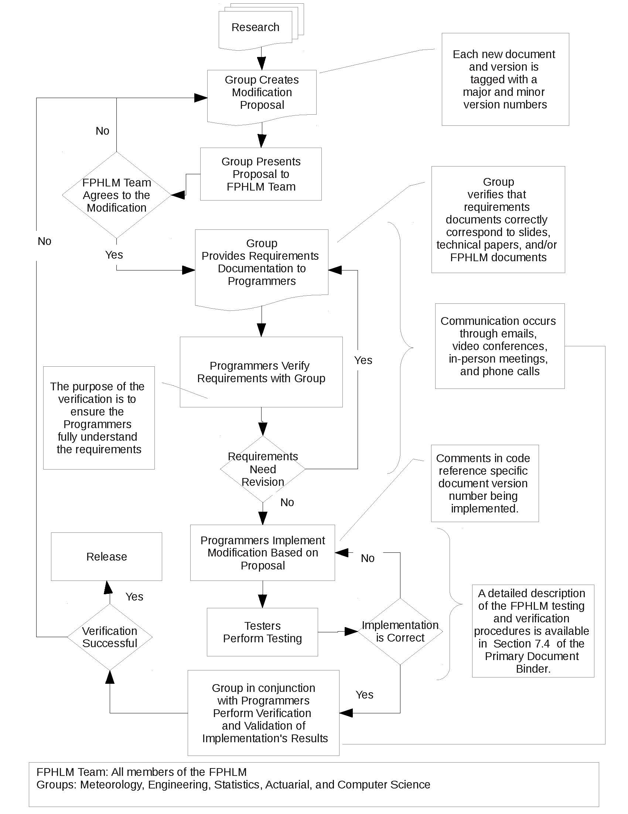
Figure 1. Process to assure continual agreement and correct correspondence.

Disclosures

- Specify the model version identification and software program version identification. If the model submitted for review is implemented on more than one software platform, specify each model software platform. Specify which software platform is the primary software platform and verify how any other software platforms produce the same model output results or are otherwise functionally equivalent as provided for in the “Process for Determining the Acceptability of a Computer Simulation Model” in VI. Review by the Commission, I. Review and Acceptance Criteria for Functionally Equivalent Model Software Platforms.

The model name is Florida Public Hurricane Loss Model (FPHLM). The current version is 6.0.

- Provide a comprehensive summary of the model. This summary shall include a technical description of the model including each major component of the model used to produce residential loss costs and probable maximum loss levels in the State of Florida. Describe the theoretical basis of the model and include a description of the methodology, particularly the wind components, the vulnerability components, and the insured loss components used in the model. The description shall be complete and shall not reference unpublished work.

The model is a very complex set of computer programs. The programs simulate probable future hurricane activity, including where and when hurricanes form; their tracks and intensities; their wind fields and sizes; how they decay and how they are affected by the terrain along the tracks after landfall; how the winds interact with different types of residential structures; how much they can damage roofs, windows, doors, interior, and contents, etc.; how much it will cost to rebuild the damaged parts; and how much of the loss will be paid by insurers. The model consists of three major components: wind hazard (meteorology), vulnerability (engineering), and insured loss cost (actuarial). It has over a dozen subcomponents. The major components are developed independently before being integrated. The computer platform is designed to accommodate future subcomponents or enhancements. Following is the description of each of the major components and the computer platform.

METEOROLOGY COMPONENT

Hurricane Track and Intensity

The storm track model generates storm tracks and intensities on the basis of historical storm conditions and motions. The initial seeds for the storms are derived from the HURDAT database. For historical landfalling storms in Florida and neighboring states, the initial positions, intensities, and motions are taken from the track fix 36 hours prior to first landfall. For historical storms that do not make landfall but come within 62 sm (100 km) of the coast, the initial conditions are taken from the track fix 36 hours prior to the point at which the storm first comes within 62 sm of the coast (threat zone) and has a central pressure below 1005 mb. Small, uniform random error terms are added to the initial position, the storm motion change, and the storm intensity change. The initial conditions derived from HURDAT are recycled as necessary to generate thousands of years of stochastic tracks. After the storm is initiated, the subsequent motion and intensity changes are sampled from empirically derived probability distribution functions over the model domain (Figure 2).

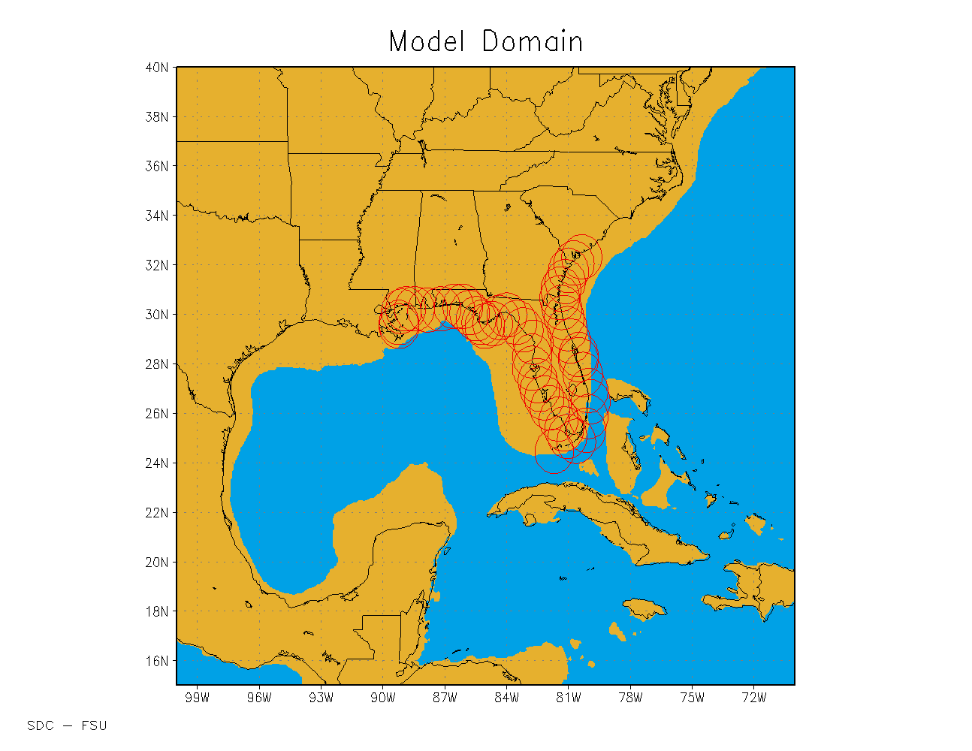
Figure 2. Florida Public Hurricane Loss Model domain. Circles represent the threat zone. Blue color indicates water depth exceeding 656 ft (200 m).
The time evolution of the stochastic storm tracks and intensity are governed by the following equations

where (x,y) are the longitude and latitude of the storm, are the storm speed and heading (in conventional mathematical sense), p is central pressure, w is the rate of change in p, and Δt is the time step. The time step of the model is currently one hour. The storm speed and directionare sampled at every 24-hour interval from a probability distribution function (PDF). The intensity change after the initial 24 hours of track evolution is sampled every six hours to capture the more detailed evolution over the continental shelf (shallow water). From the 24-hour change in speed and heading angle, we determine the speed and heading angle at each one-hour time step by assuming the storm undergoes a constant acceleration that gives the 24-hour sampled change in velocity. For changes in pressure, we first sample from a PDF of relative intensity changes,, for the six-hour period and then determine the corresponding rate of pressure change, w. The relative intensity is a function of the climatological sea surface temperatures and the upper tropospheric 100 mb temperatures. The PDFs of the changesdepend on spatial location, as well as the current storm motion and intensity. These PDFs are of the form

where a is either c, θ, or r and are implemented as discrete bins that are represented by multi-dimensional matrices (arrays), A(l,m,i,j). The indices (i,j) are the storm location bins. The model domain (100W to 70W, 15N to 40N) is divided into 0.5-degree boxes. The index m represents the bin interval that a falls into. That is, the range of all possible values of a are divided into discrete bins, the number of which depends on the variable, and the index m represents the particular bin a is in at the current time step. As with a, the range of all possible values of the change in a are also discretely binned. Given a set of indices (m,i,j), which represent the current storm location and state, the quantity A(l,m,i,j) represents the probability that the change in a,, will fall into the l'th bin. When A is randomly sampled, one of the bins represented by the l index, e.g. l', is chosen. The change of a is then assigned the midpoint value of the bin associated with l'. A uniform random error term equal to the width of bin l' is added to, so thatmay assume any value within the bin l'.

The PDFs described above were generated by parsing the HURDAT database and computing for each track the storm motion and relative intensity changes at every 24- and 6-hour interval, respectively, and then binning them. Once the counts are tallied, they are then normalized to obtain the distribution function. For intensity reports for which pressure is not available, a wind pressure relation developed by Landsea et al. (2004) is used. In cases where there is no pressure report for a track fix in the historical data but there are two pressure reports within a 24-hour period that includes the track fix, the pressures are derived by linear interpolation. Otherwise the pressure is derived by using the wind-pressure relation. Extra-tropical systems, lows, waves, and depressions are excluded. Intensity changes over land are also excluded from the PDFs. To ensure a sufficient density of counts to represent the PDFs for each grid box, counts from nearest neighbor boxes, ranging up to 2 to 5 grid units away (both north-south and east-west direction), are aggregated. Thus, the effective size of the boxes may range from 1.5 to 5.5 degrees but are generally a fixed size for a particular variable. The sizes of the bins were determined by finding a compromise between large bin sizes, which ensure a robust number of counts in each bin to define the PDF, and small bin sizes, which can better represent the detail of the distribution of storm motion characteristics. Detailed examinations of the distributions, as well as sensitivity tests, were done. Bin sizes need not be of equal width, and a nonlinear mapping function is used to provide unequal-sized bins. For example, most storm motion tends to be persistent, with small changes in direction and speed. Thus, to capture this detail, the bins are more fine-grained at lower speed and direction changes.

For intensity change PDFs, boxes which are centered over shallow water (defined to be less than 656 ft deep, see Figure 2) are not aggregated with boxes over deeper waters. Deeper waters may have significantly higher ocean heat content, which can lead to more rapid intensification [see, for example, Shay et al. (2000); DeMaria et al. (2005); Wada and Usui (2007)]. The depth that defines deep and shallow waters is not too critical, as the continental shelf drops rather sharply. The 200 m (656 ft) bathymetric contour line appears to distinguish well estimates of regions with high and low tropical cyclone heat potential (see http://www.aoml.noaa.gov/phod/cyclone/data/). When gridded long-term analyses of tropical cyclone heat potential, or similar characterization of oceanic heat content, become available, we intend to use that data in lieu of bathymetry.

In Figure 3 we show a sample of tracks generated by the stochastic track and intensity model.

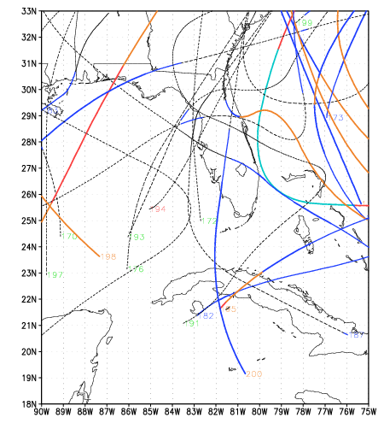
Figure 3. Examples of simulated hurricane tracks. Numbers refer to the stochastic track number, and colors represent storm intensity based on central pressure. Dashed lines represent tropical storm strength winds, and Cat 1-5 winds are represented by black, blue, orange, red, and turquoise, respectively.
When a storm is started, the parameters for radius of maximum winds and Holland B are computed and appropriate error terms are added as described below. The Holland B term is modeled as follows:

$$B=1.74425-0.007915 Lat+ 0.0000084 {DelP}^{2}-0.005024Rmax$$

where Lat is the current latitude (degrees) of the storm center, DelP is the central pressure difference (mb), and Rmax is the radius of maximum winds (km). The random error term for the Holland B is modeled using a Gaussian distribution with a standard deviation of 0.286. Figure 4 shows a comparison between the Willoughby and Rahn (2004) B dataset (see Standard M-2.1) and the modeled results (scaled to equal the 116 measured occurrences in the observed dataset). The modeled results with the error term have a mean of about 1.38 and are consistent with the observed results. The figure indicates excellent agreement between model and observations.

Figure 4. Comparison between the modeled and observed Willoughby and Rahn (2004) B dataset.
We developed an Rmax model using a landfall Rmax database, which includes more than 100 measurements for storms up to 2010. We have opted to model the Rmax at landfall rather than the entire basin for a variety of reasons. One is that the distribution of landfall Rmax may be different than that over open water. An analysis of the landfall Rmax database and the 1988–2007 DeMaria extended best track data shows that there appears to be a difference in the dependence of Rmax on central pressure (Pmin) between the two datasets (Demuth et al., 2006). The landfall dataset provides a larger set of independent measurements, more than 100 storms compared to about 31 storms affecting the Florida threat area region in the best track data. Since landfall Rmax is most relevant for loss cost estimation and has a larger independent sample size, we have chosen to model the landfall dataset. Future studies will examine how the extended best track data can be used to supplement the landfall dataset.

We modeled the distribution of Rmax using a gamma distribution. Using an approximate maximum likelihood estimation method, we found the estimated parameters for the gamma distribution, and. With these estimated values, we show a plot of the observed and expected distribution in Figure 5. The Rmax values are binned in 5 sm intervals, with the x-axis showing the end value of the interval.

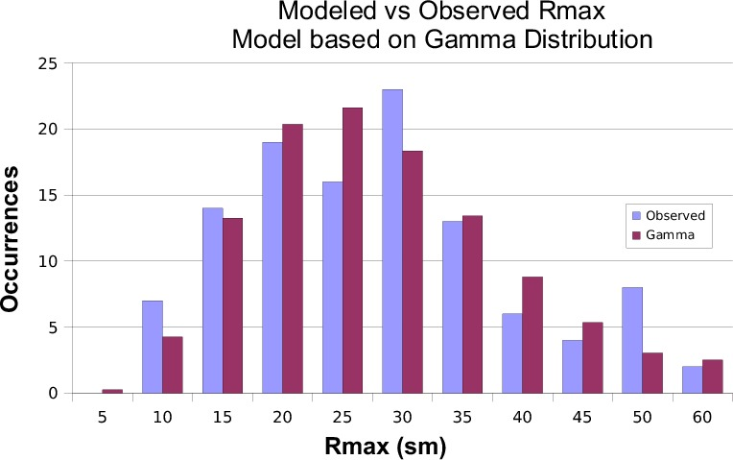
Figure 5. Observed and expected distribution for Rmax. The x-axis is the radius in statute miles, and the y-axis is the frequency of occurrence.
An examination of the Rmax database shows that intense storms, essentially Category 5 storms, have rather small radii. Thermodynamic considerations (Willoughby, 1998) also suggest that smaller radii are more likely for these storms. Thus, we model Category 5 (DelP>90 mb, where DelP=1013-Pmin and Pmin is the central pressure of the storm) storms using a gamma distribution, but with a smaller value of the θ parameter, which yields a smaller mean Rmax as well as smaller variance. We have found that for Category 1–4 (DelP<80) storms there is essentially no discernable dependence of Rmax on central pressure. This is further verified by looking at the mean and variance of Rmax in each 10 mb interval. Thus, we model Category 1–4 storms with a single set of parameters. For a gamma distribution, the mean is given by kθ, and variance is kθ². For Category 5 storms, we adjust θ such that the mean is equal to the mean of the three Category 5 storms in the database: 1935 No Name, 1969 Camille, and 1992 Andrew. An intermediate zone between DelP=80 mb and DelP=90 mb is established where the mean of the distribution is linearly interpolated between the Category 1–4 value and the Category 5 value. As the θ value is reduced, the variance is likewise reduced. Since there are insufficient observations to determine what the variance should be for Category 5 storms, we rely on the assumption that variance is appropriately described by the rescaled θ, via kθ².

A simple method is used to generate the gamma-distributed values. A uniformly distributed variable, a product of the random number generator that is intrinsic to the FORTRAN compiler, is mapped onto the range of Rmax values via the inverse cumulative gamma distribution function. For computational efficiency, a lookup table is used for the inverse cumulative gamma distribution function, with interpolation between table values. Figure 6 shows a test using 100,000 samples of Rmax for Category 1–4 storms, binned in 1 sm intervals and compared with the expected values.

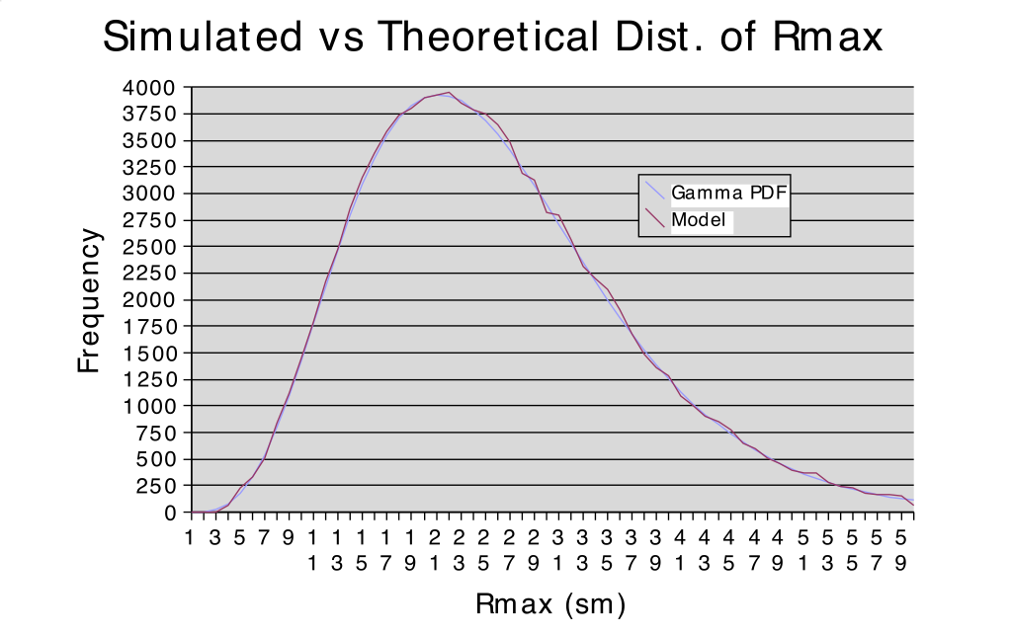
Figure 6. Comparison of 100,000 Rmax values sampled from the gamma distribution for Category 1-4 storms to the expected values.

For Category 5 and intermediate Category 4–5 storms, we use the property that the gamma cumulative distribution function is a function of (k,x/θ). Thus, by rescaling θ, we can use the same function (lookup table), but just rescale x (Rmax). The rescaled Rmax will still have a gamma distribution but with different mean and variance.

The storms in the stochastic model will undergo central pressure changes during the storm life cycle. When a storm is generated, an appropriate Rmax is sampled for the storm. To ensure the appropriate mean values of Rmax as pressure changes, the Rmax is rescaled every time step as necessary. As long as the storm has DelP < 80 mb, there is in effect no rescaling. In the stochastic storm generator, we limit the range of Rmax from 4 sm to 60 sm.

Storm landfall and decay over land are determined by comparing the storm location (x,y) with a 0.6 sm resolution land-sea mask. This land mask is obtained from the U.S. Geological Survey (USGS) land use cover data, and inland bodies of water have been reclassified as land to avoid spurious landfalls. Landfall occurs every time the storm moves from an ocean point to a land point as determined by this land mask. During landfall, the central pressure is modeled by a filling model described in Vickery (2005) and is no longer sampled from the intensity change PDFs. The Vickery (2005) model basically uses an exponentially decaying, in time, function of the central pressure difference with the decay coefficients varying by region on the basis of historical data. The pressure filling model also takes into account the speed and size of the storm. When the storm exits to sea, the land-filling model is turned off and sampling of the intensity change PDFs begins again. A storm is dissipated when its central pressure exceeds 1011 mb.

Wind Field Model

Once a simulated hurricane moves to within a threshold distance of a Florida ZIP Code, the wind field model is turned on. The model is based on the slab boundary layer concept originally conceived by Ooyama (1969) and implemented by Shapiro (1983). Similar models based on this concept have been developed by Thompson and Cardone (1996), Vickery et al. (1995), and Vickery et al. (2000a). The model is initialized by a boundary layer vortex in gradient balance. Gradient balance represents a circular flow caused by balance of forces on the flow whereby the inward directed pressure gradient force is balanced by outward directed Coriolis and centripetal accelerations. The coordinate system translates with the hurricane vortex moving at velocity c. The vortex translation is assumed to equal the geostrophic flow associated with the large-scale pressure gradient. In cylindrical coordinates that translate with the moving vortex, equations for a slab hurricane boundary layer under a prescribed pressure gradient are

$$u\frac{∂u}{∂r}-\frac{v^{2}}{r}-fv+\frac{v}{r}\frac{∂u}{∂ϕ}+\frac{∂p}{∂r}-K\left(∇^{2}u-\frac{u}{r^{2}}-\frac{2}{r^{2}}\frac{∂u}{∂ϕ}\right)+F\left(c,u\right)=0=\frac{∂u}{∂t}$$

$$u\left(\frac{∂v}{∂r}+\frac{v}{r}\right)+fu+\frac{v}{r}\frac{∂v}{∂ϕ}- K\left(∇^{2}v-\frac{v}{r^{2}}+\frac{2}{r^{2}}\frac{∂u}{∂ϕ}\right)+F\left(c,v\right)=0=\frac{∂v}{∂t}$$

where u and v are the respective radial and tangential wind components relative to the moving storm; p is the sea level pressure, which varies with radius (r); f is the Coriolis parameter, which varies with latitude; ϕ is the azimuthal coordinate; K is the eddy diffusion coefficient; and F(c,u), F(c,v) are frictional drag terms. All terms are assumed to be representative of means through the boundary layer. The motion of the vortex is determined by the modeled storm track. The symmetric pressure field p(r) is specified by the Holland (1980) pressure profile with the central pressure specified according to the intensity modeling in concert with the storm track. The model for the Holland B pressure profile and the radius of maximum wind are described above. The wind field is solved on a polar grid with a 0.1 R/Rmax resolution. The input Rmax is adjusted to remove a bias caused by a tendency of the wind field solution to place Rmax one grid point radially outward from the input value.

The marine surface winds from the slab model are adjusted to land surface winds using a surface friction model. The FPHLM includes the ability to model losses at the "street level." To incorporate this feature, the treatment of land surface friction in the model has been enhanced to provide surface winds at high resolution and to take advantage of recent developments in hurricane boundary layer theory. The 10-minute winds from the slab model are interpolated to a 1 km (0.62 sm) fixed grid covering the entire state of Florida at every time step to obtain a wind swath for each storm. Surface friction is modeled using an effective roughness model (Axe, 2004) based on the Source Area Model of Schmidt and Oke (1990) that takes into account upstream surface roughness elements. The surface roughness elements are derived from the Multi-Resolution Land Characteristics Consortium (MRLC) National Land Classification Database (NLCD) 2001 land cover/land use dataset (Homer et al., 2004) and the Statewide 2004 Florida Water Management District land use classification data (available from the Florida Department of Environmental Protection). The effective roughness elements are computed for eight incoming wind directions on a grid of approximately 90 m (295 ft) resolution covering the entire state of Florida.

For modeling losses at the ZIP Code level, the effective roughness elements are aggregated over the ZIP Code by a weighted summation of the roughness elements according to population density determined from census block data. The methodology for converting marine winds to actual terrain winds is based on Powell et al. (2003) and Vickery et al. (2009). This method assumes that wind at the top of the marine boundary layer is similar to the wind at the top of the boundary layer over land, and a modified log-wind profile is then used to determine the wind near the land surface. The winds are computed at various height levels that are needed for the vulnerability functions for residential and commercial residential structures.

The effect of the sea-land transition of hurricane winds coming onshore is modeled by modifying the terrain conversion methodology of Vickery et al. (2009). This modification is based on the concept of an internal boundary layer (IBL) (Arya, 1988) that develops as wind transitions from smooth to rough surface conditions. Winds above the IBL are assumed to be in equilibrium with marine roughness. In the equilibrium layer (EL), defined to be one-tenth of the IBL, the winds are assumed to be in equilibrium with the local effective roughness. Between the EL and IBL the winds are assumed to be in equilibrium with vertically varying step-wise changes in roughness associated with upstream surface conditions. This concept of multiple equilibrium layers is similar in philosophy to the method prescribed by the Engineering Sciences Data Unit (ESDU). The coastal transition function produces wind transitions that are very close to the ESDU and modified ESDU values reported in Vickery et al. (2009).

VULNERABILITY COMPONENT: PERSONAL RESIDENTIAL MODEL

The engineering component performs several tasks: (1) it estimates the physical damage to exterior components of typical buildings, including roof cover, roof decking, walls, and openings; (2) it assesses the interior and utilities damage and contents damage due to water penetration through exterior damage and defects to interior walls, ceiling, doors, etc.; (3) it combines the exterior and interior damage to estimate the building and content vulnerabilities; (4) it estimates additional living expenses; and (5) it estimates the appurtenant structure vulnerability (Pinelli et al., 2003a, 2003b, 2004a, 2004b, 2005a, 2005b, 2006, 2007a, 2007b, 2008a, 2008b, 2009a, 2010a, 2011a, 2011b, 2012; Cope, 2004; Cope et al., 2003a, 2003b, 2004b, 2005; Gurley et al., 2003, Torkian at al., 2011, 2014).

Exposure Study

Personal residential single-family home buildings (PRB), either site built (Figure 7) or manufactured (Figure 8), are categorized into typical generic groups with similar structural characteristics, layout, and materials within each group. These buildings can suffer substantial external structural damage (in addition to envelope and interior damage), including collapse under hurricane winds. The approach to assessing damage for each of these building types is to model the building as a whole so that interactions among components can be accounted for. The models are intended to represent the majority of the PRB’s in Florida.

An extensive survey of the Florida building stock was carried out to develop a manageable number of building models that represent the majority of the Florida residential building stock. The modelers analyzed several sources of data for building stock information. One source was the Florida Hurricane Catastrophe Fund (FHCF) exposure database. Another source was the Florida counties’ property tax appraisers’ databases. Although the database contents and format vary county to county, many of these databases contain the structural information needed to define common structural types. The 52 most populous counties were contacted to acquire their tax appraiser database, producing information from 33 counties. These 33 counties account for more than 90% of Florida’s population. The residential buildings in each county database were divided into single-family residential buildings and mobile homes.

County property tax appraiser (CPTA) databases contain large quantities of building information, and it was necessary to extract those characteristics related to the vulnerability of buildings to wind. The available building characteristics vary from county to county and include some combination of the following: exterior wall material, interior wall material, roof shape, roof cover, floor covering, foundation, opening protection, year built, number of stories, area per floor, area per unit, and geometry of the building. The parameters important for modeling are roof cover, roof shape, exterior wall material, number of stories, year built, and building area. For each of these categories, the authors extracted statistical information. The dependency between critical building characteristics was also investigated. For example, it was found that roof shape and area of the building are strongly dependent on the year built. The survey statistics were calculated for different eras to account for the correlation between various factors and year built.
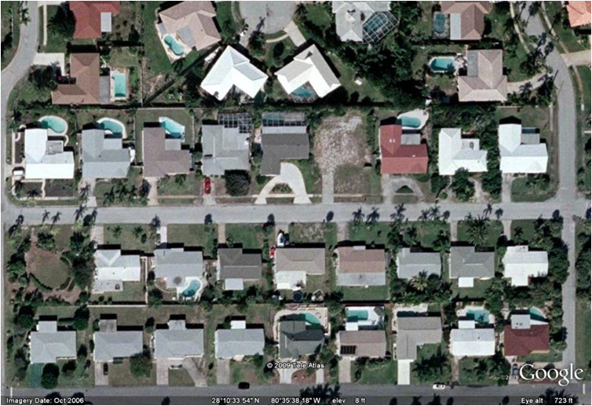
Figure 7. Typical single-family homes (Google Earth).
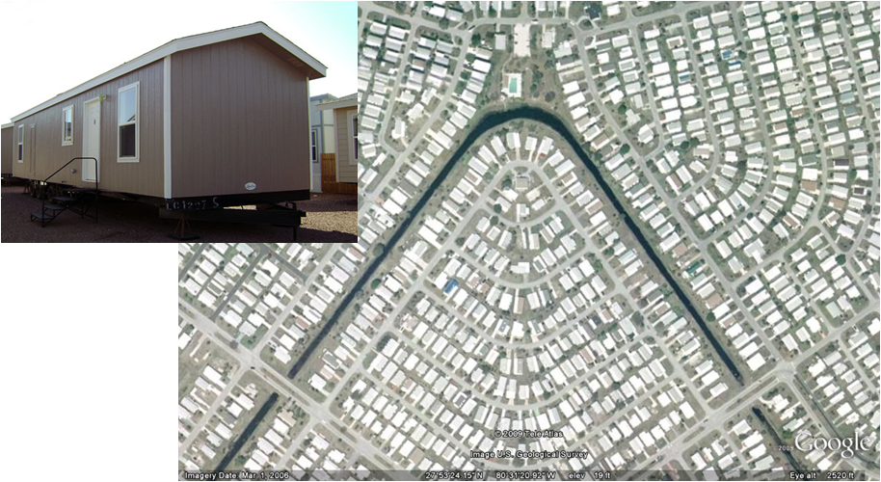
Figure 8. Manufactured homes (Google Earth).
The modelers divided Florida into four regions: North, Central, South, and the Keys. Geography and the statistics from the Florida Hurricane Catastrophe Fund (FHCF) provided guidance for defining regions that would have a similar building mix. For example, North Florida has primarily wood frame houses while South Florida primarily has masonry houses. Figure 9 shows the regions. Each county for which data were available is marked with a star and shaded.
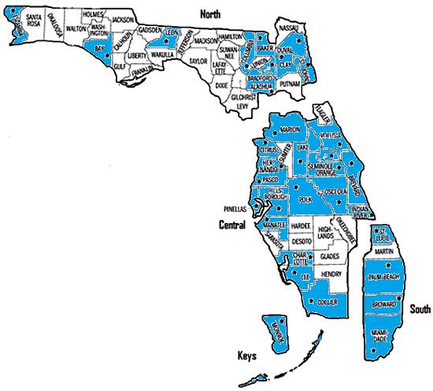
Figure 9. Regional Classification of Florida with the corresponding sample counties (blue and star).
Structural types are delineated by a combination of four characteristics: number of stories (either one or two), roof cover (either shingle, tile, or metal), roof shape (either gable or hip), and exterior wall material (either concrete blocks or timber). Statistics were computed for each structural type in every sampled county. Weighted average techniques were used to extrapolate the results to the remaining counties in each region.

Building Models

Site-Built Home Models

In addition to a classification of building by structural types (wood or masonry walls, hip or gable roof), it was also necessary to classify the buildings by relative strength to reflect changes in construction practice over many years. The vulnerability team has developed strong, medium, and weak strength models for each site-built structural type to represent relative quality of original construction as well as post-construction mitigation. The weak and medium models have additional variants that reflect historical building practices, roof retrofits, and reroofing of existing structures as mandated by the newer building standards. The strong model has two variants to delineate code requirements that are regionally dependent. One strong variant reflects inland and wind-borne debris region (WBDR) construction, and another (stronger) variant reflects construction in the high velocity hurricane zone (HVHZ).

The three strength categories are based on the same model framework, in which strength is represented by the capacities assigned to the modeled building components. For example, the strong models differ from the weak models by stronger assigned capacities for roof-to-wall (r2w) and stud to sill connections, garage pressure capacity, cracking capacity of masonry walls, gable end walls, decking and shingle capacities. The medium models differ from the weak models by increasing the strength of the roof-to-wall connections (toe nails vs. clips), roof decking capacity (nailing schedule), and masonry wall strength (un-reinforced vs. reinforced).

Any given strong, medium, or weak model may be altered by additional mitigation or retrofit measures individually or in combination. For example, from the base weak model, additional models were derived to represent historical building practices and mitigation techniques. The modified weak W10 model accounts for the use of tongue-and-groove plank decking in pre-1960s buildings. These buildings tend to exhibit higher deck strength capacities than the buildings with the plywood decking implemented in the base weak model, referred to as W00 (Shanmugam et al., 2009).

A modified medium model M10 was adopted that reflects the use of oriented strand board (OSB) decking with staples in the 1980s and pre-Andrew 1990s. This was considered an adequate alternative to nailed plywood at the time. It was, however, weaker in terms of wind resistance and was assigned a weaker deck attachment capacity than the standard medium model.

Additionally, retrofitted weak W01 and medium M01 models were derived from the base weak and medium models. They represent the case in which a structure has been reroofed and the decking re-nailed according to current code requirements. On the basis of the average lifespan of a roof, reroofing would be required periodically throughout the structure’s lifetime and would result in an increase in the deck attachment capacity and shingle ratings to meet current building code requirements. The deck attachment capacities of these models were therefore upgraded to produce the retrofitted weak W01 and medium M01 cases. The roof cover was also upgraded to rated shingles (Pinelli et al., 2012).

The base, retrofitted and modified versions of the weak and medium models were developed in order to provide a fine model resolution of quality of construction for homes constructed prior to 1994 and a portion of the homes prior to 2002. Weak and medium models represent approximately 80% of the existing single-family residential inventory in Florida, and are described in Table 1a.

Two basic variations of the strong model represent construction quality for the remaining approximately 20% of the single-family residential inventory. The base strong model, S00, represents modern construction in locations inland, as well as the WBDR that is not overlapping the HVHZ. The difference in strong models between inland, S00, and WBDR, S00-OP, is due to the presence of metal shutters in WBDR. This base strong model incorporates modern requirements for nailing schedules, roof to wall connection products, masonry reinforcing, and roof shingle products and installation methods. The second strong model, S01, has upgrades to the capacity for roof cover, roof decking and roof to wall connections to reflect additional code requirements for HVHZ construction. The strong models are described in Table 1b.

All models may be run without opening protection, with plywood opening protection, or with metal panel shutter opening protection installed, with increasing protection respectively.

The distribution of the weak, medium and strong model variations with respect to year built will be presented later in Table 6 and in the discussion of the models’ distribution in time.

Table 1a. Weak and Medium Models

 | Weak |  |  | Medium
 | W00  (base) | W01  (retrofitted*) | W10  (modified**) | M00  (base) | M01  (retrofitted*) | M10  (modified***)
Roof to wall | Weak | Weak | Weak | Medium | Medium | Medium
Stud to sill | Weak | Weak | Weak | Medium | Medium | Medium
Roof cover | Weak | Strong | Weak | Weak | Strong | Weak
Roof deck | Weak | Strong | Strong | Medium | Strong | Weak
Wall | Weak | Weak | Weak | Medium | Medium | Medium
Gable end | Weak | Weak | Weak | Weak | Weak | Weak
Garage | Weak | Weak | Weak | Weak | Weak | Weak
*retrofitted refers to re-roof and re-nailed decking, occurring post-1993 for HVHZ and Monroe, and post-2001 for everywhere else. No other retrofits are included.
**modified weak refers to the base weak model with stronger decking to reflect the use of plank decking
***modified medium refers to the base medium model with weak decking to reflect the use of staples and/or OSB

Table 1b. Strong Models
 | S00  Strong - inland | S00-OP  Strong - WBDR | S01  Strong - HVHZ
Roof to wall | Strong | Strong | Upgraded Strong
Stud to sill | Strong | Strong | Strong
Roof cover | Strong | Strong | Upgraded Strong
Roof deck | Strong | Strong | Upgraded Strong
Wall | Strong | Strong | Strong
Gable end | Strong | Strong | Strong
Garage | Strong | Strong | Strong
Shutters | no shutters | metal | metal

Manufactured Homes Model

On the basis of the exposure study, it was decided to model four manufactured home (MH) types: (1) pre-1994—fully tied down, (2) pre-1994—not tied down, (3) post-1994—Housing and Urban Development (HUD) Zone II, and (4) post-1994—HUD Zone III. The partially tied-down homes are assumed to have a vulnerability that is an average of the vulnerabilities of fully tied-down and not tied-down homes. Because little information is available regarding the distribution of manufactured home types by size or geometry, it is assumed that all model types are single-wide manufactured homes. The modeled single-wide manufactured homes are 56 ft x 13 ft, have gable roofs, eight windows, a front entrance door, and a sliding-glass back door.

Damage Matrices

Exterior Damage

The model accounts for a number of construction factors that influence the vulnerability of single-family dwellings, including classification (site-built or manufactured home), size, roof shape, location, age, and a variety of construction details and mitigation measures. The effects of mitigation measures such as code revisions and post-construction upgrades to the wind resistance of homes (e.g., new roof cover on an older home, shutter protection against debris impact, braced garage door, re-nailed roof decking, etc.) are accounted for both individually and in combination by selecting the desired statistical descriptors of the capacities of the various components. Thus the comparative vulnerability of older homes as built, older homes with combinations of mitigation measures, and homes constructed to the new code requirements can be estimated.

The vulnerability model uses a component-based Monte Carlo simulation to determine the external vulnerability at various wind speeds for the different building models. The approach accounts for the resistance capacity of the various building components, the wind-load effects from different directions, and associated uncertainties of capacity and loads to predict exterior damage at various wind speeds. The simulation relates probabilistic strength capacities of building components to a series of three-second peak gust wind speeds through a detailed wind and structural engineering analysis that includes effects of wind-borne debris. Damage to the structure occurs when the loads from wind or flying debris are greater than the components’ capacity to resist them. The vulnerability of a structure at various wind speeds is estimated by quantifying the amount of damage to the modeled components. Damage to a given component may influence the loads on other components, e.g., a change in roof loading from internal pressurization due to a damaged opening. These influences are accounted for through an iterative process of loading, damage assessment, load redistribution, and reloading until convergence is reached. The flow chart in Figure 10 summarizes the Monte Carlo procedure used to predict the external damage. The random variables include wind speed, pressure coefficients, debris impact, and the resistances of the building components (roof cover, roof sheathing, openings, walls, connections).

The damage estimations are affected by uncertainties regarding the behavior and strength of the various components and the load effects produced by hurricane winds. Field and laboratory data that better define these uncertain behaviors can thus be directly included in the model by refining the statistical descriptors of the capacities, load paths, and applied wind loads.

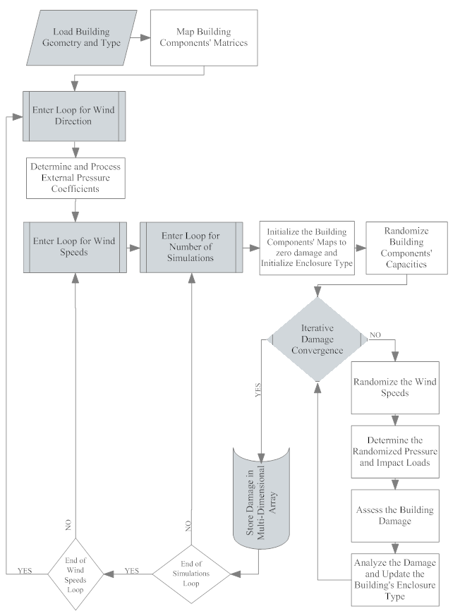
Figure 10. Monte Carlo simulation procedure to predict external damage.
The output of the Monte Carlo simulation model is an estimate of physical damage to structural and exterior components of the modeled home. The results are presented in the form of a damage matrix, where each row presents the output of an individual simulation. The 15 rows of this matrix (Table 2) correspond to damage to 14 components, and the internal pressure of the building upon completion of that simulation (column 11). A separate matrix is created for each peak three-second gust wind speed between 50 and 250 mph in 5 mph increments (50, 55, …, 250 mph) and for each wind angle between 0 and 315 degrees in 45-degree increments. A description of the values in each of the nine columns of the manufactured home damage matrix is given in Table 3. Note that internal pressure is not included as an output from the manufactured home model (Table 3). Changes in internal pressure due to breach are accounted for and utilized to quantify damage, but the final internal pressure value is not needed as an output.

Table 2. Description of values given in the damage matrices for site-built homes.
Col# | Description of Value | Min Value | Max Value
1 | % failed roof sheathing | 0 | 100
2 | % failed roof cover | 0 | 100
3 | % failed roof to wall connections | 0 | 100
4 | # of failed walls | 0 | 4
5 | # of failed windows | 0 | 15
6 | # of failed doors | 0 | 2
7 | y or n failed garage | 0 = no | 1 = yes
8 | y or n envelope breached | 0 = no | 1 = yes
9 | # of windows broken by debris impact | 0 | 15
10 | % of gable end panels broken | 0 | 100
11 | internal pressure | 0 | Not defined
12 | % failed wall panels – front | 0 | 100
13 | % failed wall panels – back | 0 | 100
14 | % failed wall panels – side | 0 | 100
15 | % failed wall panels – side | 0 | 100

Table 3. Description of values given in the damage matrices for manufactured homes.
Col # | Description of Value | Min Value | Max Value
1 | # of failed windows (out of 8 for single wide) | 0 | 8
2 | # of broken windows that were broken by impact load case | 0 | 8
3 | # of failed doors (front and back = 2 total) | 0 | 2
4 | % of roof sheathing failed | 0 | 100
5 | % of roof cover failed | 0 | 100
6 | % of wall sheathing failed | 0 | 100
7 | # of failed roof to wall connections (out of 58) | 0 | 58
8 | sliding (0 = no sliding, 1 = minor sliding, 2 = major sliding) | 0 | 2
9 | overturning (0 = not overturned, 1 = overturned) | 0 | 1

Interior and Utilities Damage

Once the external damage has been calculated for a given Monte Carlo simulation, the internal, utilities, and contents damages to the building are then extrapolated from the external damage. For the interior and utilities of a home, there is no explicit means by which to compute damage. Damage to the interior and utilities occurs when the building envelope is breached, allowing wind and rain to enter. Damage to roof sheathing, roof cover, walls, windows, doors, and gable ends present the greatest opportunities for interior damage. For manufactured homes, sliding and overturning are additional factors.

Interior damage equations were derived as functions of each of the external components. These equations are developed primarily on the basis of experience and engineering judgment. Observations of homes damaged during the 2004 hurricane season helped to validate these predictions. The interior equations are derived by estimating typical percentages of damage to each interior component, given a percentage of damage to an external component. The interior damage as a function of each modeled component is the same for both site-built and manufactured homes.

To model the uncertainties inherent in the determination of interior damage, the output of the equations is multiplied by a random factor with mean unity. The factor is assumed to have a Weibull distribution with tail length parameter 2. For the factor to have mean unity, the scale parameter must be 0.7854, resulting in a variance of 0.2732. This choice of Weibull parameters is assumed to be reasonable, and a sensitivity study was done to confirm that assumption and to show that it has no effect on the mean vulnerability, as expected.

To compute the total interior damage for each model simulation, all values in the damage matrices are converted to percentages of component damage. The interior equations are applied to each component, one at a time. The total interior damage for each simulation is the maximum interior damage value produced by these equations. The maximum value is used instead of a summation to avoid the possibility of counting the same interior damage more than once. That is, once water intrusion from one breach of the envelope has thoroughly damaged any part of the interior, further water intrusion from other sources will not increase the cost of the damage of that part.

Utilities damage is estimated on the basis of interior damage. A coefficient is defined for each utility (electrical, plumbing, and mechanical), which multiplies the interior equations defined for each component. As in the case of interior damage, the maximum value is retained as the total damage. The utilities coefficients are based on engineering judgment. In both site-built and manufactured homes, it is assumed that electrical damage occurs at half the rate of interior damage (0.5). Plumbing damage is set to 0.35 of interior damage for site-built homes and for manufactured homes. Mechanical damage is set to 0.4 of interior damage for site-built homes and for manufactured homes.

Contents Damage

As with the interior and utilities, the contents of the home are not modeled by Monte Carlo simulations. Contents damage is assumed to be a function of the interior damage caused by each failed component that causes a breach of the building envelope. The functions are based on engineering judgment and are validated using actual claims data.

Additional Living Expenses

Additional Living Expense (ALE) coverage covers only expenses actually paid by the insured. This coverage pays only the increase in living expenses that results directly from the covered damage and having to live away from the insured location. The value of an ALE claim is dependent on the time required to repair a damaged home and the surrounding utilities and infrastructure.

The equations and methods used for manufactured and residential homes are identical. However, it seems logical to reduce the manufactured home ALE predictions because typically a faster repair or replacement time may be expected for these home types. Therefore, an ALE multiplier factor of 0.75 was introduced into the manufactured home model.

Vulnerability Matrices

The estimates of total building damage result in the formulation of vulnerability matrices for each modeled building type. The flowchart in Figure 11 summarizes the procedure used to convert the Monte Carlo simulations of physical external damage into a vulnerability matrix.

Figure 11. Procedure to create vulnerability matrix.
For each Monte Carlo model, 5000 simulations are performed for each of 8 different wind angles and 41 different wind speeds. This is 5000 x 8 x 41 = 1,640,000 simulations of external damage per model, which are then expanded to cover interior, utilities, and contents damage, plus ALE, as explained above.

Knowing the components of a home and the typical square footage, the cost of repairing all damaged components is estimated using cost estimation resources [e.g., RSMeans Residential Cost Data and Construction Estimating Institute (Langedyk & Ticola, 2002)] and expert advice. These resources provide cost data from actual jobs based on estimates and represent typical conditions. Unmodeled nonstructural interior, plumbing, mechanical, and electrical utilities make up a significant portion of repair costs for a home.

Replacement cost ratios provide a link between modeled physical damage and the corresponding monetary losses. They can be defined as the cost of replacing a damaged component or assembly of a home divided by the cost of constructing a completely new home of the same type. The sum of the replacement cost ratios for all the components of a home is greater than 100% because the replacement costs include the additional costs of removal, repair, and remodeling.

An explicit procedure is used to convert physical damage of the modeled components to monetary damage. Since the replacement ratio of each modeled component is known, the monetary damage resulting from damage to a component expressed as a percentage of the home’s value can be obtained by multiplying the damaged percentage of the component by the component’s replacement ratio. For example, if 30% of the roof cover is damaged, and for this particular home type the replacement ratio of roof cover is 14%, the value of the home lost as a result of the damaged roof cover would be 0.30 x 0.14 = 4.2%. If the value of this home were $150,000, the cost to replace 30% of the roof would be $150,000 x 0.042 = $6,300. In addition, the costs will be adjusted as necessary because of certain requirements of the Florida building code that might result in an increase of the repair costs (for example, the code might require replacement of the entire roof if 30% or more is damaged).

After the simulation results have been translated into damage ratios, they are then transformed into vulnerability matrices. A total of 4356 matrices for site-built homes is created for different combinations of wall type (frame or masonry), region (North, Central, or South), subregion (high wind velocity zone, wind-borne debris region, or other), roof shape (gable or hip), roof cover (tile or shingle), window protection (shuttered or not shuttered), number of stories (one or two), and strength (base weak W00, modified weak W10, retrofitted weak W01, base medium M00, modified medium M10, retrofitted medium M01, or strong S).

The cells of a vulnerability matrix for a particular structural type represent the probability of a given damage ratio occurring at a given wind speed. The columns of the matrix represent three-second gust wind speeds at 10 m, from 50 mph to 250 mph in 5 mph bands. The rows of the matrix correspond to damage ratios (DR) in 2% increments up to 20%, and then in 4% increments up to 100%. If a damage ratio is DR= 15.3%, it is assigned to the interval 14%<DR<16% with a midpoint DR=15%. After all the simulations have been counted, the total number of instances in each damage interval is divided by the total number of simulations per wind speed to determine the percentage of simulations at any damage state occurring at each speed. These percentages are the conditional probabilities of occurrence of a level of damage, given a certain wind speed. A partial example of a vulnerability matrix is shown in Table 4.

Table 4. Partial example of vulnerability matrix.
Damage\Wind Speed (mph) | 47.5 to 52.5 | 52.5 to 57.5 | 57.5 to 62.5 | 62.5 to 67.5 | 67.5 to 72.5
0% to 2% | 1 | 0.99238 | 0.91788 | 0.77312 | 0.61025
2% to 4% | 0 | 0.00725 | 0.0806 | 0.21937 | 0.36138
4% to 6% | 0 | 0.00037 | 0.001395 | 0.007135 | 0.0235
6% to 8% | 0 | 0 | 0.000125 | 0.000375 | 0.0025
8% to 10% | 0 | 0 | 0 | 0 | 0.000375
10% to 12% | 0 | 0 | 0 | 0 | 0.000375
12% to 14% | 0 | 0 | 0 | 0 | 0.000625
14% to 16% | 0 | 0 | 0 | 0 | 0.0005
16% to 18% | 0 | 0 | 0 | 0 | 0.000125
18% to 20% | 0 | 0 | 0 | 0 | 0.00012
20% to 24% | 0 | 0 | 0 | 0 | 0.00025
24% to 28% | 0 | 0 | 0 | 0 | 0

One important plot derived from the vulnerability matrix is the vulnerability curve. The vulnerability curve for any structural type is the plot of the mean damage ratio vs. wind speed. The model can also generate fragility curves (the probability of exceedance of any given damage level as a function of the wind speed) for each vulnerability matrix, although these curves are not used in the model.

Similar vulnerability matrices and vulnerability curves are developed for contents and ALE, one for each structural type. The whole process is also applied to manufactured homes.

Weighted Vulnerability Matrices

Building vulnerability matrices were created for every combination of region (Keys, South, Central, and North), construction type (masonry, wood, or other), roof shape (gable or hip), roof cover (tile or shingle or metal), number of stories (one or two), shutters (with or without), and subregion (inland, wind-borne debris region, or high velocity hurricane zone). However, in general, there is little information available in an insurance portfolio file regarding the structural characteristics and the wind resistance of the insured property. Instead, insurance companies rely on the Insurance Services Office’s (ISO) fire resistance classification. Portfolio files have information on ZIP Code and year built. The ISO classification is used to determine if the home is constructed of masonry, timber, or other. The ZIP Code is used to define the region and subregion. The year the home was built is used to assist in defining the strength to be assigned to the home.

Region, subregion, construction type, and year built are determined from the insurance files. This leaves the roof shape, roof cover, and shutter options undefined. From the exposure study of 33 Florida counties, the distribution of number of stories, roof shapes, and roof cover by age per region can be extrapolated. For each age group, we define a weighted matrix for each construction type in each county belonging to a region and subregion. The weighted matrices are the sum of the corresponding vulnerability model matrices weighted on the basis of their statistical distribution. For example, consider a masonry home built in the wind-borne debris region of central Florida in 1990. The exposure study indicates that 66% of such homes have gable roofs, 85% have shingle roof cover, and 20% have window shutters. Weight factors can be computed for each model matrix based on these statistics. For example, the Central Florida, gable, tile, no shutters, masonry matrix would have a weight factor of 66% (masonry percent gable) x 15% (percent tile) x 80% (percent without shutters) = 7.9%; this is the percentage of that home type that would be expected in this region, for that year built. Each model matrix is multiplied by its weight factor, and the results are summed. The final result is a weighted matrix that is a combination of all the model matrices and can be applied to an insurance policy if only the ZIP Code, year built, and ISO classification are known. As a result, for each county in each subregion (inland, wind-borne debris region, and high velocity hurricane zone) of each region (Keys, South, Central, and North), there will be sets of weighted matrices (masonry, wood, and others) for weak, medium, and strong structures.

Age-Weighted Matrices

The year built or year of last upgrade of a structure in a portfolio might not be available when performing a portfolio analysis to estimate hurricane losses in a certain region. In that case, it becomes necessary to assume a certain distribution of ages in the region to develop an average vulnerability by combining weak, medium, and strong.

The tax appraisers’ databases include effective year of construction and thus provide guidance as to how to weigh the combined weak, medium, and strong model results when year built information is not available in other portfolio files. In each region, the data were analyzed to provide the age statistics. These statistics were used to weigh the average of weak, medium, and strong vulnerabilities in each region. The results are shown in Figure 12 for the wind-borne debris zone in the Central region. The different weighted vulnerability curves are shown for the weak, medium, and strong models, superimposed with the age-weighted vulnerability curve.

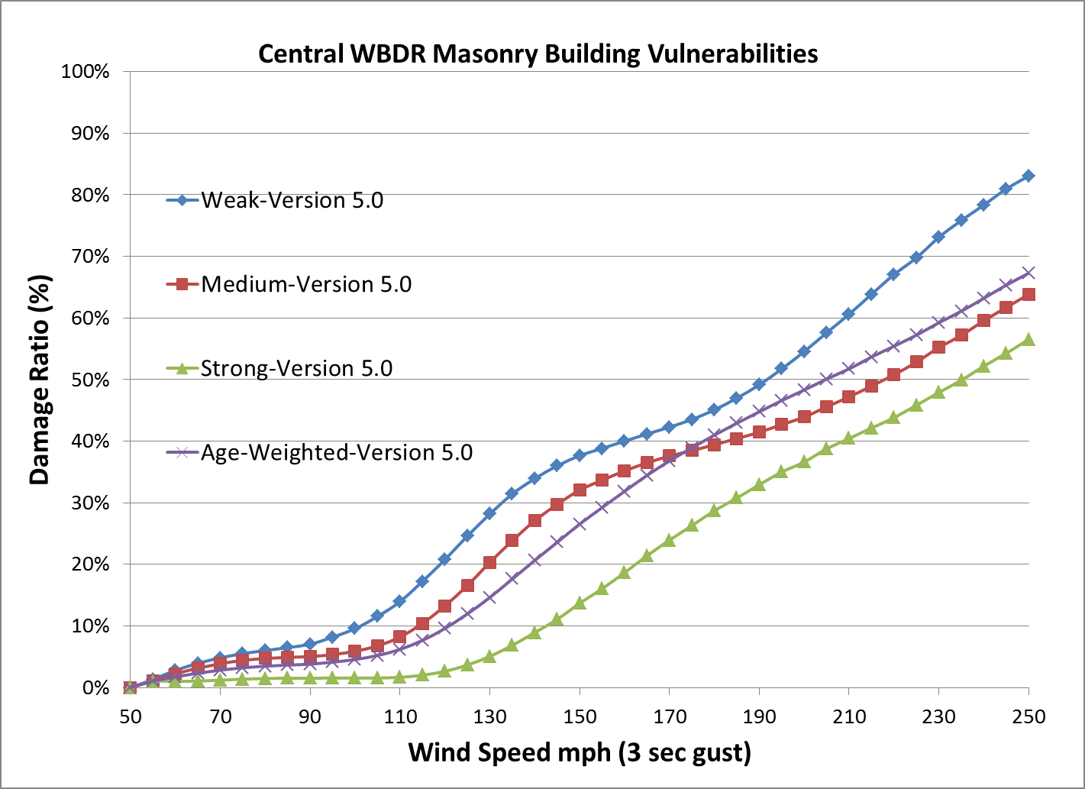
Figure 12. Weighted masonry structure vulnerabilities in the central wind-borne debris region.

Mapping of Insurance Policies to Vulnerability Matrices

The FPHLM processes insurance portfolios from many different insurance companies. Since there is no universal way to classify building characteristics, each company assigns different names or classifications to the building variables. In many cases most of the building structural information in a portfolio is unknown since, in general, detailed records of building characteristics are missing. In a minority of cases, parameters are known, but they do not match any value in the library of the FPHLM. In this case these parameters are classified as “other.” For example, the FPHLM models only timber or masonry residential single-family homes. A steel structure would be classified as other.

This makes the mapping of existing portfolio policies to available vulnerability matrices challenging. The engineering team designed a mapping tool that can be used to read a policy and assign building characteristics, if unknown or other, on the basis of building population statistics and year built, where the year built serves as a proxy for the strength of the building. The process is summarized in Table 5. Once all the unknown parameters in the policy have been defined, an unweighted vulnerability matrix based on the corresponding combination of parameters can then be assigned. If the number of unknown parameters exceeds a certain threshold defined by the user of the program, he or she always has the choice of using a weighted matrix or age-weighted matrix instead.

In the few cases in which a policy in a portfolio has a combination of parameters that would result in a vulnerability matrix different than any of the existing matrices in the library of the FPHLM, the program assigns to the policy a so-called “other” weighted matrix (see Table 5 below). The “other” matrices are an average of timber and masonry matrices.

Table 5. Assignment of vulnerability matrix depending on data availability in insurance portfolios.
Data in Insurance Portfolio | Year Built | Exterior Wall | No. of Story | Roof Shape | Roof Cover | Opening Protection | Vulnerability Matrix
Case 1 | known | known | known | known | known | known | Use unweighted vulnerability matrix
Case 2 | known | known or unknown | Any combination of the four parameters is either unknown or other |  |  |  | use weighted matrix  or  replace all unknown and others randomly based on stats and use unweighted vulnerability matrix
Case 3 | known | other | Any combination of the four parameters is either unknown or other |  |  |  | use the “other” weighted matrix
Case 4 | unknown | known | Any combination of the four parameters is either unknown or other |  |  |  | use age weighted matrix  or  replace all unknown and others randomly based on stats and use unweighted vulnerability matrix
Case 5 | unknown | other | Any combination of the four parameters is either unknown or other |  |  |  | Use age weighted matrices for “other”

Models’ Distribution in Time

Over time the codes used for construction in Florida have evolved to reduce wind damage vulnerability. The weak W00, modified weak W10, retrofitted weak W01, medium M00, modified medium M10, retrofitted medium M01, and strong models represent this evolution in time of relative quality of construction in Florida. Each model is representative of the prevalent building type for a certain historical period. However, the assignment of a building strength (its relative vulnerability to wind damage) based on its year of construction is not a straightforward task. The appropriate relationship between age and strength is a function of location within Florida, code in place in that location, and code enforcement policy (also regional). It is therefore important to define the cut-off date between the different periods since the overall aggregate losses in any region are determined as a mixture of homes of various strengths (ages). The cut-off dates are based on both the evolution of the building code and the prevailing local builder/community code enforcement standards in each era.

Given the importance of these issues in the estimation of wind damage vulnerability, a brief history of codes and enforcement is presented next.

Construction practice in South Florida recognized the importance of truss-to-wall connection as early as the 1950s, when it became common to use clips rather than toe nails. The clips were not as strong as modern straps, but they were an improvement over nails. North Florida has fewer historical occurrences of severe hurricane impact, resulting in weaker construction in general than in the south within the same given era. The use of clips became relatively standard statewide by the mid-1980s. The use of improved shingle products and resistant garage doors became more common after Hurricane Andrew.

The issue of code enforcement has also evolved over time. The State of Florida took an active role in uniform enforcement only recently. Prior to Hurricane Andrew, a given county may have built to standards that were worse than or exceeded the code in place at the time. Following consultation with building code development experts, which included the director of the Miami-Dade building department, the president of an engineering consulting firm and consultant to the South Florida Building Code, the consensus was that the issue was not only the contents of the code, but also enforcement of the code.

In an attempt to standardize construction, some cities and counties in Florida adopted building codes, some of the earliest being Clearwater, which adopted a draft of the Standard Building Code (SBC) in 1945 (Cox, 1962); Daytona Beach in 1946 (The Morning Journal, 1946); Bradenton and Manatee counties by 1950; Sarasota County in 1956 (Sarasota Journal, 1956), and Riviera Beach in Palm Beach County in 1957 (The Palm Beach Post, 1957). Miami-Dade and Broward counties adopted the South Florida Building Code (SFBC) in 1957 and 1961, respectively. The SFBC, one of the most stringent codes in the United States, had some wind provisions since its inception. SBC made wind-load provisions mandatory in 1986. Modern wind design started in 1972 and improved considerably for low-rise construction in 1982 (Mehta, 2010). In addition, Florida’s construction boom of the 1970s led the state authorities to promote a statewide uniformity of building standards. The first attempt was Chapter 553, “Building Construction Standards,” of the Florida Statutes (F.S.), which was enacted in 1974 and required all counties to adopt a code by January 1st, 1975. The statute selected four allowable minimum codes as the pool from which jurisdictions needed to adopt their official building codes, namely: (1) SBC (Southern Building Code Congress International, 1975), (2) the SFBC (South Florida Building Code, 1957), (3) the One and Two Family Dwelling Code, (CABO) (ICC, 1992) and (4) the EPCOT code (enforced in Walt Disney World and based on the SBC, SFBC, and Uniform Building Code) (Reedy Creek Improvement District, 2002). However, the responsibility for the administration and enforcement was left to the discretion of 400 local jurisdictions as diverse as local governments, local school boards, and state agencies (Governor’s Report, 1996). The State allowed the jurisdictions to choose any code from the four allowed codes and granted them the authority to amend the code according to their needs, as long as the amendments resulted in more stringent requirements and the power to enforce it.

Problems in the Building Code System

After 1975, there were two main codes in use in Florida before the 1990s: the SFBC in Miami-Dade and Broward counties and the SBC in most of the rest of the state. Although the SFBC was the most stringent code in Florida, this was uncorrelated with compliance and enforcement from many builders, design professionals, and inspectors. To a lesser extent, some of the code stringency was eroded for almost three decades (Getter, 1992; Fronstin & Holtmann, 1994). Some measures that watered down the code included the allowance of power-driven staples instead of nails for roof decking, thinner roofing-felt, 63 mph resisting shingles, and waferboards (pressed wood) as a replacement for plywood for roof decking. A study by Florida A&M University published in 1987 also highlighted deficiencies in code compliance and enforcement in the rest of Florida. Furthermore, the local amendments created a state of confusion, making it difficult for engineers, architects, and contractors to identify the locally administered codes and their jurisdictions (Shingle, 2007; Barnes et al., 1991).

The aftermath of Hurricane Andrew confirmed the concerns reported above. Post-storm damage surveys revealed innumerable violations to the SFBC (the absence of corner columns, vertical reinforcement, and gypsum board used as wall sheathing to name a few) that produced catastrophic failures of buildings (Khan & Suaris, 1993; Siddiq Khan & Associates, 1993). Clearly there were serious shortcomings in the compliance and enforcement process.

For later hurricanes like Opal and Erin in 1995, the rebuild process was also delayed because of the intricacies of the jurisdictional, enforcement, and compliance issues of the codes, exacerbating losses. An expeditious and unambiguous system would have eased proper compliance and enforcement and therefore would have drastically reduced losses (Governor’s Report, 1996).

Post-Andrew Building Code Development Enforcement

The South Florida Building Code

Three to four months after Hurricane Andrew, South Florida began to reform the code and the code enforcement system. Engineers became directly involved in the design of residential structures. OSB decking and staples were banned. Wind-rated shingles were required. In 1994 the whole SFBC was reformed and adopted the ASCE 7 wind provisions.

The Florida Building Code

After Hurricane Andrew, local and state agencies were unsure about how to guarantee building safety. Concerns arose that a diminution of insurance availability would occur, which threatened the continuity of economic growth. In response, Governor Lawton Chiles established a Building Codes Study Commission in 1996 to review the current system of codes. The Governor’s Commission found that the existing system had led to a “patchwork of technical and administrative processes.” Its recommendations led to the formation of the Florida Building Commission in 1998, which was responsible for creating a unified Florida Building Code (Governor’s Report, 1996).

For the new unified Florida Building Code (FBC), the Commission selected the SBC, developed in Alabama from 1940 to 1945 (Ratay, 2009), as the base code because 64 out of 67 counties were already using the 1973 and the 1997 versions of the code with amendments (Shingle, 2007). The SFBC was later included as an additional base code in 1999 to meet South Florida’s special requirements. The Building Commission worked to reach a consensus among all stakeholders, and the first version of a unified FBC was made effective on March 1, 2002 (Blair, 2009). Studies indicate that the losses due to hurricanes have decreased since the enactment of the FBC (Gurley et al., 2006).

Application of the Building Code History

The history above clearly indicates that a completely accurate accounting of all building practices in every region of Florida going back many decades is not possible, given the limited policy information of age and location. To accommodate the history of residential building construction practice in Florida, buildings were classified into different eras. The classifications shown in Table 6 were adopted for characterizing the regions by age and model. The strength descriptions within Table 6 are provided at the bottom of Table 6 in terms of the nomenclature used in Tables 1a and 1b. The specific building eras and classifications per region are based on the evolution of the building codes in Florida and the opinions of the experts consulted.

Table 6. Age classification of the models per region.
 | Pre-1960 | 1960-1970 | 1971-1980 | 1981-1993 | 1994-2001 | 2002-pres.
HVHZ | ⅔ modified Weak,  ⅓ Medium | ⅔ Weak,  ⅓ Medium | ½ Weak,  ½ modified Medium | ⅔ Weak,  ⅓ modified Medium | Modified Strong | Modified Strong
Keys | ½ modified Weak,  ½ Medium | Medium | Medium | Medium | ⅓ Medium  ⅔ Strong_OP | Strong_OP
WBDR | modified Weak | ⅔ Weak,  ⅓ Medium | ⅓ Weak,  ⅔ Medium | ⅓ Weak,  ⅔ Medium | ½ Medium,  ½ Strong_OP | Strong_OP
Inland | modified Weak | ⅔ Weak,  ⅓ Medium | ½ Weak,  ½ Medium | ½ Weak,  ½ Medium | ½ Medium,  ½ Strong | Strong
Table 6 Nomenclature with respect to Tables 1a and 1b
Strong: S00
Strong_OP: S00-OP
Modified Strong: S01
Medium: M00
Modified Medium: M10
Weak: W00
Modified Weak: W10

Note: HVHZ means high velocity hurricane zone; WBDR means wind borne debris region.

Appurtenant Structures

Appurtenant structures are not attached to the dwelling or main residence of the home but are located on the insured property. These types of structures could include detached garages, guesthouses, pool houses, sheds, gazebos, patio covers, patio decks, swimming pools, spas, etc. Insurance claims data reveal no obvious relationship between building damage and appurtenant structure claims. The variability of the structures covered by an appurtenant structure policy may be responsible for this result.

Since the appurtenant structures damage is not derived from the building damage, only one vulnerability matrix is developed for appurtenant structures. To model appurtenant structure damage, three equations were developed. Each determines the appurtenant structure insured damage ratio as a function of wind speed. One equation predicts damage for structures highly susceptible to wind damage, the second predicts damage for structures moderately susceptible to wind damage, and the third predicts damage for structures that are affected only slightly by wind. Because a typical insurance portfolio file gives no indication of the type of appurtenant structure covered under a particular policy, a distribution of the three types (slightly vulnerable, moderately vulnerable, and highly vulnerable) must be assumed and is validated against the claim data.

VULNERABILITY COMPONENT: COMMERCIAL RESIDENTIAL MODEL

Given the hurricane hazard defined by the atmospheric component, the engineering component performs several tasks: (1) it estimates the physical damage to exterior components of typical buildings or apartment units; (2) it assesses the interior and utilities damage and contents damage due to water penetration through exterior damage and defects to interior walls, ceiling, doors, etc.; (3) it combines the exterior and interior damage to estimate the building and content vulnerabilities; (4) it estimates the time related expenses; and (5) it estimates appurtenant structure vulnerability (Pita et al., 2008, 2009a, 2009b, 2009c, 2010, 2011a, 2011b, 2011c, 2012a, 2012b; Pinelli et al., 2009b, 2010b ; Weekes et al., 2009).

The engineering component performs several tasks: (1) it estimates the physical damage to exterior components of typical buildings, including roof cover, roof decking, walls, and openings; (2) it assesses the interior and utilities damage and contents damage due to water penetration through exterior damage and defects to interior walls, ceiling, doors, etc.; (3) it combines the exterior and interior damage to estimate the building and content vulnerabilities; (4) it estimates additional living expenses; and (5) it estimates the appurtenant structure vulnerability (Pinelli et al., 2003a, 2003b, 2004a, 2004b, 2005a, 2005b, 2006, 2007a, 2007b, 2008a, 2008b, 2009a, 2010a, 2011a, 2011b, 2012; Cope, 2004; Cope et al., 2003a, 2003b, 2004b, 2005; Gurley et al., 2003, Torkian at al., 2011, 2014).

Exposure Study

Most low-rise commercial residential buildings (LB) (Figure 13) can be categorized into a few generic groups having similar structural characteristics, layout, and materials, although they may differ somewhat in dimensions. These buildings can suffer substantial external structural damage, in addition to envelope and interior damage, from hurricane winds. The modeling approach to assessing damage for these building types is the same as that for assessing damage for single-family homes, modeling the building as a whole.

However, commercial residential mid- and high-rise buildings (MHB) (Figure 14) are very different from low-rise buildings and single-family homes. The mid-/high-rise buildings are engineered structures, which suffer few structural failures during a windstorm are subject to water ingress from cladding and opening failures. These buildings, which come in many different types, shapes, height, and geometries, consist of steel, reinforced concrete, timber, masonry, or a combination of different structural materials.

It is not realistic to perform damage simulations on a reduced collection of ‘base’ buildings, as is done for single-family residential and low-rise commercial residential buildings, because that will necessarily leave out a majority of existing mid- and high-rise typologies. For instance, for steel frame structures alone there are a wide variety of possible building shapes and configurations. These different shapes lead to very different wind-loading scenarios and therefore different vulnerabilities. Equally important, the number of MHB is at least an order of magnitude smaller than the number of PRB or LB. It is therefore not feasible to average the losses over a very large number of buildings and compensate small differences between buildings, as in the case of PRB. On the contrary, the analyst is faced with a relatively small number of buildings, each of which is different from the other.

As a result, the FPHLM has adopted a modular approach to model mid- and high-rise buildings. Rather than considering a structure as a whole, the model treats the building as a collection of apartment units. The base modules are typical apartment units, divided as corner and middle units. Thus, buildings with any number of stories and any number of units per floor can be modeled by aggregating the corresponding apartment units’ vulnerabilities and accounting for correlation of damage among units (e.g., water ingress through an envelope breach in a fifth-floor unit creates problems for lower units with no failures).

To summarize, in the case of LB (low rise buildings), typical models of the whole structure that are representative of the vast majority of this building population in Florida were defined. In the case of MHB (mid-high rise buildings), typical models of individual units that are representative of the vast majority of units in Florida were defined.

An extensive survey of the commercial residential Florida building stock was carried out to generate a manageable number of these building and apartment models to represent the majority of the Florida residential building stock. The modelers analyzed Florida counties’ property tax appraisers’ (CPTA) databases for building stock information. Although the database contents and format vary from county to county, many of the databases contain the structural information needed to define the most common structural types. Information from 21 counties was collected for commercial residential buildings. The modelers extracted information on several building characteristics for classification, including roof cover, roof shape, exterior wall material, number of stories, year built, building area, foundation type, floor plan, shape, and opening protection.

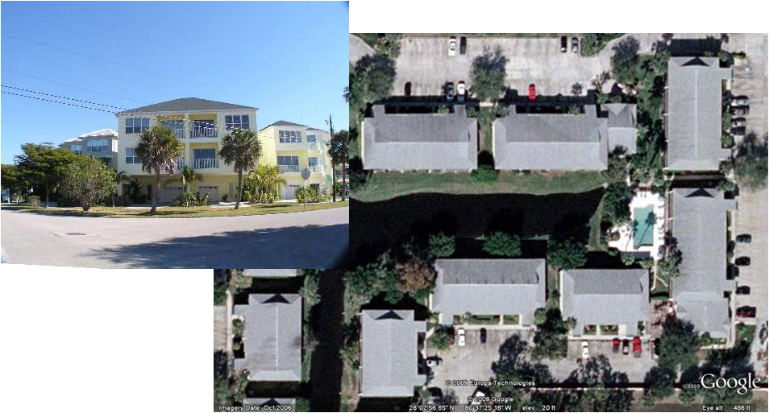
Figure 13. Typical low-rise buildings (LB).

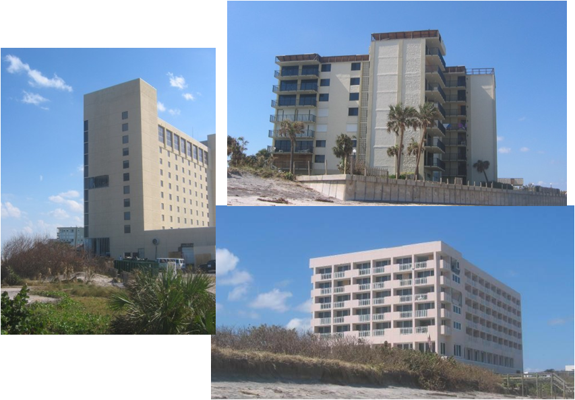
Figure 14. Examples of mid- and high-rise buildings (MHB).

Commercial Residential Building Survey

In the case of the commercial residential buildings, the CPTAs classify the buildings either as condominiums or as multifamily residential (MFR) based only on the type of ownership. Condo buildings are such that each unit or apartment has a different owner. The condo unit can then be occupied by the owner or by a renter. The CPTAs do not record if the condo unit is rented or owned. Condo owners’ expenses include the maintenance and use of the common areas and common facilities because the condo owner actually owns a percentage of the entire facility. The condo buildings relevant to this survey are all classified by the CPTAs as residential. Commercial office condo buildings are out of the scope of the survey.

A MFR building has a single owner who rents the units to tenants. The CPTAs classify MFR buildings with fewer than 10 units (duplex, triplex, and quadruplex) as residential buildings; MFR buildings with 10 units or more are classified as commercial buildings. Both residential and commercial MFR buildings were considered in this survey. MFR buildings are interchangeably referred to as apartment buildings by CPTAs. Residential MFR buildings (fewer than 10 units) account for approximately 70% of the MFR building stock, and the remaining 30% are commercial MFR buildings (10 units or more).

The commercial-residential buildings, regardless of whether they are condos or MFR buildings, were divided in two categories: low-rise (one–three stories) and mid-high rise (four stories and more). Low-rise buildings have three stories or fewer. The survey shows these buildings, which represent the majority of the building stock, have different characteristics than taller buildings. Unanwa (1997) uses a similar definition in his study. The mid- and high-rise buildings tend to be more heterogeneous and necessitate a different treatment in the vulnerability model. Owned as well as rented apartment units are included in this survey; the CPTAs do not distinguish between the two.

Appraisers have confirmed that MFR buildings tend to have fewer stories than condo buildings and the majority of MFR buildings are duplexes, triplexes, and quadruplexes. Also, the proportion of MFR buildings that can be classified as mid-/high-rise is negligible according to available information and consultation with CPTAs.

Building Models

Distinctly different construction characteristics and modes of damage in high winds led to the development of separate models for low-rise commercial residential construction (LB) and mid-/high-rise commercial residential construction (MHR).

Low-Rise Commercial Residential Models

The LB model was developed to represent typical apartment and town-house style structures of three stories or fewer (Figure 13). The model framework is based on the single-family, site-built residential model, which uses a probabilistic description of wind loads and exterior and structural component capacities to project physical damage as a function of wind speed. The components in the LB damage model include roof cover, roof sheathing, roof-to-wall connections, wall type, wall sheathing, windows, entry doors, sliding-glass doors, soffits, and gable end truss integrity.

Given the large array of sizes and geometries for low-rise commercial residential structures, the program is developed to provide flexibility in choosing a building layout and dimensioning details (footprint, overhang length, roof slope, roof shape, etc.). The changes in construction practice over decades in Florida also necessitate flexibility when choosing construction quality with regard to hurricane wind resistance. The model allows the selection of building components with a variety of strength options to represent a range from low to high wind resistance (braced or unbraced gable ends, old or new roof cover, sheathing nailing schedules, etc.).

A standard (default) model was developed based on the building exposure study that quantified average square footage per story, units per story, and other descriptors. Default settings were also developed to represent weak, medium, and strong construction practice. Any given strong, medium, or weak model may be altered by additional mitigation or retrofit measures individually or in combination. For example, reroofing an older apartment can be represented by increasing the probabilistic descriptor of capacity for the roof cover.

Outputs (damage matrices) have been produced for each combination of the following: building height (one, two, or three stories), wall type (timber or masonry), roof shape (hip or gable), strength (weak, medium, or strong), and window protection (no protection or with metal shutters).

Mid-/High-Rise Commercial Residential Models

The mid-/high-rise model uses the Monte Carlo simulation concept, but it differs from the low-rise model in significant ways. There is a high level of variability among mid-/high-rise buildings because of the combination of the number of stories, the number of units per floor, intentionally unique geometries, and the materials used for the exterior. This makes the application of a “standard” or default model unfeasible. Because of the construction methods and materials used in these structures, damage to the superstructure and exterior surfaces of the buildings tends to be relatively minor. The majority of damage accumulation in mid-/high-rise structures is due to water penetration and failure of openings. The model reflects this by focusing on the failure of windows and doors, the ingress of rain water, and the proliferation of water from the source of the ingress to adjacent living units. The structure in whole is not modeled. Rather, individual units are modeled in isolation. That is, the vulnerability of a single unit is explicitly modeled, and damage is assessed to openings as a function of wind speed.

Two different mid-/high-rise classifications are modeled for this study: “closed building” and “open building.” Closed buildings are characterized by the location of the unit entry doors at the interior of the building. The sliding-glass doors and windows are all facing the exterior of the building. For the open building model there is exterior corridor access to each unit entry door on one side of the building, and the patio areas are situated on the opposite side of the building (Figure 15). The type of building chosen can increase or decrease the vulnerability of a selected unit because of the exposure of the exterior openings. Middle units in a closed or open building have one or two exterior walls, respectively.

There are three main differences between the low-rise and mid-/high-rise models: (1) the use of a modular (i.e., per unit rather than per building) approach, (2) the exterior components being analyzed for failure, and (3) the use of two basic floor plans. Location of unit within the plan view of the building, unit square footage, and number of available openings are some of the important factors that separate one unit from another.

Corner units are subjected to higher wind pressures that are present along the edges of the building, compared to the middle units, which are located within lower pressure zones at the center of the wall area (Figure 15). Increased square footage typically results in an increase in exterior wall frontage and the number of openings vulnerable to damage.

The MHB model uses the same analysis and output technique as the LB model. The difference is the number of failure types modeled. The MHB model analyzes only the damage to the openings, which include the windows, sliding doors, and entry doors. Each of the components can fail due to pressure or debris impact.

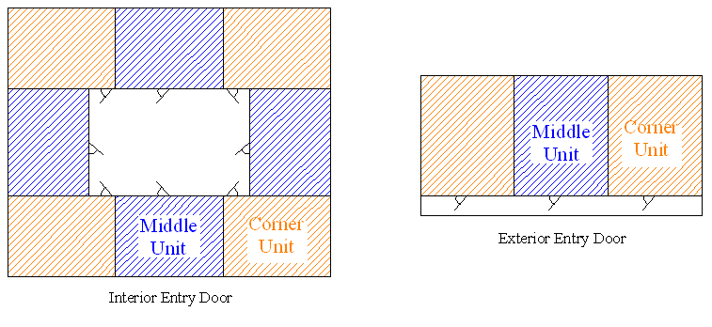
Figure 15. Apartment types according to layout (left: closed building with interior entry door; right: open building with exterior entry door).

Damage Matrices

Exterior Damage

The vulnerability model uses a Monte Carlo simulation based on a component approach to determine the external vulnerability (as shown in Figure 10) at various wind speeds of buildings in the case of LB, or apartment units in the case of MHB. For the case of LB, the procedure is identical to the one described for single-family residential (PRB). In the case of MHB, the simulations address only wind pressure and debris impact on the openings.

The damage assessment is conducted over a range of wind speeds and wind directions, and results are stored in a damage matrix. Probabilistic damage assessment is conducted by first creating an individual building realization by mapping each component according to typical construction practice. Random capacity values are assigned to the various components on the basis of a probability distribution for each component type. This realization is subjected to a peak three-second gust wind speed from a particular direction. Directional loads are calculated using randomized pressure coefficients based on directional modifications to ASCE 7 as well as wind tunnel data (NIST Aerodynamic Database - http://fris2.nist.gov/winddata), and a comparison of resulting surface and internal loads to component capacities is conducted. Damage occurs when the assigned capacity of a component is exceeded by its loading. Once the openings have been checked for failure due to pressure, the damage due to the impact of windborne debris is also evaluated. Damaged components are removed, and a series of checks are performed to determine if lost components will redistribute loading to adjacent components or change the overall loading. For example, loss of a roof-to-wall connection places additional load on adjacent connections, whereas an envelope breach will potentially alter internal loading—changing the overall loading on most components. Iterative convergence is used to produce the final damage state for that building realization. The results of this single simulation are documented on the basis of the final iteration, another realization of that building is constructed by assigning new random capacities to each component, and the process repeats for the same three-second gust, same wind direction, and newly randomized pressure coefficients based on the number of desired simulations the user would like to run. The process is repeated for eight wind directions and a series of three-second wind speeds between 50 and 250 mph in 5 mph increments.

The output of the Monte Carlo simulation model is an estimate of physical damage to structural and exterior components. The results are in the form of a four-dimensional damage matrix. Each row of the matrix lists the results of one simulation. The amount of damage to each of the modeled components for a simulation is listed in 75 columns. The third dimension represents the peak three-second gust wind speed between 50 and 250 mph in 5 mph increments, and the fourth dimension represents the eight angles between 0 and 315 degrees in 45-degree increments. Table 7 delineates the damage matrix contents for the case of the LB. A description of each of the nine columns of the MHB damage matrix is given in Table 8.

Table 7. Description of damage matrices for LB.
Column # | Timber Models | Masonry Models
Col 1 | Percent roof cover (shingles or tiles) failed
Col 2 | Percent field roof sheathing lost (field roof sheathing is all but overhang)
Col 3 | Percent edge (overhang) roof sheathing failed
Col 4 | Percent roof-to-wall connections failed
Col 5 | Collapse of gable end trusses (0 = no, 1 to 20) starting from side 1
Col 6 | Collapse of gable end trusses (0 = no, 1 to 20) starting from side 2
Col 7-8 | Percent gable end wall covering failed (side 1 and 2, positive for windward, negative for leeward)
Col 9-10 | Percent gable end sheathing failed (side 1 and 2, positive for windward, negative for leeward)
Col 11- 14 | Percent wall covering failed – 1st floor (walls 1-4, positive for windward, negative for Leeward) | Shear Damage Ratio for Masonry Walls- 1st Floor (walls 1-4, positive for windward, negative for leeward)
Col 15-18 | Percent wall sheathing failed – 1st floor (walls 1-4, positive for windward, negative for leeward) | Bending Damage Ratio for Masonry Walls- 1st Floor (walls 1-4, positive for windward, negative for leeward)
Col 19-22 | Number of windows failed from wind pressure – 1st floor - (walls 1-4, positive for windward, negative for leeward)
Col 23-26 | Number of windows failed from wind Debris– 1st floor - (walls 1-4)
Col 27 | Number of sliding glass doors failed from wind pressure – 1st floor (+ for windward - for leeward)
Col 28 | Number of sliding glass doors failed from debris impact – 1st floor
Col 29 | Number of entry doors failed from wind pressure – 1st floor (+ for windward - for leeward)
Col 30 | Number of entry doors failed from debris impact – 1st floor
Col 31-50 | Repeat Col 11 - Col 30 for 2nd Floor
Col 51-70 | Repeat Col 11 - Col 30 for 3nd Floor
Col 71 | Garage Door Damage (positive for windward, negative for leeward)
Col 72-75 | Percent Soffit Damage (walls 1-4)

Table 8. Description of the damage matrices for MHB apartments.
Commercial and Single Family Residential
Column # | Inner and Outer Stair Models
Col 1 | Number of Windows failed from wind pressure
Col 2 | Number of Entry Doors failed from wind pressure
Col 3 | Number of Sliding failed from wind pressure
Col 4 | Number of Windows failed from debris impact
Col 5 | Number of Entry Doors failed from debris impact
Col 6 | Number of Sliding failed from debris impact
Col 7 | Number of Windows breached from debris impact
Col 8 | Number of Entry Doors breach from debris impact
Col 9 | Number of Sliding breach from debris impact

Interior and Utilities Damage

The FPHLM introduces a novel approach to assessing the interior damage by considering the physics of the problem. The approach starts from the damage to the building envelope (Weekes et al., 2009), described in the previous section. The model then estimates the amount of wind-driven rain that enters through the breaches and defects in the building envelope and converts it to interior damage. The approach is described below (Pita et al., 2012a).

Description of the Model

The method described hereafter (Figure 16) combines existing building defects and estimated building envelope damage with the impinging rain to predict the amount of water that will enter a building. This physically based approach models the main contributor to interior damage, addresses the uncertainty in the interior damage source, and documents the individual water ingress contribution of each component to the total water intrusion.

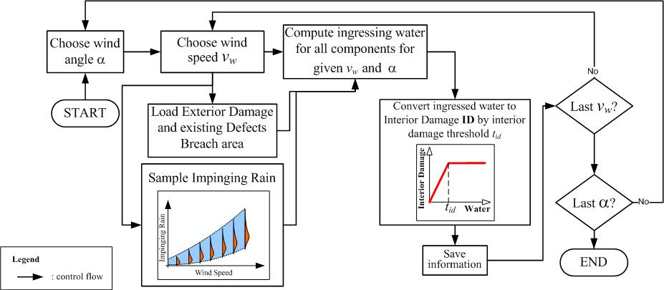
Figure 16. Flowchart of the interior damage model.

The exterior building components that the model considers include roof cover, roof sheathing, wall cover, wall sheathing, gable cover, gable sheathing, windows, doors, and sliding doors. In the case of MHB units, only windows, doors, and sliding doors are considered. For a given wind speed, the model first estimates breach areas of each component from the exterior damage array. The area of existing defects in envelope components is estimated based on surveys (Mullens et al., 2006) and engineering experience.

In order to estimate water intrusion into the buildings, a study was performed to estimate the likely accumulated horizontally impinging rain on a structure during a hurricane event. This study used a simulation model that is composed of a simplified wind model and the R-CLIPER rain rate model developed at NOAA HRD (Lonfat et al., 2007) and is used operationally at NHC. The simplified wind model is based on the Holland (1980) radial profile and includes parameters for the pressure profile ("B"), radius of maximum winds, translation speed and central pressure. Additionally, the Vickery (2005) pressure filling model was used to decay the storms. Storm parameters are sampled from distributions relevant to Florida. The R-CLIPER model determines the vertically free-falling rain rates at each time step of the simulation. The R-CLIPER rain rate is essentially an azimuthally averaged rain rate that varies as a function of radius and maximum intensity of the storm.

The total potential impinging rain rate is calculated as a function of the vertical rain rate (rr), the horizontal mean wind speed (V_{h}) and the terminal velocity of the rain drops (V_{t}). We may write this as

The actual impinging rain rate entering a building is assumed to be a fraction of the total potential impinging rain rate by the use of a rain admittance factor (RAF) that is described in Disclosure 4 in the Vulnerability Standard. The vertical rain rate is determined from the R-CLIPER model. The terminal velocity depends on the rain drop size (D), which in turn has a distribution based on rain rate. We use a rain drop distribution based on Willis and Tattelman (1989):

where

The term N_{G} is the concentration parameter, γ is the slope parameter, α is the curvature parameter, M is the water content, and D₀ is the median volume diameter.

The terminal velocity is based on Dingle and Lee (1972):

We compute an average V_{t} based on the mass flux contribution of each drop size to the rain rate

We define the Driving Rain Factor (DRF) as

The DRF is a function of the rain rate. The R-CLIPER model, as mentioned above, produces a rain rate that is based on the azimuthal average of rain rate as a function of radius to center of the storm. Thus the averaged rain rate includes locations where there is very little or no rain. So the DRF could have a high bias if based solely on an average rain rate, since the terminal velocity increases with drop size, which in turn increases with rain rate. We seek to compute an effective DRF that is an average of the DRF weighted by the distribution of rain rates that contribute to the average rain rate estimated by R-CLIPER, as follows

where g is the rain rate distribution from TRMM observations that yield a given mean rain rate, . Rain rate distributions generally follow a log normal distribution (e.g., Marks et al., 1993). A study by Lonfat et al. (2004) using TRMM data shows figures that suggest rain rates have a log normal distribution. Hence we may provisionally assume that g has a log normal distribution. We can estimate the range of the mode and frequency of the mode using probability distribution functions shown in figures from Lonfat et al. (2004) for the entire range of possible radii and storm intensity. These two parameters uniquely determine the distribution. We find that using a range of values for these two parameters, the mode ranging from 1 to 10 mm/hr and frequency of the mode ranging from 7% to 11%, the effective DRF is approximately 0.18 and does not vary by more than a few percent of this value. Given that the DRF is insensitive to relatively large changes in these parameters, it is unlikely that the DRF would be sensitive to a choice of reasonable alternative distributions (such as a gamma), and also not likely to be sensitive to parameter estimation due to maximum likelihood approximations, for example.

We use a simple wind model to provide a time series of the peak three-second gust wind for a given station location. The wind model is a simple Holland B-type model that incorporates a term for the translation speed. The wind speed, assumed to be valid at gradient wind height (taken to be 700 mb), is given by

where

and B is the Holland B shape profile, dp is the central pressure deficit, ρ is the air density, Rmax is the radius of maximum winds, r is the radius to center of the storm, c is the translation speed, f is the Coriolis parameter and θ is the angle between the vector for the storm motion and the vector pointing to the station location with reference to the center of the storm.

The gradient winds are reduced to winds at 300 m using a radially dependent gradient conversion factor based on dropsonde data from Franklin et al. (2003). Further details can be found in Axe (2004). Finally, winds are reduced to surface using a log wind profile. The surface roughness length was assumed to be 0.45 m, though tests were done using 0.30 m without significant difference in the final results. A gust factor was used to obtain the peak three-second gust based on ESDU methodology (Vickery & Skerlj, 2005).

The effects of storm decay at landfall are modeled using a pressure filling model (Vickery, 2005). This is the same pressure filling model used in the FPHLM. The distance of simulated stations to the shore line are modeled using a uniform distribution ranging from 0-100 km. This distance effectively determines the time before the storm begins to decay.

The parameters used to specify the storm characteristics are based on statistical distributions relevant to Florida. For each storm simulation, a set of parameters were sampled from their respective distributions. Table 9 provides a list of parameters and their associated distributions used in the model, as well as the reference. Please refer to the references provided in the table for details on the distributions. In the table below, the reference “FPHLM” refers to the present document, particularly the discussion above in this disclosure under Meteorology Component.

Table 9. Parameter Distributions used in the Rain Study.
Parameter | Description | Distribution | Reference
B | Pressure shape profile | Gaussian | FPHLM (Standard G-1.2)
dp | central pressure deficit | Weibull | Huang et al. (2001)
c | translation speed | Log Normal | Huang et al. (2001)
Rmax | radius maximum winds | Gamma | FPHLM (Standard G-1.2)
e_decay | pressure filling error term | Gaussian | Vickery (2005)
Dshore | distance to shore | Uniform | Present Study

The model simulates the duration of the event from the time a location enters the storm affected area (defined as being within 450 km of the storm center) until exit. The number of storm simulations was 100,000 and for each simulation, 91 locations were selected to record the accumulated impinging rain ("IR") and maximum three-second wind gust at 10 m. Each location was specified to be a multiple of 10 km away from the storm closest approach to center (from 450 km to the left of the storm to 450 km to the right of the storm, in steps of 10 km. A direct hit is at 0 km). The time step of the model was 0.1 hr. In addition to the total impinging rain during the event, separate accumulations were recorded starting at the time that a location experiences the peak wind of the storm event ("IR₂"). The impinging rain accumulated prior to the maximum peak gust ("IR₁") is computed as the difference: IR₁=IR-IR₂. The resulting accumulations are then distributions of impinging rain as a function of the peak three-second wind gust for 10 meter height.

The product of the areas of the breaches and defects by the impinging rain conveys the amount of water that enters the building. The water penetration is computed as follows.

Water penetration through defects:

Water penetration through breaches:

Where:
$h_{Ci}^{d}$ height of water that accumulates due to defects in component i, in inches
$h_{Ci}^{b}$: height of water that accumulates due to envelope breaches in component i, in inches
k: adjustment factor
RAF: rain admittance factor
d_{Ci}: defects percentage
A_{Ci}: area of component i
$A_{Ci}^{B}$: breach area of component i
A_{b}: floor area
IR₁ : accumulated impinging rain prior to maximum wind
IR₂ : accumulated impinging rain after the occurrence of maximum wind
S_{Ci} : survival factor for component i = 1 – A^{B}_{Ci} / A_{Ci}

These terms are discussed in more detail in the Vulnerability Standard.

The full distribution of impinging rain from the simulation is used in the development of the vulnerability matrices for low-rise structures. For mid-/high-rise structures, the mean value of the distribution of the impinging rain as a function of wind speed is used in the calculation of water intrusion, and hence damage, in the Loss Module. Figure 17 shows the mean IR₁ and IR₂ as a function of peak three-second gusts at 10 m. As shown in the figure, simple regressions were performed to facilitate calculations in the Loss Module. Note that for very high wind speeds there is large sampling error, as these are rare events, and thus the relation between mean rain and wind speed is less reliable.

Figure 17. Mean accumulated impinging rain as a function of peak 3-second wind gust.

This approach estimates the amount of water that enters through each component of the envelope. The total amount of water is calculated by adding the contribution of all components for a given wind speed, and by estimating the water which percolates from story to story. The final step maps water inside the building to interior damage with a bilinear relationship, where total interior damage is achieved for a certain threshold of height of accumulated water (currently set at 1 inch).

Contents Damage

Contents include anything in the building that is not attached to the structure itself. As in the case of interior and utilities damage, the contents damage is assumed to be a function of the amount of water that penetrates the building, and it is therefore proportional to interior damage. The function is based on engineering judgment and is validated using claims data. In the case of a condo building, only the contents of the common areas are covered by the policy. In the case of an apartment building, the personal contents of the renters are not covered by the building policy.

Time Related Expenses

Time Related Expenses refer to loss of rent for owners of apartment buildings, which are mainly low-rise commercial residential buildings. As in the case of interior and utilities damage, the Time Related Expenses are assumed to be a function of the amount of water that penetrates into the building, and they are therefore proportional to interior damage. The function is based on engineering judgment and should be validated using claims data, which is almost non-existent.

Vulnerability Matrices for Low-Rise Buildings

Unweighted Vulnerability Matrices of LB

A description of the process to estimate the total vulnerability of low-rise buildings is displayed in Figure 10. Given a particular building type, the Monte Carlo simulation-generated damage array that expresses the exterior damage in the envelope is loaded. For a particular wind speed and wind direction, each component’s physical damage is normalized to a percentage value. For instance, the number of damaged doors, windows, and sliding doors is divided by the total number of the corresponding openings; collapsed trusses are divided over the total number of trusses, etc. The cost of the damage is then assessed.

Interior damage is estimated by (1) simulating the amount of wind-driven rain that enters through the breaches and defects in the building envelope, (2) propagating water from floor to floor, and (3) converting to damage to interior and utilities.

Replacement cost ratios provide the link between modeled physical damage and the corresponding monetary losses. They can be defined as the cost of replacing a damaged component or assembly of a building divided by the cost of constructing a completely new building of the same type. An explicit procedure is used to convert physical damage of the modeled components to monetary damage. The procedure is almost identical to the one already described for single-family residential buildings. The damage ratio (DR) as a function of wind speed for the exterior, interior, and utilities is calculated by adding the corresponding costs of damaged exterior plus damaged interior plus damaged utilities divided over the overall building cost that is contingent upon the type and size of the building.

Derivation of the probability distribution functions of damage at each wind speed interval is the final step of the process. For each wind speed interval, the probability of damage given that wind speed interval (i.e., the cells of the vulnerability matrices) is computed as the summation of specific damage ratios for all wind directions divided by the total number of simulations at that particular wind speed interval.

Weighted Vulnerability Matrices of LB

In the case of LB, vulnerability matrices were created for every combination of construction type (masonry, timber, or other), roof shape (gable or hip), roof cover (tile or shingle or metal), shutters (with or without), number of stories (one, two, or three), and subregion (inland, wind-borne debris region, and high velocity zone). However, in general, there is little information available in an insurance portfolio file regarding the structural characteristics and the wind resistance of the insured property. Instead, insurance companies rely on the ISO fire resistance classification. Portfolio files have information on ZIP Code and year built. The ISO classification is used to determine if the home is constructed of masonry, timber, or other. The ZIP Code is used to define the subregion. The year built is used to assist in defining whether a building should be considered weak, medium, or strong.

From the insurance files, sub-region, construction type, and year built are determined. This leaves the roof shape, roof cover, number of stories, and shutter options undefined. From the exposure study of 21 Florida counties, the distribution of these parameters can be extrapolated. For each age group, we define a weighted matrix for each construction type in each sub-region. The procedure is identical to the one already described for single-family buildings.

Age-Weighted Matrices of LB

The year built or year of last upgrade of a structure in a portfolio may not be available when performing a portfolio analysis to estimate hurricane losses in a certain region. In that case, it becomes necessary to assume a certain distribution of ages in the region to develop an average vulnerability by combining weak, medium, and strong. Here again, the procedure is identical to the one described for single-family residential buildings.

Mapping of Insurance Policies to Vulnerability Matrices for LB

The mapping of the low-rise vulnerability matrices to the insurance policies in any given portfolio is also very similar to the process already reported for single-family buildings.

LB Models’ Distribution in Time

The low-rise building models’ distribution in time is similar to that of the single-family buildings.
Vulnerability of Mid-/High-Rise Buildings

MHB opening vulnerabilities

In the case of MHB, a process similar to the one described above is followed to derive exterior vulnerability and breach curves for different openings of typical apartment units. These curves are derived for the cases of open and closed buildings, for corner and middle units, with different opening protections (with or without impact-resistant glass; with or without metal shutters). Each vulnerability curve for openings of corner or middle apartment units (window, door, or slider) gives the number or fraction of opening damaged as a function of wind speed. Each breach curve for openings of corner or middle apartment units (window, door, or slider) gives the breach area in ft² of opening damaged as a function of wind speed.

MHB building vulnerability

Unlike the single-family home loss model in which interior and exterior damage was aggregated inside the vulnerability module, the aggregation for mid-/high-rise buildings is performed outside that module because of the interior damage propagation. The modular approach produces independent assessments of exterior damage for each unit while also considering the interior water damage that can spread from unit to unit and trigger damage far from its source. Therefore, interior damage is treated in two stages: the first stage occurs as a direct result of the exterior damage, and the second occurs as a consequence of propagation between units. The separate modeling of exterior and interior damage is also well suited to dealing with the insurance issue of different insurance coverage for apartment and condo buildings.

The process for damage estimation for MHB is presented in Figure 18. For each policy in the portfolio, the program reads the information on the building (location and number of stories and units) and assigns a wind speed profile based on its location (i.e., surrounding terrain). The algorithm calculates the number of corner and middle units per floor (a_{c} and a_{M}) and loads the corresponding opening vulnerability and breach curves (V_{C,M} and B_{C,M}). The vulnerability curves, combined with the wind speed value at every story, W_{i}, yield the number of openings of each kind damaged at each story, which are then assigned a replacement cost, C_{W,D,S}. The result is the cost of damage to the openings at each story (CDO_{s}), which is then accumulated over all the stories as the total expected cost of damage to the openings (TECDO).

For the interior damage estimation the process is similar. From the wind profile, the corresponding wind speed, W_{i}, is calculated at each story. For a given story and its corresponding wind speed, the value of the expected breach size for windows, entry door, and sliding door, B_{C}^{W.D,S} and B_{M}^{W.D,S,}, are retrieved from the corresponding breach curves. The breach size of each component is added to get the total breach size per story. The next step is to estimate the amount of water that will enter a particular story with a given breach size, as described in the section describing the interior damage model. Note that for the sake of simplification, defects are not represented in the flow chart.

A scheme for vertical propagation of water between floors was implemented. The water content is then transformed at each story into an interior damage ratio (ID) based on the bilinear relationship described in Standard V-1. The final product of the interior damage assessment is the Expected Interior Damage Ratio (EIDR).

At this point in the process, the algorithm has computed expected damages, both exterior (TECDO) and interior (EIDR), for the particular building of the policy under study. The EIDR is then multiplied by the interior insured value expressed as a percentage of the total insured value BV, thanks to a coefficient k_{I} which varies for condos and apartment buildings. The final value is the total expected damage value (EDV).

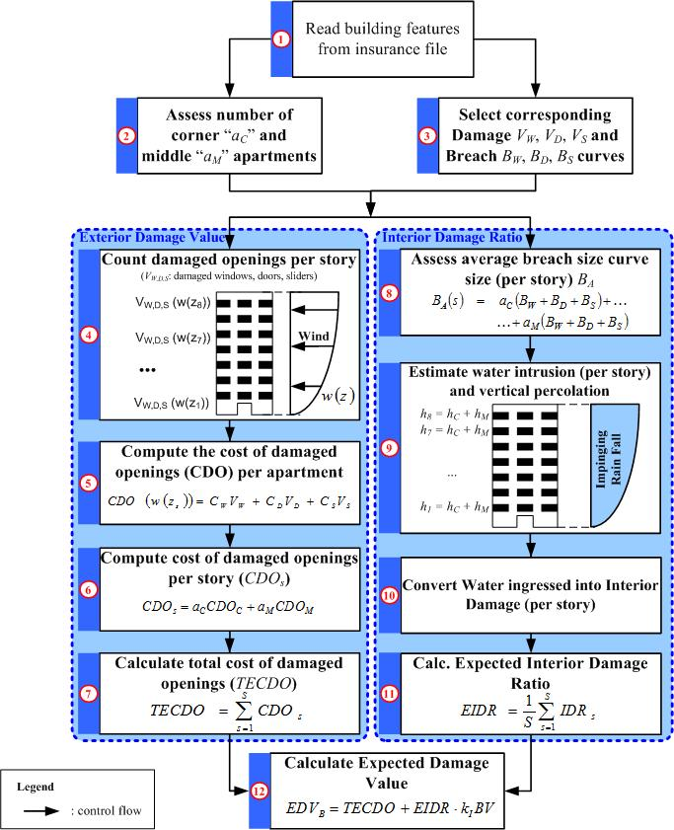
Figure 18. Exterior and interior damage assessment for MHB.

Contents Vulnerability

Contents include anything in the building that is not attached to the structure. In the case of a condo building only the contents of the common areas are covered by the policy. In the case of an apartment building, the personal contents of the renters are not covered by the building policy. In both cases, the contents vulnerability is proportional to the interior vulnerability. The constant of proportionality is based on engineering judgment and is validated using claims data.

Time-Related Expenses

Time-related expenses are coverage for loss of income due to the building damage. The value of a claim is obviously dependent on the time it takes to repair a damaged building as well as the surrounding utilities and infrastructure. This coverage applies only to apartment buildings, where the loss of income is the loss of rent. The time-related expenses are modeled as directly proportional to the interior vulnerability.

Appurtenant Structures

For commercial residential structures, appurtenant structures might include a clubhouse or administration building, which are treated like additional buildings. For other structures such as pools, etc., the appurtenant structures model developed for residential buildings is applicable.

ACTUARIAL COMPONENT

The actuarial component consists of a set of algorithms. The process involves a series of steps: rigorous check of the input data; selection and use of the relevant output produced by the meteorology component; selection and use of the appropriate vulnerability matrices for building structure, contents, appurtenant structure, and additional living expenses; running the actuarial algorithm to produce expected losses; aggregating the losses in a variety of manners to produce a set of expected annual hurricane wind losses; and producing probable maximum losses for various return periods. The expected losses can be reported by construction type (e.g., masonry, frame, manufactured homes), by county or ZIP Code, by policy form (e.g., HO-3, HO-4, etc.), by rating territory, and combinations thereof.

Expected annual losses are estimated for individual policies in the portfolio. They are estimated for building structure, appurtenant structure, contents, and ALE on the basis of their exposures and by using the respective vulnerability matrices or vulnerability curves for the construction types. For each policy, losses are estimated for all the hurricanes in the stochastic set by using appropriate damage matrices and policy exposure data. The losses are then summed over all hurricanes and divided by the number of years in the simulation to get the annual expected loss. These are aggregated at the ZIP Code, county, territory, or portfolio level and then divided by the respective level of aggregated exposure to get the loss costs. This is a computationally demanding method. Each portfolio must be run through the entire stochastic set of hurricanes.

The distribution of losses is driven by both the distribution of damage ratios generated by the engineering component and by the distribution of wind speeds generated by the meteorology component. The meteorology component provides, for each lat-long grid, the associated probabilities for a common set of wind speeds. Thus, locations are essentially differentiated by their probability distribution of wind speeds. The meteorology component uses up to 56,000 year simulations to generate a stochastic set of storms. The storms are hurricane events at landfall or when bypassing closely. Each simulated storm has a track and a set of modeled windfields at successive time intervals. The windfields generate the one-minute maximum sustained wind speeds for the storm at various locations (lat-long grid) along its track. These one-minute maximum sustained winds are then converted to three-second peak gust winds and corrected for terrain roughness by using the gust wind model and the terrain roughness model.

For each lat-long grid, an accounting is then made of all the simulated storms that pass through it. On the basis of the number of pass-through storms and their peak wind speeds, a distribution of the wind speed is then generated for the grid. On the basis of this distribution, probabilities are generated for each 5-mph interval of wind speeds, starting at 20 mph. These 5-mph bins constitute the column headings of the damage matrices generated by the engineering component.

The engineering group has produced vulnerability matrices for personal residential buildings and vulnerability curves for commercial residential buildings.

Vulnerability matrices are provided for personal residential building structure, contents, appurtenant structures and additional living expenses for a variety of residential construction types and for different policy types. The construction types are masonry, frame, mobile home, and other. The vulnerability matrices are also developed for weak, medium, and strong construction as proxy by year built.

Within each broad construction category, the vulnerability matrices are specific to the roof types and number of stories, etc. Since the policy data do not provide this level of specificity, weighted matrices are used instead, where the weights are the proportion of different roof types in given region as determined by a survey of the building blocks and exposure data. The vulnerability matrices are used as input in the actuarial model.

The starting point for the computations of personal residential losses is the vulnerability matrix with its set of damage intervals and associated probabilities. Appropriate vulnerability matrices are applied separately for building structure, content, appurtenant structure, and ALE. Once the matrix is selected, for a given wind speed, for each of the midpoint of the damage intervals, the ground up loss is computed, the appropriate deductibles and limits are applied, and the loss net of deductible is calculated. More specifically, for each damage outcome the damage ratio is multiplied by insured value to get dollar damages, the deductible is deducted, and net of deductible loss is estimated, subject to the constraints that net loss is ≥ 0 and ≤ limit – deductible. Percentage deductibles are converted into dollar amounts. Both the replacement cost and actual cash value are generally assumed to equal the coverage limit. Furthermore, if there are multiple hurricanes in a year in the stochastic set, the wind deductibles are applied to the first hurricane, and any remaining amount is then applied to the second hurricane. If none remains then the general peril deductible can be applied.

The net of deductible loss is multiplied by the probability in the corresponding cell to get the expected loss for the given damage ratio. The results are then averaged across the possible damages for the given wind speed. Next, the wind probability weighted loss is calculated to produce the expected loss for the property. The expected losses are then adjusted by the appropriate expected demand surge factor.

In the case of low-rise commercial residential structures, the expected damage ratios (EDR) are derived from the vulnerability curves for the maximum wind in the given storms. The EDRs are multiplied by the respective coverage limits to produce the expected ground up building damage value (EDV^{B}), and expected ground up content damage value (EDV^{C}) for the storm. The deductible is then applied to these damage values on a pro-rata basis to generate the net of deductible expected losses. The process is repeated across all the storms in the stochastic set to produce the average loss for the policy. The expected losses are then adjusted by the appropriate expected demand surge factor.

In the case of mid-high rise commercial residential buildings, the vulnerability component produces, for a given storm (or given vertical maximum wind profile) and across all the floors in the building, the total expected cost of damage to the openings (TECDO) and the expected interior damage ratio (EIDR). The EIDR is then multiplied by the fraction of the coverage limit corresponding to the value of the interior and added to the TECDO to produce the expected building damage value (EDV^{B}). The expected content damage value (EDV^{C}) is produced by multiplying a fraction of the EIDR by the content coverage limit. The deductible is then applied on a pro-rata basis to generate the expected loss for the storms. The process is repeated across all storms to produce the average loss for the policy. The expected losses are then adjusted by the appropriate expected demand surge factor.

For commercial residential policies, if there are multiple risks (multiple structures) within the policy, the default is to apply the deductible at the risk level. The percentage deductible is applied to each risk based on their individual limit. If information is so available, then deductible is applied at the policy level.

The demand surge factors are estimated by a separate model and applied appropriately to each hurricane in the stochastic set. The surge factors for structures are a function of the size of statewide storm losses and are produced separately for the different regions in Florida. The surge factors for content and ALE are functionally related to the surge factor for structure. To estimate the impact of demand surge on the settlement cost of structural claims following a hurricane, data from 1992 to 2007 on a quarterly construction cost index produced by Marshall & Swift/Boeckh are used. The approach to estimating structural demand surge was to examine the index for specific regions impacted by one or more hurricanes since 1992. From the history of the index we projected what the index would have been in the period following the storm had no storm occurred. Any gap between the predicted and actual index was assumed to be due to demand surge. In total ten storm–region combinations are examined. From these ten observations of structural demand surge the functional relationship is generalized.

After the losses are adjusted for demand surge, they are summed across all structures of the type in the grid and also across the grids to get expected aggregate portfolio loss. The model can process any combination of policy type, construction type, deductibles, coverage limits, etc. The model output reports include separate loss estimates for structure, content, appurtenant structure, and ALE. These losses are also reported by construction type (e.g., masonry, frame, manufactured homes), by county or ZIP Code, by policy form (e.g., HO-3, HO-4, etc.), by rating territory, and combinations thereof.

Another function of the actuarial algorithms is to produce estimates of the probable maximum loss for various return periods. The PML is produced non-parametrically using order statistics of simulated annual losses. Suppose the model produces N years of simulated annual losses. The annual losses L are ordered in increasing order so that L(1) ≤ L(2) ≤ . . . ≤ L(N). For a return period of Y years, let p = 1-1/Y. The corresponding PML for the return period Y is the pth quantile of the ordered losses. Let k = (N)*p. If k is an integer, then the estimate of the PML is the kth order statistic, L(k), of the simulated losses. If k is not an integer, then let k* = the smallest integer greater than k, and the estimate of the pth quantile is given by L(k*).

COMPUTER SYSTEM ARCHITECTURE

FPHLM is a large-scale system that is designed to store, retrieve, and process a large amount of historical and simulated hurricane data. In addition, intensive computation is supported for hurricane damage assessment and insured loss projection. To achieve system robustness and flexibility, a three-tier architecture is adopted and deployed in our system. It aims to solve a number of recurring design and development problems and make the application development work easier and more efficient. The computer system architecture consists of three layers: the user interface layer, the application logic layer, and the database layer.

The interface layer offers the user a friendly and convenient user interface to communicate with the system. To offer greater convenience to the users, the system is prototyped on the Web so that the users can access the system with existing web-browser software.

The application logic layer activates model logic based on the functionality presented to the user, processes data, and controls the information flow. This is the middle tier in the computer system architecture. It aims to bridge the gap between the user interface and the underlying database and to hide technical details from the users.

The database layer is responsible for data modeling to store, index, manage, and model information for the application. Data needed by the application logic layer are retrieved from the database, and the computational results produced by the application logic layer are stored back to the database.

Software, Hardware, and Program Structure

The system is primarily a web-based application that is hosted on an Oracle 9i web application server. The backend server environment is Linux and the server side scripts are written in Java Server Pages (JSP) and JavaBeans. Backend probabilistic calculations are coded in C++ using the IMSL library and called through Java Native Interface (JNI). The system uses an Oracle database that runs on a Sun workstation. Server side software requirements are the IMSL library CNL 5.0, OC4J 9.0.2.0.0, Oracle 9iAS 9.0.2.0.0, JNI 1.3.1, and JDK 1.3.1.

The end-user workstation requirements are minimal. The recommended web browsers are Internet Explorer 8.0 running on Windows XP or Internet Explorer 9.0 running on Windows 7. However, other modern web browsers such as Mozilla Firefox running on either Windows or Linux should also deliver optimal user experience. Typically, the manufacturer’s minimal set of features for a given web browser and operating system combination is sufficient for an optimal operation of the application.

Translation from Model Structure to Program Structure

FPHLM uses a component-based approach in converting from model to program structure. The model is divided into the following components or modules: Storm Forecast Module, Wind Field Module, Damage Estimation Module, and Loss Estimation Module. Each of these modules fulfills its individual functionality and communicates with other modules via well-defined interfaces. The architecture and program flow of each module are defined in its corresponding use case document following software engineering specifications. Each model element is translated into subroutines, functions, or class methods on a one-to-one basis. Changes to the models are strictly reflected in the software code.

- Provide a flow diagram that illustrates interactions among major model components.

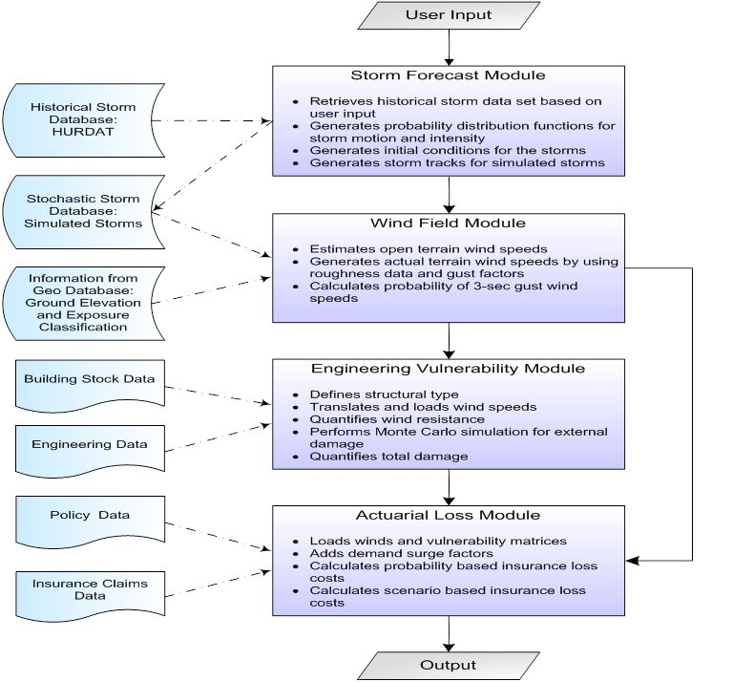
Figure 19. Flow diagram of the computer model.

- Provide a comprehensive list of complete references pertinent to the submission by standard grouping, according to professional citation standards.
References
Meteorology Standards

Anctil, F., & Donelan, M. (1996). Air–Water Momentum Flux Observations over Shoaling waves. Journal of Physical Oceanography, 26(7), 1344-1353.
Arya, S. P. (1988). Introduction to Micrometeorology. Academic Press.
ASTM. (1996). D5741-96, Standard practice for characterizing surface wind using a wind vane and rotating anemometer. In Annual Book of ASTM Standards (Vol. 11.07). American Society for Testing of Materials.
Axe, L. M. (2004). Hurricane surface wind model for risk assessment. MS Thesis, Florida State University, Department of Meteorology.
Batts, M. E., Cordes, M. R., Russell, L. R., & Simiu, E. (1980). Hurricane wind speeds in the United States. National Bureau of Standards Building Sciences Series 124. Washington, D.C.: US Government Printing Office.
Bosart, L., Velden, C. S., Bracken, W. E., Molinari, J., & Black, P. G. (2000). Environmental influences on the rapid intensification of Hurricane Opal (1995) over the Gulf of Mexico. Montly Weather Review, 128, 322-352.
Bove, M. C., Elsner, J. B., Landsea, C. W., Niu, X., & O’Brien, J. J. (1998). Effects of El Nino on U.S. land falling hurricanes, revisited. Bulletin of the American Meteorological Society, 79, 2477–2482.
Darling, R. W. (1991). Estimating probabilities of hurricane wind speeds using a large scale empirical model. Journal of Climate, 4, 1035-1046.
DeMaria, M., & Kaplan, J. (1995). Sea surface temperature and the maximum intensity of Atlantic tropical cyclones. Journal of Climate, 7, 1324-1334.
DeMaria, M., Mainelli, M., Shay, L. K., Knaff , J. A., & Kaplan, J. (2005). Further improvements to the statistical hurricane intensity prediction scheme. Weather and Forecasting, 20, 531-543.
DeMaria, M., Pennington, J., & Williams, K. (2002). Description of the Extended Best track file (EBTRK1.4) version 1.4. Retrieved 2002, from ftp://ftp.cira.colostate.edu/demaria/ebtrk/
Demuth, J., DeMaria, M., & Knaff, J. A. (2006). Improvement of advanced microwave sounder unit tropical cyclone intensity and size estimation algorithms. Journal of Appliced Meteorology, 45, 1573-1581.
Dingle, A. N., & Lee, Y. (1972, August). Terminal Fall Speeds of Raindrops. Journal of Applied Meteorology, 11, 877 - 879.
Donelan, M. A., Haus, B. K., Reul, N., Plant, W. J., Stiassnie, M., Graber, H. C., et al. (2004). On the limiting aerodynamic roughness of the ocean in very strong winds. Geophysical Research Letters, 31(18), L18306.
Dunion, J. P., & Powell, M. D. (2004). A reconstruction of Hurricane Betsy’s (1965) wind field. Final Report to Army Corps of Engineers, New Orleans District.
Dunion, J. P., Landsea, C. W., & Houston, S. H. (2003). A re-analysis of the surface winds for Hurricane Donna of 1960. Monthly Weather Review, 131, 1992-2011.
Emanuel, K. A. (1987). The Dependence of Hurricane Intensity on Climate. Nature, 326, 483-485.
Evans, J. L. (1993). Sensitivity of tropical cyclone intensity to sea surface temperature. Journal of Climate, 6, 1133-1140.
Franklin, J. L., Black, M. L., & Valde, K. (2003). GPS dropwindsonde wind profiles in hurricanes and their operational implications. Weather and Forecasting, 18, 32– 44.
Goldenberg, S. B., Landsea, C. W., Mestas-Nuñez, A. M., & Gray, W. M. (2001). The Recent Increase in Atlantic Hurricane Activity: Causes and Implications. Science, 293, 474-479.
Ho, F. P., Su, J. C., Hanevich, K. L., Smith, R. J., & Richards, F. P. (1987). Hurricane Climatology for the Atlantic and Gulf Coasts of the United States. NOAA Technical Report NWS 38. Maryland: Silver Spring.
Hock, T. R., & Franklin, J. L. (1999). The NCAR GPS drop windsonde. Bulletin of the American Meteorological Society, 80, 407–420.
Holland, G. J. (1980). An analytic model of the wind and pressure profiles in hurricanes. Monthly Weather Review, 108, 1212-1218.
Homer, C., Huang, C., Yang, L., Wylie , B., & Coan, M. (2004, July). Development of a 2001 National Landcover Database for the United States. Photogrammetric Engineering and Remote Sensing, 70(7), 829-840.
Houston, S. H., & Powell, M. D. (2003). Reconstruction of Significant Hurricanes affecting Florida Bay: The Great 1935 Hurricane and Hurricane Donna (1960). Journal of Coastal Research, 19, 503-513.
Jin, S., Yang, L., Danielson, P., Homer, C., Fry, J., and Xian, G. 2013. A comprehensive change detection method for updating the National Land Cover Database to circa 2011. Remote Sensing of Environment, 132: 159 – 175.
Jarvinen, B. R., Neumann, C. J., & Davis, M. A. (1984). A tropical cyclone data tape for the North Atlantic basin, 1886-1963: Contents, Limitations, and Uses. NOAA Technical Memo NWS NHC 22, National Hurricane Center.
Kanamitsu, M., Ebisuzaki, W., Woollen, J., Yang, S.-K., Hnilo, J. J., Fiorino, M., et al. (2002). NCEP-DEO AMIP-II Reanalysis (R-2). Bulletin of the American Meteorological Society, 83, 1631-1643.
Kaplan, J., & DeMaria, M. (1995). A simple empirical model for predicting the decay of tropical cyclone winds after landfall. Journal of Applied Meteorology, 34, 2499-2512.
Kurihara, Y. M., Bender, M. A., Tuleya, R. E., & Ross, R. J. (1995). Improvements in the GFDL hurricane prediction system. Monthly Weather Review, 123, 2791-2801.
Landsea, C. W. (2004). The Atlantic hurricane database re-analysis project- documentation for 1850-1910 alterations and additions to the HURDAT database. In R. Murnane, & K. Liu, Hurricanes and Typhoons: Past, Present, and Future (pp. 178-221). Columbia University Press.
Landsea, C. W., Pielke Jr, R. A., Mestas-Nuñez, A. M., & Knaff, J. A. (1999). Atlantic basin hurricanes: Indices of climatic changes. Climatic Change, 42, 89-129.
Large, W. G., & Pond, S. (1981). Open ocean momentum flux measurements in moderate to strong winds. Journal of Physical Oceanography, 11, 324-336.
Lonfat, M., Marks, F. D., & Chen, S. S. (2004). Precipitation Distribution in Tropical Cyclones Using the Tropical Measuring Mission (TRMM) Imager: A Global Perspective. Monthly Weather Review, 132, 1645-1660.
Lonfat, M., Rogers, R., Marchok, T., & Marks, F. D. (2007). A Parametric Model for Predicting Hurricane Rainfall. Monthly Weather Review, 135, 3086-3097.
Marks, F. D., Atlas, D., & Willis, P. T. (1993). Probability-matched Reflectivity-Rainfall relations for a Hurricane from Aircraft Observations. Journal of Applied Meteorology, 32, 1134-1141.
Masters, F. J. (2004). Measurement, modeling and simulation of ground-level tropical cyclone winds. PhD Dissertation, University of Florida.
Merrill, R. T. (1988). Environmental Influences on Hurricane Intensification. Journal of the Atmospheric Sciences, 45, 1678-1687.
Miller, B. I. (1964). A study on the filling of Hurricane Donna (1960) over land. Monthly Weather Review, 92, 389-406.
Moss, M. S., & Rosenthal, S. L. (1975). On the estimation of planetary boundary layer variables in mature hurricanes. Monthly Weather Review, 106, 841-849.
Neumann, C. J., Jarvinen, B. R., McAdie, C. J., & Hammer, G. R. (1999). Tropical Cyclones of the North Atlantic Ocean, 1871-1998. National Oceanic and Atmospheric Administration.
Ooyama, K. V. (1969). Numerical simulation of the life cycle of tropical cyclones. Journal of the Atmospheric Sciences, 26, 3-40.
Paulsen, B. M., Schroeder, J. L., Conder, M. R., & Howard, J. R. (2003). Further examination of hurricane gust factors. 11th International Conference on Wind Engineering, (pp. 2005-2012). Lubbock, Texas.
Pennington, J., DeMaria, M., & Williams, K. (2000). Development of a 10-year Atlantic basin tropical cyclone wind structure climatology. Retrieved from www.bbsr.edu/rpi/research/demaria/demaria4.html
Peterson, E. W. (1969). Modification of mean flow and turbulent energy by a change in surface roughness under conditions of neutral stability. Quarterly Journal of the Royal Meteorological Society, 95, 561-575.
Powell, M. D. (1980). Evaluations of diagnostic marine boundary layer models applied to hurricanes. Monthly Weather Review, 108, 757-766.
Powell, M. D. (1982). The transition of the Hurricane Frederic boundary layer wind field from the open Gulf of Mexico to landfall. Monthly Weather Review, 110, 1912-1932.
Powell, M. D. (1987). Changes in the low-level kinematic and thermodynamic structure of Hurricane Alicia (1983) at landfall. Monthly Weather Review, 115(1), 75-99.
Powell, M. D., & Aberson, S. D. (2001). Accuracy of United States tropical cyclone landfall forecasts in the Atlantic basin 1976-2000. Bulletin of the American Meteorological Society, 82, 2749-2767.
Powell, M. D., & Houston, S. H. (1996). Hurricane Andrew's Landfall in South Florida. Part II: Surface Wind Fields and Potential Real-time Applications. Weather and Forecasting, 11, 329-349.
Powell, M. D., & Houston, S. H. (1998). Surface wind fields of 1995 Hurricanes Erin, Opal, Luis, Marilyn, and Roxanne at landfall. Monthly Weather Review, 126, 1259-1273.
Powell, M. D., & Reinhold, T. A. (2007). Tropical cyclone destructive potential by integrated kinetic energy. Bulletin of the American Meteorological Society, 88, 513-526.
Powell, M. D., Bowman, D., Gilhousen, D., Murillo, S., Carrasco, N., & St. Fleur, R. (2004). Tropical Cyclone Winds at Landfall: The ASOS-CMAN Wind Exposure Documentation Project. Bulletin of the American Meteorological Society, 85, 845-851.
Powell, M. D., Dodge, P. P., & Black, M. L. (1991). The landfall of Hurricane Hugo in the Carolinas. Weather and Forecasting, 6, 379-399.
Powell, M. D., Houston, S. H., & Ares, I. (1995). Real-time Damage Assessment in Hurricanes. 21st AMS Conference on Hurricanes and Tropical Meteorology, (pp. 500-502). Miami, Florida.
Powell, M. D., Houston, S. H., & Reinhold, T. (1996). Hurricane Andrew's landfall in south Florida. Part I: Standardizing measurements for documentation of surface wind fields. Weather and Forecasting, 11, 304-328.
Powell, M. D., Houston, S. H., Amat, L. R., & Morisseau-Leroy, N. (1998). The HRD real-time hurricane wind analysis system. Journal of Wind Engineering and Industrial Aerodynamics, 77 & 78, 53-64.
Powell, M. D., Murillo, S., Dodge, P., Uhlhorn, E., Gamache, J., Cardone, V., et al. (2010). Reconstruction of Hurricane Katrina’s wind fields for storm surge and wave hindcasting. Ocean Engineering, 37, 26-36.
Powell, M. D., Reinhold, T. A., & Marshall, R. D. (1999). GPS sonde insights on boundary layer wind structure in hurricanes. In A. Larsen, G. L. Larose, F. M. Livesey, M. D. Powell, T. A. Reinhold, & R. D. Marshall (Eds.), Wind Engineering into the 21st Century. Rotterdam: A.A. Balkema.
Powell, M. D., Soukup, G., Cocke, S., Gulati, S., Morisseau-Leroy, N., Hamid, S., et al. (2005). State of Florida Hurricane Loss Projection Model: Atmospheric Science Component. Journal of Wind Engineering and Industrial Aerodynamics, 93, 651-674.
Powell, M. D., Uhlhorn, E., & Kepert, J. (2009). Estimating maximum surface winds from hurricane reconnaissance aircraft. Weather and Forecasting, 24, 868-883.
Powell, M. D., Vickery, P. J., & Reinhold, T. (2003). Reduced drag coefficient for high wind speeds in tropical cyclones. Nature, 422, 279-283.
Reinhold, T., & Gurley, K. (2003). Retrieved from Florida Coastal Monitoring Program: http://www.ce.ufl.edu/~fcmp
Reynolds, R. W., Rayner, N. A., Smith, T. M., Stokes, D. C., & Wang, W. (2002). An improved in situ and satellite SST analysis for climate. Journal of Climate, 15, 1609-1625.
Rotunno, R., & Emanuel, K. A. (1987). An air-sea interaction theory for tropical cyclones, Part II: Evolutionary study using a nonhydrostatic axisymmetric numerical model. Journal of the Atmospheric Sciences, 44, 542-561.
Russell, L. R. (1971). Probability distributions for hurricane effects. Journal of the Waterways, Harbors and Coastal Engineering Division, 97, 139-154.
Schmidt, H. P., & Oke, T. R. (1990). A model to estimate the source area contributing to turbulent exchange in the surface layer over patchy terrain. Quarterly Journal of the Royal Meteorological Society, 116, 965-988.
Shapiro, L. (1983). The asymmetric boundary layer flow under a translating hurricane. Journal of the Atmospheric Sciences, 40, 1984-1998.
Shay, L. K., Goni, G. j., & Black, P. G. (2000). Effects of a warm oceanic feature on Hurricane Opal. Monthly Weather Review, 125(5), 1366-1383.
Simiu, E., & Scanlan, R. H. (1996). Wind effects on structures: Fundamentals and applications to design. New York: John Wiley and Sons.
Simpson, R. H. (1974). The hurricane disaster-potential scale. Weatherwise, 27, pp. 169-186.
Smith, E. (1999). Atlantic and East Coast Hurricanes 1900–98: A Frequency and Intensity Study for the Twenty-first Century. Bulletin of the American Meteorological Society, 18(12), 2717-2720.
Thompson, E. F., & Cardone, V. J. (1996). Practical modeling of hurricane surface wind fields. Journal of Waterway, Port, Coastal, and Ocean Engineering, 122, 195-205.
Tuleya, R. E., Bender, M. A., & Kurihara, Y. (1984). A simulation study of the landfall of tropical cyclones using a movable nested-mesh model. Monthly Weather Review, 112, 124-136.
Uhlhorn, E. W., Black, P. G., Franklin, J. L., Goodberlet, M., Carswell, J., & Goldstein, A. S. (2006). Hurricane surface wind measurements from an operational stepped frequency microwave radiometer. Monthly Weather Review, 135, 3070-3085.
Uhlhorn, E., & Black, P. G. (2003). Verification of remotely sensed sea surface winds in hurricanes. Journal of Atmospheric and Oceanic Technology, 20, 99-116.
Vickery, P. J. (2005). Simple empirical models for estimating the increase in the central pressure of tropical cyclones after landfall along the coastline of the United States. Journal of Applied Meteorology, 44, 1807-1826.
Vickery, P. J., & Skerlj, P. F. (2000). Elimination of exposure D along the hurricane coastline in ASCE 7. Journal of Structural Engineering, 126, 545-549.
Vickery, P. J., & Skerlj, P. F. (2005). Hurricane gust factors revisited. Journal of Structural Engineering, 131, 825-832.
Vickery, P. J., & Twisdale, L. A. (1995). Wind field and filling models for hurricane wind speed predictions. Journal of Structural Engineering, 121, 1700-1709.
Vickery, P. J., Skerlj, P. F., & Twisdale, L. A. (2000a). Simulation of hurricane risk in the United States using an empirical storm track modeling technique. Journal of Structural Engineering, 126, 1222-1237.
Vickery, P. J., Skerlj, P. F., Steckley, A. C., & Twisdale, L. A. (2000b). A hurricane wind field model for use in simulations. Journal of Structural Engineering, 126, 1203-1222.
Vickery, P. J., Wadhera, D., Powell, M. D., & Chen, Y. (2009). A hurricane boundary layer and wind field model for use in engineering applications. Journal of Applied Meteorology and Climatology, 48, 381-405.
Vogelmann, J. E., Howard, S. M., Yang, L., Larson, C. R., Wylie, B. K., & Van Driel, N. (2001). Completion of the 1990s National Land Cover Data Set for the Conterminous United States from Landsat Thematic Mapper Data and Ancillary Data Sources. Photogrammetric Engineering and Remote Sensing, 67, 650-652.
Vukovich, F. M. (2005). Climatology of ocean features in the Gulf of Mexico: Final Report. OCS Study MMS 2005-031. U.S. Department of the Interior.
Wada, A., & Usui, N. (2007). Importance of tropical cyclone intensity and intensification in the Western North Pacific. Journal of Physical Oceanography, 63, 427-447.
Walsh, E. J., Wright, C. W., Vandemark, D., Krabill, W. B., Garcia, A. W., Houston, S. H., et al. (2002). Hurricane directional wave spectrum spatial variation at landfall. Journal of Physical Oceanography, 32, 1667-1684.
Willis, P. T., & Tattelman, P. (1989). Drop-Size Distributions Associated with Intense Rainfall. Journal of Applied Meteorology, 28, 3-15.
Willoughby, H. E. (1998). Tropical cyclone eye thermodynamics. Monthly Weather Review, 126, 3053-3067.
Willoughby, H. E., & Rahn, M. E. (2004). Parametric Representation of the Primary Hurricane Vortex. Part I: Observations and Evaluation of the Holland (1980) Model. Monthly Weather Review, 132, 3033-3048.
Willoughby, H. E., & Shoreibah, M. D. (1982). Concentric eyewalls, secondary wind maxima, and the evolution of the hurricane vortex. Journal of the Atmospheric Sciences, 39, 395-411.
Xue, M., Droegemeier, K. K., & Wong, V. (2000). The Advanced Regional Prediction System (ARPS) - A Multiscale Nonhydrostatic Atmospheric Simulation and Prediction Model. Meteorology and Atmospheric Physics, 75, 161-193.

Vulnerability Standards

ACI, ASCE, & TMS. (2008). Building Code Requirements for Masonry Structures (ACI 530-08/ASCE 5-08/TMS 402-08). American Concrete Institute, American Society of Civil Engineers, The Masonry Society.
Allen, E. (1999). Fundamentals of Building Constructions: Materials and Methods (3rd ed.). Wiley.
American Wood Council. (1997). Allowable Stress Design (ASD) Manual for Engineered Wood Construction.
Amirkhanian, S., Sparks, P. R., & Watford, S. (1994). Statistical analysis of wind damage to single family dwellings due to Hurricane Hugo. (pp. 1042-1047). Structures Congress.
Ang, A., & Tang, W. (1975). Probability Concepts in Engineering Planning and Design. John Wiley & Sons.
Aponte, L., Gurley, K., Prevatt, D., & Reinhold, T. A. (2007). Uncertainties in the measurement and analysis of full-scale hurricane wind pressures on low-rise structures. 12th International Conference on Wind Engineering.
Artiles, A. (2006). Florida Public Hurricane Loss Projection Model: Calibration and Validation of Vulnerability Matrices with 2004 Hurricane Season Claim Data. MS Thesis, Florida Institute of Technology, Department of Civil Engineering.
ASCE. (2010). Minimum Design Loads for Buildings and Other Structures (ASCE 7-10). American Society of Civil Engineers.
ASHRAE. (2001). ASHRAE Handbook Fundamentals. The American Society of Heating, Refrigerating and Air-Conditioning.
Axe, L. M. (2004). Hurricane surface wind model for risk assessment. MS Thesis, Florida State University, Department of Meteorology.
Ayed, S.B., Aponte-Bermudez, L.D., Hajj, M.R., Tieleman, H.W., Gurley, K.R., and Reinhold, T.A. (2011). Analysis of hurricane wind loads on low-rise structures. Engineering Structures, 33(12): 3590-3596.
Balderrama, J.A., Masters, F.J., Gurley, K.R. (2012). Peak factor estimation in hurricane surface winds, Journal of Wind Engineering and Industrial Aerodynamics, 102: 1-13.
Baker, C.J. (2007). The debris flight equations. Journal of Wind Engineering and Industrial Aerodynamics, 95, 329-353.
Barnes, W. C., Mitrani, J. D., & Dye, J. M. (1991). Problems in Building Code Enforcement – Local Amendments to Model Codes – Uniformity of Enforcement and Certification of Personnel. Florida International University, Department of Construction Management, Miami.
Baskaran, A., & Dutt, O. (1995). Evaluation of roof fasteners under dynamic loading. 9th International Conference on Wind Engineering.
Baskaran, A., Ham, H., & Lei, W. (2006). New Design Procedure for Wind Uplift Resistance of Architectural Metal Roofing Systems. Journal of Architectural Engineering, 12(4), 168-177.
Baskaran, A., Peterka, J. A., Cermak, J. E., Cochran, L. S., Cochran, B. C., Hosoya, N., et al. (1999). Wind Uplift Model for Asphalt Shingles. Journal of Architectural Engineering, 5(2), 67-69.
Berke, P., Larsen, T., & Ruch, C. (1984). Computer system for hurricane hazard assessment. Computers, Environment and Urban Systems, 9(4), 259-269.
Beste, F., & Cermak, J. E. (1997). Correlation of internal and area-averaged external wind pressures on low-rise buildings. Journal of Wind Engineering and Industrial Aerodynamics, 69-71, 557-566.
Bhinderwala, S. (1995). Insurance loss analysis of single family dwellings damaged in Hurricane Andrew. MS Thesis, Clemson University, Department of Civil Engineering.
Bitsuamlak, G. (2008). Assessment of Roof Secondary Water Barriers. Research Report, Florida International University, International Hurricane Research Center.
Blair, J. A. (2009). Florida Building Commission Milestones. Florida State University, FCRC Consensus Center, Tallahassee.
Blocken, B., & Carmeliet, J. (2006). On the validity of the cosine projection in wind-driven rain calculations on buildings. Building and Environment, 41, 1182-1189.
Blocken, B., & Carmeliet, J. (2007). On the errors associated with the use of hourly data in wind-driven rain calculations on building facades. Atmospheric Environment, 41, 2335-2343.
Blocken, B., & Carmeliet, J. (2010). Overview of three state-of-the-art wind-driven rain assessment models and comparison based on model theory. Building and Environment, 45, 691-703.
Boswell, M. R., Deyle, R. E., Smith, R. A., & Baker, E. J. (1999). Quantitative method for estimating probable public costs of hurricanes. Environmental Management, 23(3), 359-372.
Canfield, L., Niu, S., & Liu, H. (1991). Uplift resistance of various rafter-wall connections. Forest Products Journal, 41(7-8), 27-34.
Cardona, O. D. (2004). The Need for Rethinking the Concepts of Vulnerability and Risk from a Holistic Perspective: A Necessary Review and Criticism for Effective Risk Management. In G. Bankoff, G. Frerks, & D. Hilhorst (Eds.), Mapping Vulnerability: Disasters, Development and People. London: Earthscan.
Chandler, A., Jones, E., & Patel, M. (2001). Property loss estimation for wind and earthquake perils. Risk Analysis, 21(2), 235-249.
Conner, H., Gromala, D., & Burgess, D. (1987). Roof Connections in Houses: Key to Wind Resistance. Journal of Structural Engineering, 113(12), 2459-2474.
Cope, A. (2004). Predicting the vulnerability of typical residential buildings to hurricane damage. PhD Dissertation, University of Florida, Department of Civil Engineering.
Cope, A., & Gurley, K. (2001). Spatial characteristics of pressure coefficients on low rise gable roof structures. America’s Conference on Wind Engineering.
Cope, A., Gurley, K., Filliben, J., Simiu, E., Pinelli, J. P., Subramanian, C., et al. (2003a). A hurricane damage prediction model for residential structures. 9th International Conference on Applications of Statistics and Probability in Civil Engineering.
Cope, A., Gurley, K., Gioffre, M., & Reinhold, T. A. (2005). Low-rise gable roof wind loads: characterization and stochastic simulation. Journal of Wind Engineering and Industrial Aerodynamics, 93(9), 719-738.
Cope, A., Gurley, K., Pinelli, J. P., & Hamid, S. (2003b). A simulation model for wind damage predictions in Florida. 11th International Conference on Wind Engineering.
Cope, A., Gurley, K., Pinelli, J. P., Murphree, J., Subramanian, C., Gulati, S., et al. (2004). A Probabilistic Model of Damage to Residential Structures from Hurricane Winds. ASCE joint specialty conference on probabilistic mechanics and structural reliability.
Cox, B. (1962, November 12). Building Congress to Begin. St. Petersburg Times.
Crandell, J. H. (1998). Statistical assessment of construction characteristics and performance of homes in Hurricanes Andrew and Opal. Journal of Wind Engineering and Industrial Aerodynamics, 77-78, 695-701.
Crandell, J. H., & Kochkin, V. (2005). Scientific Damage Assessment Methodology and Practical Applications. Structures Congress.
Crandell, J. H., Gibson, M. T., Laatsch, E. M., Nowak, M. S., & vanOvereem, A. J. (1993). Statistically-Based Evaluation of Homes Damaged by Hurricanes Andrew and Iniki. In R. A. Cook, & M. Soltani (Ed.), Hurricanes of 1992 (pp. 519-528). American Society of Civil Engineers.
Croft, P., Dregger, P., Hardy-Pierce, H., Moody, R., Olson, R., Robertson, R., et al. (2006). Hurricanes Charley and Ivan Investigation Report. McDonough: Roofing Industry Committee on Weather Issues, Inc.
Cunningham, T. P. (1993). Roof sheathing fastening schedules for wind uplift. APA Report T92-28. American Plywood Association.
Dao, T. N., & van de Lindt, J. W. (2010). Methodology for Wind-Driven Rainwater Intrusion Fragilities for Light-Frame Wood Roof Systems. Journal of Structural Engineering, 136(6), 700-706.
DASMA. (2002). DASMA Garage Door and Commercial Door Wind Load Guide, Technical Data Sheet No. 155b. Door & Access Systems Manufacturer’s Association International.
Datin, P. L., Liu, Z., Prevatt, D. O., Masters, F. J., Gurley, K., & Reinhold, T. A. (2006). Wind Loads on Single-Family Dwellings in Suburban Terrain: Comparing Field Data and Wind Tunnel Simulation. ASCE Structures Congress.
Datin, P.L., Prevatt, D.O., & Pang W. (2011). Wind-uplift capacity of residential wood roof sheathing panels retrofitted with insulating foam adhesive. Journal of Architectural Engineering, 17(4), 144-154.
Dawe, J. L., & Aridru, G. G. (1993). Prestressed concrete masonry walls subjected to uniform out-of-plane loading. Canadian Journal of Civil Engineering, 20, 969-979.
Devlin, P. A. (1996). Wind resistance of roof coverings. In Natural Hazard Mitigation Insights. Insurance Institute for Property Loss Reduction.
Dingle, A. N., & Lee, Y. (1972, August). Terminal Fall Speeds of Raindrops. Journal of Applied Meteorology, 11, 877-879.
Dixon, C.R., Masters, F.J., Prevatt, D.O., Gurley, K.R. (2012). An Historical Perspective on the Wind Resistance of Asphalt Shingles, Interface Journal of the RCI, May/June.
Dyrbye, C., & Hansen, S. O. (1997). Wind Loads on Structures. Chichester: John Wiley & Sons.
Ellingwood, B., Rosowsky, D., Li, Y., & Kim, J. (2004). Fragility assessment of light-frame wood construction subjected to wind and earthquake hazards. Journal of Structural Engineering, 130(12), 1921-1930.
ENR. (2009). Square Foot Costbook. Engineering News Record.
FEMA. (1992). Building performance: Hurricane Andrew in Florida observations, recommendations, and technical guidance. FEMA Report FIA-22. Washington, D.C.: Federal Emergency Management Agency.
FEMA. (2003). Multi-hazard Loss Estimation Methodology, Hurricane Model, HAZUS®MH Technical Manual. Washington, D.C.: Federal Emergency Management Agency.
FEMA. (2005a). Home Builder’s Guide to Coastal Construction, Technical Fact Sheet Series Nos. 1-31. Washington, D.C.: Federal Emergency Management Agency.
FEMA. (2005b). Hurricane Charley in Florida: Observations, Recommendations and Technical Guidance. FEMA Report FEMA-488. Washington, D.C.: Federal Emergency Management Agency.
FEMA. (2005c). Hurricane Ivan in Alabama and Florida: Observations, Recommendations and Technical Guidance. FEMA Report FEMA-489. Washington, D.C.: Federal Emergency Management Agency.
FEMA. (2005d). Hurricanes’ impact on Florida’s Building Codes & Standards. Washington, D.C.: Federal Emergency Management Agency.
FEMA. (2006). Hurricane Katrina in the Gulf Coast: Observations, Recommendations and Technical Guidance. FEMA Report FEMA-549. Washington, D.C.: Federal Emergency Management Agency.
FEMA. (2007). Multi-hazard Loss Estimation Methodology, Hurricane Model, HAZUS®MH MR3 Technical Manual. Washington, D.C.: Federal Emergency Management Agency.
Fernandez, G., Masters, F., & Gurley, K. (2010). Performance of Hurricane Shutters Under Impact by Roof Tiles. Engineering Structures, 32(10), 3384-3393.
Florida A&M University. (1987). Building Construction Regulations in Florida. Florida A&M University, Institute for Building Sciences. State of Florida Department of Community Affairs – Division of Codes and Standards.
Florida Building Code. (2010). Retrieved from Florida Department of Community Affairs: http://www2.iccsafe.org/states/florida_codes/
FM Global Technologies. (2002). Approval standard for class 1 roof covers (FM 4470). FM Global Technologies.
Foliente, G., Kasal, B., Paevere, P., Macindoe, L., Banks, R., Mike, S., et al. (2000). Whole structure testing and analysis of a light frame wood building, phase 1 – test house details and preliminary results. NAHB Research Center.
Franklin, J. L., Black, M. L., & Valde, K. (2003). GPS dropwindsonde wind profiles in hurricanes and their operational implications. Weather and Forecasting, 18, 32– 44.
Fronstin, P., & Holtmann, A. G. (1994). The determinants of residential property damage caused by Hurricane Andrew. Southern Economic Journal, 61(2), 387-397.
Garcia, F. (2005). Cost Effectiveness of Mitigation Measures in Florida. MS Thesis, Florida Institute of Technology, Department of Civil Engineering.
Getter, L. (1992, October 11). Building Code Eroded over Years Watered-Down Rules Meant Weaker Homes. The Miami Herald.
Ginger, J. D., & Letchford, C. W. (1995). Pressure factors for edge regions on low rise building roofs. Journal of Wind Engineering and Industrial Aerodynamics, 54-55, 337-344.
Ginger, J. D., & Letchford, C. W. (1999). Net pressures on a low-rise full-scale building. Journal of Wind Engineering and Industrial Aerodynamics, 83(1-3), 239-250.
Gioffre, M., Gurley, K., & Cope, A. (2002). Stochastic simulation of correlated wind pressure fields on low-rise gable roof structures. 15th ASCE Engineering Mechanics Conference.
Gioffre, M., Gusella, V., & Grigoriu, M. (2000). Simulation of non-Gaussian field applied to wind pressure fluctuations. Probabilistic Engineering Mechanics, 15(4), 339-345.
Governor's Building Codes Study Commission. (1997). Five Foundations for a Better Built Environment. Tallahassee: Governor's Building Codes Study Commission.
Grossi, P., & Kunreuther, H. (2006, March/April). New Catastrophe Models for Hard Times. Contingencies, pp. 32-36.
Gurley, K. (2006). Post 2004 Hurricane Field Survey – An Evaluation of the Relative Performance of the Standard Building Code and the Florida Building Code. University of Florida, Department of Civil and Coastal Engineering. Florida Building Commission.
Gurley, K., Cope, A., Pinelli, J. P., & Hamid, S. (2003). A simulation model for wind damage predictions in Florida. 11th International Conference in Wind Engineering.
Gurley, K., Davis, R. H., Ferrera, S., Burton, J., Masters, F., Reinhold, T. A., et al. (2006). Post 2004 hurricane field survey – an evaluation of the relative performance of the Standard Building Code and the Florida Building Code. ASCE Structures Congress.
Gurley, K. and Masters, F. (2011). Post 2004 Hurricane Field Survey of Residential Building Performance. ASCE Natural Hazards Review, 12(4), 177-183.
Hajj, M. R., Jordan, D. A., & Tieleman, H. W. (1998). Analysis of atmospheric wind and pressures on a low-rise building. Journal of Fluids and Structures, 12(5), 537-547.
Hamid, S., Golam Kibria, B. M., Gulati, S., Powell, M. D., Annane, B., Cocke, S., et al. (2010). Predicting Losses of Residential Structures in the State of Florida by the Public Hurricane Loss Evaluation Models. Journal of Statistical Methodology, 7(5), 552-573.
Hamid, S., Pinelli, J.-P., Chen, S.-C., & Gurley, K. (2011). Catastrophe Model Based Assessment of Hurricane Risk and Estimates of Potential Insured Losses for the State of Florida. ASCE Natural Hazard Review, 12(4), 171-176.
Harris, R. I. (1990). The propagation of internal pressures in buildings. Journal of Wind Engineering and Industrial Aerodynamics, 34(2), 169-184.
Ho, T., Davenport, A. G., & Surry, D. (1995). Characteristic pressure distribution shapes and load repetitions for the wind loading of low building roof panels. Journal of Wind Engineering and Industrial Aerodynamics, 57(2-3), 261-279.
Holland, G. J. (1980). An analytic model of the wind and pressure profiles in hurricanes. Monthly Weather Review, 108, 1212-1218.
Holmes, J. D. (1996). Vulnerability curves for buildings in tropical cyclone regions. Probabilistic Mechanics and Structural Reliability, (pp. 78-81).
Holmes, J. D. (2004). Trajectories of spheres in strong winds with application to wind-borne debris. Journal of Wind Engineering and Industrial Aerodynamics, 92(1), 9-22.
Holmes, J. D., Letchford, C. W., & Lin, N. (2006). Investigations of plate-type windborne debris--Part II: Computed trajectories. Journal of Wind Engineering and Industrial Aerodynamics, 94(1), 21-39.
Hosoya, N., Cermak, J., & Dodge, S. (1999). Area-averaged pressure fluctuations on surfaces at roof corners and gable peaks. In A. Larsen, G. L. Larose, & F. M. Livesey (Eds.), Wind Engineering in the 21st Century. Rotterdam: A.A. Balkema.
Huang, Z. (1999). Stochastic models for hurricane hazard analysis. PhD Dissertation, Clemson University, Department of Civil Engineering.
Huang, Z., Rosowsky, D., & Sparks, P. R. (1999). Event-based hurricane simulation for the evaluation of wind speeds and expected insurance loss. In A. Larsen, G. L. Larose, & F. M. Livesey (Eds.), Wind Engineering into the 21st Century. Rotterdam: A.A. Balkema.
Huang, Z., Rosowsky, D., & Sparks, P. R. (2001a). Hurricane simulation techniques for the evaluation of wind-speeds and expected insurance losses. Journal of Wind Engineering and Industrial Aerodynamics, 89(7-8), 605-617.
Huang, Z., Rosowsky, D., & Sparks, P. R. (2001b). Long-term hurricane risk assessment and expected damage to residential structures. Reliability Engineering and System Safety, 74(3), 239-249.
ICC. (1992). CABO/ANSI A117.1 Standard. International Code Council.
Iman, R. L., Johnson, M. E., & Watson, C. C. (2005a). Sensitivity Analysis for Computer Model Projections of Hurricane Loss. Risk Analysis, 25(5), 1277-1297.
Iman, R. L., Johnson, M. E., & Watson, C. C. (2005b). Uncertainty Analysis for Computer Model Projections of Hurricane Losses. Risk Analysis, 25(5), 1299-1312.
Institute for Business and Home Safety. (2000, February). Industry Perspective: Impact Resistance Standards. Natural Hazard Mitigation Insights, 12.
Insurance Information Institute. (2001). Catastrophes: Insurance Issues. Issues Update.
Jain, V. K., Guin, J., & He, H. (2009). Statistical Analysis of 2004 and 2005 Hurricane Claims Data. 11th American Conference on Wind Engineering. San Juan.
Jordan, D., Hajj, M., Miksad, R., & Tieleman, H. (1999). Analysis of the velocity-pressure peak relation for wind loads in structures. 10th International Conference on Wind Engineering, (pp. 443-448).
Kareem, A. (1985). Structural performance and wind speed-damage correlation in Hurricane Alicia. Journal of Structural Engineering, 111(12), 2596-2610.
Kareem, A. (1986). Performance of cladding in Hurricane Alicia. Journal of Structural Engineering, 112(12), 2679-2693.
Kareem, A. (1987). Wind effects on structures: a probabilistic viewpoint. Probabilistic Engineering Mechanics, 2(4), 166-200.
Kasperski, M. (1996). Design wind loads for low-rise buildings: a critical review of wind load specifications for industrial buildings. Journal of Wind Engineering and Industrial Aerodynamics, 61(2-3), 169-179.
Keith, E. L., & Rose, J. D. (1994). Hurricane Andrew – structural performance of buildings in South Florida. Journal of Performance of Constructed Facilities, 8(3), 178-191.
Khan, M. S., & Suaris, W. (1993). Design and Construction Deficiencies and Building Code Adherence. In R. A. Cook, & M. Sotani (Ed.), Hurricanes of 1992. American Society of Civil Engineers.
Khanduri, A. C., & Morrow, G. C. (2003). Vulnerability of buildings to windstorms and insurance loss estimation. Journal of Wind Engineering and Industrial Aerodynamics, 91(4), 455-467.
Kleindorfer, P. R., & Kunreuther, H. (1999). The complementary roles of mitigation and insurance in managing catastrophic risks. Risk Analysis, 19(4), 727-738.
Kordi, B. and Kopp, G.A. (2009). The debris flight equations by C.J. Baker. Journal of Wind Engineering and Industrial Aerodynamics, 97, 151-154.
Laboy, S., Smith, D., Gurley, K.R. and Masters, F.J. Roof tile frangibility and puncture of metal window shutters. Accepted for publication October 2012: Wind and Structures.
Landsea, C. W., Pielke, R. A., Mestas-Nunez, A. M., & Knaff, J. A. (1999). Atlantic basin hurricanes: indices of climatic changes. Climatic Change, 42, 89-129.
Langedyk, R., & Ticola, V. (2002). CEIA Cost 2002. Construction Estimating Institute, Sarasota.
Lavelle, F. M., Vickery, P. J., Schauer, B., Twisdale, L. A., & Laatsch, E. (2003). The HAZUS-MH hurricane model. 11th International Conference on Wind Engineering.
Li, Y., & Ellingwood, B. R. (2005). Vulnerability of Wood Residential Construction to Hurricane Winds. Wood Design Focus, 15(1), 11-16.
Liu, Z., Dearhart, E., Prevatt, D., Reinhold, T. A., & Gurley, K. (2005). Wind load on components and cladding systems for houses in coastal suburban areas. 10th Americas Conference on Wind Engineering.
Liu, Z., Pita, G., Francis, R., Mitrani-Reiser, J., Guikema, S., & Pinelli, J.-P. (2010). Imputation Models for Use in Hurricane Building-Risk Analysis. Salt Lake City: Society of Risk Analysis.
Liu, Z., Prevatt, D., Gurley, K., & Reinhold, T. A. (2007). Validating wind tunnel technique using full scale wind pressure data. 12th International Conference on Wind Engineering.
Lonfat, M., Marks, F. D., & Chen, S. S. (2004). Precipitation Distribution in Tropical Cyclones Using the Tropical Rainfall Measuring Mission (TRMM) Microwave Imager: A Global Perspective. Monthly Weather Review, 132(7), 1645-1660.
Lonfat, M., Rogers, R., Marchok, T., & Marks, F. D. (2007). A Parametric Model for Predicting Hurricane Rainfall. Monthly Weather Review, 135(9), 3086–3097.
Lstiburek, J. W. (2005). Rainwater Management Performance of Newly Constructed Residential Building Enclosures During August and September 2004. Florida Home Builders Association.
Mahendran, M. (1995). Wind resistant low-rise buildings in the tropics. Journal of Performance of Constructed Facilities, 9(4), 330-346.
Marks, F. D., Atlas, D., & Willis, P. T. (1993). Probability-matched Reflectivity-Rainfall relations for a Hurricane from Aircraft Observations. Journal of Applied Meteorology, 32, 1134-1141.
Marshall, R. D. (1977). The measurement of wind loads on a full-scale mobile home (NBS IR 77-1289). National Bureau of Standards.
Marshall, R. D. (1993). Wind load provisions of the manufactured home construction and safety standards: A review and recommendations for improvement (NIST IR 5189). National Institute of Standards and Technology.
Marshall, R. D. (1994). Manufactured homes – probability of failure and the need for better windstorm protection through improved anchoring systems (NIST IR 5370). National Institute of Standards and Technology.
Marshall, R. D., & Yokel, F. (1995). Recommended Performance-Based Criteria for the Design of Manufactured Home Foundation Systems to Resist Wind and Seismic Loads (NIST IR 5664). National Institute of Standards and Technology.
Maruta, E., Kanda, M., & Sato, J. (1998). Effects on surface roughness for wind pressure on glass and cladding of buildings. Journal of Wind Engineering and Industrial Aerodynamics, 74-76, 651-663.
Marwood, R., & Wood, C. J. (1997). Conical vortex movement and its effect on roof pressures. Journal of Wind Engineering and Industrial Aerodynamics, 69-71, 589-595.
Masters, Forrest J. and Kiesling, Audra A. 2012. Task 5 Final Report-Soffits (structural and wind driven-rain resistance of soffits). University of Florida Department of Civil and Coastal Endgineering. s.l.: Florida Building Commission, 2012.
Masters, Forrest J. 2006. Preliminary Investigation of Wind-Driven Rain Intrusion through soffits. Miami: The International Hurricane Research Center Florida International University, 2006.
Masters, F. J., Gurley, K., Shah, N., & Fernandez, G. (2010). Vulnerability of Residential Window Glass to Lightweight Windborne Debris. Engineering Structures, 32(4), 911-921.
Meecham, D. (1992). The improved performance of hip roofs in extreme winds -- A case study. Journal of Wind Engineering and Industrial Aerodynamics, 43(1-3), 1717-1726.
Meecham, D., Surry, D., & Davenport, A.G. (1991). The magnitude and distribution of wind-induced pressures on hip and gable roofs. Journal of Wind Engineering and Industrial Aerodynamics, 38, 257-272.
Mehta, K. C. (2010). Wind Load History: ANSI A58.1-1972 to ASCE 7-05. (pp. 2134-2140). Structures Congress.
Mehta, K. C., Cheshire, R. H., & McDonald, J. R. (1992). Wind resistance categorization of buildings for insurance. Journal of Wind Engineering and Industrial Aerodynamics, 44(1-3), 2617-2628.
Meloy, N., Sen, R., Pai, N., & Mullins, G. (2007). Roof damage in new homes caused by Hurricane Charley. Journal of Performance of Constructed Facilities, 21(2), 97-107.
Mewis, B., Babbitt, C., & Baker, T. (Eds.). (2009). RSMeans Residential Cost Data 2010. R.S. Means.
Mileti, D. (1999). Disasters by Design: A Reassessment of Natural Hazards in the United States. Joseph Henry Press.
Minor, J. E. (1994). Windborne debris and the building envelope. Journal of Wind Engineering and Industrial Aerodynamics, 53(1-2), 207-227.
Minor, J. E., & Schneider, P. (2001). Hurricane loss estimation – The HAZUS preview model. 1st America’s Conference on Wind Engineering.
Mitsuta, Y., Fujii, T., & Nagashima, I. (1996). A predicting method of typhoon wind damages. 7th Specialty Conference (pp. 970-973). Probabilistic Mechanics and Structural Reliability.

Mizzell, D. P. (1994). Wind Resistance of Sheathing for Residential Roofs. MS Thesis, Clemson University, Department of Civil Engineering.
Morrison, M.J., Henderson, D.J., & Kopp, G.A. (2012). The response of a wood-frame, gable roof to fluctuating wind loads. Engineering Structures, 41, 498-509.
Mullens, M., Hoekstra, R., Nahmens, I., & Martinez, F. (2006). Water Intrusion in Central Florida Homes During Hurricane Jeanne in September 2004. University of Central Florida Constructability Lab.
Munich Re Group. (2002). topics - Annual Review: Natural Catastrophes 2001. Annual Review. Munich: Munich Re Group.
Munson, B., Young, D., & Okiishi, T. (1990). Fundamentals of Fluid Mechanics. John Wiley & Sons.
Murphree, J. (2004). Florida Public Hurricane Loss Projection Model:Development Calibration and Validation of Vulnerability Matrices. MS Thesis, Florida Institute of Technology, Department of Civil Engineering.
NAHB Research Center. (1993). Assessment of Damage to Single-Family Homes Caused by Hurricanes Andrew and Iniki. U.S. Department of Housing and Urban Development.
NAHB Research Center. (1996). Assessment of Damage to Homes caused by Hurricane Opal. Florida State Home Builders Association.
NAHB Research Center. (1998). Factory and site built housing, a comparison for the 21st century. U.S. Department of Housing and Urban Development.
NAHB Research Center. (1999). Reliability of conventional residential construction: an assessment of roof component performance in Hurricane Andrew and typical wind regions of the United States. U.S. Department of Housing and Urban Development.
NAHB Research Center. (2003). Roof Sheathing Connection Tolerances. US Department of Housing and Urban Development.
Oliver, C., & Hanson, C. (1994). Failure of Residential building envelopes as a result of hurricane Andrew in Dade County. In R. A. Cook, & M. Soltani (Ed.), Hurricanes of 1992, (pp. 496-508).
Owens Corning. (2001). Certificate of conformance, owens corning select vinyl siding. Owens Corning.
Pearson, J. E., Longinow, A., & Meinheit, D. F. (1996). Wind protection tie- downs for manufactured homes. Practice Periodical on Structural Design and Construction, 1(4), 126-140.
Peterka, J. A., Cermak, J. E., Cochran, L. S., Cochran, B. C., Hosoya, N., Derickson, R. G., et al. (1997). Wind uplift model for asphalt shingles. Journal of Architectural Engineering, 3(4), 147-155.
Peterka, J. A., Hosoya, N., Dodge, S., Cochran, L. S., & Cermak, J. E. (1998). Area average peak pressures in a gable roof vortex region. Journal of Wind Engineering and Industrial Aerodynamics, 77-78, 205-215.
Pettit, C., Jones, N., & Ghanem, R. (1999). Detection, analysis and simulation of roof-corner pressure transients. 10th International Conference on Wind Engineering, (pp. 1831-1838).
Phang, M. K. (1999). Wind damage investigation of low rise buildings. Structures Congress.
Pielke, R. A., & Landsea, C. W. (1998). Normalized hurricane damages in the United States: 1925-1995. Weather and Forecasting, 13(3), 621-631.
Pielke, R. A., Landsea, C. W., Musulin, R. T., & Downton, M. (1999). Evaluation of catastrophic models using a normalized historical record: Why it is needed and how to do it. Journal of Risk and Insurance, 18(2), 177-194.
Pinelli, J.-P., & O'Neill, S. (2000). Effect of tornadoes on residential masonry structures. Wind and Structures Journal, 3(1).
Pinelli, J.-P., Gurley, K., & Pita, G. (2010a). Hurricane Risk Management in Florida. 14th Australasian Wind Engineering Workshop. Canberra.
Pinelli, J.-P., Gurley, K., Subramanian, C., Hamid, S., & Pita, G. (2008a). Validation of a probabilistic model for hurricane insurance loss projections in Florida. Journal of Reliability Engineering and System Safety, 93(12), 1896-1905.
Pinelli, J.-P., Hamid, S., Gurley, K., & Pita, G. (2009a). Florida Public Hurricane Loss Model: Vulnerability Modeling, Loss Prediction, and Certification Process. 2nd International Conference on Asian Catastrophe Insurance. Beijing.
Pinelli, J.-P., Hamid, S., Gurley, K., Pita, G., & Subramanian, C. (2008b). Impact of the 2004 Hurricane Season on the Florida Public Hurricane Loss Model. Vancouver: Structures Congress.
Pinelli, J.-P., Murphree, J., Subramanian, C., Zhang, L., Gurley, K., Cope, A., et al. (2004a). Hurricane loss estimation: model development, results and validation. Joint International Conference on Probabilistic Safety Assessment and Management.
Pinelli, J.-P., Pita, G., Gurley, K., Subramanian, C., & Hamid, S. (2010b). Commercial-Residential Buildings Vulnerability in the Florida Public Hurricane Loss Model. Orlando: Structures Congress.
Pinelli, J.-P., Pita, G., Gurley, K., Torkian, B. B., Hamid, S., & Subramanian, C. (2011). Damage Characterization: Application to Florida Public Hurricane Loss Model. ASCE Natural Hazard Review, 12(4), 190-195.
Pinelli, J.-P., Pita, G.L., (2011b) “Management of Hurricane Risk in Florida,” Proceedings, ESREL 11, September 18-22, Troyes, France.
Pinelli, J.-P., Simiu, E., Gurley, K., Subramanian, C., Zhang, L., Cope, A., et al. (2004b). Hurricane damage prediction model for residential structures. Journal of Structural Engineering, 130(11), 1685-1691.
Pinelli, J.-P., Subramanian, C., Artiles, A., Gurley, K., & Hamid, S. (2006). Validation of a probabilistic model for hurricane insurance loss projections in Florida. European Safety and Reliability Conference.
Pinelli, J.-P., Subramanian, C., Garcia, F., & Gurley, K. (2007a). A study of hurricane mitigation cost effectiveness in Florida. European Safety and Reliability Conference.
Pinelli, J.-P., Subramanian, C., Gurley, K., & Hamid, S. (2007b). Validation of the Florida public hurricane loss model. 12th International Conference on Wind Engineering.
Pinelli, J.-P., Subramanian, C., Murphree, J., Gurley, K., Cope, A., Gulati, S., et al. (2005a). Hurricane loss prediction: model development, results, and validation. International Conference on Structural Safety and Reliability. Rome.
Pinelli, J.-P., Subramanian, C., Murphree, J., Gurley, K., Hamid, S., & Gulati, S. (2005b). Florida public hurricane loss projection vulnerability model. 10th American Conference on Wind Engineering.
Pinelli, J.-P., Subramanian, C., Zhang, L., Gurley, K., Cope , A., Simiu, E., et al. (2003a). A model to predict hurricane damage for residential structures. 11th International Conference on Wind Engineering.
Pinelli, J.-P., Torkian, B. B., Gurley, K., Subramanian, C., & Hamid, S. (2009b). Cost effectiveness of hurricane mitigation measures for residential buildings. 11th Americas Conference on Wind Engineering. San Juan.
Pinelli, J.-P., Zhang, L., Subramanian, C., Cope, A., Gurley, K., Gulati, S., et al. (2003b). Classification of structural models for wind damage predictions in Florida. 11th International Conference on Wind Engineering.
Pita, G.L., Pinelli, J.P., Cocke, S., Gurley, K., Weekes, J. and Mitrani-Reiser J. (2012a). Assessment of hurricane-induced internal damage to low-rise buildings in the Florida Public Loss Model, Journal of Wind Engineering and Industrial Aerodynamics, 104: 76-87.

Pita, G.L., Pinelli, J.-P. (2012b) “Probabilistic Hurricane Rain Model for the Evaluation of Building Damage Due to Water Penetration,” Proceedings, ESREL 12, June 25-29, Helsinki, Finland.
Pita, G.L., Pinelli, J.-P. (2011a) “Analytical Method for Low Rise Building Vulnerability Curves,” Proceedings, ESREL 11, September 18-22, Troyes, France.

Pita, G.L., Pinelli, J.-P. (2011b) 'Wind Vulnerability Curves Assessment in the Florida Public Hurricane Loss Model,' Proceedings, ICVRAM 2011, Hyattsville, MD, April 11-13, 2011.
Pita, G.L., Pinelli, J.-P., Gurley, K., Weekes, J., Hamid, S., (2011c) “Challenges in Developing the Florida Public Hurricane Loss Model for Residential and Commercial-Residential structures,” Proceedings, 11th International Conference on Applications of Statistics and Probability in Civil Engineering, August 1-4, Zurich, Switzerland.
Pita, G., Pinelli, J.-P., Gurley, K., Weekes, J., Subramanian, C., & Hamid, S. (2009a). Vulnerability of low-rise commercial-residential buildings in the Florida Public Hurricane Loss Model. 11th Americas Conference on Wind Engineering. San Juan.
Pita, G., Pinelli, J.-P., Gurley, K., Weekes, J., Subramanian, C., & Hamid, S. (2009b). Vulnerability of Mid/high-rise Commercial-Residential buildings in the Florida Public Hurricane Loss Model. European Safety and Reliability Conference. Prague.
Pita, G., Pinelli, J.-P., Mitrani-Reiser, J., Gurley, K., & Hamid, S. (2010). Latest Improvements in the Florida Public Hurricane Loss Model. 2nd American Association for Wind Engineering Workshop. Marco Island.
Pita, G., Pinelli, J.-P., Mitrani-Reiser, J., Gurley, K., Hamid, S., & Jones, N. (2009c). Risk analysis of Buildings with the Florida Public Hurricane Loss Model. Society of Risk Analysis. Baltimore.
Pita, G., Pinelli, J.-P., Subramanian, C., Gurley, K., & Hamid, S. (2008). Hurricane Vulnerability of Multi-Story Residential Buildings in Florida. European Safety & Reliability Conference. Valencia.
Porter, K., Scawthorn, C., & Beck, J. (2006). Cost-effectiveness of stronger woodframe buildings. Earthquake Spectra, 22(1), 239–266.
Powell, M. D., Houston, S. H., & Reinhold, T. (1996). Hurricane Andrew's landfall in south Florida. Part I: Standardizing measurements for documentation of surface wind fields. Weather and Forecasting, 11, 304-328.
Powell, M. D., Soukup, G., Cocke, S., Gulati, S., Morisseau-Leroy, N., Hamid, S., et al. (2005). State of Florida hurricane loss projection model: atmospheric science component. Journal of Wind Engineering and Industrial Aerodynamics, 93, 651-674.
Prevatt, D. O., Hill, K. M., Datin, P. L., & Kopp, G. A. (2009). Revisiting Wind Uplift Testing of Wood Roof Sheathing - Interpretation of Static and Dynamic Test Results. Hurricane Hugo 20th Anniversary Symposium on Building Safer Communities - Improving Disaster Resilience. Charleston.
Ratay, R. (2009). Forensic Structural Engineering Handbook. McGraw-Hill Professional.
Reed, T., Rosowksy, D., & Schiff, S. (1997). Uplift capacity of light-frame rafter to top plate connections. Journal of Architectural Engineering, 3(4), 156-163.
Reed, T., Rosowsky, D., & Schiff, S. (1996). Structural analysis of light-framed wood roof construction (PBS-9606-02). Clemson University, Wind Load Test Facility.
Reedy Creek Improvement District. (2002). EPCOT Building Code, 2002 Edition (13th ed.). Lake Buena Vista, Florida.
Reinhold, T. A. (2002). 13 Homes destroyed. Disaster Safety Review, 1(1), 9-14.
Reinhold, T. A., Dearhart, A., Gurley, K., & Prevatt, D. (2005a). Wind loads on low-rise buildings: is one set of pressure coefficients sufficient for all types of terrain? The Second International Symposium on Wind Effects on Buildings and Urban Environment. Tokyo.
Reinhold, T. A., Gurley, K., Masters, F., & Burton, J. (2005b). US hurricanes of 2004: A clear demonstration that improvements in building codes, enforcement and construction are reducing structural damage. 6th Asia Pacific Conference on Wind Engineering.
Rigato, A., Chang, P., & Simiu, E. (2001). Database-assisted design, standardization, and wind direction effects. Journal of Structural Engineering, 127(8), 855-860.
Robertson, A. P. (1992). The wind-Induced response of a full-scale portal framed building. Journal of Wind Engineering and Industrial Aerodynamics, 41, 1677-1688.
Rosowsky, D., & Cheng, N. (1998). Reliability of a light frame roof systems subjected to wind uplift. NAHB Research Center and the National Association of Home Builders.
Rosowsky, D., & Reinhold, T. A. (1999). Rate-of-load and duration-of-load effects for wood fasteners. Journal of Structural Engineering, 125(7), 719-724.
Rosowsky, D., & Schiff, S. (1999). Combined loads on sheathing to framing fasteners in wood construction. Journal of Architectural Engineering, 5(2), 37-43.
Rosowsky, D., Schiff, S., Reinhold, T. A., Sparks, P. R., & Sill, B. (2000). Performance of Low-Rise Structures Subject to High Wind Loads: Experimental and Analytical Program. In Wind Performance and Safety of Wood Buildings (pp. 67-83). Madison: Forest Products Society.
Russell, J. (2004). National Renovation & Insurance Repair Estimator. Carlsbad, California: Craftsman Book Company.
Sadek, F., & Simiu, E. (2002). Peak non-gaussian wind effects for database-assisted low rise building design. Journal of Engineering Mechanics, 128(5), 530-539.
Salzano, C., Masters, F., & Katsaros, J. (2010). Water Penetration Resistance of Residential Window Installation Options for Hurricane-Prone Areas. Building and Environment, 45(6), 1373-1388.
Sambare, D., Khan, H., Tecle, A., & Bitsuamlak, G. (2008). Assessing Effectiveness of Roof Secondary Water Barriers. 1st Workshop of the American Association for Wind Engineering. Vail, Colorado.
Sarasota Journal. (1956, April 23). County Building Code is Approved. p. 1956.
Schneider, P. J., & Schauer, B. A. (2006). HAZUS - Its Development and Its Future. Natural Hazards Review, 7(2), 40-44.
Sciaudone, J., Freuerborn, D., Rao, G., & Daneshvaran, S. (1997). Development of objective wind damage functions to predict wind damage to low-rise structures. 8th U.S. National Conference on Wind Engineering.
Shanmugam, B., Nielson, B. G., & Prevatt, D. O. (2009). Statistical and analytical models for roof components in existing light-framed wood structures. Engineering Structures, 31(11), 2607-2616.
Sharma, R. N., & Richards, P. J. (1997). The effect of roof flexibility on internal pressure fluctuations. Journal of Wind Engineering and Industrial Aerodynamics, 72, 175-186.
Sheffield, J. (1993). A Survey of Building Performance in Hurricane Iniki and Typhoon Omar. Hurricanes of 1992 (pp. 446-455). American Society of Civil Engineers.
Shingle, H. (2007). Joe Belcher lives with the Florida Building Code. Hurricane Protection Magazine.
Siddiq Khan & Associates. (1993). Identified Violations and Constructions Deficiencies in the Aftermath of Hurricane Andrew Reports. Metro-Dade County Building and Zoning Department.
Sill, B. L., & Kozlowski, R. T. (1997). Analysis of storm damage factors for low-rise structures. Journal of Performance of Constructed Facilities, 11(4), 168-176.
Sill, B. L., & Sparks, P. R. (1990). Hurricane Hugo one year later. Symposium and Public Forum. American Society of Civil Engineers.
Simiu, E., & Cordes, M. R. (1980). Probabilistic assessment of tornado-borne missile speeds. Technical Report, National Engineering Lab, Report No. 80-2117.
Simiu, E., & Cordes, M. R. (1983). Tornado-borne Missile Speed Probabilities. Journal of Structural Engineering, 109(1), 154-168.
Simiu, E., & Scanlan, R. (1996). Wind Effects on Structures, Fundamentals and Applications to Design (3rd ed.). New York: John Wiley & Sons.
Simmons, K., & Kruse, J. (2002). Does a market of mitigation exist? Disaster Safety Review, 3, 7-8.
Simmons, K., & Willner, J. (2001). Hurricane mitigation: rational choice or market failure. Atlantic Economic Journal, 29(4), 470-471.
Simpson Strongtie. (2003). Connectors for factory built homes, Technical Bulletin T-FBS02. Retrieved from http://www.strongtie.com/ftp/bulletins/T-FBS02.pdf
Simpson Strongtie. (2011). High Wind Resistant Construction Guide. Retrieved from
http://www.strongtie.com/products/highwind/.

Smith, T. L. (1994). Causes of Roof Covering Damage and Failure Modes: Insights provided by Hurricane Andrew. Hurricanes of 1992 (pp. 303-312). New York: ASCE.
South Florida Building Code. (1957). Board of County Commissioners, Miami, Florida.
Southern Building Code Congress International. (1975). Standard Building Code. Birmingham, Alabama.
Sparks, P. R. (1991). Damages and lessons learned from hurricane Hugo. 23rd Joint Meeting of the US-Japan Cooperative Program in Natural Resources Panel on Wind and Seismic Effects.
Sparks, P. R., & Schiff, P. (1994). Wind damage to the envelopes of houses and consequent insurance losses. Journal of Wind Engineering and Industrial Aerodynamics, 53, 145–155.
Stewart, M. G. (2003). Cyclone damage and temporal changes to building vulnerability and economic risks for residential construction. Journal of Wind Engineering and Industrial Aerodynamics, 91(5), 671-691.
Stewart, M. G., Rosowsky, D., & Huang, Z. (2003, February). Hurricane risks and economic viability of strengthened construction subjected to wind and earthquake hazards. Natural Hazard Review, 4(1), 12-19.
Straube, J. F., & Burnett, E. F. (2000). Simplified Prediction of Driving Rain Deposition. International Building Physics Conference, (pp. 375-382). Eindhoven, Netherlands.
Stricklin, D. L. (1996). Investigation of light-framed wood wall systems under wind uplift loads. MS Thesis, Clemson University, Department of Civil Engineering.
Stubbs, N., & Perry, D. C. (1996). A Damage Simulation model for Buildings and Contents in a Hurricane Environment. ASCE Structures Congress XIV, (pp. 989-996).
Suresh Kumar, K., & Stathopoulos, T. (1998). Power spectra of wind pressures on low building roofs. Journal of Wind Engineering and Industrial Aerodynamics, 74-76, 665-674.
The Morning Journal. (1946, December 6). New Building Code Gets First Okeh. p. 2.
The Palm Beach Post. (1957, September 26). p. 8.
Torkian, B. B. (2009). Vulnerability and Cost Effectiveness of Residential Structures Mitigated Against Hurricane. MS Thesis, Florida Institute of Technology, Department of Civil Engineering.
Torkian, B. B., Pinelli, J.-P., & Gurley, K. (2010). Mitigation Techniques to Improve Residential Buildings Behavior During Hurricanes. ASCE 2010 Structures Congress. Orlando, Florida.
Torkian, B. B., Pinelli, J.-P., & Gurley, K., Hamid, S., (2011) “Classification of Current Building Stock for Hurricane Risk Analysis,” Proceedings, ICVRAM 2011, Hyattsville, MD, April 11-13, 2011.
Torres, D. S., Porrá, J. M., & Creutin, J.-D. (1994). A General Formulation of Raindrop Size Distributions. Journal of Applied Meteorology, 33, 1494-1502.
Uematsu, Y., & Isyumov, N. (1999). Wind pressures acting on low-rise buildings. Journal of Wind Engineering and Industrial Aerodynamics, 82, 1-25.
Unanwa, C. O. (1997). A model for probable maximum loss in hurricanes. Ph.D. Dissertation, Tech University, Lubbock, Texas.
Unanwa, C. O., McDonald, J. R., Mehta, K. C., & Smith, D. A. (2000). The development of wind damage bands for buildings. Journal of Wind Engineering and Industrial Aerodynamics, 84, 119-149.
van de Lindt, J. W., Graettinger, A., Gupta, R., Skaggs, T., Pryor, S., & Fridley, K. J. (2007). Performance of wood-frame structures during Hurricane Katrina. Journal of Performance of Constructed Facilities, 21(2), 108-116.
Vickery, B. J. (1986). Gust-factors for internal-pressures in low rise buildings. Journal of Wind Engineering and Industrial Aerodynamics, 23, 259-271.
Vickery, B. J. (1994). Internal pressures and interactions with the building envelope. Journal of Wind Engineering and Industrial Aerodynamics, 53, 125-144.
Vickery, B. J., & Georgiou, P. N. (1991). A simplified approach to the determination of the influence of internal pressures on the dynamics of large span roofs. Journal of Wind Engineering and Industrial Aerodynamics, 38, 357-369.
Vickery, P. J. (2005a). Simple empirical models for estimating the increase in the central pressure of tropical cyclones after landfall along the coastline of the United States. Journal of Applied Meteorology, 44, 1807-1826.
Vickery, P. J., & Skerlj, P. F. (2005). Hurricane gust factors revisited. Journal of Structural Engineering, 131, 825-832.
Vickery, P. J., Lavelle, F. M., Drury, C., & Schauer, B. A. (2003). FEMA’s HAZUS hurricane model. 11th International Conference on Wind Engineering.
Vickery, P. J., Lin, J., Skerlj, P. F., Twisdale, L. A., & Huang, K. (2006a). HAZUS-MH Hurricane Model Methodology. I: Hurricane Hazard, Terrain, and Wind Load Modeling. Natural Hazards Review, 7(2), 82-93.
Vickery, P. J., Skerlj, P. F., Lin, J., Twisdale, L. A., Young, M. A., & Lavelle, F. M. (2006b). HAZUS-MH Hurricane Model Methodology. II: Damage and Loss Estimation. Natural Hazards Review, 7(2), 94-103.
Walpole, R., Myers, R., & Myers, S. (1997). Probability and Statistics for Engineers and Scientists (6th ed.). Prentice Hall.
Watson, C., & Johnson, M. (2004). Hurricane Loss Estimation Models: Opportunities for Improving the State of the Art. Bulletin of the American Meteorological Society, 85(11), 1713-1726.
Weekes, J., Balderrama, J., Gurley, K., Pinelli, J.-P., Pita, G., & Hamid, S. (2009). Physical Damage Modeling of Commercial-Residential Structures in Hurricane Winds. 11th Americas Conference on Wind Engineering.
Willis, P. T., & Tattelman , P. (1989). Drop-Size Distribution Associated With Intense Rainfall. Journal of Applied Meteorology, 28, 3-15.
Wills, J. A., Lee, B. E., & Wyatt, T. A. (2002). A model of wind-borne debris damage. Journal of Wind Engineering and Industrial Aerodynamics, 90, 555-565.
Xu, Y. L., & Reardon, G. F. (1998). Variations of wind pressure on hip roofs with roof pitch. Journal of Wind Engineering and Industrial Aerodynamics, 73(3), 267-284.
Yancey, C. W., Cheok, G. S., Sadek, F., & Mohraz, B. (1988). A summary of the Structural Performance of Single-Family, Wood-Frame Housing. Gaithersburg: U.S. Deptartment of Commerce, Technology Administration, National Institute of Standards and Technology.
Yokel, F., Chung, R., Rankin, F., & Yancey, C. (1982). Load-displacement characteristics of shallow soil anchors. Washington, D.C.: U.S. Department of Commerce, National Bureau of Standards.
Young, M. A. (1997). Effect of open fields on low building wind loads in a suburban environment. MS Thesis, University of Western Ontario, Department of Civil Engineering.
Zhang, L. (2003). Public hurricane loss projection model: exposure and vulnerability components. MS Thesis, Florida Institute of Technology, Department of Civil Engineering.

Actuarial Standards

Hogg, R. V., & Klugman, S. (1984). Loss Distributions. New York: Wiley.
Klugman, S., Panjer, H., & Willmot, G. (1998). Loss Models: From Data to Decisions. New York: Wiley.
Wilkinson, M. E. (1982). Estimating Probable Maximum Loss with Order Statistics. Casualty Actuarial Society, LXIX, pp. 195-209.

Computer Science Standards

AIRAC. (1986). Catastrophic Losses: How the Insurance System Would Handle Two $7 Billion Hurricanes. Oak Brook, Illinois: The All-Industry Research Advisory Council.
Boehm, B., & Abts, C. (1999). COTS Integration: Plug and Pray? Computer, 32(1), pp. 135-138.
Brereton, P., & Budgen, D. (2000). Component-Based Systems: A Classification of Issues. Computer, 33(11), pp. 54-62.
Bruegge, B., & Dutoit, A. H. (2004). Object-oriented Software Engineering Using UML, Patterns, and Java (2nd ed.). Upper Saddle River, NJ: Prentice Hall.
Cai, X., Lyu, M. R., & Wong, K. (2000). Component-based Software Engineering: Technologies, Development Frameworks, and Quality Assurance Schemes. 7th Asia-Pacific Software Engineering Conference, (pp. 372-379). Singapore.
Chatterjee, K., Saleem, K., Zhao, N., Chen, M., Chen, S.-C., & Hamid, S. (2006). Modeling Methodology for Component Reuse and System Integration for Hurricane Loss Projection Application. 2006 IEEE International Conference on Information Reuse and Integration, (pp. 57-62). Hawaii, USA.
Chen, S.-C., Chen, M., Zhao, N., Hamid, S., Chatterjee, K., & Armella, M. (2009, April). Florida Public Hurricane Loss Model: Research in Multi-Disciplinary System Integration Assisting Government Policy Making. Government Information Quarterly, 26(2), 285-294.
Chen, S.-C., Chen, M., Zhao, N., Hamid, S., Saleem, K., & Chatterjee, K. (2008a). Florida Public Hurricane Loss Model (FPHLM) Research Experience in System Integration. 9th Annual International Conference on Digital Government Research. Montreal, Canada.
Chen, S.-C., Chen, M., Zhao, N., Hamid, S., Saleem, K., & Chatterjee, K. (2008b). Florida Public Hurricane Loss Model (FPHLM): Research Experience in System Integration. 9th Annual International Conference on Digital Government Research, (pp. 99-106). Montreal, Canada.
Chen, S.-C., Gulati, S., Hamid, S., Huang, X., Luo, L., Morisseau-Leroy, N., et al. (2003a). A Three-Tier System Architecture Design and Development for Hurricane Occurrence Simulation. IEEE International Conference on Information Technology: Research and Education, (pp. 113-117). Newark, New Jersey.
Chen, S.-C., Gulati, S., Hamid, S., Huang, X., Luo, L., Morisseau-Leroy, N., et al. (2004a). A Web-based Distributed System for Hurricane Occurrence Projection. Software: Practice and Experience, 34(6), 549-571.
Chen, S.-C., Hamid, S., Gulati, S., Chen, G., Huang, X., Luo, L., et al. (2003b). Information Reuse and System Integration in the Development of a Hurricane Simulation System. 2003 IEEE International Conference on Information Reuse and Integration, (pp. 535-542). Las Vegas, Nevada.
Chen, S.-C., Hamid, S., Gulati, S., Zhao, N., Zhang, C., & Gupta, P. (2004b). A Reliable Web-based System for Hurricane Analysis and Simulation. the IEEE International Conference on Systems, Man and Cybernetics, (pp. 5215-5220). The Hague, The Netherlands.
Fraternali, P. (1992). Tools and Approaches for Developing Data-intensive Web Applications: A Survey. ACM Computing Survey, 31(3), 227-263.
Gornik, D. (2002). UML Data Modeling Profile. Technical Report, IBM Rational Software Whitepaper.
Morisseau-Leroy, N., Solomon, M. K., & Basu, J. (2000). Oracle8i: Java Component Programming with EJB, CORBA, and JSP. McGraw-Hill Professional.
Needham, D., Caballero, R., Demurjian, S., Eickhoff, F., Mehta, J., & Zhang, Y. (2005). A Reuse Definition, Assessment, and Analysis Framework for UML. In H. Yang (Ed.), Advances in UML and XML-Based Software Evolution (pp. 292-307). Hershey, Pennsylvania: Idea Group Publishing.
Price, M. W., & Demurjian, S. A. (1997). Analyzing and Measuring Reusability in Object-Oriented Design. 12th ACM SIGPLAN Conference on Object-oriented programming, systems, languages, and applications, (pp. 22-33). Atlanta, Georgia.
Price, M. W., Demurjian, S. A., & Needham, D. (1997). Reusability Measurement Framework and tool for Ada95. TRI-Ada'97, (pp. 125-132). St. Louis, Missouri.
Russell, L. R. (1971). Probability Distributions for Hurricane Effects. Journal of the Waterways, Harbors, and Coastal Engineering Division, 139-154.
Sheldon, F. T., Jerath, K., Kwon, Y.-J., & Baik, Y.-W. (2002). Case Study: Implementing a Web Based Auction System Using UML and Component-Based Programming. 26th International Computer Software and Applications Conference, (pp. 211-216). Oxford, England.
USDA. (1992). State Soil Geographic (STATSGO) Data Users Guide. Miscellaneous Publication No. 1492. United States Department of Agriculture, Natural Resources Conservation Service.
Zhou, Y., Chen, Y., & Lu, H. (2004). UML-based Systems Integration Modeling Technique for the Design and Development of Intelligent Transportation Management System. IEEE International Conference on Systems, Man and Cybernetics, (pp. 6061-6066). The Hague, The Netherlands.

Statistical Standards

Burpee, R. W., Aberson, S. D., Black, P. G., Demaria, M., Franklin, J. L., Griffin, J. S., et al. (1994). Real-Time Guidance Provided by NOAA's Hurricane Research Division to Forecasters during Emily of 1993. Bulletin of the American Meteorological Society, 75(10), 1765-1784.
Conover, W. J. (1999). Practical Nonparametric Statistics. New York: Wiley.
Draper, N. R., & Smith, H. (1998). Applied Regression Analysis. New York: Wiley.
Greene, W. H. (2003). Econometric Analysis (5th ed.). New Jersey: Prentice Hall.
Hamid, S., Golam Kibria, B. M., Gulati, S., Powell, M. D., Annane, B., Cocke, S., et al. (2010a). Authors' responses to the discussion on Predicting losses of residential structures in the state of Florida by the Public Hurricane Loss Evaluation Model. Statistical Methodology, 7(5), 596-600.
Hamid, S., Golam Kibria, B. M., Gulati, S., Powell, M. D., Annane, B., Cocke, S., et al. (2010b). Predicting Losses of Residential Structures in the State of Florida by the Public Hurricane Loss Evaluation Models. Statistical Methodology, 7(5), 552-573.
Iman, R. L., Johnson, M. E., & Schroeder, T. (2000a). Assessing Hurricane Effects. Part 1. Sensitivity Analysis. Reliability Engineering & System Safety, 78(2), 131-145.
Iman, R. L., Johnson, M. E., & Schroeder, T. (2000b). Assessing Hurricane Effects. Part 2. Uncertainty Analysis. Reliability Engineering & System Safety, 78(2), 147-155.
Lin, L. I. (1989). A concordance correlation coefficient to evaluate reproducibility. Biometrics, 45, 255-268.
Reiss, R. D. (1989). Approximate Distributions of Order Statistics with Applications to Nonparametric Statistics. New York: Springer Verlag.
Tamhane, A. C., & Dunlop, D. (2000). Statistics and Data Analysis. New York: Prentice Hall.

Relevant Web Sites

Applied Insurance Research, Inc. (AIR) page.
http://www.airboston.com_public/html/rmansoft.asp

Applied Research Associates, Inc. (ARA) page.
http://www.ara.com/risk_and_reliability_analysis.htm

ARIS Reference.
http://www.idsscheer.com/international/english/products/aris_design_platform/50324

CIMOSA Reference. http://cimosa.cnt.pl

EQECAT home page. http://www.eqecat.com/

FEMA hurricanes page. http://www.fema.gov/hazards/hurricanes

Global Ecosystems Database (GED). http://www.ngdc.noaa.gov/seg/fliers/se- 2006.shtml

HAZUS Home. http://www.hazus.org/

HAZUS Overview. http://www.nibs.org/hazusweb/verview/overview.php

HAZUS manuals page, http://www.fema.gov/hazus/li_manuals.shtm

HURDAT data. http://www.aoml.noaa.gov/hrd/hurdat/Data Storm.html

IMSL Mathematical & Statistical Libraries. http://www.vni.com/products/imsl

Java Native Interface. http://java.sun.com/docs/books/tutorial/native1.1/

Java Server Pages (TM) Technology. http://java.sun.com/products/jsp/

National Hurricane Center. http://www.nhc.noaa.gov/

NIST Aerodynamic Database - http://fris2.nist.gov/winddata

NOAA Coastal Services Center. http:www.csc.noaa.gov

NOAA EL Nino Page. http://www.elnino.noaa.gov/

NOAA LA Nina Page. http://www.elnino.noaa.gov/lanina.html

Oracle Reference. http://www.oracle.com/ip/deploy/database/oracle9i/

Oracle9iAS Container for J2EE.
http://technet.oracle.com/tech/java/oc4j/content.html

Panda D. Oracle Container for J2EE (OC4J). http://www.onjava.com/pub/a/onjava/2002/01/16/oracle.html

PHRLM Manual. http://www.cis.fiu.edu/hurricaneloss

RAMS: Regional Atmospheric Modeling System. http://rams.atmos.colostate.edu/

R.L. Walko, C.J. Tremback, “RAMS: regional atmospheric modeling system, version 4.3/4.4 - Introduction to RAMS 4.3/4.4.”
http://www.atmet.com/html/docs/rams/ug44-rams-intro.pdf

RMS home page. http://www.rms.com

The JDBC API Universal Data Access for the Enterprise.
http://java.sun.com/products/jdbc/overview.html

The Interactive Data Language. http://www.rsinc.com/idl/

Track of hurricane Andrew (1992) (Source from NOVA). http://www.pbs.org/newshour/science/hurricane/facts.html

Tropical cyclone heat potential: http://www.aoml.noaa.gov/phod/cyclone/data/

The Ptolemy Java Applet package. http://ptolemy.eecs.berkeley.edu/papers/99/HMAD/html/plotb.html

- Provide the following information related to changes in the model from the previously accepted submission to the initial submission this year.

  - Model changes:

    - A summary description of changes that affect the personal or commercial residential loss costs or probable maximum loss levels,

Meteorological Component

      - Updated the Probability Distribution Functions in the Storm Track Generator. Note that this change affects the draw of random numbers in the Storm Track Generator. Thus, difference in winds or losses due to this change will inherently include sampling variation in addition to variations due to changes in the PDFs. An estimate of the impact of this change by a comparison of differences in winds or losses from a finite length stochastic run will likely overstate the magnitude of the impact of the change.

      - Updated ZIP Code Centroids.

      - Modified hurricane marine PBL height in terrain conversion model.

Vulnerability Component

- General. The Wind Borne Debris Region boundaries were updated

- Personal Residential Model. The following new components were added as an option for all strength models: metal roof, metal shutters. Gradation of strong models was implemented. The window capacities were increased for strong models. The footprint options for the physical damage model were consolidated into a single timber frame and single masonry footprint. The life cycle duration for roof replacement was changed from 20 to 30 years.

- Low Rise Commercial Residential Model. The following new components were added: soffit; metal shutters; metal roof. The following items were modified: window protection in the presence of metal shutters; debris impact model; rain adjustment factors; wind speed variation with height in rain model; costing scheme; wall sheathing capacities; window capacities for strong model; pressure coefficients c_{p} for hip roof models; relationship between ASCE vs. model pressure coefficients c_{p}; roof to wall connection capacities; roof to wall failure connection algorithm; masonry wall capacity.

- Mid/High Rise Commercial Residential Model. The following new features were added: debris impact zones; option with no sliders; differentiation between damaged and breached openings. The following items were modified: opening pressure capacities; external damage costing scheme; interior damage cost coefficient; number of windows in open layout.

    - A list of all other changes, and

No other changes are reported.

    - The rationale for each change.

Meteorological Component

- Change made to update to the latest HURDAT (5/14/2012) and to take advantage of new observations of Rmax that have recently become available for storms that have occurred up to the 2010 hurricane season.

- Updated centroid locations as per Standard G-3.

- Changed hurricane marine PBL height in terrain conversion model to be the same as in the wind model.

Vulnerability Component

Personal Residential Model Changes:

- The capacity of the metal roof option was upgraded for strong models and retrofitted weak and medium models. The metal roof capacity is a representative of modern metal roof product and installation, and thus highly resilient to wind loads. The roof decking nailing schedule required for the application of metal roofs was employed concurrently, rendering models with metal roofs stronger in both roof cover and roof decking capacity. This modification was made to allow model variations to reflect the most recent exposure study results (Datin et al. 2011).

- Metal panel window protection is now the default for the shutter-on option for strong models in HVHZ and WBDR, while plywood is employed for weak and medium models, and for inland structures. This reflects the code requirement for new construction in HVHZ and WBDR. Inland structures are not required to have window protection, thus those structures are more likely to employ plywood (FBC 2010).

- The strong model was updated to include an upgraded (modified) strong option. This variation has an increased capacity of roof to wall connections, roof sheathing and roof cover relative to the strong model in the 4.1 submission. This reflects current FBC requirements for sheathing nailing schedule, roof to wall connection products, and shingle products for HVHZ (FBC 2010, Datin et al. 2011, Simpson Strong Tie 2011).

- The window pressure capacities for strong models were upgraded based on manufacturer design specifications and test pressures (FBC 2010).

- The definition of the WBDR boundaries were updated based on the latest FBC definition (FBC 2010).

The footprint options for the physical damage matrix simulation model were consolidated into a single timber frame and single masonry footprint. The previous version used four footprints (south concrete block, south timber, north concrete block, north timber). This version uses a single timber footprint (the north model) and a single concrete block footprint (the south model). This change was based on the relative distribution of concrete block and timber construction in the north and south, respectively.

- The life cycle duration (time between re-roofing) was changed from 20 to 30 years. This is a reflection of the longer replacement cycle for metal roofs, and field studies that indicate homeowners are reluctant to follow the recommendation to replace shingle roofs on a 20 year cycle.

For LR CR:

- Physical modeling of soffit wind damage was added to offer more refinement of the rain water ingress modeling.

- Plywood shutters were replaced with metal shutters. Based on current code requirements metal shutters are a more realistic choice for HVHZ and WBDR (FBC 2010).

- Updated the debris and pressure protection factors offered by metal shutters. The probability of window damage from either debris impact or pressure is reduced with the employment of shutters. The reduction for debris was modified to reflect the prevalence of shingle roof neighborhoods, where metal shutters provide excellent protection (Fernandez et al., 2010). The reduction for pressure damage was modified to reflect the observations from post-storm investigations that indicate a reduction in pressure damage on windows protected by metal shutters.

- A metal roof option was added for strong models to broaden the representation of the building inventory.

- The debris impact model was updated by the employment of a trajectory model to track the flight of roof cover debris impacting neighboring structures (Baker 2007, Kordi and Kopp 2009). As a result, the probability of impact on a given window is now a function of the floor that window is on, and total height of the building and surrounding buildings. This modification was made as a leveraged opportunity, whereby a debris trajectory study was funded by the Florida Building Commission, and results adapted to this model.

- The adjustment factors in the rain damage model were modified, to achieve a more realistic simulation of the rain structure interaction. The modifications reflect the fact that any breach and defect can change from leeward to windward or vice versa during the duration of the storm due to the rotation of the hurricane winds.

- In v4.1, the wind speed was assumed constant with height in the rain model. In version 5.0, the wind speeds variation with height in the rain model follows a more realistic logwind profile, in accordance with accepted wind engineering practice and to be consistent with the wind speed variation in the Monte Carlo damage simulations (Simiu and Scanlan 1996).

- The costing model was extensively upgraded based on input with contractors, and comparisons with RSMeans. The unit costs are more realistic, and better adapted to the market conditions in Florida. The unit costs are now a function of the size of the repairs, and of the height of the building.

- The capacities of wall sheathing (timber frame structures) were updated to reflect wall nailing schedules in the FBC (FBC 2010, Datin et al. 2011).

- The window pressure capacities for strong models were upgraded based on manufacturer specifications of design and test pressures (FBC 2010).

- The roof pressure coefficients on hip roof buildings were adjusted based on literature that shows Cp lower on hip roofs than ASCE suggests (Meecham et al. 1991, Meecham 1992). The change was made to bring this aspect of the model up to the current state of knowledge on wind loading.

- The relationship between C_{p} values in ASCE and those applied to the model to calculate wind loads have been changed to reflect the current implementation in the personal residential model. This change was made to resolve a difference in the frames of reference used in ASCE and the model. ASCE C_{p} values are conservatively based on a low probability of exceedence of a peak Cp value, while the model C_{p} values are intended to represent a typical C_{p} value rather than an extreme value.

- Roof to wall capacities have been adjusted upward for all LR CR models to reflect the additional load sharing available on buildings larger than PR footprints (Morrison et al. 2012). The additional load sharing effectively reduces the load on the connections, which was modeled by increasing capacity rather than reducing load.

- Roof to wall damage for hip roof buildings is post-processed to remove non-monotonic behavior. This behavior is an artificial artifact associated with the reduction in connection uplift as sheathing loss increases at higher winds.

- The masonry wall capacity algorithm was updated to delineate bending and shear failure modes. The failure modes were separated to better distinguish potential wall collapse (bending failure mode) and wall cracking (shear failure mode).

For MH CR

- The debris impact model was expanded to include three levels of impact probability (low, medium and high). This was done to accommodate the probability of debris impact as a function of the height of the residence unit.

- Options with or without sliding doors were created, where an additional window is added when sliding door option is off

- The interaction of impacting debris and opening failures was updated. Doors and windows may be impacted and require repair/replacement, but the impact may or may not result in a breach and resultant internal pressure change. In the event of an impact, the model now separately evaluates the probability of damage and the probability of breach. This modification was made to reflect the observation that debris may a) impact, damage (incurring repair or replacement cost) but not breach, or b) impact, damage and breach the opening. Breached openings result in both internal pressurization and a path for wind driven rain ingress and resultant additional internal losses.

- Adjustments were made to the pressure capacities for all openings. This was done to reflect the design and test pressures reported by fenestration manufacturers.

- The costing algorithm for external damage to the openings was changed. The model does not produce any more vulnerability curves for apartment units, but instead produces vulnerability curves for the different types of opening within a unit. These vulnerability curves directly yield the number of openings damaged at every story, which are then multiplied by the opening replacement costs.

- The interior cost coefficient is now a function of the height and size of the building in addition to being also a function of the type of layout (open or closed) and type of property (condo vs. apartment building).

- The number of windows per apartment units was increased in the case of an open layout building, to reflect the fact that in general they will have more windows than for similar units in a closed layout.

  - Percentage difference in average annual zero deductible statewide loss costs based on the 2007 Florida Hurricane Catastrophe Fund’s aggregate personal and commercial residential exposure data found in the file named “hlpm2007c.exe” for:

      - All changes combined, and

Overall statewide percentage changed in loss cost is a decrease of -7.35%.

      - Each individual model component change.

Meteorological Component

The estimated change in statewide loss costs due to the updated probability distribution functions in the storm track generator (updated Rmax and HURDAT) is a 2.35% increase. The estimated change in statewide loss costs due to updated ZIP code centroids is a 0.63% decrease. The estimated change in statewide loss costs due to the modification of the hurricane PBL height is approximately a 2.37% decrease. The overall change in loss costs resulting from meteorological component is -.73%.

Vulnerability Component

The combined statewide percentage change in loss costs due to all the changes in the personal residential model is an approximate 3.69 % decrease.

The combined statewide percentage change in loss costs due to all the changes in the commercial residential model is an approximate 19.07% decrease.

The overall change in loss costs resulting from the vulnerability component is -6.6%.

It is not possible to apply each of the individual model component changes reported above by themselves into version 5.0 to isolate any change in losses due to each change alone. The best and most meaningful compromise was to evaluate the influence on the overall losses of all the changes together in version 5.0.

  - Color-coded maps by county reflecting the percentage difference in average annual zero deductible statewide loss costs based on the 2007 Florida Hurricane Catastrophe Fund’s aggregate personal and commercial residential exposure data found in the file named “hlpm2007c.exe” for each model component change.

  - Color-coded map by county reflecting the percentage difference in average annual zero deductible statewide loss costs based on the 2007 Florida Hurricane Catastrophe Fund’s aggregate personal and commercial residential exposure data found in the file named “hlpm2007c.exe” for all model components changed.

- Provide a list and description of any potential interim updates to underlying data relied upon by the model. State whether the time interval for the update has a possibility of occurring during the period of time the model could be found acceptable by the Commission under the review cycle in this Report of Activities.

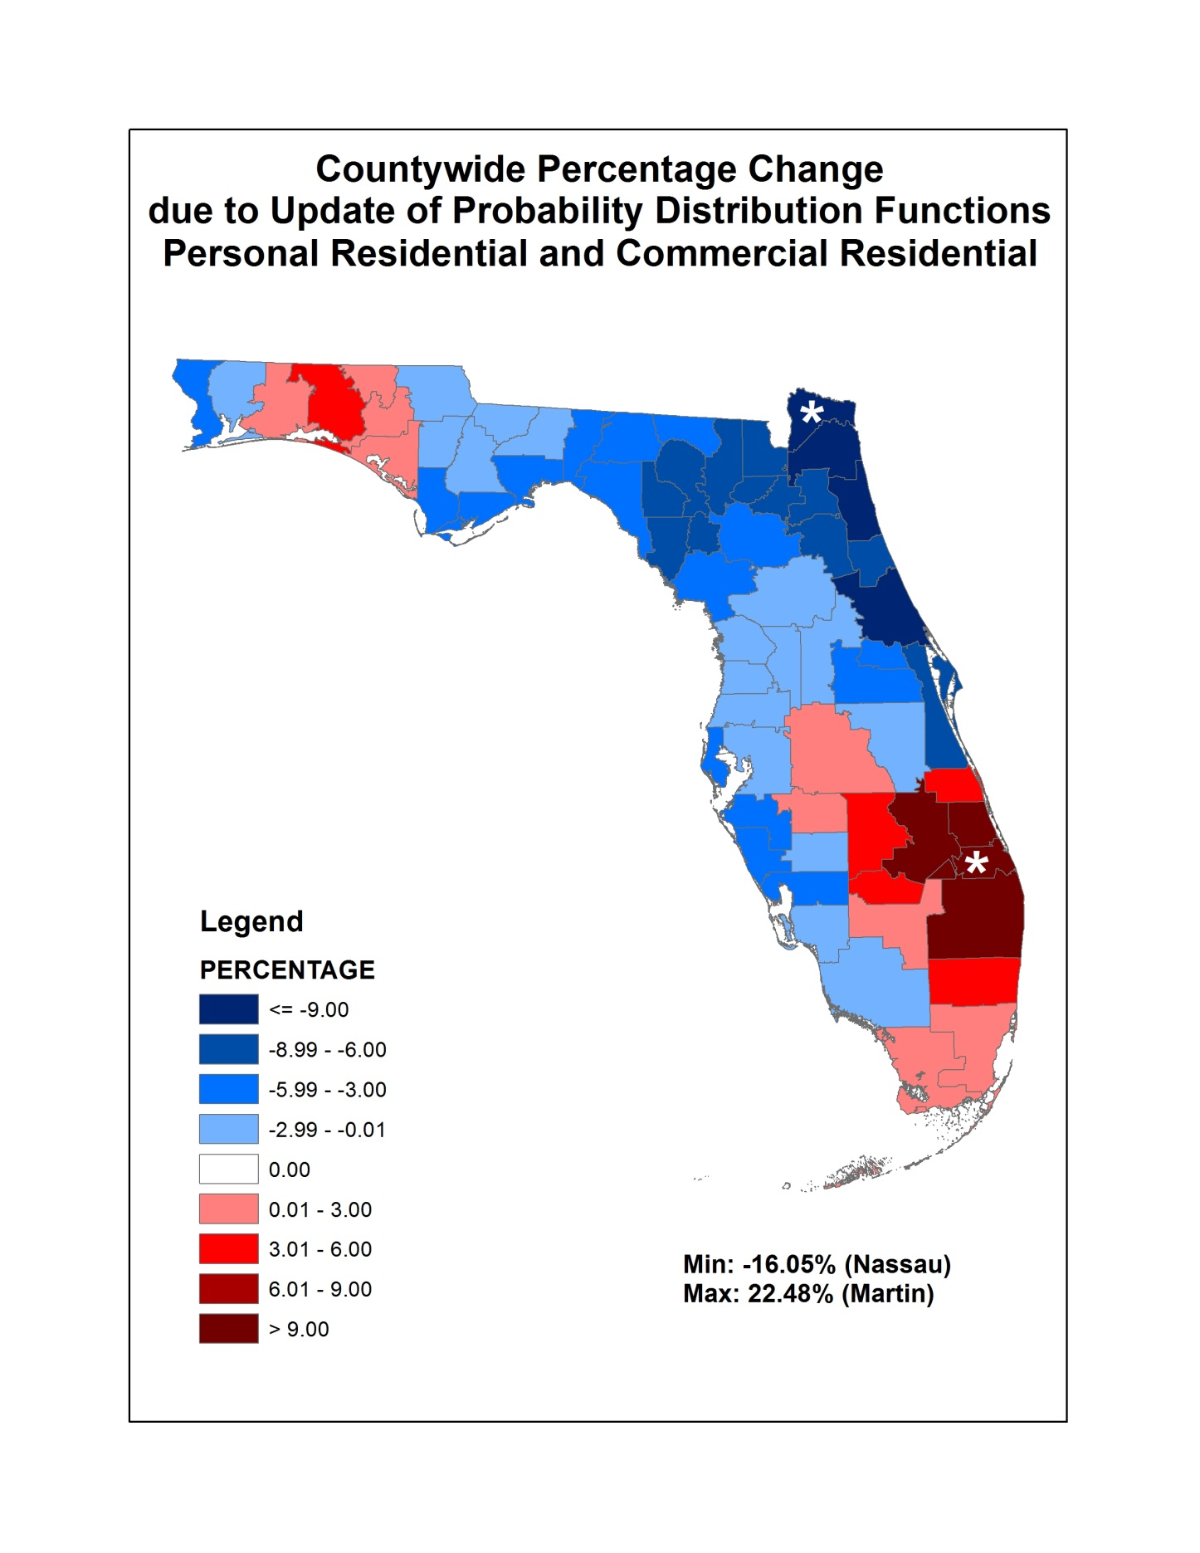
Figure 20. Personal residential and commercial residential county wide percentage change due to update of probability distribution functions.

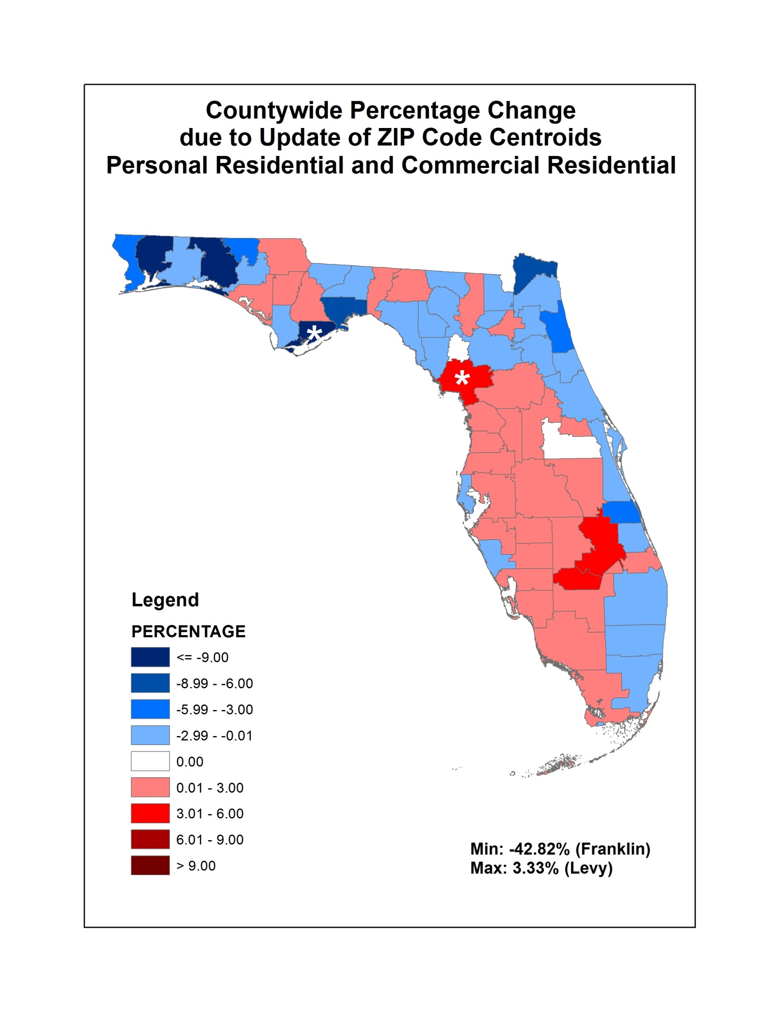
Figure 21. Personal residential and commercial residential county wide percentage change due to update of ZIP code centroids.

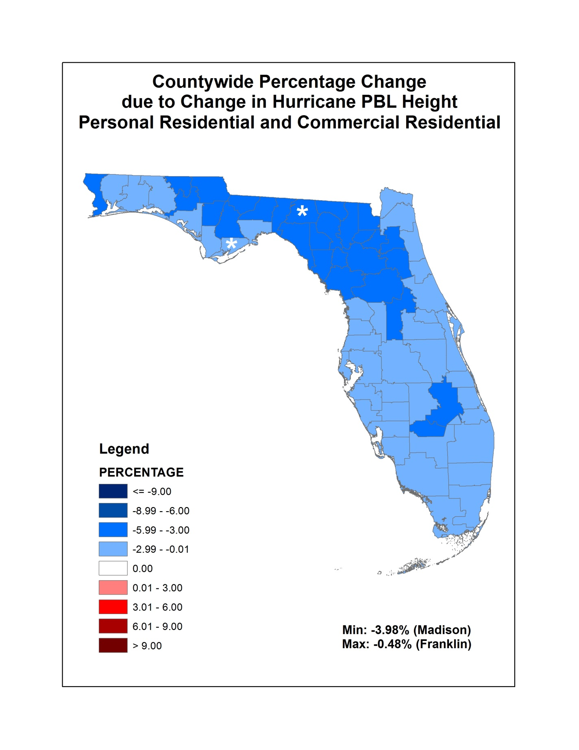
Figure 22. Personal residential and commercial residential county wide percentage change due to change in hurricane PBL height.
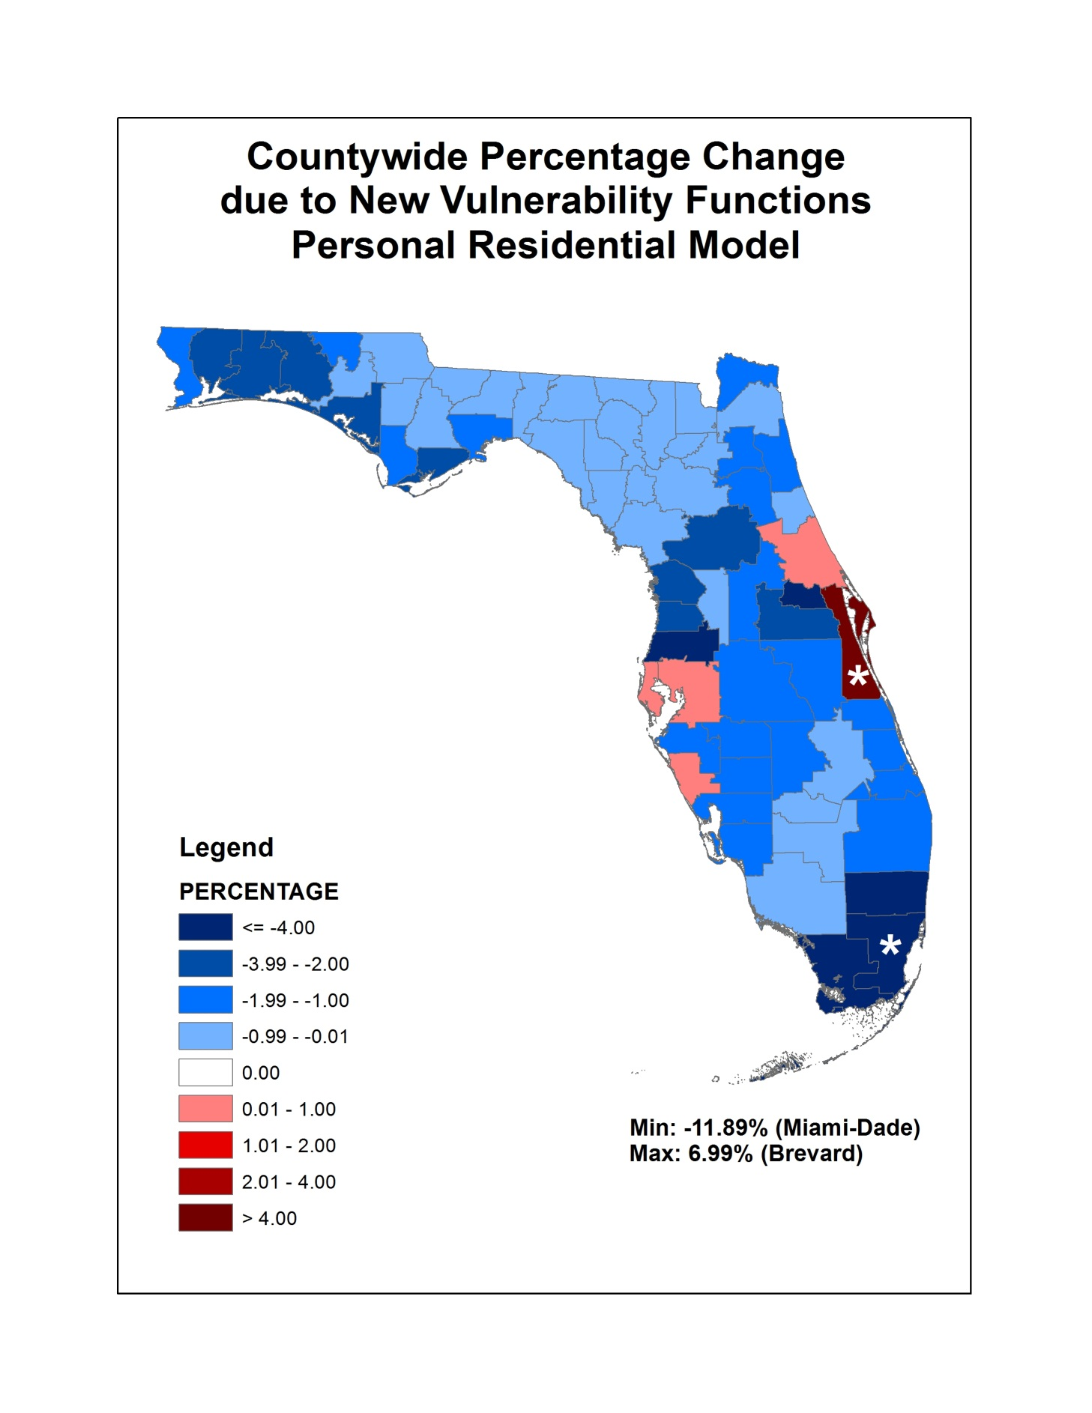
Figure 23. County wide percentage change due to vulnerability functions personal residential model.

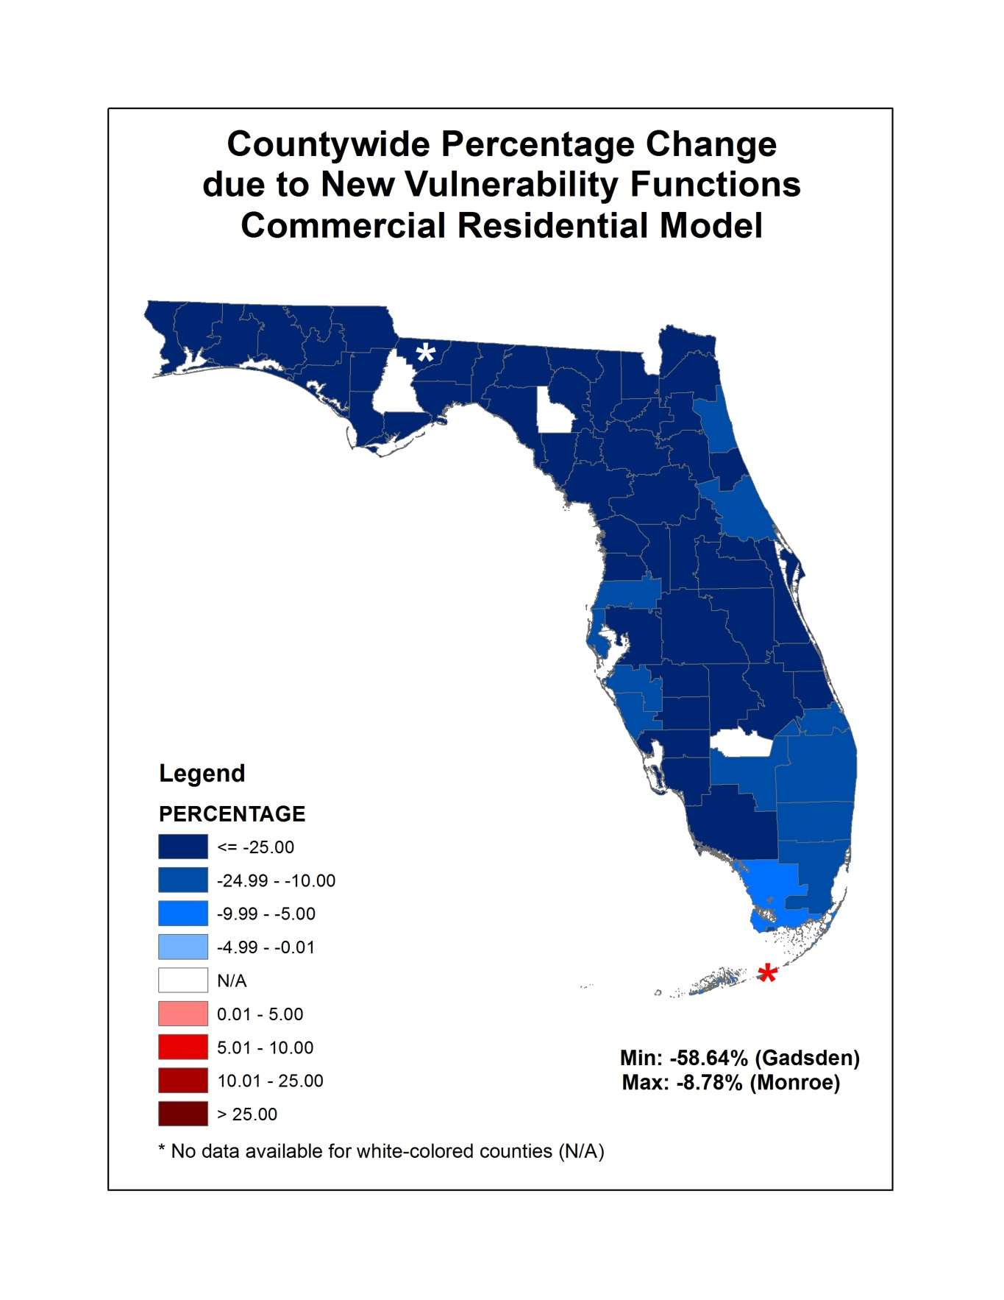
Figure 24. County wide percentage change due to new vulnerability functions commercial residential model.

G-2 Qualifications of Modeling Organization Personnel and Consultants

- Model construction, testing, and evaluation shall be performed by modeling organization personnel or consultants who possess the necessary skills, formal education, and experience to develop the relevant components for hurricane loss projection methodologies.

The model was developed, tested, and evaluated by a multi-disciplinary team of professors and experts in the fields of meteorology, wind and structural engineering, computer science, statistics, finance, economics, and actuarial science. The experts work primarily at Florida International University, Florida Institute of Technology, Florida State University, University of Florida, Hurricane Research Division of NOAA, and University of Miami.

- The model and model submission documentation shall be reviewed by either modeling organization personnel or consultants in the following professional disciplines: structural/wind engineering (licensed Professional Engineer), statistics (advanced degree), actuarial science (Associate or Fellow of Casualty Actuarial Society), meteorology (advanced degree), and computer/information science (advanced degree). These individuals shall certify Forms G-1 through G-6 as applicable.

The model has been reviewed by modeler personnel and consultants in the required professional disciplines. These individuals abide by the standards of professional conduct as adopted by their profession.

Disclosures

- Organization Background

  - Describe the ownership structure of the modeling organization. Describe affiliations with other companies and the nature of the relationship, if any. Indicate if your organization has changed its name and explain the circumstances.

The model was developed independently by a multi-disciplinary team of professors and experts. The lead university is the Florida International University. The model was commissioned by the Florida Office of Insurance Regulation.

  - If the model is developed by an entity other than a modeling company, describe its organizational structure and indicate how proprietary rights and control over the model and its critical components is exercised. If more than one entity is involved in the development of the model, describe all involved.

Figure25. Organizational structure.

The Florida Office of Insurance Regulation (OIR) contracted and funded Florida International University to develop the Florida Public Hurricane Loss Model. The model is based at the Laboratory for Insurance, Financial and Economic Research, which is part of the International Hurricane Research Center at Florida International University. The OIR did not influence the development of the model. The model was developed independently by a team of professors, experts, and graduate students working primarily at Florida International University, Florida Institute of Technology, Florida State University, University of Florida, Hurricane Research Division of NOAA, University of Miami, and AMI Risk Consultants. The copyright for the model belongs to OIR.

  - If the model is developed by an entity other than a modeling company, describe the funding source for the model.

The model was funded by the state legislature at the request of the Florida Office of Insurance Regulation.

  - Describe the modeling organization’s services.

Until 2008 the modeler provided services to only one major client, the FL-OIR. Effective January 2009 the modeler is providing services to the firms and organizations in the insurance and reinsurance industries. It has expanded the infrastructure and computational capacity to handle the added load.

The first version of the model was completed in May 2005 and was based on the knowledge and the limited data available prior to the 2004–2005 hurricane seasons. It was not used for purposes of estimating loss costs for insurance company exposures. Essentially, it was an internal model that was never implemented.
The next version of the model was developed upon the acquisition of a limited amount of meteorological, engineering, and insurance claim data from the 2004–2005 hurricane events and was implemented in March 2006. This version was used to process the insurance company data on behalf of the Florida Office of Insurance Regulation.

In summer 2007 a revised and updated version of the model, 2.6, was accepted by the Florida Commission on Hurricane Loss Projection Methodology and put to immediate use. Another revised and updated version, 3.0, was accepted by the Commission in June 2008. The next updated version of the model was 3.1, which was accepted by the Commission in June 2009. The latest updated version of the model is 4.1, which was accepted by the Commission in August 2011.

  - Indicate if the modeling organization has ever been involved directly in litigation or challenged by a statutory authority where the credibility of one of its U.S. hurricane model versions for projection of loss costs or probable maximum loss levels was disputed. Describe the nature of each case and its conclusion.

None.

- Professional Credentials

- Provide in a chart format (a) the highest degree obtained (discipline and university), (b) employment or consultant status and tenure in years, and (c) relevant experience and responsibilities of individuals currently involved in the acceptability process or in any of the following aspects of the model:

    - Meteorology
    - Statistics
    - Vulnerability
    - Actuarial Science
    - Computer Science

See below.

Table 10. Professional credentials.
Key Personnel | Degree/  Discipline | University | Employment Status | Tenure | Experience
Meteorology:
Dr. Mark Powell | Ph.D. Meteorology | Florida State University | Senior Atmospheric Scientist HRD/NOAA | 33 | Meteorology wind field model
Dr. Steve Cocke | Ph.D. Physics | Univ. Texas Austin | Scholar/Scientist FSU, Dept of Meteorology | 16 | Meteorology track, intensity, roughness models
Bachir Annane | M.S. Meteorology,  M.S. Mathematics | Florida State University | Meteorologist, Univ. of Miami | 18 | Meteorology
Neal Durst | B.S. Meteorology | Florida State University | Meteorologist, HRD/NOAA | 28 | Meteorology
Engineering:
Dr. Jean-Paul Pinelli | Ph.D. Civil Engineering | Georgia Tech | Professor, CE Florida Institute of Technology | 16 | Wind engineering, vulnerability functions
Dr. Kurt Gurley | Ph.D. Civil Engineering | University of Notre Dame | Associate Professor, CE University of Florida | 13 | Wind engineering, simulations
Dr. Gonzalo Pita | Ph.D. Civil Engineering | Florida Institute of Technology | Post Doc John Hopkins University | 9 | Wind engineering, vulnerability functions
Timothy Johnson | B.S. Civil Engineering | Florida Institute of Technology | M.S. candidate (FIT) | 2 | Wind engineering, vulnerability functions
Johann Weekes | M.S. Civil Engineering | University of Florida | Ph.D. Candidate (UF Civil) | 6 | Wind and structural engineering
Steven Bell | B.S. Civil Engineering | Florida Institute of Technology | M.S. candidate (FIT) | 1 | Wind engineering, vulnerability functions
Actuarial/Finance:
Dr. Shahid Hamid Project Manager, PI | Ph.D. Economics (Financial), CFA | University of Maryland | Professor of Finance Florida International University | 22 | Insurance and finance
Gail Flannery | FCAS, Actuary | CAS | VP, AMI Risk Consultants | 28 | Reviewer, demand surge, actuarial analysis
Aguedo Ingco | FCAS, Actuary | CAS | President, AMI Risk Consultants | 38 | Reviewer, demand surge
Nino Joseph Paz | BS Statistics | University of Philippines-Diliman | Actuarial supervisor, AMI Risk Consultants | 2 | Actuarial consulting
Computer Science
Dr. Shu-Ching Chen | Ph.D. Electrical and Computer Engineering | Purdue University | Professor of Computer Science at FIU | 12 | Software and database development
Dr. Mei-ling Shyu | Ph.D. Electrical and Computer Engineering | Purdue University | Associate Professor of Electrical and Computer Engineering at University of Miami | 12 | Software quality assurance
Fausto Fleites | B.S. Computer Science | Florida Int’l University | Ph.D. Student FIU | 10 | Software development and database development
Hsin-Yu Ha | B.S. Information Management | Chang Gung University | Ph.D. Student FIU | 6 | Data processing
Yimin Yang | M.S. Electrical Engineering | Xidian University | Ph.D Student FIU | 3 | Software development
Raul Garcia | Computer Science Undergraduate Student | Florida International University | Undergraduate Student FIU | 2 | Software and database development
Diana Machado | Computer Science Undergraduate Student | Florida International University | Undergraduate Student FIU | 1 | Software and database development
Dianting Liu | Ph.D. Mechanical Engineering | Dalian University of Technology | Ph.D. Student UM | 1 | Data processing
Roberto Aleman | B.S. Computer Science | Florida International University | M.S. Student FIU | 1 | Web development
Alex Sarracino | Computer Science Undergraduate Student | Florida International University | Undergraduate Student FIU | 1 | Data processing and software development
Laura Alonso | Information Technology Undergraduate Student | Florida International University | Undergraduate Student FIU | 1 | Data processing
Statistics
Dr. S. Gulati | Ph.D. Statistics | University of South Carolina | Professor, Statistics, FIU | 17 | Statistical tests and nonparametric analysis
Dr. B. M. Golam Kibria | Ph.D. Statistics | University of Western Ontario | Associate Professor of Statistics at FIU | 12 | Statistical testing and sensitivity analysis
Technical Editor
Teresa Grullon | Financial Certification | Institute of Financial Education | Administrative Assistant, FIU | 23 | Administrative, Accounting, technical editing

  - Identify any new employees or consultants (since the previous submission) working on the model or the acceptability process.

Raul Garcia, Diana Machado, Teresa Grullon, Steven Bell, Dianting Liu, Roberto Aleman, Alex Sarracino, Laura Alonso.

  - Provide visual business workflow documentation connecting all personnel related to model design, testing, execution, maintenance, and decision-making.

Figure 25. Florida Public Hurricane Loss Model workflow.

  - Indicate specifically whether individuals listed in A. and B. are associated with the insurance industry, a consumer advocacy group, or a government entity, as well as their involvement in consulting activities.

Dr. Mark Powell and Neal Dorst work for the Hurricane Research Division of NOAA.

- Independent Peer Review

- Provide reviewer names and dates of external independent peer reviews that have been performed on the following components as currently functioning in the model:

- Meteorology
    - Statistics
    - Vulnerability
    - Actuarial Science
    - Computer Science

Dr. Gary Barnes, Professor of Meteorology at University of Hawaii, performed the external review of the meteorology component in December 2006. The current version was reviewed by modeler personnel.

Gail Flannery, FCAS, and Aguedo Ingco, FCAS, actuaries and vice president and president, respectively, of AMI Risk Consultants in Miami, performed the external review of the actuarial component and submission. Gail Flannery was also involved in the development of the demand surge model and the commercial residential model.

The vulnerability, statistical, and computer science components were reviewed by modeler personnel.

  - Provide documentation of independent peer reviews directly relevant to the modeling organization’s responses to the current standards, disclosures, or forms. Identify any unresolved or outstanding issues as a result of these reviews.

The written independent review of the wind component by Dr. Gary Barnes is presented in Appendix A. No unresolved outstanding issues remain after the review.

Gail Flannery, FCAS, performed the independent review of the actuarial component. She attended many on-site meetings with the model team and helped in the understanding of the requirements of the actuarial standards, disclosures, and forms. She was provided with all relevant forms and supporting documents. She conducted independent analysis of the A forms and asked questions and provided feedback and suggestions; her questions were addressed, and the feedback and suggestions were acted upon so that no unresolved outstanding issues remain. She largely prepared the submission document for the actuarial standards. A letter from Gail Flannery can be found in Appendix A. See also Form G-4.

  - Describe the nature of any on-going or functional relationship the organization has with any of the persons performing the independent peer reviews.

Dr. Gary Barnes, Professor of Meteorology at University of Hawaii, performed the external review of the version 2.6 meteorology component of the model, particularly the wind field model. He has no on-going or functional relationship to FIU or the modeling organization, other than as an independent reviewer. He did not take part in the development or testing of the model. His role in the model has been confined to being an independent external reviewer.

- Provide a completed Form G-1, General Standards Expert Certification. Provide a link to the location of the form here.

See Form G-1

- Provide a completed Form G-2, Meteorological Standards Expert Certification. Provide a link to the location of the form here.

See Form G-2

- Provide a completed Form G-3, Statistical Standards Expert Certification. Provide a link to the location of the form here.

See Form G-3

- Provide a completed Form G-4, Vulnerability Standards Expert Certification. Provide a link to the location of the form here.

See Form G-4

- Provide a completed Form G-5, Actuarial Standards Expert Certification. Provide a link to the location of the form here.

See Form G-5

- Provide a completed Form G-6, Computer Standards Expert Certification. Provide a link to the location of the form here.

See Form G-6

G-3 Risk Location

- ZIP Codes used in the model shall not differ from the United States Postal Service publication date by more than 24 months at the date of submission of the model. ZIP Code information shall originate from the United States Postal Service.

Our model uses ZIP Code data exclusively from a third-party developer, which bases its information on the ZIP Code definitions issued by the United States Postal Service. The version we used has a USPS vintage of December 2011. The ZIP Code data have been changed in the current release of the model from last year's submission.

- ZIP Code centroids, when used in the model, shall be based on population data.

ZIP Code centroids used in the model are population centroids and are updated at least every 24 months.

- ZIP Code information purchased by the modeling organization shall be verified by the modeling organization for accuracy and appropriateness.

ZIP Code information is checked for consistency by experts developing our model. Maps showing the ZIP Code boundaries and the associated centroids will be provided to the professional team during the on-site visit.

- If any hazard or any model vulnerability components are dependent on ZIP Code databases, the modeling organization shall maintain a logical process for ensuring these components are consistent with the recent ZIP Code database updates.

- Geocoding methodology shall be consistent and justifiable.

Disclosures

- List the current ZIP Code databases used by the model and the components of the model to which they relate. Provide the effective (official United States Postal Service) date corresponding to the ZIP Code databases.

The FPHLM uses 5-Digit ZIP Codes distributed by Pitney Bowes. The data is sourced from a combination of the MultiNet data, the United States Postal Service (USPS) ZIP+4 data file, the USPS National 5-Digit ZIP Code and Post Office Directory, the USPS ZIP+4 State Directories, and the USPS City State file.

The ZIP Code data are updated quarterly. The release we used in this submission has a Tele Atlas (GDT, Inc.) vintage of 2011.12 (December 2011) and a USPS vintage of 2011.12. The 5-Digit ZIP Code aligns with StreetPro v2011.12, MapMarker Plus v24.1, Routing J Server v2011.12, and Census Boundary Products (block groups, counties, census tracks, places, MCDs, and municipal boundaries) v2011.12.

The ZIP Code data are used in the Wind Speed Correction Module of the model.

- Describe in detail how invalid ZIP Codes are handled.

For historical loss costs where street addresses are not available, we use contemporaneous ZIP Codes and associated population-based centroids to locate the exposure. The Wind Speed Correction module subsequently determines the current (2011) ZIP Code that contains the historical centroid, and the exposure is then modeled on the basis of the 2011 ZIP code centroid location. If a policy has a ZIP Code that cannot be found in the contemporaneous database of ZIP Codes, it is not modeled.

- Describe the data, methods, and process used in the model to convert among street addresses, geocode locations (latitude-longitude), and ZIP Codes.

- List and provide a brief description of each model ZIP Code-based database (e.g., ZIP Code centroids).

- Describe the process for updating model ZIP Code-based databases.

G-4 Independence of Model Components

The meteorological, vulnerability, and actuarial components of the model shall each be theoretically sound without compensation for potential bias from the other two components.

The meteorology, vulnerability, and actuarial components of the model are theoretically sound and were developed and validated independently before being integrated. The model components were tested individually.

G-5 Editorial Compliance

The submission and any revisions provided to the Commission throughout the review process shall be reviewed and edited by a person or persons with experience in reviewing technical documents who shall certify on Form G-7, Editorial Certification that the submission has been personally reviewed and is editorially correct.

The current submission document has been reviewed and edited by persons who are qualified to perform such tasks. Future revisions and related documentation will likewise be reviewed and edited by the qualified individual listed in Form G-7.

Disclosures

- Describe the process used for document control of the submission. Describe the process used to ensure that the paper and electronic versions of specific files are identical in content.

All submission document revisions are passed to the Editor prior to inclusion in the document. Several Word tools are utilized to automate the process of formatting and editing the document. For example, we used Source Manager for APA-style bibliographies, consistent formatting via styles for standards, forms and disclosures, cross-references to cite figures and tables, and multi-level lists to ensure consistent numbering. In addition, Word’s track changes tool is used to keep track of modifications to the document since the initial submission. An export filter to PDF format is used to export the document directly to PDF format, which subsequently is printed directly to paper via a printer. The PDF and printed document should be identical barring unforeseen bugs in the PDF export plug-in or PDF printing software.

- Describe the process used by the signatories on Forms G-1 through G-6 (Standards Expert Certification forms) to ensure that the information contained under each set of standards is accurate and complete.

Each signatory was responsible for doing a final review of the standards related to their expertise prior to submission to verify the accuracy and completeness of the information in the submission document. A professional technical editor was hired to perform a thorough edit of the document. All signatories were required to proof-read a PDF version of the document to ensure accuracy and completeness. On-site meetings were held to perform a thorough review of the final version of the document.

- Provide a completed Form G-7, Editorial Certification. Provide a link to the location of the form here.

See Form G-7.

Form G-1
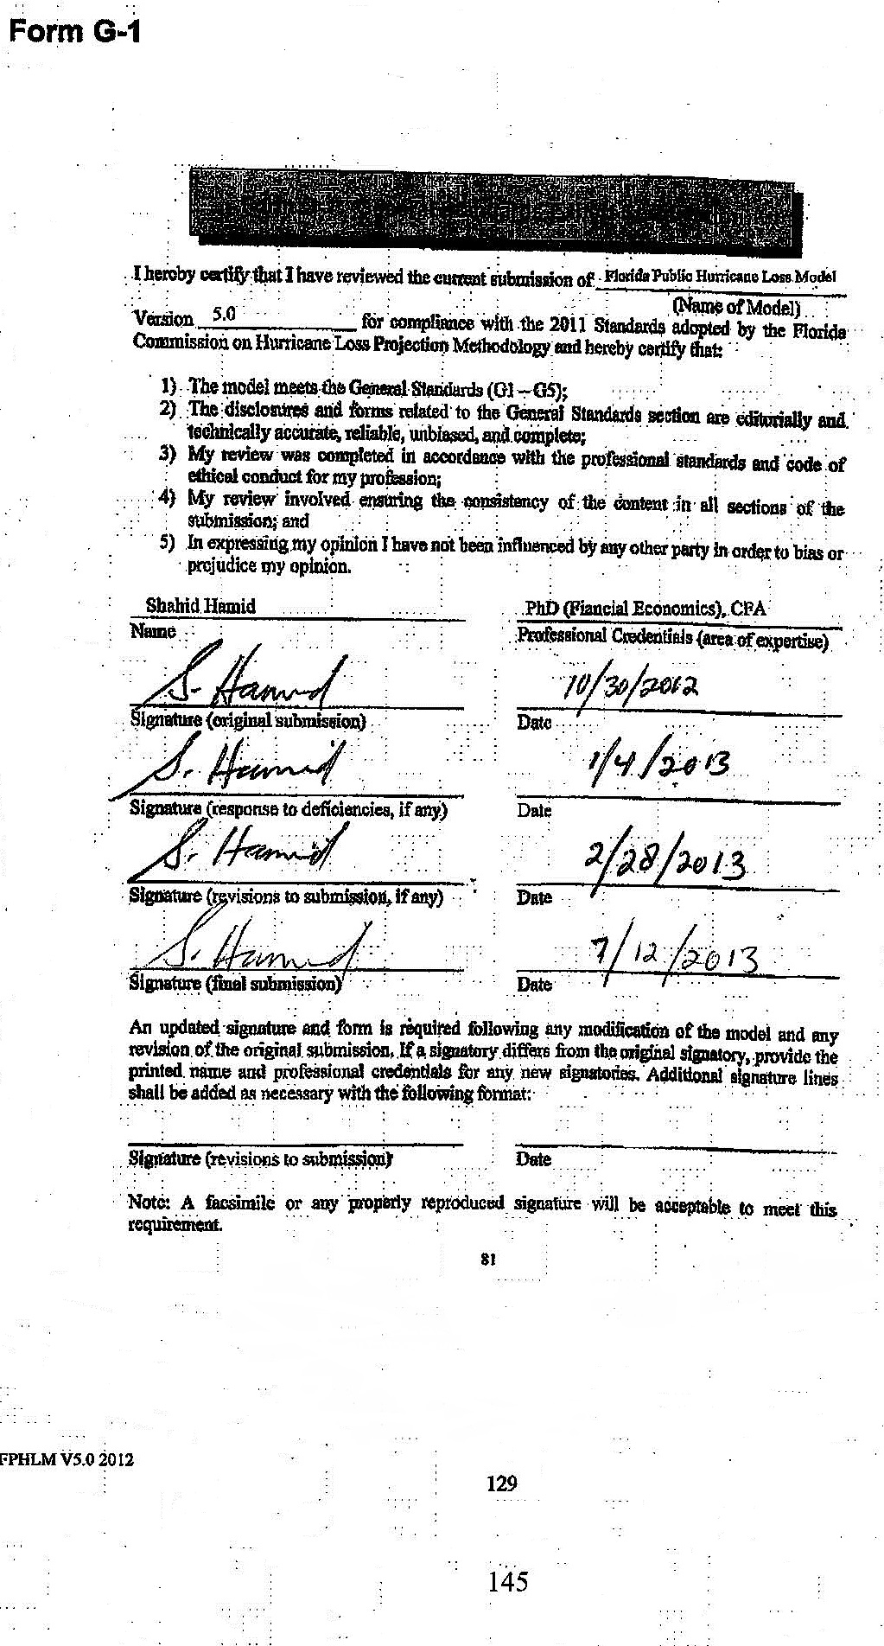

Form G-2



Form G-3



Form G-4



Form G-5

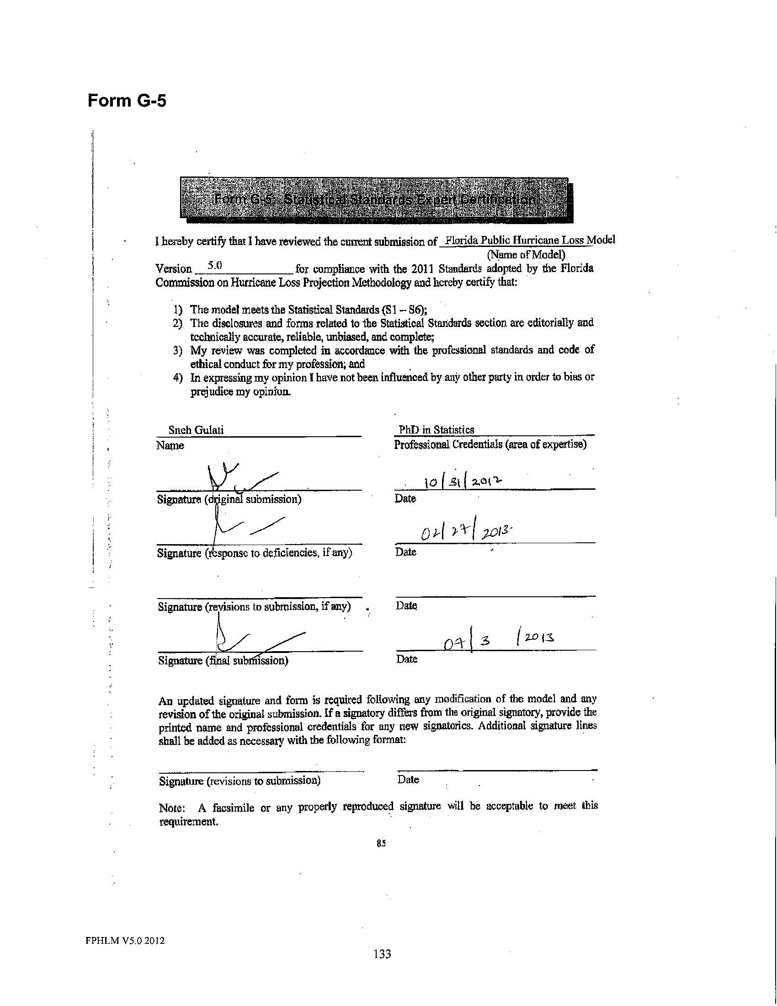

Form G-6

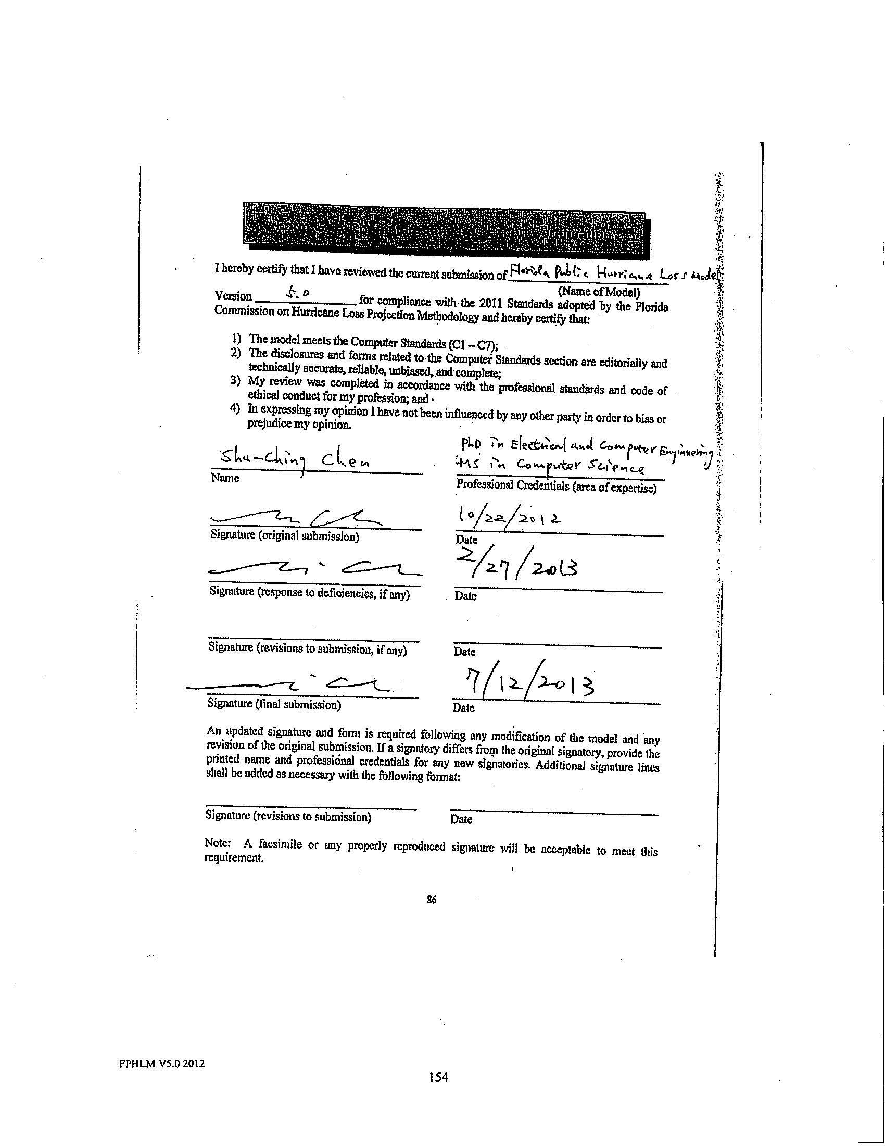

Form G-7

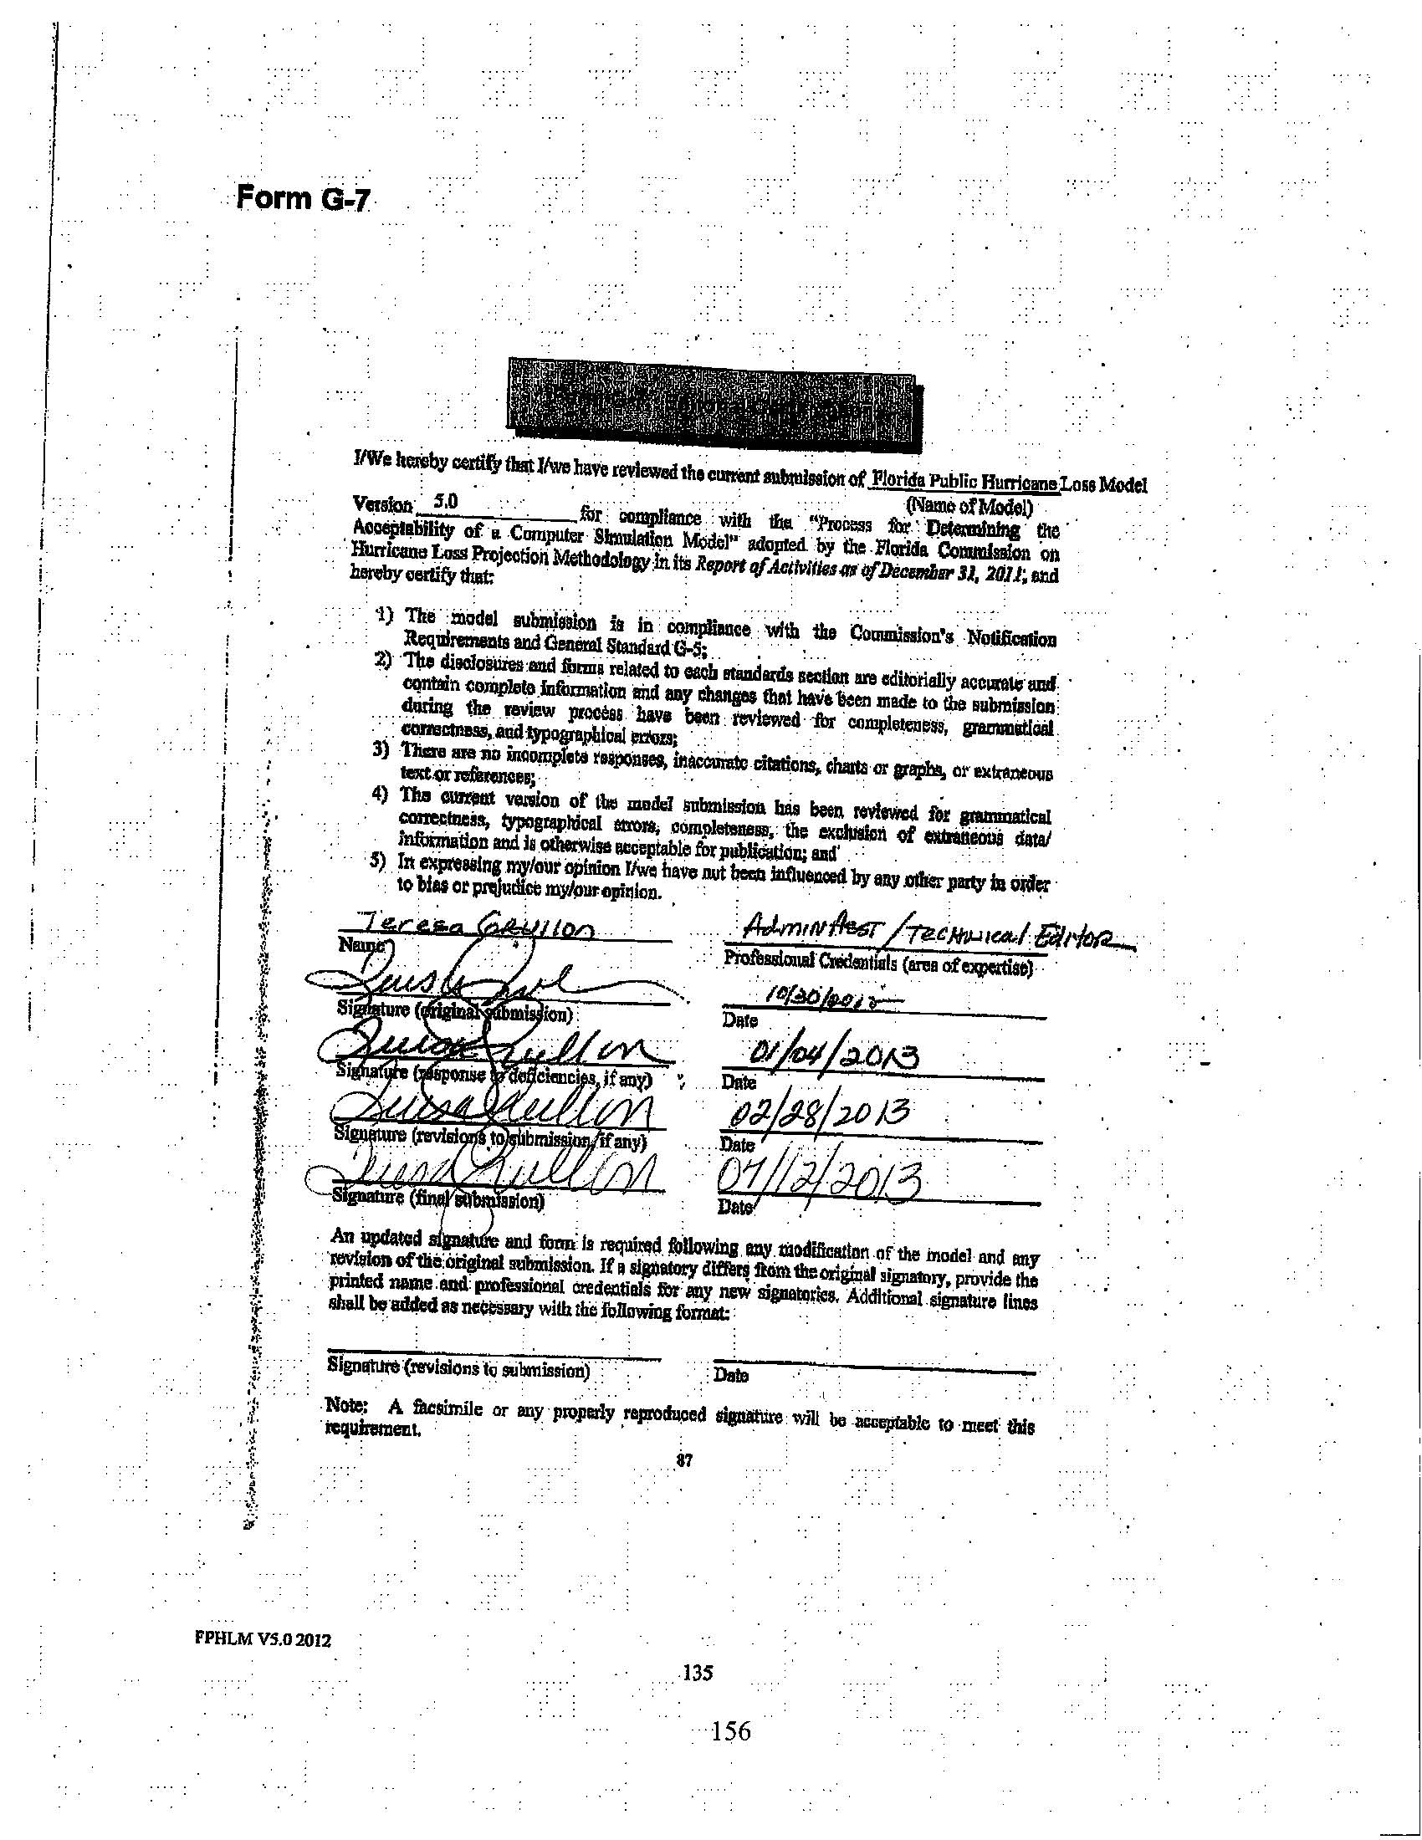

METEOROLOGICAL STANDARDS

M-1 Base Hurricane Storm Set

- Annual frequencies used in both model calibration and model validation shall be based upon the National Hurricane Center HURDAT2 starting at 1900 as of August 15, 2013 (or later). Complete additional season increments based on updates to HURDAT2 approved by the Tropical Prediction Center/National Hurricane Center are acceptable modifications to these storm sets. Peer reviewed atmospheric science literature can be used to justify modifications to the Base Hurricane Storm Set.

Validation of the FPHLM is based on the 1900–2013 period of historical record as provided in the April, 2014 version of HURDAT released by the National Hurricane Center.

- Any trends, weighting, or partitioning shall be justified and consistent with currently accepted scientific literature and statistical techniques. Calibration and validation shall encompass the complete Base Hurricane Storm Set as well as any partitions.

Validation and comparison of the FPHLM encompasses the complete Base Hurricane Storm Set provided in HURDAT. We conduct no trending, weighting, or partitioning of the Base Hurricane Set.

Disclosures

- Identify the Base Hurricane Storm Set, the release date, and the time period included to develop and implement landfall and by-passing hurricane frequencies into the model.

The National Hurricane Center HURDAT file from April, 2014 for the period 1900–2013 is used to establish the official hurricane base set used by our model. All HURDAT storm tracks that have made landfall in Florida or bypassed Florida but passed close enough to produce damaging winds are documented in our archives.

- If the modeling organization has made any modifications to the Base Hurricane Storm Set related to landfall frequency and characteristics, provide justification for such modifications.

For stochastic hurricane loss modeling, the HURDAT database indicated in Disclosure 1 is used, unmodified, to develop the probability distribution functions for track and intensity changes and to determine storm frequency.

To model historical losses, we developed a Historical Base Set. This base set is based on the latest HURDAT but includes additional data, such as central pressure and Rmax, that may not be available in HURDAT but is needed by the wind model.

- Where the model incorporates short-term or long-term modification of the historical data leading to differences between modeled climatology and that in the entire Base Hurricane Storm Set, describe how this is incorporated.

The FPHLM incorporates no short-term or long-term modifications of the climate record. Storm frequencies are based on historical occurrences derived from HURDAT and thus implicitly contain any long- or short-term variations that are contained in the historical record. No attempt is made to explicitly model long- or short-term variations.

- Provide a completed Form M-1, Annual Occurrence Rates. Provide a link to the location of the form here.

See Form M-1.

M-2 Hurricane Parameters and Characteristics

Methods for depicting all modeled hurricane parameters and characteristics including but not limited to windspeed, radial distributions of wind and pressure, minimum central pressure, radius of maximum winds, landfall frequency, tracks, spatial and time variant windfields, and conversion factors, shall be based on information documented in currently accepted scientific literature.

All methods used to depict storm characteristics are based on methods described in the peer-reviewed scientific literature. Our scientists developed datasets using data from published reports, the HURDAT database, archives, observations, and analyses from NOAA’s Hurricane Research Division, The Florida State University, Florida International University, and the Florida Coastal Monitoring Program.

Disclosures

- Identify the hurricane parameters (e.g., central pressure or radius of maximum winds) that are used in the model.

Hurricane parameters used in the model include storm track (translation speed and direction of the storm), radius of maximum wind (Rmax), Holland surface pressure profile parameter (B), the minimum central sea level pressure (Pmin), the damage threshold distance, and the pressure decay as a function of time after landfall.

The storm initial position and motion are modeled using the HURDAT database. For pressure decay we use the Vickery (2005) decay model. Vickery developed the model on the basis of pressure observations in HURDAT and NWS-38, together with Rmax and storm motion data as described in the publication. The radius of maximum winds at landfall is modeled by fitting a gamma distribution to a comprehensive set of historical data published in NWS-38 by Ho et al. (1987) and supplemented by the extended best track data of DeMaria, NOAA HRD research flight data, and NOAA-AOML-HRD H*Wind analyses (Powell & Houston, 1996; Powell et al., 1996; Powell & Houston, 1998; Powell et al., 1998).

Additional research was used to construct a historical landfall Rmax-Pmin database using existing literature (Ho et al., 1987), extended best track data, HRD Hurricane field program data, and the H*Wind wind analysis archive (Demuth et al., 2006). We developed an Rmax model using the revised landfall Rmax database, which includes more than 100 measurements for hurricanes up to 2010. We have opted to model the Rmax at landfall rather than the entire basin for a variety of reasons. One is that the distribution of landfall Rmax may be different than that over open water. An analysis of the landfall Rmax database and the 1988–2007 extended best track data shows that there appears to be a difference in the dependence of Rmax on central pressure (Pmin) between the two datasets (Demuth et al., 2006). The landfall dataset provides a larger set of independent measurements (more than 100 storms compared to about 31 storms affecting the Florida threat area region in the best track data). Since landfall Rmax is most relevant for loss cost estimation and has a larger independent sample size, we have chosen to model the landfall dataset. Future studies will examine how the extended best track data can be used to supplement the landfall dataset.

Recent research results by Willoughby and Rahn (2004) based on the NOAA-AOML-HRD annual hurricane field program and Air Force reconnaissance flight-level observations are used to create a model for the “Holland B” parameter. Ongoing research on the relationship between horizontal surface wind distributions (based on Stepped Frequency Microwave Radiometer observations) to flight level distributions (Powell et al., 2009) is used to correct the flight-level Rmax to a surface Rmax when developing a relationship for the Holland B term. We multiply the flight-level Rmax from the Willoughby and Rahn (2004) dataset by 0.815 to estimate the surface Rmax (based on SFMR, flight-level maxima pair data). This adjustment keeps the Holland pressure profile parameter consistent with a surface Rmax and because of the negative term in the equation produces a larger value of B than if a flight-level value of Rmax were used. This is consistent with the concept of a stronger radial pressure gradient for the mean boundary layer slab than at flight level (due to the warm core of the storm), which agrees with GPS dropsonde wind profile observations showing boundary layer winds that are stronger than those at the 10,000 ft flight level, which is the level for most of the B data in Willoughby and Rahn (2004). The B adjustment for a surface Rmax produces an overall stronger surface wind field than if B were not adjusted. In addition, surface pressures from the “best track” information on HURDAT are used to associate a particular flight-level pressure profile B with a surface pressure.

The NOAA-AOML-HRD H*Wind analysis archive was used to develop a relationship between Rmax and the extent of damaging winds to make sure that the model would only consider land locations that have potential for damaging winds. HRD wind modeling research initiated by Ooyama (1969) and extended by Shapiro (1983) has been used to develop the HRD wind field model. This model is based on the concept of a slab boundary layer model, a concept pioneered at NOAA-AOML-HRD and now in use by other modelers for risk applications (Thompson & Cardone, 1996; Vickery & Twisdale, 1995; Vickery et al., 2000b). The HURDAT historical database is used to develop the track and intensity model. Historical data used for computing the potential intensity is based on the National Centers for Environmental Prediction (NCEP) sea surface temperature archives and the NCEP reanalysis for determining the upper tropospheric outflow temperatures. Use cases describing the various model functions and their research bases are available with the model documentation.

- Describe the dependencies among variables in the windfield component and how they are represented in the model, including the mathematical dependence of modeled windfield as a function of distance and direction from the center position.

B depends linearly on latitude and Rmax, and quadratically on DelP. The gradient wind for the slab boundary layer depends on Pmin (through DelP) and B; the mean slab planetary boundary layer (PBL) wind depends on the gradient wind, the drag coefficient (which depends on wind speed), the air density, the gradients of the tangential and radial components of the wind, and the Coriolis parameter (which also depends on latitude). The wind field model solves the equations of motion on a polar grid with a 0.1 R/Rmax radial grid resolution. The input Rmax is reduced by 10% to correct a small bias in Rmax caused by a tendency of the wind field solution to place Rmax radially outward by one grid point. The wind field model terms and dependencies are further described in Powell et al. (2005).

- Identify whether hurricane parameters are modeled as random variables, as functions, or as fixed values for the stochastic storm set. Provide rationale for the choice of parameter representations.

Initial storm positions and motion changes derived from HURDAT are modified by the addition of small uniform random error terms. Subsequent storm motion change and intensity are obtained by sampling from empirically derived PDFs as described in Section G-1.2. The random error term for the B parameter is a normal distribution with zero mean and a standard deviation derived from observed reconnaissance aircraft pressure profile fits for B (Willoughby & Rahn, 2004). The radius of maximum winds is sampled from a gamma distribution based on landfall Rmax data and is described in more detail below and in Standard G-1.2.

Since Rmax is nonnegative and skewed, we model the distribution using a gamma distribution. Using the maximum likelihood estimators, we found the parameters for the gamma distribution to be k=4.76, θ=5.41. A discussion of the goodness of fit for Rmax is found in Standard S-1.

An examination of the Rmax database shows that intense storms, essentially Category 5 storms, have rather small radii. Thermodynamic considerations (Willoughby, 1998) also suggest that smaller radii are more likely for these storms. Thus, we model Category 5 (DelP>90 mb, where DelP=1013-Pmin and Pmin is the central pressure of the storm) storms using a gamma distribution, but with a smaller value of the θ parameter, which yields a smaller mean Rmax as well as smaller variance. We have found that for Category 1–4 (DelP<80) storms there is essentially no discernable dependence of Rmax on central pressure. This is further verified by looking at the mean and variance of Rmax in each 10 mb interval. Thus, we model Category 1–4 storms with a single set of parameters. For a gamma distribution, the mean is given by kθ, and variance is kθ². For Category 5 storms, we adjust θ such that the mean is equal to the mean of the three Category 5 storms in the database: 1935 No Name, 1969 Camille, and 1992 Andrew. An intermediate zone between DelP=80 mb and DelP=90 mb is established where the mean of the distribution is linearly interpolated between the Category 1–4 value and the Category 5 value. As the θ value is reduced, the variance is likewise reduced. Since there are insufficient observations to determine what the variance should be for Category 5 storms, we rely on the assumption that variance is appropriately described by the rescaled θ, via kθ².

A simple method is used to generate the gamma-distributed values. A uniformly distributed variable is mapped onto the range of Rmax values via the inverse cumulative gamma distribution function. For computational efficiency, a lookup table is used for the inverse cumulative gamma distribution function.

For Category 5 and intermediate Category 4–5 storms, we use the property that the gamma cumulative distribution function is a function of (k,x/θ). Thus, by rescaling θ, we can use the same function (lookup table), but just rescale x (Rmax). The rescaled Rmax will then still have a gamma distribution but with different mean and variance.

The storms in the stochastic model will undergo central pressure changes during the storm life cycle. When a storm is generated, an appropriate Rmax is sampled for the storm. To ensure the appropriate mean values of Rmax as pressure changes, the Rmax is rescaled every time step as necessary. As long as the storm has DelP < 80 mb, there is in effect no rescaling. In the stochastic storm generator, we limit the range of Rmax from 4 sm to 120 sm. The wind field solution, after including the translation speed, results in values of Rmax that are outside this range less than 2% of the time.

- Describe how any hurricane parameters are treated differently in the historical and stochastic storm sets (e.g., has a fixed value in one set and not the other).

All historical storm sets consist of input files containing information derived from HURDAT or other observation sources as described in Standard M-1. All stochastic input storm tracks are modeled.

- State whether the model simulates surface winds directly or requires conversion between some other reference level or layer and the surface. Describe the source(s) of conversion factors and the rationale for their use. Describe the process for converting the modeled vortex winds to surface winds including the treatment of the inherent uncertainties in the conversion factor with respect to location of the site compared to the radius of maximum winds over time. Justify the variation in the surface winds conversion factor as a function of hurricane intensity and distance from the hurricane center.

The mean boundary layer winds computed by the model are adjusted to the surface using results from Powell et al. (2003), which estimated a mean surface wind factor of 77.5% on the basis of over 300 GPS sonde wind profile observations in hurricanes. The surface wind factor is based on the ratio of the surface wind speed at 10 m to the mean wind speed for the 0–500 m layer (mean boundary layer wind speed or MBL) published in Powell et al. (2003). This ratio is far more relevant to a slab boundary layer model than using data based on higher, reconnaissance aircraft flight levels. The depth of the slab boundary layer model is assigned a value of 450 m, which is the level of the maximum mean wind speed from GPS sonde wind profiles published in Powell et al. (2003). The uncertainty of the surface wind factor is ~8%, based on the standard deviation of the measurements, but no attempt is made to model this uncertainty. No radial distance from center or intensity dependent variation of reduction factor is used at this time because of a lack of dependency on these quantities based on examination of GPS dropsonde data (Figure 29).

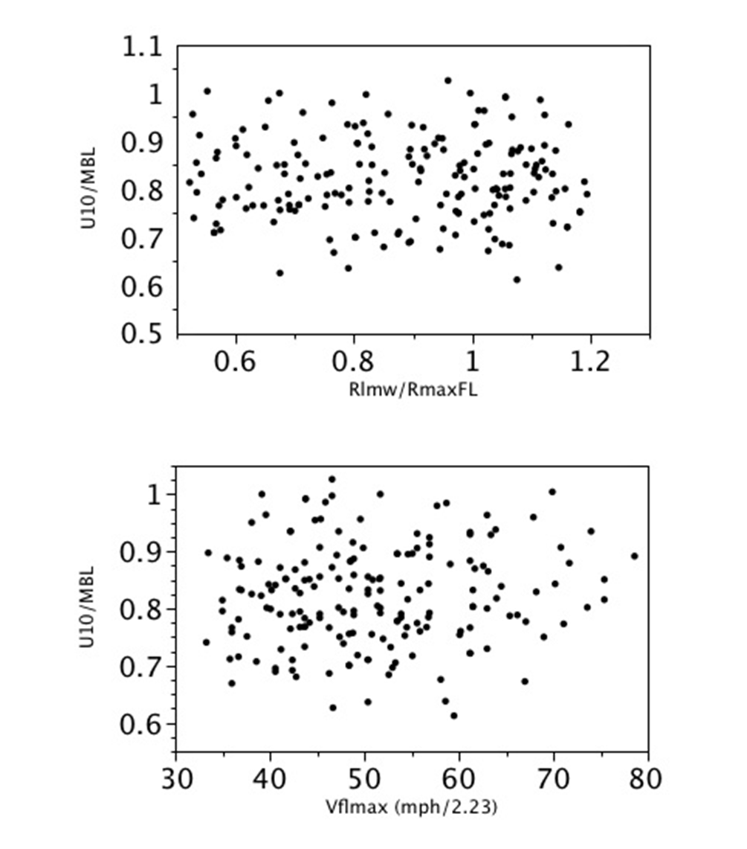
Figure 26. Analysis of 742 GPS dropsonde profiles launched from 2-4 km with flight-level winds at launch greater than hurricane force and with measured surface winds. Upper figure: Dependence of the ratio of 10 m wind speed (U10) to the mean boundary layer wind speed (MBL) on the scaled radius (ratio of radius of last measured wind (Rlmw) to the radius of maximum wind at flight level (RmaxFL). Lower figure: Surface wind factor (U10/MBL) dependence on maximum flight level wind speed (Vflmax, in units of miles per hour / 2.23).
- Describe how the windspeeds generated in the windfield model are converted from sustained to gust and identify the averaging time.

Wind speeds from the HRD slab boundary layer wind field model are assumed to represent ten-minute averages. A sustained wind is computed by applying a gust factor to account for the highest one-minute wind speed over the ten-minute period. A peak three-second gust is also computed. Gust factors depend on wind speed and the upstream fetch roughness, which in turn depends on wind direction at a particular location. Gust factor calculations were developed using research in the Engineering Sciences Data Unit (ESDU) series papers as summarized and applied to tropical cyclones by Vickery and Skerlj (2005).

- Describe the historical data used as the basis for the model’s hurricane tracks. Discuss the appropriateness of the model stochastic hurricane tracks with reference to the historical hurricane database.

The hurricane tracks are modeled as a Markov process. Initial storm conditions are derived from HURDAT. Small uniform random perturbations are added to the historical initial conditions, including initial storm location, change in motion, and intensity.

Storm motion is determined by sampling empirical distributions, based on HURDAT, of change in speed and change in direction, as well as change in relative intensity. These functions are also spatially dependent, binned in variable box sizes (typically 2.5 degrees), and enlarged as necessary to ensure sufficient density of storms for the distribution.

The model has been validated by examining key hurricane statistics relative to HURDAT at roughly 30 sm milepost locations along the Gulf and Atlantic coasts. The parameters examined include average central pressure deficit, average heading angle and speed, and total occurrence by Saffir-Simpson category.

- If the historical data are partitioned or modified, describe how the hurricane parameters are affected.

The FPHLM does not partition or modify the historical data.

- Describe how the coastline is segmented (or partitioned) in determining the parameters for hurricane frequency used in the model. Provide the hurricane frequency distribution by intensity for each segment.

The model does not use coastline segmentation to determine hurricane frequency.

- Describe any evolution of the functional representation of hurricane parameters during an individual storm life cycle.

Upon landfall, the evolution of the central pressure changes from sampling a PDF to a decay model described in Vickery (2005). When the storm exits back over water, the pressure is again modeled via the PDF. After landfall, the slab boundary layer, surface drag coefficient changes from a functional marine form to a constant based on a mean aerodynamic roughness length of 0.2 m. The slab boundary layer height increases from 450 m to 1 km after the center makes landfall and decreases back to 450 m if the center exits land to go back to sea.

M-3 Hurricane Probabilities

- Modeled probability distributions of hurricane parameters and characteristics shall be consistent with historical hurricanes in the Atlantic basin.

Hurricane motion (track) is modeled based on historical geographic probability distributions of hurricane translation velocity and velocity change, initial intensity, intensity change, and potential intensity. Modeled probability distributions for hurricane intensity, forward speed, Rmax, and storm heading are consistent with historical hurricanes in the Atlantic basin.

- Modeled hurricane landfall frequency distributions shall reflect the Base Hurricane Storm Set used for category 1 to 5 hurricanes and shall be consistent with those observed for each coastal segment of Florida and neighboring states (Alabama, Georgia, and Mississippi).

As shown in Form M-1 and the accompanying plots, our model reflects reasonably the 1900–2013 Base Hurricane Set for hurricanes of Saffir-Simpson Categories 1–5 in each coastal region of Florida, as well as in the neighboring states. In addition, a finer scale coastal milepost study of model parameters (occurrence rate, storm translation speed, storm heading, and Pmin) was conducted during the development of the model.

- Models shall use maximum one-minute sustained 10-meter windspeed when defining hurricane landfall intensity. This applies both to the Base Hurricane Storm Set used to develop landfall frequency distributions as a function of coastal location and to the modeled winds in each hurricane which causes damage. The associated maximum one-minute sustained 10-meter windspeed shall be within the range of windspeeds (in statute miles per hour) categorized by the Saffir-Simpson Scale.

Saffir-Simpson Hurricane Scale:

Category | Winds (mph) | Damage
1 | 74 – 95 | Minimal
2 | 96 – 110 | Moderate
3 | 111 – 129 | Extensive
4 | 130 – 156 | Extreme
5 | 157 or higher | Catastrophic

The HRD wind field model simulates landfall intensity according to the maximum one-minute sustained wind for the 10 m level for both stochastic simulations and the Base Hurricane Set. The Saffir-Simpson damage potential scale is used to further categorize the intensity at landfall, and the range of simulated wind speeds (in miles per hour) is within the range defined in the scale.

Disclosures

- List assumptions used in creating the hurricane characteristic databases.

The Holland B database is based on flight-level pressure profiles corresponding to constant pressure surfaces at 700 mb and below. Because of a lack of surface pressure field data, an assumption is made that the Holland B at the surface is equivalent to a B determined from information collected at flight level. The surface pressure profile uses Pmin, DelP, and Rmax at the surface. It would be ideal to have a B dataset also corresponding to the surface, but such data are not available. The best available data on B are flight-level data from Willoughby and Rahn (2004). Willoughby and Rahn (2004) reveal that during major hurricanes most flights flew at 3 km (700 mb). Few lower-level data are available for mature hurricanes, so their plot (Figure 3) of B vs. flight level does not provide data about average vertical structure. In lieu of lower-level data, we model B using flight data supplied by Willoughby, but with Rmax adjusted to a surface Rmax, and with surface DelP added from NHC best track data for each flight. Since we are modeling hurricane winds during landfall, our Rmax model applies only to landfall and is not designed to model the life cycle of Rmax as a function of intensity.

- Provide a brief rationale for the probability distributions used for all hurricane parameters and characteristics.

Form S-3 provides a list of probability distributions used to model hurricane parameters. Further discussion and rationale for these functions are provided in Standard M-2, Disclosure 1 and Standard S-1, Disclosure 1. Some of the details pertaining to data sources used are described below.

Monthly geographic distributions of climatological sea surface temperatures (Reynolds et al., 2002) and upper tropospheric outflow temperatures (Kanamitsu et al., 2002) are used to determine physically realistic potential intensities that help to bound the modeled intensity. Terrain elevation and bathymetry data were obtained from the United States Geological Survey. The radius of maximum wind at landfall is modeled from a comprehensive set of historical data published in NWS-38 by Ho et al. (1987) but supplemented by the extended best track data of DeMaria (Pennington et al., 2000), the HURDAT Reanalysis Project (Landsea et al, 2004), NOAA HRD research flight data, and NOAA-HRD H*Wind analyses (Powell et al., 1996, 1998). The development of the Rmax frequency distribution fit and its comparison to historical hurricane data are discussed in M-2.1, M-2.3 and in Standard S-1. Comparisons of the modeled radius of maximum wind to the observed data are shown in Form M-3.

M-4 Hurricane Windfield Structure

- Windfields generated by the model shall be consistent with observed historical storms affecting Florida.

As described in Statistical Standards S-1, Disclosure 2, comparisons of FPHLM to gridded H*Wind fields indicate that the FPHLM wind fields are consistent with observed historical wind fields from Florida landfalling hurricanes.

- The land use and land cover database shall be consistent with National Land Cover Database (NLCD) 2006 or later. Use of alternate data sets shall be justified.

We use the MRLC NLCD 2011 land use dataset as well as the Statewide 2004-2011 Land Use/Land Cover dataset developed and maintained by the Florida Water Management Districts (WMD) and compiled and distributed by the Florida Department of Environmental Protection. The NLCD dataset became available in Spring 2014 and provides detailed (30 m) land use characteristics circa 2011. The datasets of the individual water management districts were combined in the statewide WMD dataset to form a unified dataset. The WMD data are based on 2004-2011 imagery. Both of these data sets are based on imagery that is generally more current than NLCD 2006.

- The translation of land use and land cover or other source information into a surface roughness distribution shall be consistent with current state-of-the-science and shall be implemented with appropriate geographic information system data.

Land friction is modeled according to the currently accepted, state-of-the-science principles of surface layer similarity theory as described in the disciplines of micrometeorology, atmospheric turbulence, and wind engineering. The geographic distribution of surface roughness is determined by careful studies of aerial photography and satellite remote sensing measurements used to create land use-land cover classification systems. We have developed a roughness dataset at 90 meter resolution covering the state of Florida to enable modeling losses at the "street level." For modeling losses at the ZIP Code level, we use population-weighted roughness.

All street level locations (at 90 m resolution) and population-weighted ZIP Code centroids are assigned roughness values as a function of upstream fetch for each wind direction octant. After landfall, the surface drag coefficient used in the hurricane PBL slab model changes from a marine value to a fixed value associated with a roughness of 0.2 m.

- With respect to multi-story buildings, the model windfield shall account for the effects of the vertical variation of winds if not accounted for in the vulnerability functions.

The modeled wind fields take into account vertical variation through the new terrain conversion methodology based on Vickery et al. (2009). The coastal transition function also takes into account variation of wind with height.

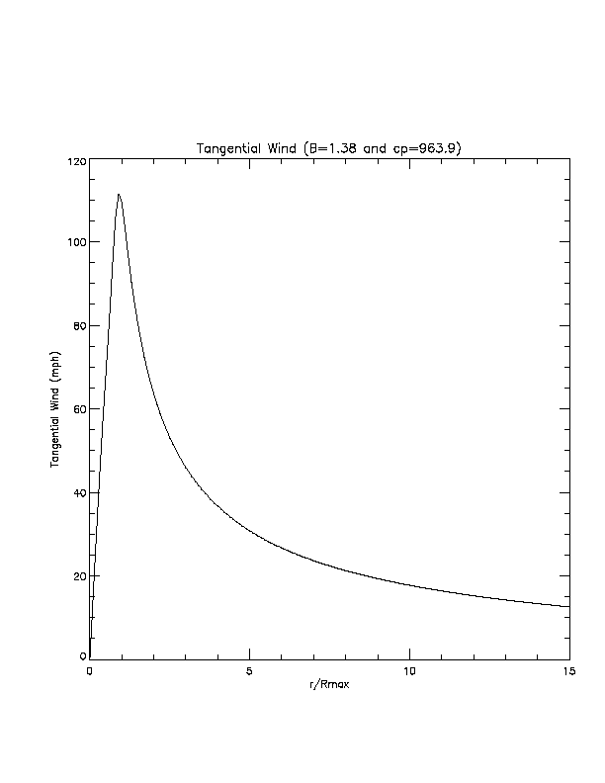
Figure 27. Axisymmetric rotational wind speed (mph) vs. scaled radius for B = 1.38, DelP = 49.1 mb.
Disclosures

- Provide a rotational windspeed (y-axis) versus radius (x-axis) plot of the average or default symmetric wind profile used in the model and justify the choice of this wind profile.

See Figure 30. The Holland B profile has been compared extensively to historical data (Holland, 1980; Willoughby & Rahn, 2004) and found to be a reasonable fit.

- If the model windfield has been modified in any way from the previous submission, provide a rotational windspeed (y-axis) versus radius (x-axis) plot of the average or default symmetric wind profile for both the new and old functions. The choice of average or default shall be consistent for the new and old functions.

The wind field model has not been modified since the previous submission.

- If the model windfield has been modified in any way from the previous submission, describe variations between the new and old windfield functions with reference to historical storms.

The wind field model has not been modified since the previous submission.

- Describe how the vertical variation of winds is accounted for in the model where applicable. Document and justify any difference in the methodology for treating historical and stochastic storm sets.

Vertical variation of wind is accounted for in the terrain conversion methodology described in Vickery et al. (2009). This methodology is a modification of the log wind profile and has been validated against dropsonde data. The coastal transition function, which is based on the above methodology, also incorporates variation with height so that the impact of a larger marine fetch on taller structures in coastal regions can be modeled. The treatment of vertical variation of winds is the same for both historical and stochastic storm sets.

- Describe the relevance of the formulation of gust factor(s) used in the model.

The gust factors used in the model were developed from hurricane wind speed data and the Engineering Sciences Data Unit methods as described in Vickery and Skerlj (2005).

- Identify all non-meteorological variables that affect windspeed estimation (e.g., surface roughness, topography, etc.).

Upstream aerodynamic surface roughness within a fixed 45-degree sector extending upstream has an effect on the determination of wind speed for a given street location (latitude and longitude) or ZIP Code centroid and is a significant variable that affects estimation of surface wind speeds. The upstream sectors are defined according to the Tropical Cyclone Winds at Landfall Project (Powell et al., 2004), which characterized upstream wind exposure for each of eight wind direction sectors at over 200 coastal automated weather stations (Figure 31). In additional, a coastal transition function is employed to account for the smooth marine fetch near coastal regions.
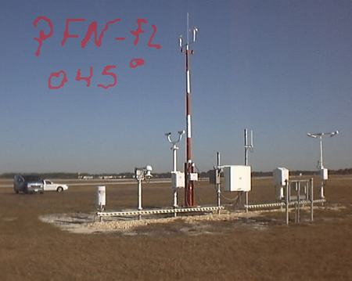
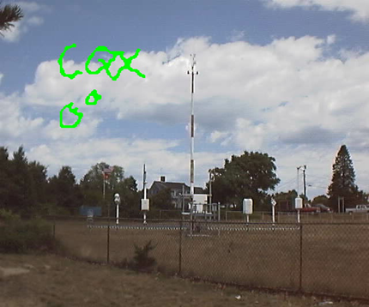
Figure 28. Upstream fetch wind exposure photograph for Chatham, MS (left, looking north), and Panama City, FL (right, looking northeast). After Powell et al. (2004).
- Provide the collection and publication dates of the land use and land cover data used in the model and justify their timeliness for Florida.

We use the 2011 Multi-Resolution Land Characteristics Consortium (MRLC) National Land Cover Database released on March 31, 2014. This is a high-resolution (30 m) land cover dataset that covers not only Florida, but the entire United States, and roughly depicts land characteristics circa 2011 [see Jin et al. (2013) for more details]. We also use the Statewide 2004-2011 Florida Water Management District Land Use/Land Cover dataset based on 2004-2011 imagery. This dataset was published by the Florida Department of Environmental Protection on March 8, 2013.

- Describe the methodology used to convert land use and land cover information into a spatial distribution of roughness coefficients in Florida and adjacent states.

The land cover classifications provided by the MRLC Land Cover Database and the WMD land use/land cover data are first mapped to roughness values using a lookup table that associates a representative roughness for the land use category on the basis of peer-reviewed literature. An algorithm was developed to merge the datasets based on how well each dataset classified the land surface with respect to surface roughness. An effective roughness model (Axe, 2004) is then used to incorporate upstream roughness elements to provide a more realistic roughness on a 90 m (295 ft) grid covering Florida.

- Demonstrate the consistency of the spatial distribution of model-generated winds with observed windfields for hurricanes affecting Florida. Describe and justify the appropriateness of the databases used in the windfield validations.

As shown below in Disclosure 10 and in Statistical Standard 1, Disclosure 2, the spatial distribution of model-generated winds is consistent with observed wind fields for hurricanes affecting Florida.

- Describe how the model’s windfield is consistent with the inherent differences in windfields for such diverse hurricanes as Hurricane Charley (2004), Hurricane Jeanne (2004), and Hurricane Wilma (2005).

The model can represent a wide variety of storms through variation of parameters for radius of maximum winds, central pressure deficit, and Holland B. Snapshots of model wind fields at landfall are compared to NOAA-AOML-HRD H*Wind analyses below (for further details see Disclosure 2 for Standard S-1). In these cases, rather than tuning the model to best fit the observations by varying the Holland B parameter, we derived the input B from the H*Wind analyses. Hurricane Charley, a small, fast moving 2004 hurricane (Figure 32, top), was modeled quite well; the motion asymmetry and extent of strong winds in the core of the storm were captured but the peak wind (near 150 mph) was underestimated by the model. Hurricane Jeanne Figure 32, bottom) struck the central Florida Atlantic coast in 2004. Similar to the observed (H*Wind) field, the modeled wind field maximum is on the right (north) side of the storm, but the model underestimates the peak wind of 105 mph and the area of winds above 70 mph. Wilma made landfall in Florida in 2005 as a very large hurricane (Figure 33). The FPHLM captures the location of maximum winds in the core of the storm and represents the left-right motion asymmetry, but tends to produce too broad of a wind field.

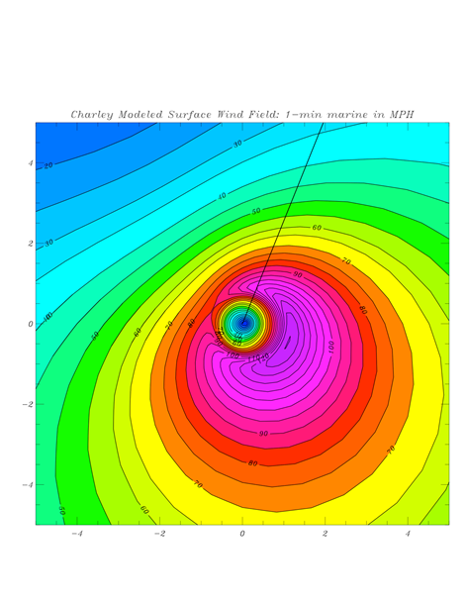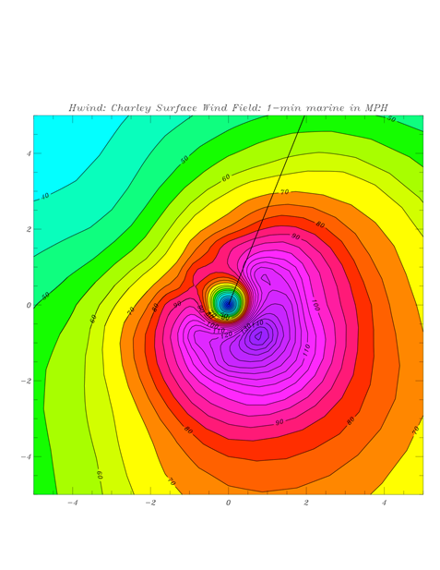
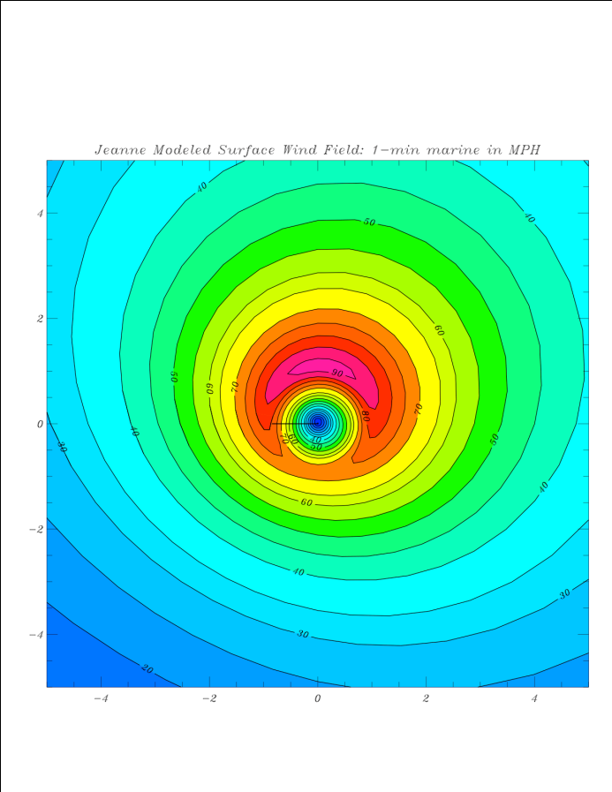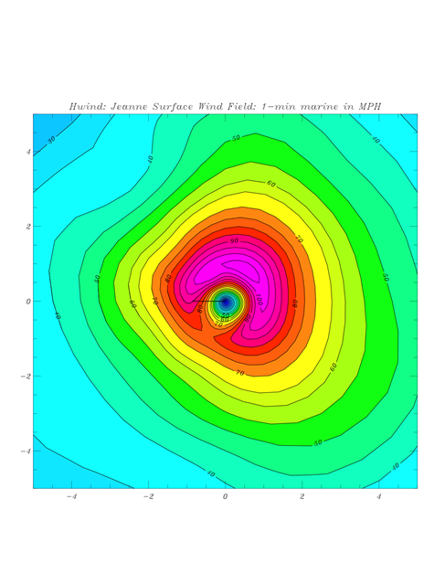
Figure 29. Comparison of modeled (left) and observed (H*Wind, right) landfall wind fields of Hurricane Charley (2004, top) and Hurricane Jeanne (2004, bottom). Line segment indicates storm heading. Horizontal coordinates are in units of R/Rmax and winds units of miles per hour. All wind fields are for marine exposure.

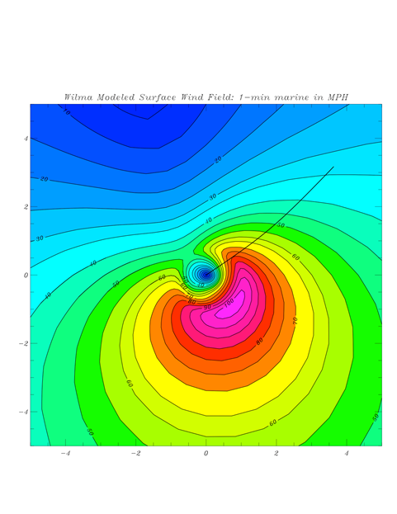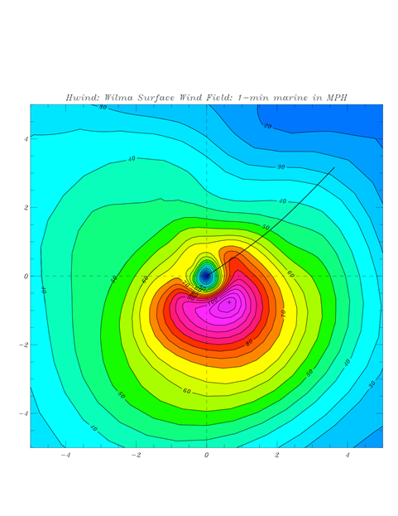
Figure 30. As in Fig. 33 but for Hurricane Wilma of 2005.

- Describe any variations in the treatment of the model windfield for stochastic versus historical storms and justify this variation.

All historical storm sets consist of input files containing information derived from HURDAT or other observation sources as described in Standard M-1. All stochastic input storm tracks are modeled. The wind field is modeled from the stochastic or historical input files in the same manner.

- Provide a completed Form M-2, Maps of Maximum Winds. Explain the differences between the spatial distributions of maximum winds for open terrain and actual terrain for historical storms. Provide a link to the location of the form here.

See Form M-2.

The open terrain winds are based on the common assumption that the wind is in equilibrium with open terrain roughness (0.03 m) with infinite fetch. The actual terrain winds are assumed to be in equilibrium with the local (effective) roughness near the surface, but near coastal regions the winds aloft may be more in equilibrium with marine roughness. Thus, it is possible for regions near the coast to have actual terrain winds that are larger than open terrain winds. The spatial distributions of open and actual terrain wind can be quite different because of the coastal transition and the fact that surface roughness in general has a large impact on the wind field. Spatial variations of roughness on the order of a few miles can cause large differences in the wind on that spatial scale.

M-5 Landfall and Over-Land Weakening Methodologies

- The hurricane over-land weakening rate methodology used by the model shall be consistent with historical records and with current state-of-the-science.

Overland weakening rates are based on a pressure decay model developed from historical data as described by a recent paper published in peer-reviewed atmospheric science literature (Vickery, 2005).

- The transition of winds from over-water to over-land within the model shall be consistent with current state-of-the-science.

The transition of winds from over-water to over-land is consistent with the current state of the science through the use of a pressure decay model (Vickery, 2005), a terrain conversion model from marine to actual roughness, and a coastal transition function (Vickery et al., 2009).

Disclosures

- Describe and justify the functional form of hurricane decay rates used by the model.

The hurricane decay rate function acts to decrease the DelP with time after landfall. The functional form is an exponential in time since landfall and is based on historical data (Vickery, 2005).

- Provide a graphical representation of the modeled decay rates for Florida hurricanes over time compared to wind observations.

The degradation of the wind field of a landfalling hurricane is associated with the filling of the central sea level pressure and the associated weakening of the surface pressure gradient; also the hurricane is over land, where the flow is subject to friction while flowing across obstacles in the form of roughness elements. Maximum wind degradation is shown according to how the maximum sustained surface wind (at the location containing the maximum winds in the storm) changes with time after landfall. At landfall the marine exposure wind is assumed to be representative of the maximum winds occurring onshore. After landfall the open terrain wind is chosen to represent the maximum envelope of sustained winds over land. The NOAA-HRD H*Wind system is used to analyze the maximum winds at a sequence of times following landfalls of Hurricanes Katrina, Charley, Frances, Jeanne, and Wilma. H*Wind uses all available wind observations. The landfall wind field is used as a background field for times after landfall and compared to the available observations at a sequence of times after landfall. An empirical decay is applied to the background field based on the comparisons to the observations. These data are then objectively analyzed to determine the wind field at each time. The model maximum sustained winds are compared to the maximum winds from the H*Wind analyses for the same times and roughness exposures. In general, points after landfall are given for open terrain exposure. At times, even though the storm center is over land, the maximum wind speed may remain over water. For example, in the Hurricane Frances plot (Figure 34), the first three pairs of points represent marine exposure, the next three open terrain, and the final three marine exposure again, while all Hurricane Wilma point pairs (Figure 35) represent marine exposure. The plots indicate that the public wind field model realistically simulates decay of the maximum wind speed during the landfall process, as well as subsequent strengthening after exit.

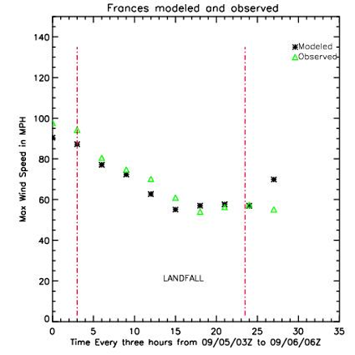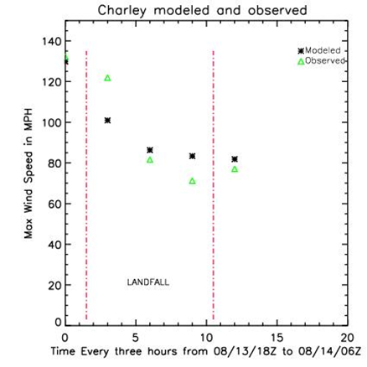

Figure 31. Observed (green) and modeled (black) maximum sustained surface winds as a function of time for 2004 Hurricanes Frances (left) and Charley (right). Landfall is represented by the vertical dash-dot red line at the left and time of exit as the red line on the right.

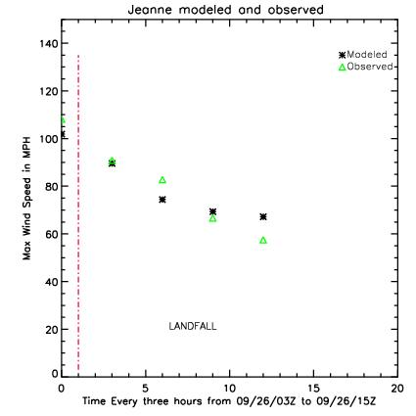 | 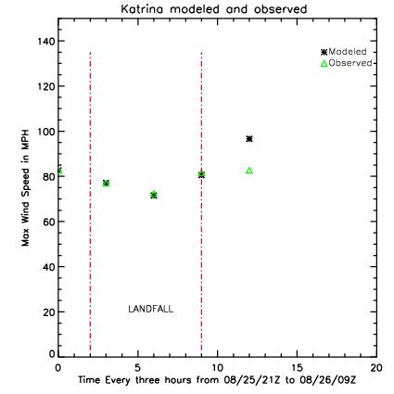
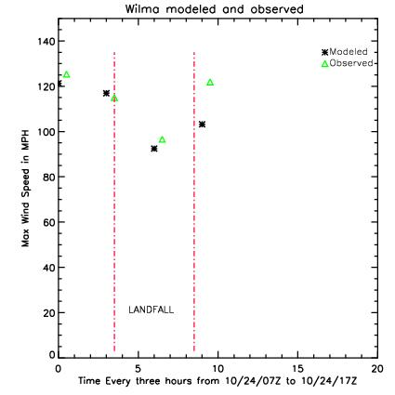
Figure 32. Observed (green) and modeled (black) maximum sustained surface winds as a function of time for Hurricanes Jeanne (2004, top left), Katrina (2005 in South Florida, top right), and Wilma (2005, lower left). Landfall is represented by the vertical dash-dot red line at the left and time of exit as the red line on the right.

- Describe the transition from over-water to over-land boundary layer simulated in the model.

After landfall, the slab boundary layer, surface drag coefficient changes from a functional marine form to a constant based on a mean aerodynamic roughness length of 0.2 m. The slab boundary layer height increases from 450 m to 1 km after the center makes landfall and decreases back to 450 m if the center exits land to go back to sea. To determine surface winds, an effective roughness model is used along with a coastal transition function. The coastal transition function is based on the concept of a growing internal boundary layer (Arya, 1988) for the sea-to-land transition. Within the equilibrium layer, assumed to be one tenth of the internal boundary layer (IBL) height in depth, the wind is assumed to be in equilibrium with the local effective roughness. Above the IBL the wind is assumed to be in equilibrium with marine roughness. Between the equilibrium layer and the IBL we assume that the wind is in equilibrium with vertically varying, stepwise increments of roughness that decay linearly from the local roughness to marine roughness. This is similar in concept to the methodology described in ESDU, and the modeled transition is very close to the ESDU values reported in Vickery et al. (2009).

- Describe any changes in hurricane parameters, other than intensity, resulting from the transition from over-water to over-land.

See Standard M-2, Disclosure 10. The Holland B parameter has a weak dependence on pressure and will undergo slight change. The radius of maximum winds has an implicit dependence on pressure through the scale and shape parameters of the gamma distribution (see M-2, Disclosure 3), and thus strong storms making landfall could undergo some expansion.

- Describe the representation in the model of passage over non-continental U.S. land masses on hurricanes affecting Florida.

Noncontinental U. S. land masses are identified by a land-ocean mask that keeps track of whether the storm center is over the land or ocean. Storms that pass over noncontinental U.S. land masses (e.g., Cuba) undergo decay, just as storms do crossing continental land masses (e.g., mainland U. S.) using a pressure-filling model (Vickery, 2005).

- Document any differences between the treatment of decay rates in the model for stochastic hurricanes compared to historical hurricanes affecting Florida.

In the FPHLM model, decay is defined as the change in minimum sea level pressure (Pmin) with time after landfall. The input file for the wind field model consists of a hurricane track file that contains storm position, Pmin, Rmax, and Holland B at 1 h frequency. The wind field model is exactly the same for scenario (historical) or stochastic events. When running the model in scenario mode for historical hurricanes affecting Florida, we use a set of historical hurricane tracks as input to the model. When the model is run in stochastic mode, the input hurricane tracks are provided by the track and intensity model. The track and intensity model uses the Vickery (2005) pressure decay after landfall. When a hurricane exits land, the Pmin over water is determined on the basis of the Markov process as described in Disclosure G-1.2.

For historical hurricane tracks the landfall pressure is determined from HURDAT or from the Ho et al. (1987) report. If post-landfall pressure data are available in HURDAT, we interpolate pressure values over land. If post-landfall pressure data are not available, we apply the Vickery (2005) pressure decay model to the landfall pressure. After the storm exits land, the pressure is based on HURDAT data. Therefore, decay rates for historical hurricanes are based on HURDAT data if available, or the Vickery decay rate model applied to the HURDAT or Ho et al. (1987) landfall Pmin, and decay rates for stochastic hurricanes are based on Vickery (2005).

M-6 Logical Relationships of Hurricane Characteristics

- The magnitude of asymmetry shall increase as the translation speed increases, all other factors held constant.

With all other factors held constant, the wind field asymmetry increases with translation speed. The storm translation speed causes a major right-left (looking in the direction the storm is moving) asymmetry in the wind field, which in turn causes an asymmetry in surface friction since the surface stress is wind-speed dependent. The magnitude of the asymmetry increases as the translation speed increases; there is no asymmetry for a stationary storm except for possible land friction effects if a storm becomes stationary while a large percentage of its circulation is over both land and water.

- The mean windspeed shall decrease with increasing surface roughness (friction), all other factors held constant.

With all other factors held constant, the mean wind speed decreases with increasing surface roughness. However, the gust factor, which is used to estimate the peak one-minute wind and the peak three-second gust over the time period corresponding to the model mean wind increases as a function of turbulence intensity, which increases with surface roughness (Paulsen et al., 2003; Masters, 2004; Powell et al., 2004). For roughness values representative of ZIP Codes in Florida, with residential roughness values on the order of 0.2–0.3 m, the roughness effect on decreasing the mean wind speed overwhelms the enhanced turbulence intensity effect that increases the gust factor.

Disclosures

- Describe how the asymmetric structure of hurricanes is represented in the model.

The asymmetry of the wind field is determined by the storm translation motion (right-left asymmetry) and the associated asymmetric surface friction. A set of form factors for the wind field also contributes to the asymmetry, and the proximity of the storm to land introduces an additional asymmetry because of the effect of land roughness elements on the flow. Azimuthal variation is introduced through the use of two form factors [see Appendix of Powell et al. (2005) for more detail]. The form factors multiply the radial and tangential profiles and provide a “factorized” ansatz for both the radial and tangential storm–relative wind components. Each form factor contains three constant coefficients that are variationally determined in such a way that the ansatz constructed satisfies (as far as its numerical degrees of freedom permit) the scaled momentum equations for the storm-relative polar wind components.

- Provide a completed Form M-3, Radius of Maximum Winds and Radii of Standard Wind Thresholds. Provide a link to the location of the form here.

See Form M-3.

- Discuss the radii values for each wind threshold in Form M-3 (Radius of Maximum Winds and Radii of Standard Wind Thresholds) with reference to available hurricane observations such as those in HURDAT2. Justify the appropriateness of the databases used in the radii validations.

The Extended Best Track Database (EXBT) [DeMuth et al. (2006), available for download from http://rammb.cira.colostate.edu] contains NHC’s estimated Rmax and advisory outermost radii of hurricane and tropical storm magnitude winds, which are included in the Supplemental Form M-3 Table 12. The EXBT does not contain estimates of the 110 mph wind radius (R110), so we found examples of the R110 from the H*Wind archive. We should mention that NHC considers the outer wind radii quality to be poor because of data sparseness, and therefore NHC does not validate wind radii forecasts. Furthermore, the values in Form M-3 and Form M-3 Supplemental represent relatively small samples at particular pressure values, so the ranges in the radii listed on the forms do not represent the full variability of model outputs or observed radii at a given pressure value. Therefore, comparisons are qualitative.

For Rmax, the model minima tend to be smaller than the EXBT for storms with Pmin of 930 or less but generally compare well for storms with Pmin > 930 mb. Model Rmax maxima are greater than the EXBT sample for storms with Pmin > of 930–950 mb.

For the outer extent of 110 mph winds (R110), for pressures of 940 mb or less, the model radii minima tend to be smaller than the sampled H*Wind values and either above or below for Pmin values at or above 950 mb. The model R110 maxima are all larger than the H*Wind sample.

For the radius of hurricane winds (R74), the model minima tend to be smaller than the EXBT sample; the model R74 maxima also tend to be smaller than the EXBT sample for Pmin of 920 mb or less or Pmin > 950 mb but are larger than the EXBT sample for storms with Pmin of 930–950 mb.

For the outer extent of tropical storm winds (R39), the model minima are generally smaller than the EXBT. The R39 maxima are also typically smaller than the EXBT R39 sample, except for the 930–950 mb range of Pmin, in which the model has larger radii.

In general the model maximum radii fall within the range of the EXBT or H*Wind values; however, there are instances where model outer radii exceed the EXBT or H*Wind radii. In such cases it is possible that the EXBT and H*Wind radii are not representative of the full range of tropical cyclone radii.

Form M-1: Annual Occurrence Rates

- Provide annual occurrence rates for landfall from the dataset defined by marine exposure that the model generates by hurricane category (defined by maximum windspeed at landfall in the Saffir-Simpson scale) for the entire state of Florida and selected regions as defined in Figure 3 [of the 2011 ROA]. List the annual occurrence rate per hurricane category. Annual occurrence rates shall be rounded to two decimal places. The historical frequencies below have been derived from the Base Hurricane Storm Set as defined in Standard M-1 (Base Hurricane Storm Set).

Form M-1 follows. The historical counts are determined primarily from HURDAT impact (or “trailer”) codes for the storms, but in some cases the intensities are based on the HURDAT 6 h wind reports near landfall. A report detailing the counts will be available for review.

Statewide counts are determined using two different methods. Under the heading “Entire State,” we provide the counts using the most intense landfall for each storm affecting Florida; that is, there is only one landfall per storm. Under the heading “Entire State Landfalls,” we provide the counts of all landfalls for each storm, using only one storm per region. This table is the sum of the counts for Regions A–D.

Form M-1. Modeled Annual Occurrence Rates

 | Entire State |  |  |  | Region A – NW Florida
 | Historical |  | Modeled |  | Historical |  | Modeled
Category | Number | Rate | Number | Rate | Number | Rate | Number | Rate
1 | 24 | 0.21 | 27.02 | 0.24 | 14 | 0.13 | 14.58 | 0.13
2 | 13 | 0.12 | 13.75 | 0.12 | 5 | 0.04 | 5.78 | 0.05
3 | 17 | 0.15 | 13.84 | 0.12 | 6 | 0.05 | 4.40 | 0.04
4 | 7 | 0.06 | 7.52 | 0.07 | 0 | 0 | 1.80 | 0.02
5 | 2 | 0.02 | 2.39 | 0.02 | 0 | 0 | 0.21 | 0
 | Region B – SW Florida |  |  |  | Region C – SE Florida
 | Historical |  | Modeled |  | Historical |  | Modeled
Category | Number | Rate | Number | Rate | Number | Rate | Number | Rate
1 | 8 | 0.07 | 8.02 | 0.07 | 6 | 0.05 | 7.43 | 0.07
2 | 1 | 0.01 | 4.91 | 0.04 | 6 | 0.05 | 4.05 | 0.04
3 | 6 | 0.05 | 4.95 | 0.04 | 6 | 0.05 | 5.00 | 0.04
4 | 2 | 0.02 | 2.19 | 0.02 | 5 | 0.04 | 3.73 | 0.03
5 | 1 | 0.01 | 0.43 | 0 | 1 | 0.01 | 1.80 | 0.02
 | Region D – NE Florida |  |  |  | Florida By-Passing Hurricanes
 | Historical |  | Modeled |  | Historical |  | Modeled
Category | Number | Rate | Number | Rate | Number | Rate | Number | Rate
1 | 1 | 0.01 | 1.28 | 0.01 | 6 | 0.05 | 5.66 | 0.05
2 | 2 | 0.02 | 0.72 | 0.01 | 4 | 0.04 | 2.89 | 0.03
3 | 0 | 0 | 0.64 | 0.01 | 4 | 0.04 | 2.97 | 0.03
4 | 0 | 0 | 0.17 | 0 | 1 | 0.01 | 1.24 | 0.01
5 | 0 | 0 | 0.02 | 0 | 0 | 0 | 0.80 | 0.01
 | Region E – Georgia |  |  |  | Region F – Alabama/Mississippi
 | Historical |  | Modeled |  | Historical |  | Modeled
Category | Number | Rate | Number | Rate | Number | Rate | Number | Rate
1 | 3 | 0.03 | 1.48 | 0.01 | 6 | 0.05 | 5.05 | 0.05
2 | 0 | 0 | 0.42 | 0 | 2 | 0.02 | 2.68 | 0.02
3 | 0 | 0 | 0.26 | 0 | 3 | 0.03 | 2.72 | 0.02
4 | 0 | 0 | 0.19 | 0 | 1 | 0.01 | 0.98 | 0.01
5 | 0 | 0 | 0.06 | 0 | 1 | 0.01 | 0.62 | 0.01

Form M-1 continued

 | Entire State Landfalls
 | Historical |  | Modeled
Category | Number | Rate | Number | Rate
1 | 29 | 0.26 | 31.30 | 0.28
2 | 14 | 0.13 | 15.46 | 0.14
3 | 18 | 0.16 | 14.99 | 0.13
4 | 7 | 0.06 | 7.88 | 0.07
5 | 2 | 0.02 | 2.46 | 0.02

- Describe model variations from the historical frequencies.

Form M-1 landfall frequencies were determined from the impact codes listed in the “trailer” information provided in the HURDAT database. In some cases the HURDAT codes did not agree with the 6 h HURDAT information. We revised some landfall intensities indicated by the codes based on HURDAT 6 h winds near landfall.

The modeled frequencies are consistent with the historical record, to the extent that we may consider the historical record reliable. Statewide, the model produces 72.1 Florida landfalls (64.5 storms) in 112 years, compared to 70 landfalls (63 storms) historically. For major (Category 3–5) storms, the model produces 25.3 landfalls, compared to about 27 landfalls historically.

On a regional basis, the model is also consistent with the historical record. In Part C below we show bar charts for each region. The bar charts show reasonable agreement between the modeled and historical frequencies. Goodness of fit tests have been performed and indicate that the model results are consistent with the historical record. These tests will be available for review.

- Provide vertical bar graphs depicting distributions of hurricane frequencies by category by region of Florida (Figure 3 [of the 2011 ROA]) and for the neighboring states of Alabama/Mississippi and Georgia. For the neighboring states, statistics based on the closest milepost to the state boundaries used in the model are adequate.

Vertical bar charts are shown in the figure below. These charts show the number of hurricanes in a 112- year period. Note that there are two charts for Florida statewide hurricanes. The “FL Landfalls” chart shows the total number of landfalls in the state (basically the sum of Regions A–D), whereas the “FL Hurricanes” chart shows only the number of hurricanes making at least one landfall, and the intensity is the maximum intensity landfall in the case of multiple landfalls.

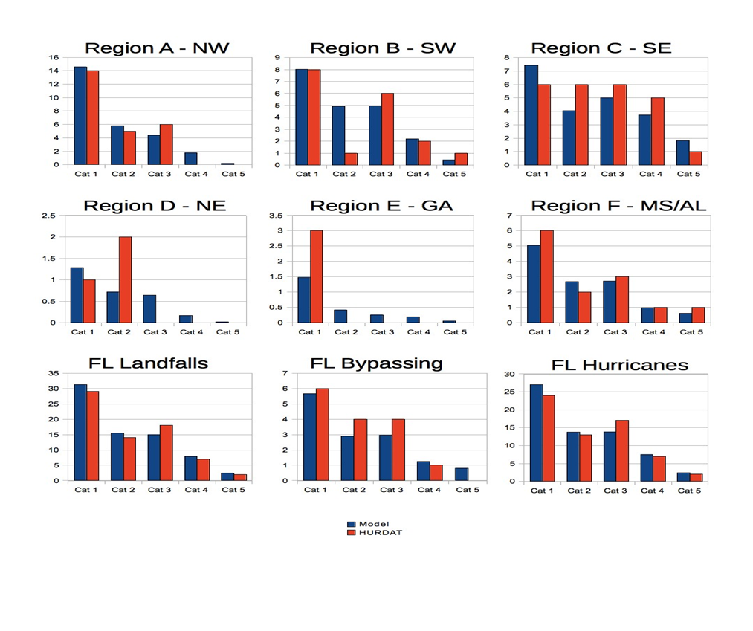
Figure 33. Form M-1 comparison of modeled and historical landfalling hurricane frequency (storms occurring in 112 years) for Regions A–F, FL statewide landfalls (one per FL region), FL bypassing storms, and FL state-wide hurricanes.
- If the data are partitioned or modified, provide the historical annual occurrence rates for the applicable partition (and its complement) or modification as well as the modeled annual occurrence rates in additional copies of Form M-1 (Annual Occurrence Rates).

Not Applicable.

- List all hurricanes added, removed, or modified from the previously accepted submission version of the Base Hurricane Storm Set.

Due to revisions in the latest HURDAT, 7 storms were affected. The 1925 #4 storm was downgraded to a tropical storm, and hence removed. Six storms were modified based on intensity or region impacted: 1926 #7, 1926 #10, 1929 #2, 1932 #3, 1935 #3 and 1935 #7.

- Provide this form in Excel format. The file name shall include the abbreviated name of the modeling organization, the standards year, and the form name. Form M-1 (Annual Occurrence Rates) shall also be included in a submission appendix.

The form is provided in Excel format and is included above.

Form M-2: Maps of Maximum Winds

- Provide color maps of the maximum winds for the modeled version of the Base Hurricane Storm Set for land use as set for open terrain and land use as set for actual terrain as defined by the modeling organization.

- Provide color maps of the maximum winds for a 100-year and a 250-year return period from the stochastic storm set for both open terrain and actual terrain.

- Plot the position and values of the maximum windspeeds on each contour map.

Actual terrain is the roughness distribution used in the standard version of the model. Open terrain uses the same roughness value of 0.03 meters at all land points.

All maps shall be color coded at the ZIP Code level.

Maximum winds in these maps are defined as the maximum one-minute sustained winds over the terrain as modeled and recorded at each location.

The same color scheme and increments shall be used for all maps.

Use the following eight isotach values and interval color coding:

- Minimum damaging Blue
- 50 mph Medium Blue
- 65 mph Light Blue
- 80 mph White
- 95 mph Light Red
- 110 mph Medium Red
- 125 mph Red
- 140 mph Magenta

Contouring in addition to these isotach values may be included.

Maximum and Minimum Values for Form M-2 Figures

Below the maximum and minimum values for the Form M-2 contour maps are
provided. In some cases the maximum or minimum value may occur at multiple
locations.

Figure 37 (M-2A Open Terrain)

max: 133 mph at 33036, 33156.
min: 67 mph at 32648, 32628, 32066, 32064, 32060.

Figure 38 (M-2A Actual Terrain)

max: 137 mph at 33036.
min: less than 50 mph(*) at 32696, 32693, 32680, 32669, 32653, 32643, 32628,
32626, 32621, 32619, 32618, 32607, 32359, 32356, 32350, 32348, 32347, 32344,
32340, 32336, 32331, 32317, 32311, 32308, 32305, 32301, 32215, 32212, 32096,
32094, 32091, 32087, 32071, 32066, 32064, 32062, 32061, 32060, 32059, 32058,
32055, 32053, 32052, 32046, 32038, 32025, 32024, 32013, 32008.

Figure 39 (upper, M-2B 100 yr Open Terrain)
max: 109 mph at 33010, 33012, 33013, 33016, 33023, 33030, 33031, 33032, 33033,
33034, 33035, 33037, 33039, 33054, 33056, 33070, 33109, 33122, 33125, 33126,
33127, 33128, 33129, 33130, 33131, 33132, 33133, 33134, 33135, 33136, 33137,
33138, 33139, 33140, 33141, 33142, 33143, 33144, 33145, 33146, 33147, 33149,
33150, 33154, 33155, 33156, 33157, 33158, 33160, 33161, 33162, 33165, 33166,
33167, 33168, 33169, 33170, 33172, 33173, 33174, 33175, 33176, 33177, 33179,
33181, 33183, 33184, 33185, 33186, 33187, 33189, 33190, 33193, 33194, 33196,
33199.
min: 72 mph at 32350, 32053, 32052.

Figure 39 (lower, M-2B 250 yr Open Terrain)

max: 119 mph at 33060, 33062, 33064, 33304, 33306, 33308, 33309.
min: 81 mph at 32350, 32053.

Figure 40 (upper, M-2B 100 yr Actual Terrain)

max: 109 mph at 33050, 33109.
min: less than 50 mph(*) at 32352, 32350, 32343, 32340, 32336, 32234, 32215,
32096, 32087, 32064, 32061, 32060, 32059, 32053, 32052, 32046, 32009.

Figure 40 (lower, M-2B 250 yr Actual Terrain)

max: 123 mph at 33036.
min: 51 mph at 32215.

(*) Winds below 50 mph were not retained for this calculation. Therefore, the
precise value for the minimum cannot be calculated.
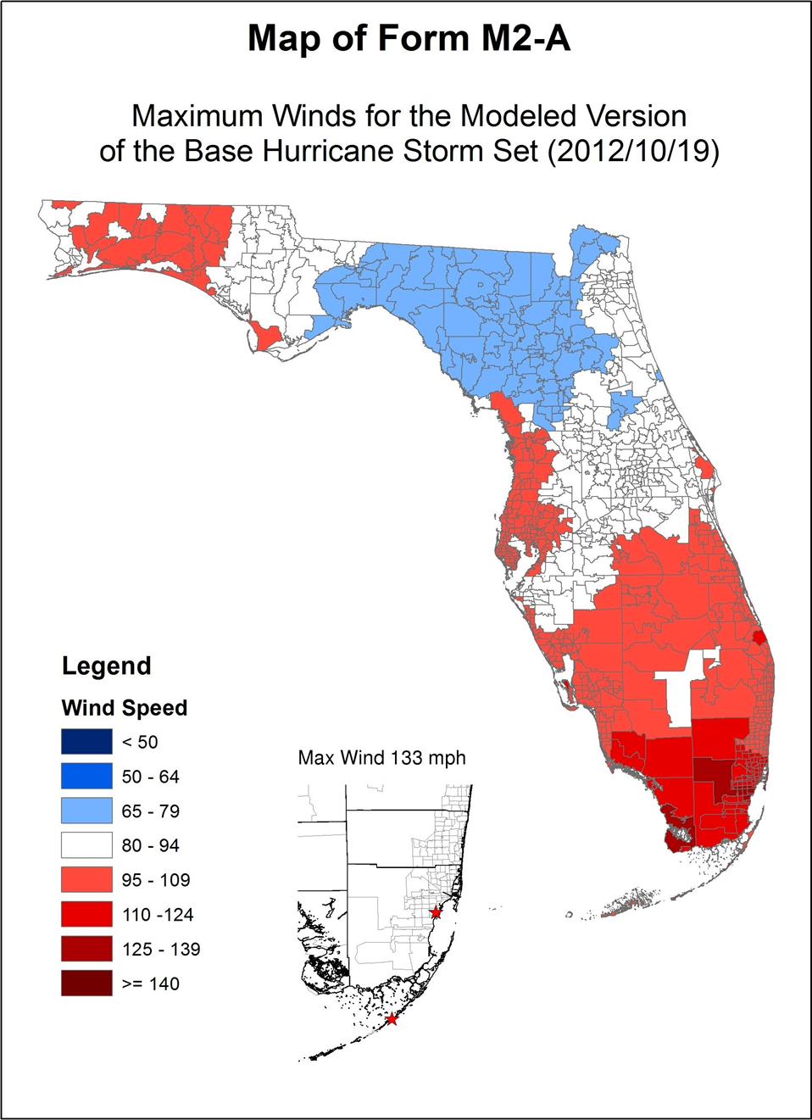
Figure 34. Maximum ZIP Code wind speed for open terrain wind exposure based on simulations of the historical storm set.
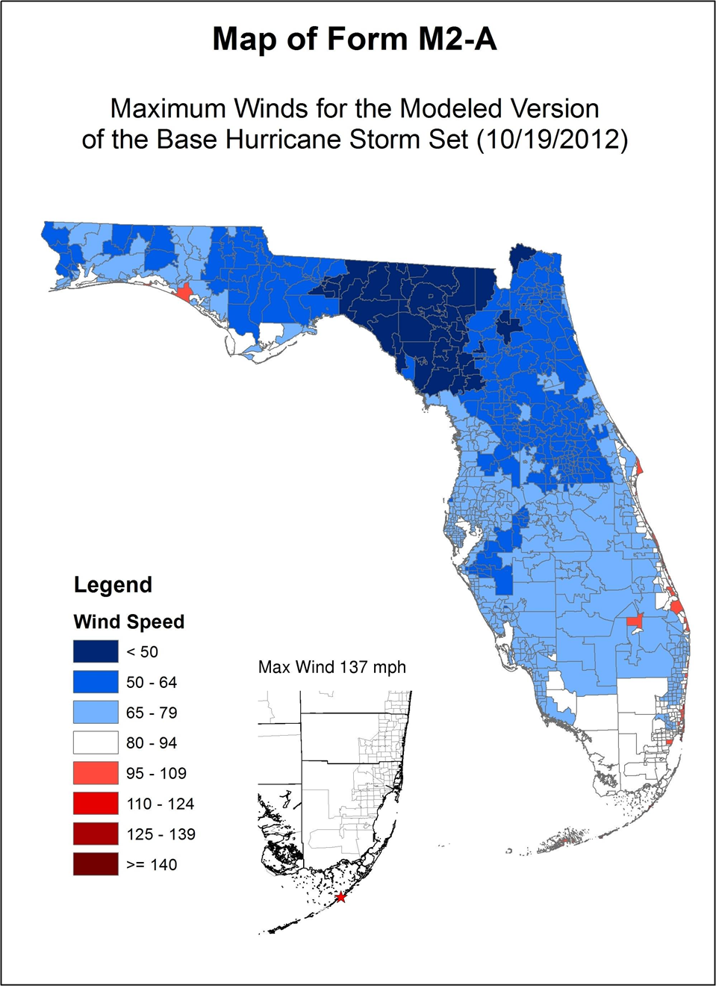
Figure 35. Maximum ZIP Code wind speed for actual terrain wind exposure based on simulations of the historical storm set.
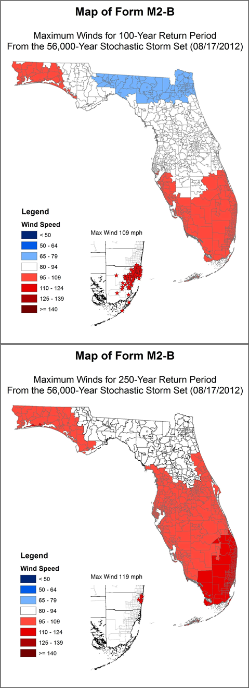
Figure 36. 100- and 250-year return period wind speeds at Florida ZIP Codes for open terrain wind exposure.
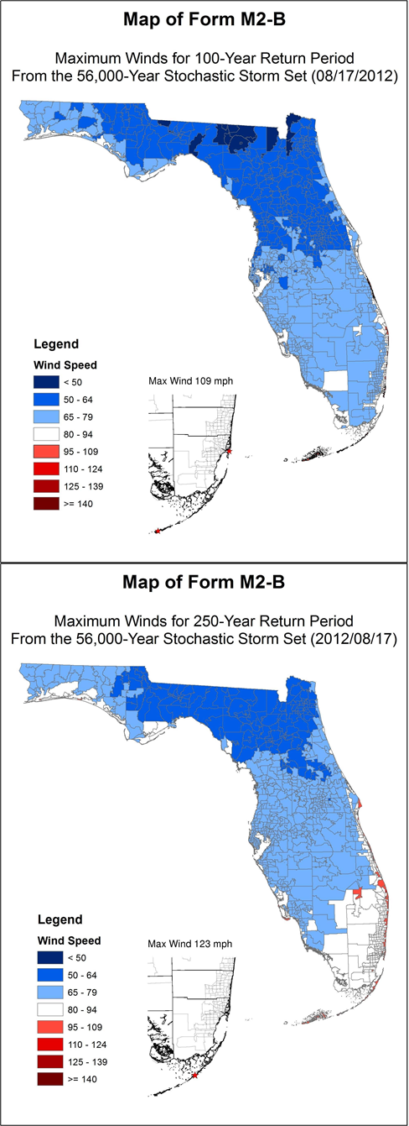
Figure 37. 100- and 250-year return period wind speeds at Florida ZIP Codes for actual terrain wind exposure.

Form M-3: Radius of Maximum Winds and Radii of Standard Wind Thresholds

- For the central pressures in the table below, provide the minimum and maximum values for 1) the radius of maximum winds (Rmax) used by the model to create the stochastic storm set and minimum and maximum values for the outer radii (R) of 2) Category 3 winds (>110 mph), 3) Category 1 winds (>73 mph), and 4) gale force winds (>40 mph). This information should be readily calculated from the windfield formula input to the model and does not require running the stochastic storm set. Describe the procedure used to complete this Form.

From the entire set of stochastic track files, 10 sets of track files (totaling 400) were extracted; each set was selected on the basis of the central pressure at landfall as listed in Form M-3. The tracks were processed and the model output from the range of solutions for all times in each track (2600 wind field snapshots) was used to populate the table. Note that the table represents a subset of the possible ranges of Rmax because of the selection of landfall tracks close (+/- 0.05 to 0.5 mb) to the pressure values in the table. Note that the Rmax values listed also represent model wind field snapshots from when the storms are offshore, while Form M-3 “C” (below) is limited to values at landfall. Input Rmax can vary slightly from Rmax determined from the gridded wind field because of the effects of translation speed on the wind field and interpolation truncation over the 0.1 R/Rmax model grid. Observed estimates of Rmax and outer wind radii from historical Atlantic basin hurricanes are included for comparison in Table 12. Observational estimates are limited by spatial data coverage and availability.

Table 11. Range of outer wind radii (sm) as a function of central sea level pressure (mb).
Central Pressure (mb) | Rmax  (sm) |  | Outer Radii (>110 mph) (sm) |  | Outer Radii (>73 mph) (sm) |  | Outer Radii (>40 mph) (sm)
Central Pressure (mb) | Min | Max | Min | Max | Min | Max | Min | Max
900 | 3.52 | 19.69 | 8.21 | 41.80 | 13.30 | 78.24 | 25.03 | 186.22
910 | 3.35 | 20.83 | 7.82 | 41.80 | 12.91 | 81.86 | 25.03 | 211.03
920 | 3.52 | 36.04 | 7.43 | 66.07 | 12.12 | 129.15 | 24.25 | 258.21
930 | 5.19 | 72.12 | 10.96 | 84.85 | 18.08 | 199.40 | 35.62 | 448.46
940 | 6.66 | 91.91 | 12.11 | 72.93 | 20.59 | 202.85 | 44.83 | 433.95
950 | 7.57 | 87.32 | 12.29 | 69.30 | 21.34 | 169.51 | 47.06 | 394.28
960 | 6.14 | 82.27 | 8.94 | 60.36 | 16.76 | 144.86 | 39.68 | 356.91
970 | 6.14 | 81.37 | 6.14 | 51.30 | 12.29 | 137.32 | 28.50 | 367.30
980 | 6.14 | 75.11 | 7.26 | 29.50 | 9.83 | 97.69 | 24.59 | 318.57
990 | 6.14 | 71.98 | NA | NA | 6.76 | 76.23 | 20.12 | 314.32

Table 12. Extended Best-Track and H*Wind wind radii ranges based on Atlantic basin hurricanes.
Storms  Ext. Best Track  (DeMaria 2010) | Central Pressure (mb) | Rmax  (sm) |  | Outer Radii  (>110 mph)  (sm)  From H*Wind |  | Outer Radii (>73 mph)  (sm) |  | Outer Radii (>40 mph)  (sm)
Storms  Ext. Best Track  (DeMaria 2010) | Central Pressure (mb) | min | max | min | max | min | max | min | max
Katrina, Rita, Wilma 2005 | 900 | 6 | 23 | 21 Rita | 31 Wilma | 69 | 103 | 102 | 230
Mitch 98, Ivan 04, Katrina, Wilma 05 | 910 | 14 | 29 | 33 Wilma | 34.5 Mitch | 57 | 115 | 172 | 230
Isabel 03, Ivan 04, Rita 05, Dean 07 | 920 | 11 | 29 | 26 Ivan | 34.5 Isabel | 34 | 144 | 161 | 287
Andrew 92, Floyd 99, Ivan 04, Dennis 05, Dean 07 | 930 | 11 | 34 | 22 Andrew | 32 Ivan | 29 | 126.5 | 115 | 287
Luis 95, Lili 02, Floyd 99 | 940 | 6 | 40 | 16Lili | 55 Isabel | 29 | 138.0 | 115 | 287
Gabrielle 89, Iris 01, Bret 99 | 950 | 6 | 63 | 7 Iris | 46 Wilma | 17 | 172 | 98 | 345
Gustav 02, Dennis 05, Gilbert 88, Claudette 01 | 960 | 6 | 86 | 13 Gustav | n/a | 23 | 161 | 86 | 402
Joan 88, Felix 95, Lili 96, Karl 10 | 970 | 6 | 103 | 6 Karl | n/a | 17 | 287 | 57 | 621
Gabrielle 01, Emily 05, Noel 07, Beta 05 | 980 | 11 | 138 | n/a | n/a | 17 | 144 | 57 | 690
Lili 02, Olga 01, Lisa 04 | 990 | 11 | 207 | n/a | n/a | 17 | 138.0 | 34 | 632

- Identify the other variables that influence Rmax.

For our input values of Rmax that determine the initial boundary layer mean vortex, we sample Rmax from a gamma distribution, which only explicitly depends on central pressure. For Rmax determined from the wind field, the translation speed (which is added after the steady state boundary layer model solution is obtained) may also influence Rmax.

- Provide a box plot and histogram of Central Pressure (x-axis) versus Rmax (y-axis) to demonstrate relative populations and continuity of sampled hurricanes in the stochastic storm set.

A scatter plot with histograms and box plot is shown below.

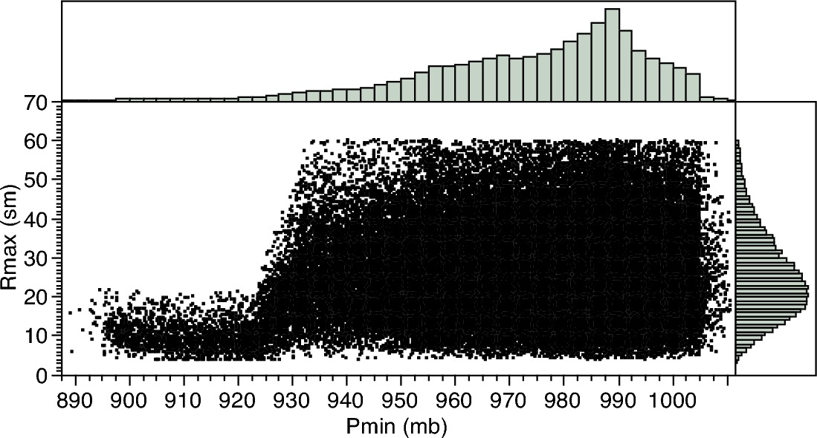
Figure 38. Representative scatter plot of the model input radius of maximum wind (y axis) versus minimum sea-level air pressure at landfall (mb). Relative histograms for each quantity are also shown.

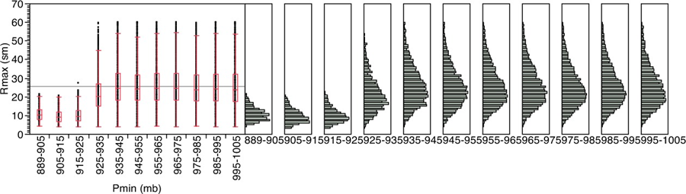
Figure 39. One way box plot (left) of Rmax (continuous) response across 10 mb Pmin groups. Boxes (and whiskers) are in red; standard deviations are in blue. Histograms (right) for each Pmin group.
- Provide this form in Excel using the format given in the file named “2013FormM3.xlsx.” The file name shall include the abbreviated name of the modeling organization, the standards year, and the form name. Form M-3 (Radius of Maximum Winds and Radii of Standard Wind Thresholds) shall also be included in a submission appendix.

The form is provided in Excel format and is included above.

STATISTICAL STANDARDS

S-1 Modeled Results and Goodness-of-Fit

- The use of historical data in developing the model shall be supported by rigorous methods published in currently accepted scientific literature.

The historical data for the period 1900-2011 were modeled using scientifically accepted methods that have been published in accepted scientific literature.

- Modeled and historical results shall reflect statistical agreement using currently accepted scientific and statistical methods for the academic disciplines appropriate for the various model components or characteristics.

Modeled and historical results are in agreement as indicated by appropriate statistical and scientific tests. Some of these tests will be discussed below.

Disclosures

- Identify the form of the probability distributions used for each function or variable, if applicable. Identify statistical techniques used for the estimates and the specific goodness-of-fit tests applied. Describe whether the p-values associated with the fitted distributions provide a reasonable agreement with the historical data. Provide a completed Form S-3, Distributions of Stochastic Hurricane Parameters. Provide a link to the location of the form here.

Form S-3 at the end of this section identifies the form of the probability distribution used for each variable. Some of the methods and distributions are described below.

Historical initial conditions are used to provide the seed for storm genesis in the model. Small uniform random error terms are added to the historical starting positions, intensities and changes in storm motion. Subsequent storm motion and intensity are determined by randomly sampling empirical probability distribution functions derived from the HURDAT historical record.

Figure 84 shows the occurrence rate of both modeled and historical land-falling hurricanes in Florida. The figure shows a high level of agreement between historical and modeled occurrences. A chi-square goodness-of-fit test, for the number of years with 0, 1, 2, and 3 or more hurricanes per year (4 bins each with 5 or more occurrences giving 3 degrees of freedom), gives a p-value of approximately 0.749. An analysis of landfalls by each region and intensity in Florida is given in Form M-1. The landfall occurrences by region are reasonable as indicated by chi-square goodness-of-fit tests.

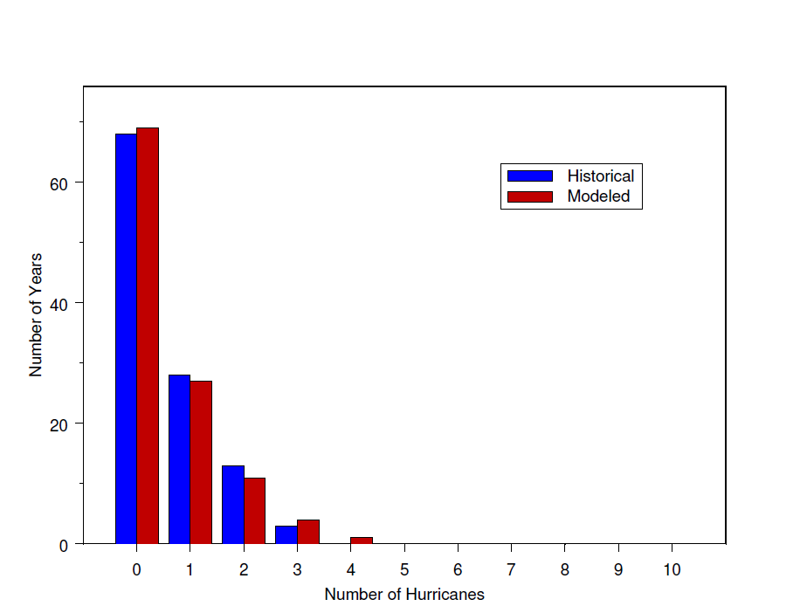
Figure 40. Comparison of modeled vs. historical occurrences.

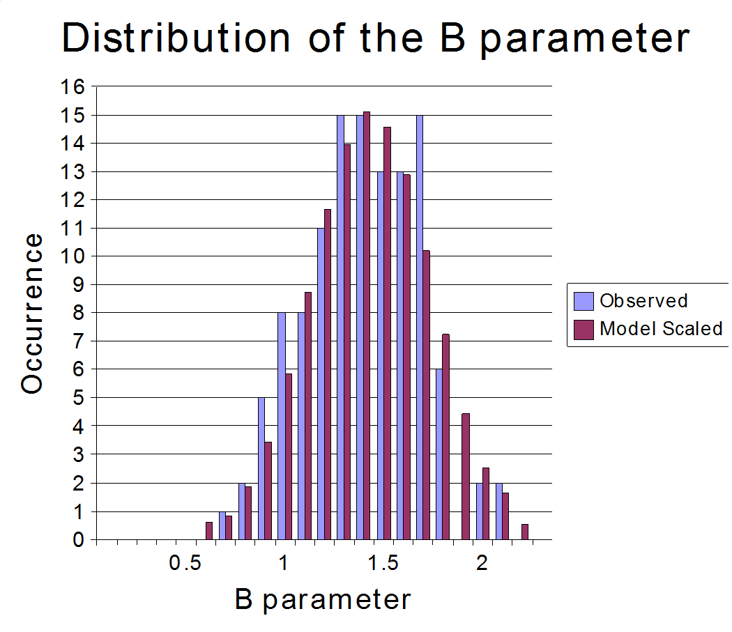
Figure 41. Comparison between the modeled and observed Willoughby and Rahn (2004) B data set.

The random error term for the Holland B is modeled using a Gaussian distribution with a standard deviation of 0.286. Figure 85 shows a comparison between the Willoughby and Rahn (2004) B data set (see Standard M-2.1) and the modeled results (scaled to equal the 116 measured occurrences in the observed data set). The modeled results with the error term have a mean of about 1.38 and are consistent with the observed results. The figure indicates a high level of agreement, and the chi-square goodness-of-fit test gives a p-value about 0.57, using 8 degrees of freedom (re-binning to 11 bins and two estimated parameters). A KS goodness-of-fit yields a p-value of 0.845 (ks=0.057).

We developed an Rmax model using the revised landfall Rmax database which includes 112 measurements for storms up to 2010. We have opted to model the Rmax at landfall rather than the entire basin for a variety of reasons. One is that the distribution of landfall Rmax may be different from the Rmax distribution over open water. An analysis of the landfall Rmax database and the 1988-2007 DeMaria Extended Best Track data show that there appears to be a difference in the dependence of Rmax on central pressure (Pmin) between the two data sets. The landfall data set provides a larger set of independent measurements, which is more than 100 storms compared to about 31 storms affecting the Florida threat area region in the Best Track Data. Since landfall Rmax is most relevant for loss cost estimation, and has a larger independent sample size, we have chosen to model the landfall data set. Future studies will examine how the Extended Best Track Data can be used to supplement the landfall data set.

Based on the skewness of Rmax and the fact that it is nonnegative, we sought to model the distribution using a gamma distribution. Using an approximate maximum likelihood estimation method, we found the estimated shape and scale parameters for the gamma distribution are respectively as follows, and. Rmax is limited to the range of 4 to 60 km. Using these estimated values, we plotted the observed and expected distribution in Figure 86. The Rmax values are binned in 5 sm intervals, with the x-axis showing the end value of the interval.

Plot of Observed Rmax vs. Gamma Distribution

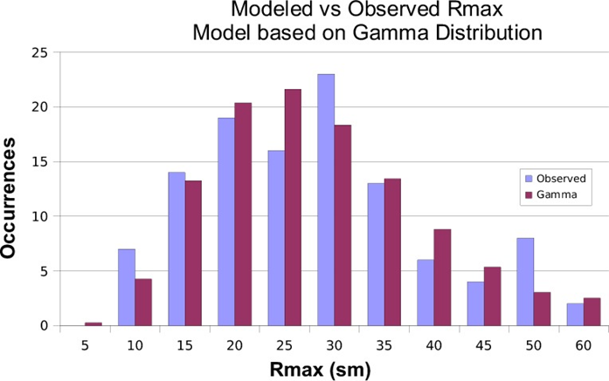
Figure 42. Observed and expected distribution using a gamma distribution.
The gamma distribution showed a reasonable fit. A chi-square goodness-of-fit test yields a p-value of 0.3221 with 4 degrees of freedom (re-binning to 7 bins to ensure more than 5 occurrences per bin and 2 estimated parameters). A KS goodness-of-fit yields a p-value of 0.6233 (ks= 0.0711).

- Describe the nature and results of the tests performed to validate the windspeeds generated.

We compared the cumulative effect of a series of modeled and observed wind fields by comparing the peak winds observed at a particular ZIP Code during the entire storm life-cycle. We also compared our modeled wind fields to those that have been constructed from all available observations which are freely available on the NOAA AOML-HRD web site. A subsequent section describes the process for recording the peak modeled and observed wind speeds (wind swaths) from which the validation statistics are generated. Our validation is based on nine hurricanes that passed by or made landfall in Florida. These hurricanes were well-observed. We will have the ability to add new storms and quickly conduct new validation studies as our validation set grows and we make enhancements to the model. In order to run the Loss Model in “scenario” mode for doing validation studies, we had to construct detailed storm track histories for recent storms affecting Florida using the HURDAT, Rmax and Holland B databases. The validation suite included 1992 Hurricane Andrew and the following 2004 and 2005 storms: Charley, Frances, Jeanne, Ivan, Dennis, Katrina, Rita, and Wilma. The validations make use of the Hurricane Research Division’s Surface Wind Analysis System (H*Wind).

H*Wind
The HRD approach to hurricane wind analysis employed in H*Wind evolved from a series of peer-reviewed, scientific publications analyzing landfalls of major hurricanes including Frederic of 1979, Alicia of 1983, Hugo of 1989, and Andrew of 1992 (Powell et al., 1991; Powell et al., 1996; Powell et al., 1998). In Powell et al. (1991) which described Hurricane Hugo's landfall, a concept was developed for conducting a real-time analysis of hurricane wind fields. The system was first used in real-time during Hurricane Emily in 1993 (Burpee et al., 1994). Since 1994, HRD wind analyses have been conducted on a research basis to create real time hurricane wind field guidance for forecasters at the National Hurricane Center. During hurricane landfall episodes from 1995-2005, HRD scientists have conducted research side by side with hurricane specialists at NHC analyzing wind observations on a regular 3 or 6 hour schedule consistent with NHC's warning and forecast cycle.

An HRD wind analysis requires the input of all available surface weather observations (e.g., ships, buoys, coastal platforms, surface aviation reports, reconnaissance aircraft data adjusted to the surface, etc.). Observational data are downloaded on a regular schedule and then processed to fit the analysis framework. This includes the data sent by NOAA P3 and G4 research aircraft during the HRD hurricane field program, including the Step Frequency Microwave Radiometer measurements of surface winds and U.S. Air Force Reserves (AFRES) C-130 reconnaissance aircraft, the ASCAT, OceanScat, and QuikScat (pre 2010) scatterometer platform, and GOES cloud drift winds derived from tracking low level near-infrared cloud imagery from geostationary satellites. These data are composited relative to the storm over a 4-6 hour period. All data are quality controlled and processed to conform to a common framework for height (10 m or 33 feet), exposure (marine or open terrain over land), and averaging period (maximum sustained 1 minute wind speed) using accepted methods from micrometeorology and wind engineering (Powell et al., 1996). This framework is consistent with that used by the National Hurricane Center (NHC) and is readily converted to wind load frameworks used in building codes.

Based on a qualitative examination of various observing platforms and methods used to standardize observations, Powell et al. (2005) suggest that the uncertainty of the maximum wind from a given analysis ranges from 10-20% depending on the observing platform. In general the uncertainty of a given H*Wind analysis is of the order of 10% for analysis of Hurricanes Ivan, Frances, Jeanne, and Katrina, all of which incorporated more accurate surface wind measurements from the Stepped Frequency Microwave Radiometer (SFMR) aboard the NOAA research aircraft. The SFMR data used for those analyses was post-processed during the fall of 2005 using the latest geophysical model function relating wind speed to sea surface foam emissivity. Hurricanes Charley, Dennis, Rita, Wilma, and Andrew did not have the benefit of SFMR measurements but relied on adjusting Air Force reconnaissance observations at the 3 km altitude to the surface with empirical reduction methods. The method used was based on how SFMR measurements compared to flight level winds and depended on storm relative azimuth. Preliminary results suggest that this method has an uncertainty of 15%.

We created wind swaths for both the modeled and observed winds. We also computed the maximum winds at ZIP Codes for both the observed and modeled winds; from that we derived the mean and root-mean-square error (see Table 26 and Table 27).
WIND SWATHS
For each storm in the validation set, the peak sustained surface wind speed is recorded at each ZIP Code in Florida for the duration of the storm event. Observed wind fields from H*Wind and modeled wind fields from the public model are moved along the exact same tracks, which are the observed high-resolution storm tracks assembled from reconnaissance aircraft and radar data. For each storm, the recorded peak of the observed and modeled wind speed is saved at each grid point and each ZIP Code, and the resulting ZIP Code comparison pairs provide the basis for the model validation statistics. The peak grid point values are color contoured and mapped as graphics showing the “swath” of maximum winds swept out by the storm passage. Wind swaths are sometimes confused with wind fields. The winds depicted in a wind swath do not have time continuity, cannot depict a circulation, and therefore cannot be described as a wind field. A wind field represents a vector field that represents a representative instance of the surface wind circulation.

Wind swaths were constructed for both the modeled and observed winds. Maximum marine exposure winds were compared at all ZIP Codes for both the observed and modeled winds (Figure 87) from which we derived the mean and root-mean-square error statistics shown in Table 26 and Table 27. This type of comparison provides an unvarnished assessment of model performance.

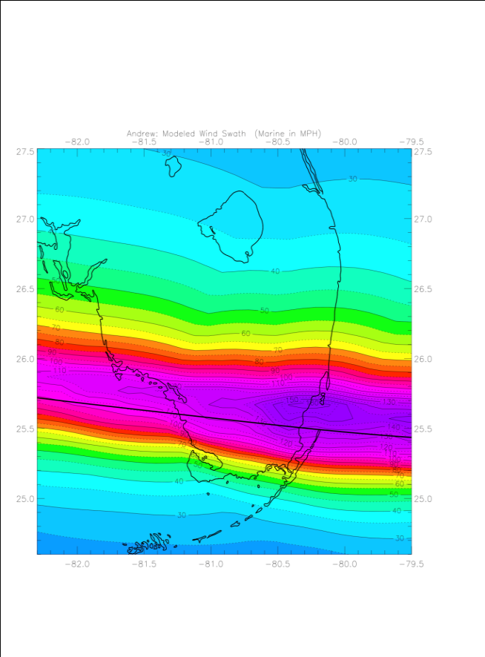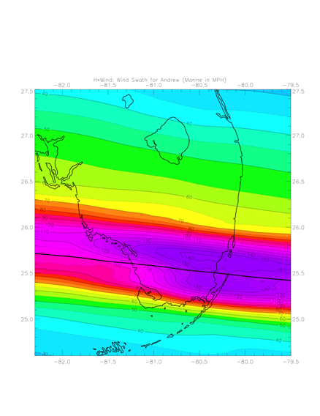
Figure 43. Comparison of modeled (left) and observed (right) swaths of maximum sustained marine surface winds for Hurricane Andrew of 1992 in South Florida. The Hurricane Andrew observed swath is based on adjusting flight-level winds with the SFMR-based wind reduction method.

Table 13. Validation Table based on ZIP Code wind swath comparison of the Public wind field model to H*Wind. Mean errors (bias) of model for the set of validation wind swaths. Errors (upper number in each cell) are computed as Modeled – Observed (Obs) at ZIP Codes were modeled winds were within wind thresholds (model threshold) or where observed winds were within respective wind speed threshold (H*Wind threshold). Number of ZIP Codes for the comparisons is indicated as the lower number in each cell.
Storms | Year | 56-74  Model  Threshold | 75-112 Model Thresh. | >112mph  Model Thresh. | >56mph Model Thresh. | 56-74  H*Wind  Thresh. | 75-112  H*Wind Thresh. | >112mph  H*Wind  Thresh. | >56mph H*Wind Thresh.
Andrew | 1992 | 5.25  92 | 13.86  107 | 2.73  100 | 7.49  299 | 10.26  139 | 12.47  54 | 0.66  88 | 7.68  281
Charley | 2004 | 12.96  112 | 21.36  244 | -7.36  13 | 17.80  369 | 8.58  122 | -3.09  63 | -8.91  17 | 3.47  202
Frances | 2004 | 3.99  693 | -0.99  96 | None | 3.38  789 | -0.59  372 | -4.48  96 | None | -1.38  468
Ivan | 2004 | -6.95  20 | -3.35  38 | None | -4.59  58 | -5.76  22 | -3.73  41 | None | -4.44  63
Jeanne | 2004 | 6.78  250 | 3.95  190 | None | 5.56  440 | 2.67  225 | -3.87  121 | None | 0.38  346
Dennis | 2005 | 2.45  15 | 6.98  46 | None | 5.87  61 | 5.22  29 | 7.57  29 | -4.37  3 | 5.87  61
Dennis Keys | 2005 | None | None | None | None | -12.65  5 | None | None | -12.65  5
Katrina | 2005 | -11.43  77 | -2.42  100 | None | -6.34  177 | -8.93  93 | -11.57  149 | None | -10.55  242
Rita | 2005 | 6.28  5 | 14.54  3 | None | 9.38  8 | 12.01  5 | None | None | 12.01  5
Wilma | 2005 | 0.44  133 | -9.99  394 | None | -7.35  527 | 6.54  87 | -13.35  396 | None | -9.77  483

Table 14. Validation Table based on ZIP Code wind swath comparison of the Public wind field model to H*Wind. Root mean square (RMS) wind speed errors (mph) of model for the set of validation wind swaths. Errors are based on Modeled – Observed (Obs) at ZIP Codes where modeled winds were within wind thresholds (model threshold) or where observed winds were within respective wind speed threshold (H*Wind threshold).
Storms | Year | 56-74  Model  Threshold | 75-112 Model Thresh. | >112mph  Model Thresh. | >56mph Model Thresh. | 56-74  H*Wind  Thresh. | 75-112  H*Wind Thresh. | >112mph  H*Wind  Thresh. | >56mph H*Wind Thresh.
Andrew | 1992 | 6.11 | 15.75 | 7.024 | 10.81 | 12.19 | 14.26 | 5.82 | 11.10
Charley | 2004 | 19.84 | 26.59 | 10.08 | 24.30 | 16.65 | 8.60 | 11.69 | 14.21
Frances | 2004 | 8.08 | 11.20 | None | 8.52 | 4.99 | 10.20 | None | 6.41
Ivan | 2004 | 7.07 | 5.20 | None | 5.91 | 6.11 | 5.51 | None | 5.72
Jeanne | 2004 | 10.14 | 9.65 | None | 9.93 | 10.88 | 6.16 | None | 9.50
Dennis | 2005 | 3.06 | 9.19 | None | 8.12 | 6.15 | 9.93 | 4.59 | 8.12
Dennis Keys | 2005 | None | None | None | None | 12.67 | None | None | 12.67
Katrina | 2005 | 14.66 | 8.25 | None | 11.49 | 12.50 | 17.97 | None | 16.09
Rita | 2005 | 6.4992 | 14.54 | None | 10.28 | 12.41 | None | None | 12.41
Wilma | 2005 | 14.73 | 14.05 | None | 14.22 | 12.51 | 14.83 | None | 14.44
RMS  N | All | 10.18  1397 | 14.87  1218 | 6.26  113 | 12.37  2728 | 9.75  1099 | 12.79  949 | 6.71  108 | 11.19  2156

Comparison of model and H*Wind sustained marine exposure wind speeds at ZIP Codes receiving model wind speeds over the given thresholds (Table 26) indicates a positive bias. For ZIP Codes where model wind speeds exceeded 56 mph, the bias is +3.3 mph; negative bias was apparent in Hurricanes Ivan, Katrina, and Wilma. At other wind speed thresholds, low bias is evident for winds > 112 mph in Hurricane Charley, and winds of 75-112 mph in Hurricanes Frances, Ivan, Katrina, and Wilma. For winds of 56-74 mph, low bias is noted in Hurricanes Ivan, and Katrina. Errors for Hurricane Andrew are relatively high, but the lack of observations for Hurricane Andrew makes it difficult to determine if it was a Cat 4 or Cat 5 hurricane during its landfall in South Florida. Hurricane Rita in the Keys also shows relatively high bias, but observations indicate that there were fluctuations in intensity over a short period of time during its passage past the Keys. Model errors for Hurricane Charley are also relatively high, likely due to the model producing a wind field that was too broad. When model winds are compared to H*Wind at ZIP Codes exceeding H*Wind and sustained wind speed thresholds of 56 mph are considered, the mean bias is -2.2 mph. However, bias at other wind speed thresholds is larger, primarily caused by large model - H*Wind differences in Hurricanes Andrew, Charley, and Rita.

When swaths are evaluated at ZIP Codes, a positive wind speed bias of ~3 mph is indicated. However, the model can also under-predict swaths for individual cases. While bias correction is an accepted practice for numerical weather prediction, there is no evidence that the model has a consistent bias. The swath bias is probably associated with limitations in specifying the radial pressure profile after landfall. The tendency for the Holland pressure profile parameter to produce too broad an area of strong winds near the eyewall is the most likely cause of bias and is likely a feature found in many of the current risk models. Therefore we have decided to forgo any corrective measures at this point.

Our validation set is unique in that the values of storm position, motion, Rmax and Pmin are observed, and B is determined independently from the H*Wind field. In other words, it is impossible to fine-tune our results. Although additional validation storms are desired, we believe the positive bias for locations with winds > 56 mph is a characteristic of models that use the Holland B pressure profile parameter, which tends to produce model fields that are too broad outside the radius of maximum winds. Our validation method provides an objective means of assessing model performance by evaluating the portion of the wind field that contains damaging winds.

The root mean square (RMS) error (Table 27) provides a better estimate of model uncertainty. For ZIP Codes in which model winds were 56-74 mph, the RMS error is +/- 10 mph (~ 15%), for 75-112 mph the error is +/- 15 mph (~16%), and for winds > 112 mph the errors is +/- 6 mph (~ 5%). In general, for winds > 56 mph, the RMS error is +/- 12 mph or ~ 13%. RMS errors are similar for ZIP Codes in which H*Wind wind speeds fell into the respective thresholds.

SUMMARY OF WIND SWATH VALIDATION
Validation of the winds from the wind model against the H*Wind analyses was prepared by considering winds that would be strong enough to be associated with damage. Threshold-based comparisons could miss places where the observed winds were greater than the model and the model was below the threshold. Conversely, observed winds over the same thresholds can be compared to the co-located model grid points but would miss places where the observed winds were below the threshold. It is important to evaluate the errors both ways to see if a consistent bias is evident. According to our validation statistics, albeit for a relatively small number of cases, wind swath ZIP Code comparisons show evidence of a 3 mph positive bias, but it is not consistent for all storms. The bias is likely related to the limitations of the Holland B pressure profile specification. The model uncertainty, as estimated by the RMS error, is on the order of 15%.

- Provide the date of loss of the insurance company data available for validation and verification of the model.

The following hurricane data from different insurance companies are used to validate the model:

Andrew | 1992
Erin | 1995
Charley | 2004
Frances | 2004
Jeanne | 2004
Dennis | 2005
Wilma | 2005
Katrina | 2005

- Provide an assessment of uncertainty in loss costs for output ranges using confidence intervals or other accepted scientific characterizations of uncertainty.

While the model does not automatically produce confidence intervals for the output ranges, the data do allow for the calculation of confidence intervals. We calculated the mean and the standard deviation of the losses for each county, and it was found that the standard errors were within 2.5% of the means for all counties. We also calculated the coefficient of variation (CV) for all counties and drew a histogram which is provided in Figure 89. The range of the CVs was between 2.81 and 5.52. Finally, we computed 95% confidence intervals for the average loss for each county. Some of these intervals are reproduced in Table 28.

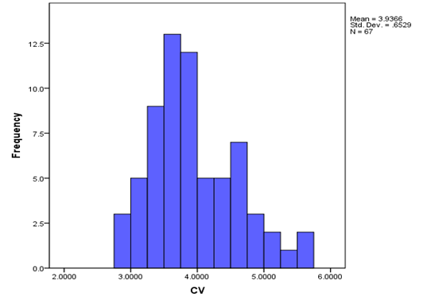
Figure 44. Histogram of CVs for all counties combined.

Table 15. 95% Confidence intervals for mean loss for selected counties (based on 56,000) year simulation.
county | average_loss | stdev_loss | LCL | UCL
Alachua | $10,796,224.33 | $44,346,599.09 | 10428923.1 | 11163525.56
Brevard | $159,480,725.27 | $596,596,988.38 | 154539403.7 | 164422046.8
Broward | $524,384,931.96 | $1,594,317,725.22 | 511179976.8 | 537589887.2
Duval | $38,979,038.13 | $179,076,321.85 | 37495836.4 | 40462239.86
Escambia | $36,941,528.93 | $128,578,678.81 | 35876574.52 | 38006483.34
Gulf | $1,681,229.43 | $6,251,301.60 | 1629452.951 | 1733005.909
Hamilton | $180,842.97 | $998,483.44 | 172573.0192 | 189112.9208
Hillsborough | $190,098,430.37 | $665,740,221.20 | 184584429.2 | 195612431.5
Jackson | $1,770,435.84 | $7,092,169.01 | 1711694.867 | 1829176.813
Jefferson | $320,520.44 | $1,723,902.76 | 306242.1952 | 334798.6848
Lee | $231,201,914.42 | $666,137,262.63 | 225684624.8 | 236719204.1
Leon | $9,925,659.33 | $46,947,299.63 | 9536817.772 | 10314500.89
Madison | $314,465.82 | $1,737,186.77 | 300077.5503 | $328,854.09
Miami-Dade | $548,470,438.29 | $1,655,650,173.96 | 534757496.4 | 562183380.2
Monroe | $72,896,820.09 | $213,213,792.55 | 71130874.36 | 74662765.82
Nassau | $4,592,837.82 | $21,939,080.97 | 4411127.125 | 4774548.515
Okeechobee | $10,044,860.52 | $34,985,457.75 | 9755093.057 | 10334627.98
Osceola | $43,049,508.19 | $151,982,319.89 | 41790712.85 | 44308303.53
Palm Beach | $655,165,866.76 | $2,085,938,272.25 | 637889058.6 | 672442674.9
Sarasota | $127,096,816.99 | $414,345,855.83 | 123664992.6 | 130528641.4

LCL: 95% Lower Confidence Limit for the Average Loss
UCL: 95% Upper Confidence Limit for the Average Loss

- Justify any differences between the historical and modeled results using current accepted scientific and statistical methods in the appropriate disciplines.

The various statistical tests as well as other validation tests presented here and elsewhere indicate that any differences between modeled results and historical observations are not statistically significant given the large known uncertainties in the historical record.

- Provide graphical comparisons of modeled and historical data and goodness-of-fit tests. Examples include hurricane frequencies, tracks, intensities, and physical damage.

For hurricane frequencies as a function of intensity by region, see Form M-1 plots and the goodness-of-fit table. The histogram in Figure 84 compares the modeled and historical annual landfall distribution by number of events per year. The agreement between the two distributions is quite close and the histogram shows a good fit. The chi-square goodness-of-fit test gives a p-value of approximately 0.749 as described in S-1.1. Plots and goodness-of-fit tests for the radius of maximum wind and the Holland pressure profile parameter are shown in Disclosure 1 of this standard. Plots and statistical comparisons of historical and modeled losses are shown in Standard S-5, Form S-4 and Form S-5.

- Provide a completed Form S-1, Probability and Frequency of Florida Landfalling Hurricanes per Year. Provide a link to the location of the form here.

Please see the completed Form S-1 at the end of this section.

- Provide a completed Form S-2A, Examples of Loss Exceedance Estimates, using the 2007 Florida Hurricane Catastrophe Fund aggregate personal and commercial residential exposure data. Provide a link to the location of the form here.

Please see the completed Form S-2 at the end of this section.

- Provide a completed Form S-2B, Examples of Loss Exceedance Estimates, using the 2012 Florida Hurricane Catastrophe Fund aggregate personal and commercial residential exposure data. Provide a link to the location of the form here.

S-2 Sensitivity Analysis for Model Output

The modeling organization shall have assessed the sensitivity of temporal and spatial outputs with respect to the simultaneous variation of input variables using currently accepted scientific and statistical methods in the appropriate disciplines and have taken appropriate action.

We have performed sensitivity analysis on the temporal and spatial outputs of the model using currently accepted scientific and statistical methods. We examined the effects of five input variables on the expected loss cost. The input variables were as follows:

CP = central pressure (in millibars)
Rmax = radius of maximum winds (in statute miles)
VT = translational velocity (forward speed in miles per hour)
Holland B = pressure profile parameter and
FFP = far field pressure

The effects of the above input variables on the expected loss cost were examined using the methods described by Iman et al. (2000a).

Disclosures

- Identify the most sensitive aspect of the model and the basis for making this determination. Provide a full discussion of the degree to which these sensitivities affect output results and illustrate with an example.

Figure 86 provides the graph of the standardized regression coefficients of the expected loss cost as a function of the input variables for Category 1, 3 and 5 hurricanes. From the graph, we observe that the sensitivity of expected loss cost depends on the category of the hurricanes. For a Category 1 hurricane, expected loss cost is most sensitive to Holland B parameter followed by FFP and then CP. For a Category 3 hurricane, expected loss cost is most sensitive to Holland B followed by FFP and Rmax and finally for a Category 5 hurricane, expected loss cost is most sensitive to Rmax, followed by Holland B and then CP and FFP. The expected loss cost is least sensitive to Rmax for Category 1, while the expected loss cost is least sensitive to VT for Category 3 and 5.

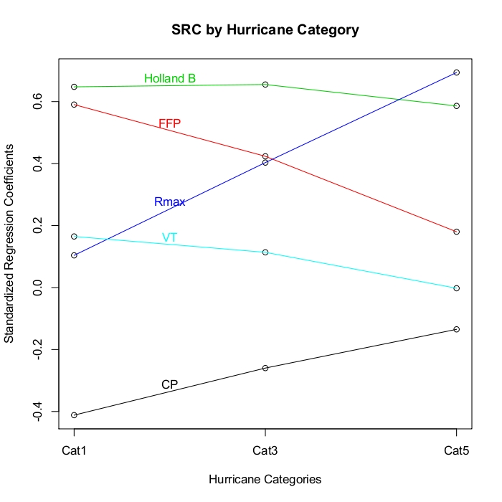
Figure 45. SRCs for Expected Loss Cost for all Input Variables for all Hurricane Categories.

- Describe how other aspects of the model may have a significant impact on the sensitivities in output results and the basis for making this determination.

Validation studies (described in Standard S-1.2) indicated that air density, boundary layer height, fraction of the boundary layer depth over which the turbulent stresses act, the drag coefficient, the averaging time chosen to represent the boundary layer slab winds, and the conversion of the 0-500 m layer mean wind to 10 m surface wind could all have a significant impact on the output. These quantities were evaluated during the validation process, resulting in the selection of physically consistent values. For example, the values chosen for air density, marine boundary layer height and reduction factor from the mean boundary layer to the surface are representative of near surface GPS dropsonde measurements in hurricanes.

Model wind speeds (and therefore, output results) are very sensitive to surface roughness, which in turn depend on land use/land cover determined from satellite remote sensing. The assignment of roughness to mean land use / land cover classifications as well as the upstream filtering or weighting factor was applied to integrate the upstream roughness elements within a 45 degree sector to windward of the corresponding ZIP Code.

- Describe and justify action or inaction as a result of the sensitivity analyses performed.

No actions were taken in light of the aforementioned sensitivity experiments.

- Provide a completed Form S-6, Hypothetical Events for Sensitivity and Uncertainty Analysis. (Requirement for models submitted by modeling organizations which have not previously provided the Commission with this analysis. For models previously found acceptable, the Commission will determine, at the meeting to review modeling organization submissions, if an existing modeling organization will be required to provide Form S-6 (Hypothetical Events for Sensitivity and Uncertainty Analysis) prior to the Professional Team on-site review). If applicable, provide a link to the location of the form here.

Please see the completed Form S-6 (Hypothetical Events for Sensitivity and Uncertainty Analysis) at the end of this section.

S-3 Uncertainty Analysis for Model Output

The modeling organization shall have performed an uncertainty analysis on the temporal and spatial outputs of the model using currently accepted scientific and statistical methods in the appropriate disciplines and have taken appropriate action. The analysis shall identify and quantify the extent that input variables impact the uncertainty in model output as the input variables are simultaneously varied.

We have performed uncertainty analysis on the temporal and spatial outputs of the model using currently accepted scientific and statistical methods. We examined the effects of five input variables on the expected loss cost. The input variables were as follows:

CP = central pressure (in millibars)
Rmax = radius of maximum winds (in statute miles)
VT = translational velocity (forward speed in miles per hour)
Holland B = pressure profile parameter and
FFP = far field pressure

The effects of the above input variables on the expected loss cost were examined using the methods described by Iman et al. (2000b).

Disclosures

- Identify the major contributors to the uncertainty in model outputs and the basis for making this determination. Provide a full discussion of the degree to which these uncertainties affect output results and illustrate with an example.

Figure 87 gives the expected percentage reductions in the variance of expected loss costs for Category 1, 3 and 5 hurricanes as a function of the input variables. As with the sensitivity analysis, the category of the hurricane determines which variables contributes most to the uncertainty of the expected loss costs. For a Category 1 hurricane, the major contributor to the uncertainty in expected loss cost is the Holland B parameter followed by FFP and then CP. For a Category 3 hurricane, the major contributor to the uncertainty in loss costs is Holland B followed by Rmax and then FFP and finally for a Category 5 hurricane, the major contributor to the uncertainty of expected loss costs is Rmax followed by Holland B and then FFP and CP. The variable VT has negligible effect on the uncertainty in expected loss costs.

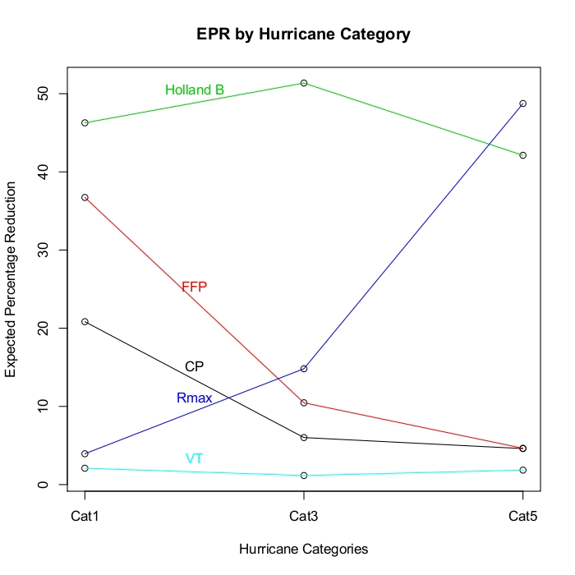
Figure 46. EPRs for Expected Loss Cost for all Input Variables for all Hurricane Categories.
- Describe how other aspects of the model may have a significant impact on the uncertainties in output results and the basis for making this determination.

Limitations in the HURDAT record contribute to the uncertainty of modeled tracks and pressures. Surface pressure measurements are not always available in HURDAT and estimating surface pressures by pressure-wind relationships is also fraught with uncertainty since well-observed hurricanes can demonstrate a large variation in maximum wind speeds for a given minimum surface pressure. The HURDAT record prior to the advent of satellites in the mid 1960s could have missed or incorrectly classified many hurricanes that affected Florida in the early 20th century. Even today, there is still considerable uncertainty in the assessment of hurricane intensity. Recent research results based on SFMR measurements (Powell et al., 2009) indicate that some Saffir-Simpson 1-3 Category hurricanes may be rated too highly while the Category 4 and 5 storms are probably rated accurately.

Uncertainty in surface roughness has a significant impact on wind uncertainty which in turn leads to a significant impact on losses.

- Describe and justify action or inaction as a result of the uncertainty analyses performed.

No actions were taken in light of the aforementioned uncertainty analysis.

- Form S-6 (Hypothetical Events for Sensitivity and Uncertainty Analysis), if disclosed under Standard S-2 (Sensitivity Analysis for Model Output), will be used in the verification of Standard S-3 (Uncertainty Analysis for Model Output).

Please see the completed Form S-6 (Hypothetical Events for Sensitivity and Uncertainty Analysis) at the end of this section.

S-4 County Level Aggregation

At the county level of aggregation, the contribution to the error in loss cost estimates attributable to the sampling process shall be negligible.

The error in the county level loss costs induced by the sampling process can be quantified by computing standard errors for the county level loss costs. These loss costs have been computed for all counties in the state of Florida using 57,000 years of simulation. The results indicate that the standard errors are less than 2.5% of the average loss cost estimates for all counties.

Disclosure

- Describe the sampling plan used to obtain the average annual loss costs and output ranges. For a direct Monte Carlo simulation, indicate steps taken to determine sample size. For an importance sampling design, describe the underpinnings of the design.

The number of simulation years was determined through the following process:

The average loss cost,, and standard deviation S_{Y}, were determined for each county Y using an initial run of an 11,400 year simulation. Then the maximum error of the estimate will be 2.5% of the estimated mean loss cost, if the number of simulation years for county Y is:

Based on the initial 11,400 year simulation runs, the minimum number of years required is N_{Y} = 44,032 for Jefferson County, which had the highest number of years required of all the counties. Therefore, we have decided to use 57,000 (500x114) years of simulation for our final results. For the 57,000 year simulation run we found that the standard errors are less than 2.5% of the average loss costs for each county.

S-5 Replication of Known Hurricane Losses

The model shall estimate incurred losses in an unbiased manner on a sufficient body of past hurricane events from more than one company, including the most current data available to the modeling organization. This standard applies separately to personal residential and, to the extent data are available, to commercial residential. Personal residential experience may be used to replicate structure-only and contents-only losses. The replications shall be produced on an objective body of loss data by county or an appropriate level of geographic detail and shall include loss data from both 2004 and 2005.

Table 29 compares the modeled and actual total losses by hurricane and company for personal residential coverage. Moreover, Figure 91 indicates reasonable agreement between the observed and modeled losses. This was also supported by the various statistical tests described below.

Disclosures

- Describe the nature and results of the analyses performed to validate the loss projections generated by the model for personal and commercial residential separately. Include analyses for the 2004 and 2005 hurricane seasons.

For model validation purposes, the actual and modeled losses for some selected companies and hurricanes are provided in Table 29.

Table 16. Total Actual vs. Total Modeled Losses - Personal Residential
Company Name | Event | Total Exposure | Total Actual Loss | Total Modeled Loss
A | Charley | 14572357458.00 | 274702333.00 | 192782631.00
A | Frances | 9406748586.00 | 224656954.00 | 135225540.00
B | Charley | 7155996653.00 | 110471361.00 | 120720131.00
B | Frances | 1921696601.00 | 20201407.00 | 59952673.00
C | Charley | 27568302239.00 | 526544555.00 | 328479701.97
C | Dennis | 8858384208.00 | 20384468.00 | 55684738.00
C | Frances | 19509886123.00 | 392510598.00 | 270139416.42
C | Jeanne | 39525022665.00 | 177552030.00 | 401863199.62
C | Katrina | 6232468582.00 | 19712702.00 | 79909488.96
C | Wilma | 39461443904.00 | 340628254.00 | 543021524.08
D | Charley | 1377700566.00 | 63889029.00 | 21708782.00
D | Frances | 4304794382.00 | 122776727.00 | 70397893.00
E | Charley | 35580184.00 | 952353.00 | 644463.00
E | Frances | 316411703.00 | 10007410.00 | 4012959.00
E | Charley | 2498971217.00 | 113313510.00 | 45832355.00
E | Frances | 3631578831.00 | 78377163.00 | 57747468.00
E | Jeanne | 4307858204.00 | 40245030.00 | 68678289.00
F | Charley | 1386793895.00 | 32316645.00 | 19668904.00
G | Charley | 587526292.00 | 3884930.00 | 6641333.28
G | Frances | 179081534.00 | 2918642.00 | 3636948.23
G | Katrina | 135143330.00 | 464971.00 | 858448.83
G | Wilma | 767025160.00 | 6120435.00 | 9217331.98
H | Charley | 844602098.00 | 78535467.00 | 51557230.62
H | Dennis | 28266337.00 | 928111.00 | 2142032.00
H | Jeanne | 1854530377.00 | 74983526.00 | 54296228.26
H | Katrina | 6903619.00 | 330018.00 | 234998.48
H | Wilma | 727865863.00 | 47056668.00 | 18797871.31
I | Charley | 2506896464.00 | 62086256.00 | 49220499.00
I | Frances | 71919163.00 | 43799401.00 | 6719958.00
K | Jeanne | 6169965775.00 | 84545829.00 | 87459704.00
L | Charley_Mob | 932092266.00 | 79751698.00 | 55233775.00
L | Jeanne_Mob | 2558106618.00 | 81552694.00 | 92736739.00
M | Charley_Mob | 41558803.00 | 4511656.00 | 2496591.00
M | Charley | 166263166.00 | 8645559.00 | 3133884.00
M | Frances_Mob | 34555100.00 | 4009884.00 | 1356303.00
M | Frances | 367999344.00 | 11489176.00 | 5479394.00
M | Jeanne_Mob | 78735391.00 | 3590284.00 | 3175468.00
M | Jeanne | 347104726.00 | 4812837.00 | 5844041.00
N | Charley | 1517072812.00 | 15135021.00 | 21770116.00
N | Frances | 788753177.00 | 9399468.00 | 15495894.00
N | Jeanne | 2272770727.00 | 9048905.00 | 26613493.00
O | Charley | 9974317521.00 | 250201871.00 | 155825974.93
O | Frances | 8000326844.00 | 185676998.00 | 154776743.96
O | Jeanne | 15900477962.00 | 127752952.00 | 208018427.62
O | Katrina | 482901644.00 | 1498112.00 | 4203642.78
O | Wilma | 13042930295.00 | 156638501.00 | 170034281.48
P | Charley | 475100767.00 | 2015902.00 | 3000264.00
P | Frances | 1078479766.00 | 2659551.00 | 4683178.00
P | Jeanne_Mob | 905676619.00 | 29144703.00 | 35180149.00
P | Jeanne | 1436506385.00 | 2059383.00 | 5997854.00
Q | Jeanne | 3434049257.00 | 31066792.00 | 50161126.00
R | Andrew | 30391564010.00 | 2984373067.00 | 2046681070.00
R | Charley_Mob | 427213972.00 | 23395988.00 | 15910825.00
R | Charley | 51283638860.00 | 1037108745.00 | 584354386.00
R | Dennis | 8560926395.00 | 30098559.00 | 55014031.00
R | Erin | 3193215496.00 | 50519119.00 | 58410471.00
R | Frances_Mob | 467259719.00 | 18467176.00 | 7500134.00
R | Frances | 35893609287.00 | 614006549.00 | 400541942.00
R | Katrina | 19486034141.00 | 54163254.00 | 102899060.88
R | Wilma | 80021657140.00 | 1185407656.00 | 732908955.18
S | Jeanne | 1178562197.00 | 3125588.00 | 14288468.00
T | Charley | 9721434560.00 | 111013524.00 | 210096366.00
T | Frances | 12560929210.00 | 94272660.00 | 364423935.00
U | Charley | 2685932544.00 | 54207520.00 | 40433667.00
U | Frances | 3525383315.00 | 121893725.00 | 49841303.00

Figure 89 provides a comparison of total actual losses vs. total modeled losses for different hurricanes. The comparison indicates a reasonable agreement between the actual and modeled losses. The correlation between actual and modeled losses is found to be 0.969, which shows a strong positive linear relationship between actual and modeled losses. We tested whether the difference in paired mean values equals zero using the paired t test (t = 1.5064, df = 64, p-value = 0.1369) and Wilcoxon signed rank test (Z = 0.9476, p-value = 0.3434). Based on these tests, we failed to reject the null hypothesis of equality of paired means and concluded that there is insufficient evidence to suggest a difference between actual and modeled losses. We also observed from Table 30 that about 51% of the actual losses are more than the corresponding modeled losses, and 49% of the modeled losses are more than the corresponding actual losses. This shows that our modeling process is not biased. Following Lin (1989), the bias correction factor (measure of accuracy) is obtained as 0.930, and the sample concordance correlation coefficient is found to be 0.901, which again shows a strong agreement between actual and modeled losses.

Due to the lack of a sufficient body of claims data for commercial losses, extensive statistical tests were not conducted to validate the model losses. However, a tabular comparison of the modeled vs. actual commercial insured loss costs in Table 30 shows a reasonable agreement (Wilcoxon Signed Rank Test Statistic = 23, p-value = 0.5469) between the two.

Table 17. Comparison of Total vs. Actual Losses - Commercial Residential
Company | Event | TotalExposure | TotalActualLoss | TotalModeledLoss
D | Charley | $ 2,330,314,147.00 | $ 63,245,008.00 | $ 41,577,368.33
D | Jeanne | $ 4,866,082,786.00 | $ 34,826,257.00 | $ 91,253,833.37
D | Katrina | $ 6,489,785,877.00 | $ 11,846,697.00 | $ 29,613,473.16
D | Wilma | $ 20,490,736,703.00 | $318,671,056.00 | $ 192,220,824.24
R | Frances | $ 861,896,543.00 | $ 42,238,244.00 | $ 10,437,972.70
R | Jeanne | $1,021,543,325.00 | $ 8,446,718.00 | $11,967,504.05
R | Katrina | $ 224,056,700.00 | $ 2,178,110.00 | $ 8,852,463.23
R | Wilma | $ 2,423,207,666.00 | $ 62,492,371.00 | $ 14,252,608.97

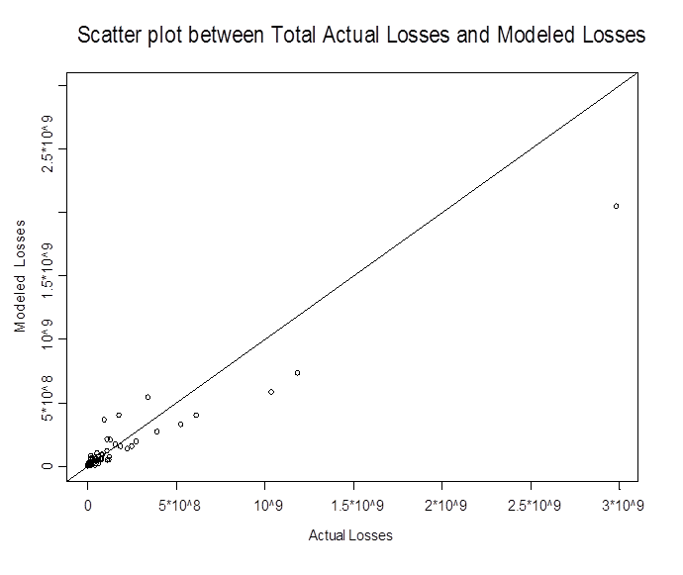
Figure 47. Scatter plot between total actual losses vs. total modeled losses.

- Provide a completed Form S-4, Validation Comparisons. Provide a link to the location of the form here.

Please see the completed Form S-4 at the end of this section.

S-6 Comparison of Projected Hurricane Loss Costs

The difference, due to uncertainty, between historical and modeled annual average statewide loss costs shall be reasonable, given the body of data, by established statistical expectations and norms.

The difference, due to uncertainty, between historical and modeled annual average statewide loss costs is reasonable as shown in the following description.

Disclosures

- Describe the nature and results of the tests performed to validate the expected loss projections generated. If a set of simulated hurricanes or simulation trials was used to determine these loss projections, specify the convergence tests that were used and the results. Specify the number of hurricanes or trials that were used.

Loss costs are generated using a simulated number of hurricanes. The number of years used in the simulations was calculated as described in Standard S-4, and was found to be 56,000. The standard errors are within 2.5% of the means for all counties. From Form S-5 we found that the 95% confidence interval on the difference between the mean of the losses from the historical and modeled contains 0, indicating that there is no statistically significant difference. In addition, as shown in Standard S-5, modeled loss costs have also been validated against insurance company data and are in reasonable agreement with the same.

- Identify and justify differences, if any, in how the model produces loss costs for specific historical events versus loss costs for events in the stochastic hurricane set.

The historical and stochastic storm loss costs are treated the same.

- Provide a completed Form S-5, Average Annual Zero Deductible Statewide Loss Costs – Historical versus Modeled. Provide a link to the location of the form here.

Please see the completed Form S-5 at the end of this section.

Form S-1: Probability and Frequency of Florida Landfalling Hurricanes per Year

Complete the table below showing the probability and modeled frequency of landfalling Florida hurricanes per year. Modeled probability shall be rounded to four decimal places. The historical probabilities and frequencies below have been derived from the Base Hurricane Storm Set for the
113 year period 1900-2012 (as given in Form A-2, Base Hurricane Storm Set Statewide Losses).
Exclusion of hurricanes that caused zero modeled Florida damage or additional Florida landfalls included in the modeling organization Base Hurricane Storm Set as identified in their response to
Standard M-1 (Base Hurricane Storm Set) should be used to adjust the historical probabilities and frequencies provided here.

If the data are partitioned or modified, provide the historical probabilities and frequencies for the applicable partition (and its complement) or modification as well as the modeled probabilities and frequencies in additional copies of Form S-1 (Probability and Frequency of Florida Landfalling Hurricanes per Year).

Model Results
Probability and Frequency of Florida Landfalling Hurricanes per Year
Number  Of Hurricanes  Per Year | Historical  Probabilities | Modeled  Probabilities | Historical  Frequencies | Modeled  Frequencies
0 | 0.6071 | 0.6201 | 68 | 69
1 | 0.2500 | 0.2384 | 28 | 27
2 | 0.1161 | 0.0969 | 13 | 11
3 | 0.0268 | 0.0350 | 3 | 4
4 | 0.0000 | 0.0087 | 0 | 1
5 | 0.0000 | 0.0008 | 0 | 0
6 | 0.0000 | 0.0000 | 0 | 0
7 | 0.0000 | 0.0000 | 0 | 0
8 | 0.0000 | 0.0000 | 0 | 0
9 | 0.0000 | 0.0000 | 0 | 0
10 or more | 0.0000 | 0.0000 | 0 | 0

Note: Historical and modeled frequencies are the number of occurrences in a 112 year
period, rounded to nearest integer.

Form S-2A: Examples of Loss Exceedance Estimates (2007 FHCF Exposure Data)

Provide projections of the aggregate personal and commercial insured losses for various probability levels using the notional risk data set specified in Form A-1 (Zero Deductible
Personal Residential Loss Costs by ZIP Code) and using the 2007 Florida Hurricane Catastrophe
Fund aggregate personal and commercial residential exposure data provided in the file named
“hlpm2007c.exe.” Provide the total average annual loss for the loss exceedance distribution. If the modeling methodology does not allow the model to produce a viable answer, please state so and why.

Part A

Return Period (Years) | Probability of Exceedance | Estimated Loss Notional Risk Data Set | Estimated Personal and Commercial Residential Loss FHCF Data Set
Top Event | NA | $73,924,486 | $174,210,398,506
10000 | 0.01% | $63,977,042 | $146,776,764,287
5000 | 0.02% | $58,639,417 | $131,547,949,709
2000 | 0.05% | $49,717,591 | $108,504,279,774
1000 | 0.10% | $43,086,024 | $95,864,252,569
500 | 0.20% | $37,650,317 | $83,070,567,278
250 | 0.40% | $32,735,876 | $72,196,600,421
100 | 1.00% | $26,715,797 | $58,746,548,004
50 | 2.00% | $22,045,379 | $47,451,128,470
20 | 5.00% | $14,989,960 | $31,707,675,501
10 | 10.00% | $9,385,345 | $19,625,750,590
5 | 20.00% | $3,404,655 | $7,158,290,622

Part B

Mean (Total Average Annual Loss) | $2,566,767 | $5,407,994,894
Median | $0 | $1,928
Standard Deviation | $5,722,545 | $12,370,046,057
Interquartile Range | $1,760,899 | $3,384,500,966
Sample Size | 56000 | 56000

Form S-2B: Examples of Loss Exceedance Estimates (2012 FHCF Exposure Data)

Provide projections of the aggregate personal and commercial insured losses for various
probability levels using the notional risk data set specified in Form A-1 (Zero Deductible
Personal Residential Loss Costs by ZIP Code) and using the 2012 Florida Hurricane Catastrophe
Fund aggregate personal and commercial residential exposure data provided in the file named
“hlpm2012c.exe.” Provide the total average annual loss for the loss exceedance distribution. If the modeling methodology does not allow the model to produce a viable answer, please state so and why.

Part A

Part B

Form S-3: Distributions of Stochastic Hurricane Parameters

Provide the probability distribution functional form used for each stochastic hurricane parameter in the model. Provide a summary of the rationale for each functional form selected for each general classification.

Stochastic Hurricane Parameter (Function or Variable) | Functional Form  of Distribution | Data Source | Year Range  Used | Justification  for Functional Form
Holland B Error term | Normal | Willoughby and Rahn (2004) | 1977-2000 | The Gaussian Distribution provided a good fit for the error term. See Standard S-1, Disclosure 1.
Rmax | Gamma | Ho et al. (1987) , supplemented by the extended best track data of DeMaria (Penington 2000), Air Force Recon , NOAA HRD research flight data, and NOAA-HRD H*Wind analyses (Powell et al. 1996, 1998). | 1901-2010 | Rmax is skewed, nonnegative and does not have a long tail. So the gamma distribution was tried and found to be a good fit. We limit the range of Rmax to the interval (4, 60).  See Standard S-1, Disclosure 1.
Pressure decay Term | Normal | Vickery (2005) | 1979-1996 | Vickery (2005)
Storm initial location perturbation | Uniform | N/A | N/A | Plausible variations in initial storm locations are assumed to be uniform
Storm initial motion perturbation | Uniform | N/A | N/A | Plausible variations in initial storm motion are assumed to be uniform
Storm change in motion and intensity distributions | Empirical | HURDAT | 1900-2011 | Sampling from historical data  See Standard G-1, Disclosure 2 for details

Form S-4: Validation Comparisons

- Provide five validation comparisons of actual personal residential exposures and loss to modeled exposures and loss. These comparisons must be provided by line of insurance, construction type, policy coverage, county or other level of similar detail in addition to total losses. Include loss as a percent of total exposure. Total exposure represents the total amount of insured values (all coverages combined) in the area affected by the hurricane. This would include exposures for policies that did not have a loss. If this is not available, use exposures for only those policies that had a loss. Specify which was used. Also, specify the name of the hurricane event compared.

- Provide a validation comparison of actual commercial residential exposures and loss to modeled exposures and loss. Use and provide a definition of the model’s relevant commercial residential classifications.

- Provide scatter plot(s) of modeled vs. historical losses for each of the required validation comparisons. (Plot the historical losses on the x-axis and the modeled losses on the y-axis.)

Rather than using directly a specific published hurricane wind field, the winds underlying the modeled loss cost calculations must be produced by the model being evaluated and should be the same hurricane parameters as used in completing Form A-2 (Base Hurricane Storm Set
Statewide Losses).

Personal Residential

Comparison #1: Hurricane Charley and Company O by Coverage

 | Company Actual | Modeled | Difference
Coverage | Loss/Exposure | Loss/Exposure
Building | 0.00764 | 0.00897 | -0.00133
Contents | 0.00007 | 0.00245 | -0.00238
Appurtenants | 0.00107 | 0.01012 | -0.00905
ALE | 0.00025 | 0.00167 | -0.00142
Total | 0.00424 | 0.00632 | -0.00207

Comparison #2: Different Companies by Different Hurricanes
 |  | Company Actual | Modeled |  | Difference
Company | Event | Loss/Exposure | Loss/Exposure
K | Jeanne | 0.01370 | 0.01418 |  | -0.00047
R | Erin | 0.01582 | 0.01829 |  | -0.00247
B | Charley | 0.01544 | 0.01687 |  | -0.00143
P | Frances | 0.00247 | 0.00434 |  | -0.00188
P | Charley | 0.00424 | 0.00632 |  | -0.00207

Comparison #3: Company P by Hurricane Frances, Charley, Jeanne
 |  | Company Actual | Modeled | Difference
Company | Event | Loss/Exposure | Loss/Exposure
P | Frances | 0.00247 | 0.00434 | -0.00188
P | Charley | 0.00424 | 0.00632 | -0.00207
P | Jeanne | 0.00143 | 0.00418 | -0.00274

Comparison #4: Construction Type for Hurricane Charley
Construction | Company | Company Actual | Modeled | Difference
Construction | Company | Loss/Exposure | Loss/Exposure
Frame | B | 0.01363 | 0.01694 | -0.00331
Masonry | B | 0.01584 | 0.01685 | -0.00101
Manufactured | R | 0.05476 | 0.03724 | 0.01752
Other | A | 0.01803 | 0.01448 | 0.00355

Comparison #5: County wise for Company A and Hurricane Frances
 | Company Actual | Modeled | Difference
Lee | 0.000019 | 0.000025 | -0.000007
Sarasota | 0.000122 | 0.000076 | 0.000046
Collier | 0.000031 | 0.000081 | -0.000051
Madison | 0.000865 | 0.000931 | -0.000066
Manatee | 0.000257 | 0.000333 | -0.000076

Figure 48. Scatter plot for comparison # 1.

Figure 49. Scatter plot for comparison # 2.

Figure 50. Scatter plot for comparison # 3.

Figure 51. Scatter plot for comparison # 4.

Figure 52. Scatter plot for comparison # 5.

Commercial Residential:

Comparison # 1: Companies D and M by Hurricane Charley, Katrina, Wilma, and Jeanne
 |  | Company Actual | Modeled | Difference
Company | Event | Loss/Exposure | Loss/Exposure
D | Charley | 0.02714 | 0.01784 | 0.00930
D | Katrina | 0.00183 | 0.00456 | -0.00274
D | Wilma | 0.01555 | 0.00938 | 0.00617
R | Jeanne | 0.00827 | 0.01172 | -0.00345

Figure 53. Scatter plot for comparison # 1.

Form S-5: Average Annual Zero Deductible Statewide Loss Costs – Historical versus Modeled

Part A

- Provide the average annual zero deductible statewide personal and commercial residential loss costs produced using the list of hurricanes in the Base Hurricane Storm Set as defined in Standard M-1 (Base Hurricane Storm Set) based on the 2007 Florida Hurricane Catastrophe Fund’s aggregate personal and commercial residential exposure data found in the file named “hlpm2007c.exe.”

Average Annual Zero Deductible Statewide Personal Residential and Commercial Loss Costs (in millions of dollars)

Time Period – 2007 FHCF  Exposure Data | Historical Hurricanes | Produced by Model
Current Submission | $5,277.44 | $5,407.99
Previously Accepted Submission | $5,938.63 | $5,896.72
Percentage Change Current  Submission/Previously  Accepted Submission | -11.13% | -8.29%
Second Previously
Accepted Submission
Percentage Change Current
Submission/Second
Previously Accepted
Submission

- Provide a comparison with the statewide personal and commercial residential loss costs produced by the model on an average industry basis.

The loss cost produced by the model on an average industry basis is 5.4 billion dollars and the corresponding historical average loss is 5.3 billion dollars.

- Provide the 95% confidence interval on the differences between the mean of the historical and modeled personal and commercial residential loss.

The 95% confidence interval on the difference between the mean of the historical and the mean of the modeled losses is between -2.12 and 1.86 billion dollars. Since the interval contains 0, we are 95% confident that there is no significant difference between the historical and the modeled losses.

- If the data are partitioned or modified, provide the average annual zero deductible statewide personal residential and commercial loss costs for the applicable partition (and its complement) or modification as well as the modeled average annual zero deductible statewide personal residential loss costs in additional copies of Form S-5 (Average Annual Zero Deductible Statewide Loss Costs – Historical versus Modeled).

Not applicable.

Part B

- Provide the average annual zero deductible statewide personal and commercial residential loss costs produced using the list of hurricanes in the Base Hurricane Storm Set as defined in Standard M-1 (Base Hurricane Storm Set) based on the 2012 Florida Hurricane Catastrophe Fund’s aggregate personal and commercial residential exposure data found in the file named “hlpm2012c.exe.”

Average Annual Zero Deductible Statewide Personal and
Commercial Residential Loss Costs

Time Period – 2012 FHCF  Exposure Data | Historical Hurricanes | Produced by Model
Current Submission

- Provide a comparison with the statewide personal and commercial residential loss costs produced by the model on an average industry basis.

- Provide the 95% confidence interval on the differences between the mean of the historical and modeled personal and commercial residential loss.

- If the data are partitioned or modified, provide the average annual zero deductible statewide personal and commercial residential loss costs for the applicable partition (and its complement) or modification, as well as the modeled average annual zero deductible statewide personal and commercial residential loss costs in additional copies of Form S-5 (Average Annual Zero Deductible Statewide Loss Costs – Historical versus Modeled).

Form S-6: Hypothetical Events for Sensitivity and Uncertainty Analysis

We have provided the output in ASCII files based on running a series of hurricanes as provided in the Excel file “FormS5Input09.xls.” The output files consist of wind speeds (in miles per hour for one minute sustained 10 meter winds) at hourly intervals over a 21×40 grid for the 500 combinations of initial conditions specified in the Excel file for the following model inputs:

- CP = central pressure (in millibars)
- Rmax = radius of maximum winds (in statute miles)
- VT = translational velocity (forward speed in miles per hour)
- Holland B = pressure profile parameter for other input used by the modeler
(0 ≤ p ≤ 1)
- FFP = far field pressure (in millibars)

The value of CP, Rmax, VT, FFP and Quantile are used as direct inputs. Quantiles from 0 to 1 have been provided in the Excel input file. For the FPHLM (V4.1) model, we used the first quantile input for the Holland B parameter.

On a CD, we have provided an ASCII file and a PDF file named FPHLM09Expected Loss Costs. This file gives aggregate and expected loss costs for each input vector for each category of hurricane and contains 3x100=300 rows.

We have also provided, on a CD, the results in an ASCII file and a PDF file named FPHLM09Loss Cost Contour, which contains 3 x 682 = 2,046 rows. This file gives the mean loss cost at each of the 682 land based vertices over all 100 input vectors for each hurricane category.

Distribution of Loss Costs

Figure 98 provides the comparison of CDFs of the Expected Loss Costs for all Hurricane Categories.

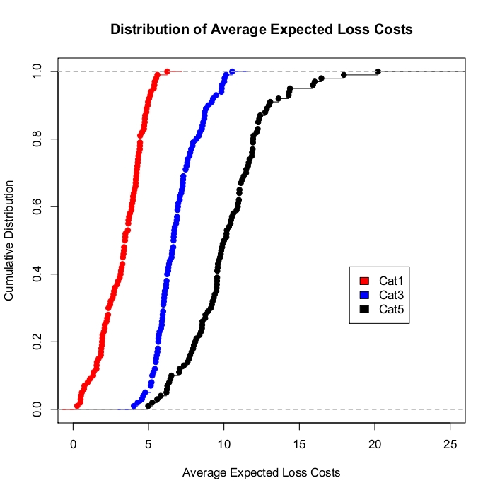
Figure 54. Comparison of CDFs of Loss Costs for all Hurricane Categories.
Figure 99 – Figure 101 show contours of the mean loss cost for Category 1, 3 and 5 hurricane respectively for each land based grid point. The mean percentage loss costs are found to be about between 1.14 %-8.3% for Category 1, between 3.64%-24.6% for Category 3 and between 2.57%-41.84% for Category 5 hurricanes. The largest losses occur shortly after landfall to the right of the hurricane path.

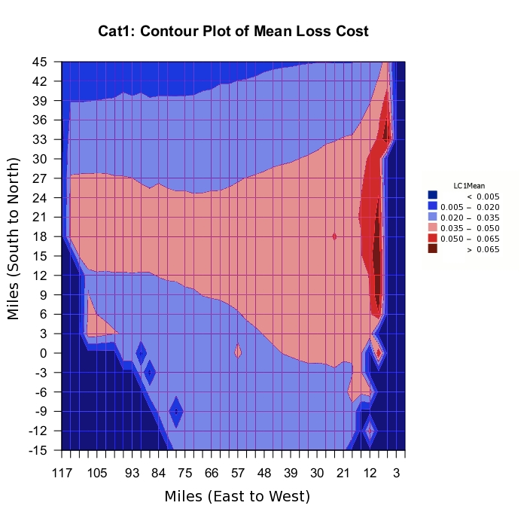
Figure 55. Contour Plot of Loss Cost for a Category 1 Hurricane.

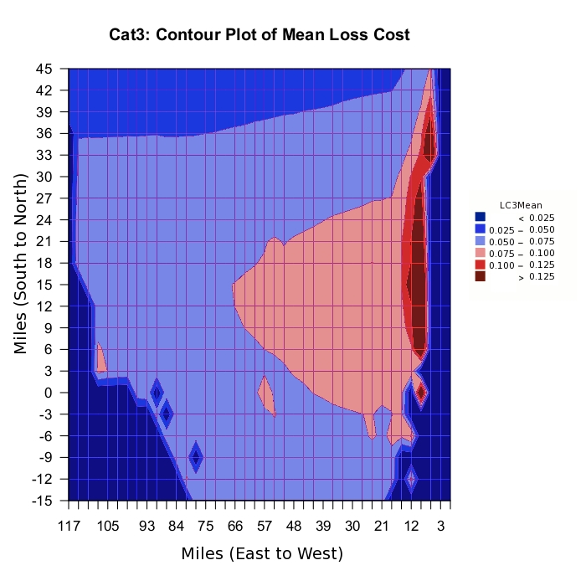
Figure 56. Contour Plot of Loss Cost for a Category 3 Hurricane.

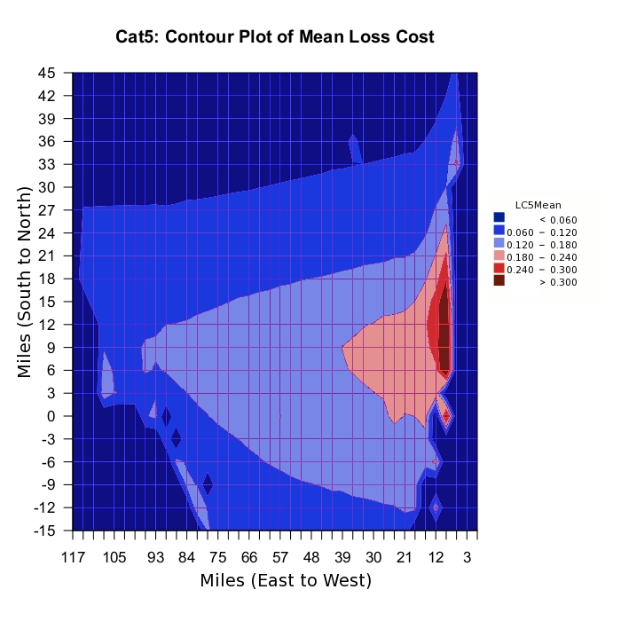
Figure 57. Contour Plot of Loss Cost for a Category 5 Hurricane.

Sensitivity and Uncertainty Analysis for Expected Loss Costs

Sensitivity analysis for the expected loss costs was conducted through the use of the standardized regression coefficients of the expected loss cost as a function of the input variables for Category, 1, 3 and 5 hurricanes. We used the methods described by Iman et al. (2000a, 2000b). The values of standardized regression coefficients are summarized in the table below.

Category | CP | Rmax | VT | Holland B | FFP
1 | -0.4118 | 0.1039 | 0.1648 | 0.6477 | 0.5905
3 | -0.2599 | 0.4033 | 0.1137 | 0.6552 | 0.4236
5 | -0.1349 | 0.6939 | -0.0022 | 0.5862 | 0.1801

Figure 102 gives the graph of the standardized regression coefficients for all input variables for Category 1, 3 and 5 hurricanes. From the graph, we observed that the sensitivity of expected loss cost depends on the category of the hurricanes. For a Category 1 hurricane, expected loss cost is most sensitive to Holland B parameter followed by FFP, CP and VT. For a Category 3 hurricane, expected loss cost is most sensitive to Holland B followed by FFP, Rmax and CP and finally for a Category 5 hurricane, expected loss cost is most sensitive to Rmax, followed by Holland B, CP and FFP. The expected loss cost is least sensitive to Rmax for Category 1 while the expected loss cost is least sensitive to VT for Categories 3 and 5.

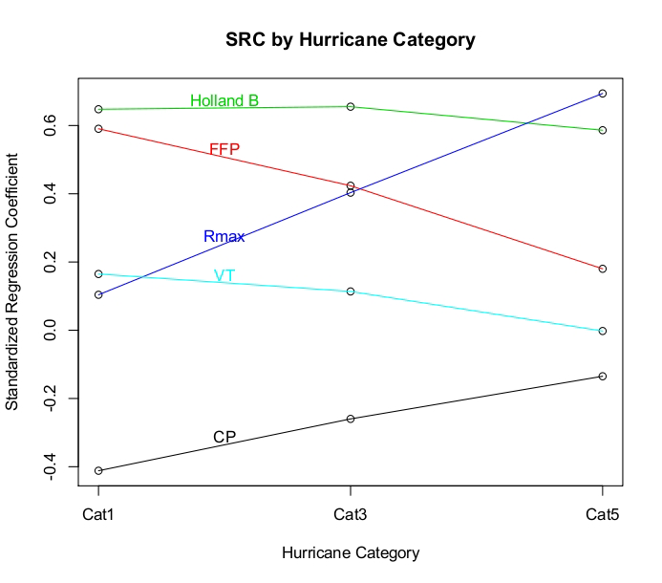
Figure 58. SRCs for expected loss cost for all input variables for all hurricane categories.

Uncertainty analysis for the expected loss costs was conducted through the use of the expected percentage reduction (EPR) in the variance of the expected loss cost as a function of the input variables for Category, 1, 3 and 5 hurricanes. We used the methods described by Iman et al. (2000a, 2000b). The values of EPR’s are summarized in the table below.

Category | CP | Rmax | VT | Holland B | FFP
1 | 20.8398% | 3.9463% | 2.0921% | 46.2717% | 36.7245%
3 | 6.0155% | 14.8201% | 1.1625% | 51.3594% | 10.4668%
5 | 4.6087% | 48.7428% | 1.8529% | 42.1176% | 4.6455%

Figure 103 gives the expected percentage reductions in the variance of expected loss cost for Category 1, 3 and 5 Hurricanes for all input variables. As with the sensitivity analysis, the category of the hurricane determines which variable contributes most to the uncertainty of the expected loss cost. For a Category 1 hurricane, the major contributor to the uncertainty in loss cost is the Holland B parameter, followed by FFP, then CP. For a Category 3 hurricane, the major contributor to the uncertainty in loss cost is Holland B, followed by Rmax, then FFP. For a Category 5 hurricane, the major contributor to the uncertainty of expected loss cost is Rmax, followed by Holland B, then FFP, and finally CP. The variable VT has negligible effect on the uncertainty in expected loss costs.

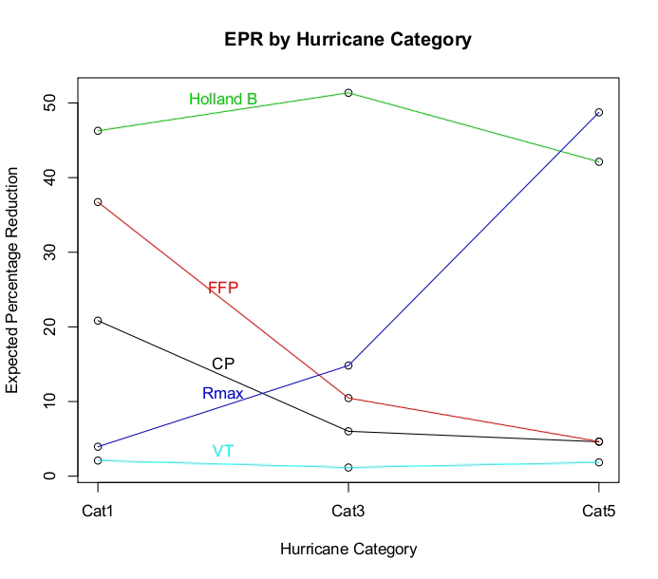
Figure 59. EPRs for Expected Loss Cost for all Input Variables for all Hurricane Categories.

VULNERABILITY STANDARDS

V-1 Derivation of Vulnerability Functions

- Development of the building vulnerability functions shall be based on at least one of the following: (1) historical data, (2) tests, (3) rational structural analysis, and (4) site inspections. Any development of the building vulnerability functions based on rational structural analysis, site inspections, and tests shall be supported by historical data.
The development of the vulnerabilities is based on a component approach that combines engineering modeling, simulations with engineering judgment, and observed (historical) data. The determination of external damage to buildings is based on structural calculations, tests, and Monte Carlo simulations. The wind loads and strength of the building components in the simulations are based on laboratory and in-situ tests, manufacturer’s data, expert opinion based on post-hurricane site inspections of actual damage, and codes and standards. The internal and content damage are extrapolated from the external damage on the basis of expert opinion and are confirmed using historical claims data and site inspections of areas impacted by recent hurricanes.
- The method of derivation of the building vulnerability functions and their associated uncertainties shall be theoretically sound and consistent with fundamental engineering principles.
The method used in the derivation is based on extrapolating the results of Monte Carlo simulations of physical exterior damage through simple equations based on engineering judgment, expert opinion, and claims data. Uncertainties at each stage are accounted for by distributing the damage according to reasonable probability distributions and are validated with claims data.
The Monte Carlo component models take into account many variations in structural characteristics, and the result clearly filters through the cost estimation model. There are also different and clearly defined costing considerations applied to each structural type. These adjustments come directly from resources developed exclusively for defining repair costs to structures and therefore are theoretically sound.
- Residential building stock classification shall be representative of Florida construction for personal and commercial residential properties.
A detailed exposure study was carried out to define the most significant (prevalent) construction types and characteristics in the Florida residential building stock for different regions. The corresponding engineering models were built for each of the identified common structural types. In the case of the residential model and the low-rise, commercial residential model, the models include differing wall types (wood and masonry) of varying strengths (e.g., reinforced or not, various roof to wall connection types), differing roof shapes (hip and gable end) and their effect on uplift loading, various strengths of roof-to-wall connections (toe nail through straps), varying window types and sizes, opening protection systems, varying garage door pressure capacities, and one and two story houses and one-to-three story commercial residential buildings.
Models of varying combinations of the above characteristics (e.g., wood frame, gable end, no window shutters) were created for four different regions in Florida. In all cases, the probabilistic capacities of the various components were determined by a variety of sources, including testing, test results in the literature, in-field data collection (post-hurricane damage evaluations), manufacturer’s specifications and manufacturer’s test data, and expert opinion.
In the case of the mid-/high-rise commercial residential model (buildings with more than three stories), the models include different apartment units corresponding to different building layouts (interior or exterior entry door), different locations within the floor plan (corner or middle units), different heights (subject to different probabilities of missile impact and wind speed), and different openings (windows, doors, sliders) with different protection options (none or impact resistant).
- Building height/number of stories, primary construction material, year of construction, location, building code, and other construction characteristics, as applicable, shall be used in the derivation and application of building vulnerability functions.
The structural models include options that allow the representation of building code revisions. Three models were derived for each structural type: weak construction, medium construction, and strong construction. For example, each model for wood frame and gable roof homes has weak, medium, and strong versions. The assignment of a given strength level is based on the assumed age of the home being modeled and the available information on construction practice in that region of the state in that era of construction. Florida Building Code requirements that apply to the repair of existing homes are also taken into consideration when computing the repair costs of a structure. Separate models were also developed for manufactured housing constructed based on pre- and post-1994 HUD regulations and for different wind zones.
In addition to the various models that reflect construction type, region of Florida, and era of construction (multiple variations of weak, medium, or strong construction), each model has numerous additional strength features that can be adjusted before simulations are conducted to represent various combinations of mitigation features. For example, a weak constructed home in central Florida with masonry walls (no reinforcing) may have been recently re-roofed with renailed roof decking and modern code-approved shingles. The simulation model is capable of reflecting this combination of weak original construction and new, strong roof sheathing and roof cover mitigation.
- Vulnerability functions shall be separately derived for commercial residential building structures, personal residential building structures, mobile homes, and appurtenant structures.
This requirement is fully met. The building structures, mobile homes, and appurtenant structures are independently derived. The contents and time element coverages are separate vulnerabilities, which are functions of (receiving input from) the results of structure vulnerability simulations.
- The minimum windspeed that generates damage shall be consistent with fundamental engineering principles.

The minimum one-minute average sustained wind speed at which some damage is observed is 38 mph (3-second gust 50 mph) for appurtenant structures. Site-built and manufactured homes have a very small probability of some very minor damage at 42 mph (3-second gust 55 mph). This probability becomes more significant at 46 mph (3-second gust 60 mph) and increases with higher wind speed. Simulations are run for 3-second gusts ranging from 50 mph to 250 mph.
- Building vulnerability functions shall include damage as attributable to windspeed and wind pressure, water infiltration, and missile impact associated with hurricanes. Building vulnerability functions shall not include explicit damage to the building due to flood, storm surge, or wave action.

The vulnerability functions do not explicitly include damage due to flood, storm surge, or wave action. The vulnerability functions for all models (site-built residential, manufactured homes, low-rise commercial residential, and mid-/high-rise commercial residential) include damage due to the wind hazard (wind speed and wind pressure), missile impact, and water infiltration.

Disclosures

- Describe any modifications to the building vulnerability component in the model since the previously accepted model.

- Provide a flow chart documenting the process by which the building vulnerability functions are derived and implemented.

The flow chart in Figure 43 summarizes the procedure used in the Monte Carlo simulations to predict the external damage to the different structural types for the case of residential buildings and commercial residential buildings. The random variables include wind speed, pressure coefficients, and the resistances of the various building components (roof cover, roof sheathing, openings, walls, connections).

Figure 60. Monte Carlo simulation procedure to predict damage.

The flow chart in Figure 44 summarizes the procedure used to convert the results of the Monte Carlo simulations of physical external damage into a vulnerability matrix.

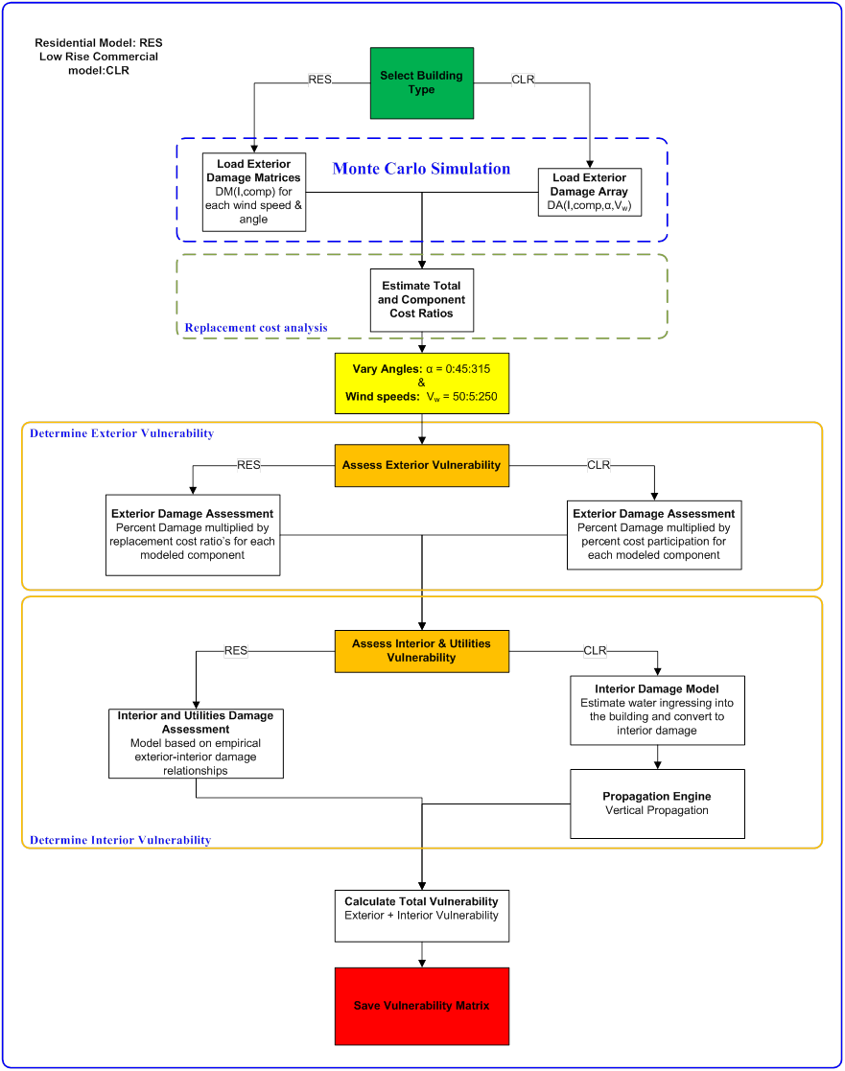
Figure 61. Procedure to create vulnerability matrix.
The flowchart in Figure 44 is also partially applicable to the apartment facades of the mid-/high-rise commercial residential model, in which building components modeled include windows, entry doors, and balcony (sliding-glass) doors. In the case of MHB, a process similar to the one described above is followed to derive exterior vulnerability and breach curves for different openings of typical apartment units. These curves are derived for the cases of open and closed buildings, for corner and middle units, with different opening protections (with or without impact-resistant glass; with or without metal shutters). Each vulnerability curve for openings of corner or middle apartment units (window, door, or slider) gives the number or fraction of openings damaged as a function of wind speed. Each breach curve for openings of corner or middle apartment units (window, door, or slider) gives the breach area in ft² of opening damaged as a function of wind speed.

The flow chart in Figure 45 summarizes the procedure used to convert the apartment unit opening vulnerability and breach curves into an overall estimate of building vulnerability. This figure is already presented in Standard G-1, as Figure 17 where the values represented in the flow chart are explained in detail.

Figure 62. Exterior and interior damage assessment for MHB.

- Describe the nature and extent of actual insurance claims data used to develop the model’s building vulnerability functions. Describe in detail what is included, such as, number of policies, number of insurers, date of loss, and number of units of dollar exposure, separated into personal residential, commercial residential, and mobile home.

Pre-2004 Personal Residential Claim Data
At the request of the Florida Department of Financial Services (FDFS), four insurance companies provided insurance claims data for several hurricanes that impacted Florida prior to 2004, including Andrew. The companies provided the following two types of files:
1. Sample files with 10% of the exposure selected at random, plus the claims on this 10% exposure since 1996
2. Hurricane files with premium files for all hurricane claims since 1996, plus all the corresponding claim data since 1996
Because of a confidentiality agreement, these companies will remain anonymous; they will be referred to as Company A, B, C, or D. These companies represent between 75% and 85% of the insured exposure in the state and approximately 70% of the claims. Most of the data provided come only from minor hurricanes and tropical storms that impacted Florida between 1994 and 2002.

Company A provided the only significant data for storms prior to 2004, in particular for Hurricane Andrew, as shown in Table 13. Wind speed estimates are also available, so validation efforts were primarily concentrated on the use of these data. Attempts were made to make use of additional data from Hurricane Opal and other storms. However, the amount of processed data available was too small to be statistically significant for validation.

Table 18. Summary of processed claims data (number of claims provided).
 | Hurricane Andrew | Hurricane Georges | Hurricane Opal | Tropical Storm Irene | Tropical Storm Earl | Hurricane Erin
Company A
Masonry | 78636 | 266 | 1973 | 3638 | 59 | 11460
Timber | 1603 | 1078 | 9166 | 776 | 89 | 11878
Manufactured | 1775 | 0 | 256 | 184 | 16 | 690

Note: Only building, contents, and appurtenant structure claims were provided by Company A (ALE was not provided).

2004 Personal Residential Claim Data

Claims data for the 2004 hurricane season from a series of insurance companies were also used to validate the FPHLM. Although 21 companies submitted data for a total of almost 675,000 claims, only two main companies are detailed here. These two companies (they will be referred as Company 1 and Company 2) represent 386,000 claims, mainly for site-built homes. These claims are divided between Hurricanes Charley, Frances, and Jeanne for central Florida, and Hurricane Ivan for the Panhandle. The validation consists of a series of comparisons between the actual claim data and the FPHLM results. The claims files were provided by the insurance companies. Table 14, Table 15, and Table 16 show the number of policies provided by the two companies for the four different hurricanes in 2004. As expected, there are more masonry claims in central Florida and more timber claims in the Panhandle. The claim data for Ivan was not used in the validation process because it was contaminated by storm surge damage.

Table 19. Company 1: Claim number for each year-build category
Company | Hurricane | Construction | Year Built | Number of Claims
Company 1 | Charley | Masonry | yb<1970 | 5026
Company 1 | Charley | Masonry | 1970<=yb<1984 | 8216
Company 1 | Charley | Masonry | 1984<=yb<1994 | 11850
Company 1 | Charley | Masonry | yb>=1994 | 8110
Company 1 | Charley | Frame | yb<1970 | 956
Company 1 | Charley | Frame | 1970<=yb<1984 | 1232
Company 1 | Charley | Frame | 1984<=yb<1994 | 3044
Company 1 | Charley | Frame | yb>=1994 | 677
Company 1 | Charley | Manufactured | yb<1994 | 2966
Company 1 | Charley | Manufactured | yb>=1994 | 212
Company 1 | Frances | Masonry | yb<1970 | 5009
Company 1 | Frances | Masonry | 1970<=yb<1984 | 6989
Company 1 | Frances | Masonry | 1984<=yb<1994 | 7903
Company 1 | Frances | Masonry | yb>=1994 | 4384
Company 1 | Frances | Frame | yb<1970 | 902
Company 1 | Frances | Frame | 1970<=yb<1984 | 2081
Company 1 | Frances | Frame | 1984<=yb<1994 | 5648
Company 1 | Frances | Frame | yb>=1994 | 721
Company 1 | Frances | Manufactured | yb<1994 | 3186
Company 1 | Frances | Manufactured | yb>=1994 | 222
Company 1 | Ivan | Masonry | yb<1970 | 2029
Company 1 | Ivan | Masonry | 1970<=yb<1984 | 2099
Company 1 | Ivan | Masonry | 1984<=yb<1994 | 1719
Company 1 | Ivan | Masonry | yb>=1994 | 1769
Company 1 | Ivan | Frame | yb<1970 | 3048
Company 1 | Ivan | Frame | 1970<=yb<1984 | 3956
Company 1 | Ivan | Frame | 1984<=yb<1994 | 4829
Company 1 | Ivan | Frame | yb>=1994 | 3890
Company 1 | Ivan | Manufactured | yb<1994 | 634
Company 1 | Ivan | Manufactured | yb>=1994 | 79
Company 1 | Jeanne | Masonry | yb<1970 | 3601
Company 1 | Jeanne | Masonry | 1970<=yb<1984 | 5274
Company 1 | Jeanne | Masonry | 1984<=yb<1994 | 5698
Company 1 | Jeanne | Masonry | yb>=1994 | 4999
Company 1 | Jeanne | Frame | yb<1970 | 825
Company 1 | Jeanne | Frame | 1970<=yb<1984 | 1386
Company 1 | Jeanne | Frame | 1984<=yb<1994 | 3430
Company 1 | Jeanne | Frame | yb>=1994 | 674
Company 1 | Jeanne | Manufactured | yb<1994 | 2717
Company 1 | Jeanne | Manufactured | yb>=1994 | 177

Table 20. Company 2: Claim number for each year-built category.
Company | Hurricane | Construction | Year Built | Number of Claims
Company 2 | Charley | Masonry | yb<1970 | 8677
Company 2 | Charley | Masonry | 1970<=yb<1984 | 15085
Company 2 | Charley | Masonry | 1984<=yb<1994 | 18324
Company 2 | Charley | Masonry | yb>=1994 | 6376
Company 2 | Charley | Frame | yb<1970 | 1920
Company 2 | Charley | Frame | 1970<=yb<1984 | 1782
Company 2 | Charley | Frame | 1984<=yb<1994 | 3786
Company 2 | Charley | Frame | yb>=1994 | 443
Company 2 | Charley | Manufactured | yb<1994 | 1843
Company 2 | Charley | Manufactured | yb>=1994 | 159
Company 2 | Frances | Masonry | yb<1970 | 8276
Company 2 | Frances | Masonry | 1970<=yb<1984 | 11978
Company 2 | Frances | Masonry | 1984<=yb<1994 | 11394
Company 2 | Frances | Masonry | yb>=1994 | 3224
Company 2 | Frances | Frame | yb<1970 | 1453
Company 2 | Frances | Frame | 1970<=yb<1984 | 3202
Company 2 | Frances | Frame | 1984<=yb<1994 | 7731
Company 2 | Frances | Frame | yb>=1994 | 601
Company 2 | Frances | Manufactured | yb<1994 | 1590
Company 2 | Frances | Manufactured | yb>=1994 | 131
Company 2 | Ivan | Masonry | yb<1970 | 1399
Company 2 | Ivan | Masonry | 1970<=yb<1984 | 746
Company 2 | Ivan | Masonry | 1984<=yb<1994 | 449
Company 2 | Ivan | Masonry | yb>=1994 | 275
Company 2 | Ivan | Frame | yb<1970 | 4004
Company 2 | Ivan | Frame | 1970<=yb<1984 | 5546
Company 2 | Ivan | Frame | 1984<=yb<1994 | 4637
Company 2 | Ivan | Frame | yb>=1994 | 2229
Company 2 | Ivan | Manufactured | yb<1994 | 171
Company 2 | Ivan | Manufactured | yb>=1994 | 41
Company 2 | Jeanne | Masonry | yb<1970 | 6907
Company 2 | Jeanne | Masonry | 1970<=yb<1984 | 10767
Company 2 | Jeanne | Masonry | 1984<=yb<1994 | 9629
Company 2 | Jeanne | Masonry | yb>=1994 | 4176
Company 2 | Jeanne | Frame | yb<1970 | 1555
Company 2 | Jeanne | Frame | 1970<=yb<1984 | 2087
Company 2 | Jeanne | Frame | 1984<=yb<1994 | 4561
Company 2 | Jeanne | Frame | yb>=1994 | 484
Company 2 | Jeanne | Manufactured | yb<1994 | 1401
Company 2 | Jeanne | Manufactured | yb>=1994 | 128

Table 21. Company 1 and Company 2: Claim numbers combined.
Company | Hurricane | Construction | Number of Claims
Company 1 | Charley | Masonry | 33202
Company 1 | Charley | Frame | 5909
Company 1 | Charley | Manufactured | 3178
Company 1 | Charley | Other | 260
Company 1 | Frances | Masonry | 24285
Company 1 | Frances | Frame | 9352
Company 1 | Frances | Manufactured | 3408
Company 1 | Frances | Other | 566
Company 1 | Ivan | Masonry | 7616
Company 1 | Ivan | Frame | 15723
Company 1 | Ivan | Manufactured | 713
Company 1 | Ivan | Other | 100
Company 1 | Jeanne | Masonry | 19572
Company 1 | Jeanne | Frame | 6315
Company 1 | Jeanne | Manufactured | 2894
Company 1 | Jeanne | Other | 331
Company 2 | Charley | Masonry | 48462
Company 2 | Charley | Frame | 7931
Company 2 | Charley | Manufactured | 2002
Company 2 | Charley | Other | 582
Company 2 | Frances | Masonry | 34872
Company 2 | Frances | Frame | 12987
Company 2 | Frances | Manufactured | 1721
Company 2 | Frances | Other | 1134
Company 2 | Ivan | Masonry | 2869
Company 2 | Ivan | Frame | 16416
Company 2 | Ivan | Manufactured | 212
Company 2 | Ivan | Other | 87
Company 2 | Jeanne | Masonry | 31479
Company 2 | Jeanne | Frame | 8687
Company 2 | Jeanne | Manufactured | 1529
Company 2 | Jeanne | Other | 1167

The claims are divided by the type of coverage for structure and contents. Company 1 has two types of coverage, replacement cost and actual cash value, but does not specify whether both structure and contents have the same coverage for each claim.

For Company 2, there are six types of coverage, as shown below.

ACV S/ACV C Structure Actual-Cash-Value, Contents Actual-Cash-Value
ACV S/RC C Structure Actual-Cash-Value, Contents Replacement-Cost
RC S/ACV C Structure Replacement-Cost, Contents Actual-Cash-Value
RC S/RC C Structure Replacement-Cost, Contents Replacement-Cost
SV S/RC C Structure Stated-Value, Contents Replacement-Cost
SV S/SV C Structure Stated-Value, Contents Stated-Value

Table 17a and Table 17b summarize the distribution of claims in both companies.

Table 22a. Distribution of coverage for Company 1.

Coverage | Premium Policy Count |  | Claim Policy Count
A | 44020 | 1% | 2759 | 2%
R | 3706219 | 99% | 163692 | 98%
Total | 3750240 |  | 166451

Table 22b. Distribution of coverage for Company 2.
Coverage | Premium Policy Count |  | Claim Policy Count
ACV S/ACV C | 13173 | 3% | 3496 | 3%
ACV S/RC C | 44805 | 10% | 12150 | 9%
RC S/ACV C | 162122 | 35% | 41484 | 30%
RC S/RC C | 232688 | 51% | 77146 | 57%
SV S/RC C | 235 | 0% | 69 | 0%
SV S/SV C | 6019 | 1% | 1717 | 1%
Total | 459042 | 100% | 136062 | 100%

There are 29,372 claims with $0 losses (i.e., Loss structure + Loss app + Loss contents + Loss ALE = 0), though they are listed in the claim file of Company 2. They probably correspond to claims whose losses were lower than the deductible.

2004 Personal Residential Claim Data

New claim data for the 2004 hurricane season from a series of insurance companies were also used to validate the FPHLM. Four new insurance companies provided claim data for the 2004 hurricane season. They will be referred to as companies PR2 to 5-2004. Company PR5-2004 has only manufactured homes. See Table PR04a to q. The claim data for Ivan was not used in the validation process because it was contaminated by storm surge damage.

Table 23a. 2004 Personal Residential Claim Data

PR04a. Distribution of claims per hurricane for PR-2004 Companies.

 | PR2-2004 | PR3-2004 | PR4-2004 | PR5-2004
Charley | 12641 | 34149 | 289 | 8030
Frances | 12731 | 27866 | 200 | 7,301
Ivan | 6202 | 21424 | 31 | 817
Jeanne | 11547 | 19975 | 248 | 10,390

PR04b. Distribution of claims per coverage for PR-2004 Companies.

Year Built | PR2-2004 | PR3-2004 | PR4-2004 | PR5-2004
A | 0 | 155 | 0 | 0
R | 43121 | 103414 | 768 | 26,538

PR04c. Distribution of claims per construction type for PR-2004 Companies.

Exterior Wall | PR2-2004 | PR3-2004 | PR4-2004 | PR5-2004
Frame | 10760 | 23471 | 198 | 0
Manuf. Homes | 0 | 0 | 0 | 26,538
Masonry | 31673 | 79911 | 569 | 0
Other | 688 | 32 | 1 | 0

PR04d. Distribution of claims per story for PR-2004 Companies.

Stories | PR2-2004 | PR3-2004 | PR4-2004 | PR5-2004
1 | 0 | 0 | 0 | 26,538
2 | 0 | 0 | 0 | 0
Unknown | 43121 | 103,414 | 768 | 0

PR04e. Distribution of claims per era for PR-2004 Companies.

Year Built | PR2-2004 | PR3-2004 | PR4-2004 | PR5-2004
pre1960 | 1785 | 7854 | 125 | 0
1960-1970 | 3983 | 12033 | 102 | 0
1971-1980 | 8312 | 19,772 | 145 | 0
1981-1993 | 18621 | 46,525 | 276 | 0
1994-2001 | 5545 | 14,436 | 91 | 0
2002-present | 4875 | 2,785 | 29 | 0
MH pre-1994 | 0 | 0 | 0 | 22172
MH 1994-present | 0 | 0 | 0 | 4366

PR04f. Distribution of claims per era for PR-2004 Companies, for hurricane Charley, and construction types Frame and Manufactured Homes.

Year Built | PR2-2004 | PR3-2004 | PR4-2004 | PR5-2004
pre1960 | 119 | 535 | 20 | 0
1960-1970 | 80 | 190 | 2 | 0
1971-1980 | 212 | 471 | 3 | 0
1981-1993 | 956 | 2752 | 31 | 0
1994-2001 | 128 | 247 | 8 | 0
2002-present | 237 | 29 | 1 | 0
MH pre-1994 | 0 | 0 | 0 | 6665
MH 1994-present | 0 | 0 | 0 | 1365

PR04g. Distribution of claims per era for PR-2004 Companies, for hurricane Charley, and construction type Masonry

Year Built | PR2-2004 | PR3-2004 | PR4-2004 | PR5-2004
pre1960 | 409 | 1870 | 32 | 0
1960-1970 | 972 | 3051 | 37 | 0
1971-1980 | 1909 | 5478 | 46 | 0
1981-1993 | 4674 | 13668 | 64 | 0
1994-2001 | 1580 | 4877 | 34 | 0
2002-present | 1271 | 968 | 10 | 0

PR04h. Distribution of claims per era for PR-2004 Companies, for hurricane Charley, and construction type Other

Year Built | PR2-2004 | PR3-2004 | PR4-2004 | PR5-2004
pre1960 | 0 | 0 | 0 | 0
1960-1970 | 5 | 0 | 0 | 0
1971-1980 | 35 | 0 | 0 | 0
1981-1993 | 35 | 8 | 0 | 0
1994-2001 | 3 | 1 | 0 | 0
2002-present | 16 | 0 | 0 | 0

PR04i. Distribution of claims per era for PR-2004 Companies, for hurricane Frances, and construction type Frame and Manufactured Homes

Year Built | PR2-2004 | PR3-2004 | PR4-2004 | PR5-2004
pre1960 | 110 | 419 | 7 | 0
1960-1970 | 96 | 218 | 4 | 0
1971-1980 | 555 | 922 | 6 | 0
1981-1993 | 2845 | 5689 | 24 | 0
1994-2001 | 265 | 311 | 8 | 0
2002-present- | 358 | 30 | 3 | 0
MH pre-1994 | 0 | 0 | 0 | 6145
MH 1994-present | 0 | 0 | 0 | 1156

PR04j. Distribution of claims per era for PR-2004 Companies, for hurricane Frances, and construction type Masonry

Year Built | PR2-2004 | PR3-2004 | PR4-2004 | PR5-2004
pre1960 | 348 | 1433 | 15 | 0
1960-1970 | 1043 | 3181 | 27 | 0
1971-1980 | 1906 | 4770 | 34 | 0
1981-1993 | 3129 | 8165 | 56 | 0
1994-2001 | 954 | 2206 | 15 | 0
2002-present | 864 | 511 | 1 | 0

PR04k. Distribution of claims per era for PR-2004 Companies, for hurricane Frances, and construction type Other

Year Built | PR2-2004 | PR3-2004 | PR4-2004 | PR5-2004
pre1960 | 0 | 0 | 0 | 0
1960-1970 | 8 | 0 | 0 | 0
1971-1980 | 50 | 2 | 0 | 0
1981-1993 | 114 | 4 | 0 | 0
1994-2001 | 5 | 3 | 0 | 0
2002-present | 81 | 0 | 0 | 0

PR04l. Distribution of claims per era for PR-2004 Companies, for hurricane Ivan, and construction type Frame and Manufactured Homes

Year Built | PR2-2004 | PR3-2004 | PR4-2004 | PR5-2004
pre1960 | 140 | 914 | 4 | 0
1960-1970 | 117 | 538 | 2 | 0
1971-1980 | 174 | 759 | 2 | 0
1981-1993 | 626 | 3292 | 4 | 0
1994-2001 | 302 | 1636 | 0 | 0
2002-present- | 273 | 223 | 0 | 0
MH pre-1994 | 0 | 0 | 0 | 620
MH 1994-present | 0 | 0 | 0 | 197

PR04m. Distribution of claims per era for PR-2004 Companies, for hurricane Ivan, and construction type Masonry

Year Built | PR2-2004 | PR3-2004 | PR4-2004 | PR5-2004
pre1960 | 151 | 1,207 | 4 | 0
1960-1970 | 624 | 2,557 | 4 | 0
1971-1980 | 1279 | 3,573 | 3 | 0
1981-1993 | 1320 | 4,087 | 6 | 0
1994-2001 | 676 | 2,251 | 2 | 0
2002-present | 467 | 378 | 0 | 0

PR04n. Distribution of claims per era for PR-2004 Companies, for hurricane Ivan, and construction type Other

Year Built | PR2-2004 | PR3-2004 | PR4-2004 | PR5-2004
pre1960 | 1 | 0 | 0 | 0
1960-1970 | 0 | 0 | 0 | 0
1971-1980 | 12 | 1 | 0 | 0
1981-1993 | 23 | 2 | 0 | 0
1994-2001 | 3 | 3 | 0 | 0
2002-present | 13 | 1 | 0 | 0

PR04o. Distribution of claims per era for PR-2004 Companies, for hurricane Jeanne, and construction type Frame and Manufactured Homes

Year Built | PR2-2004 | PR3-2004 | PR4-2004 | PR5-2004
pre1960 | 137 | 376 | 16 | 0
1960-1970 | 81 | 166 | 2 | 0
1971-1980 | 399 | 493 | 9 | 0
1981-1993 | 1983 | 2939 | 30 | 0
1994-2001 | 276 | 296 | 10 | 0
2002-present- | 290 | 24 | 2 | 0
MH pre-1994 | 0 | 0 | 0 | 8742
MH 1994-present | 0 | 0 | 0 | 1648

PR04p. Distribution of claims per era for PR-2004 Companies, for hurricane Jeanne, and construction type Masonry

Year Built | PR2-2004 | PR3-2004 | PR4-2004 | PR5-2004
pre1960 | 369 | 1,100 | 26 | 0
1960-1970 | 951 | 2,132 | 24 | 0
1971-1980 | 1716 | 3,303 | 42 | 0
1981-1993 | 2795 | 5,915 | 61 | 0
1994-2001 | 1340 | 2,604 | 14 | 0
2002-present | 926 | 619 | 12 | 0

PR04q. Distribution of claims per era for PR-2004 Companies, for hurricane Jeanne, and construction type Other

Year Built | PR2-2004 | PR3-2004 | PR4-2004 | PR5-2004
pre1960 | 1 | 0 | 0 | 0
1960-1970 | 5 | 0 | 0 | 0
1971-1980 | 65 | 0 | 0 | 0
1981-1993 | 121 | 4 | 0 | 0
1994-2001 | 13 | 1 | 0 | 0
2002-present | 79 | 2 | 0 | 0

2005 Personal Residential Claim Data
Claims data for the 2005 hurricane season from a series of insurance companies were also used to validate the FPHLM. Five insurance companies provided claim data for the 2005 hurricane season. They will be referred to as companies PR1 to 5-2005. Company PR5-2005 has only manufactured homes. See Table PR05a to q. The data for hurricane Rita was not used given the small number of claims.
Table 23b. 2005 Personal Residential Claim Data
PR05a. Distribution of claims per hurricane for PR-2005 Companies.

 | PR1-2005 | PR2-2005 | PR3-2005 | PR4-2005 | PR5-2005
Dennis | 3968 | 1251 | 3,467 | 9 | 232
Katrina | 5382 | 201 | 2,379 | 30 | 78
Rita | 56 | 34 | 0 | 1 | 4
Wilma | 62677 | 9247 | 21328 | 264 | 5,302

PR05b. Distribution of claims per coverage for PR-2005 Companies.

Year Built | PR1-2005 | PR2-2005 | PR3-2005 | PR4-2005 | PR5-2005
A | 5990 | 10733 | 43 | 304 | 0
R | 66093 | 0 | 27,131 | 0 | 5616

PR05c. Distribution of claims per construction type for PR-2005 Companies.

Exterior Wall | PR1-2005 | PR2-2005 | PR3-2005 | PR4-2005 | PR5-2005
Frame | 6920 | 1629 | 2,881 | 44 | 0
Manuf. Homes | 1402 | 0 | 0 | 0 | 5616
Masonry | 60475 | 8538 | 24,292 | 258 | 0
Other | 3286 | 566 | 1 | 2 | 0

PR05d. Distribution of claims per story for PR-2005 Companies.

Stories | PR1-2005 | PR2-2005 | PR3-2005 | PR4-2005 | PR5-2005
1 | 664 | 0 | 0 | 0 | 0
2 | 146 | 0 | 0 | 0 | 0
Unknown | 71273 | 10733 | 27,174 | 304 | 0

PR05e. Distribution of claims per era for PR-2005 Companies.

Year Built | PR1-2005 | PR2-2005 | PR3-2005 | PR4-2005 | PR5-2005
pre1960 | 6204 | 233 | 2,526 | 47 | 0
1960-1970 | 10865 | 770 | 3,715 | 58 | 0
1971-1980 | 18922 | 2441 | 7172 | 69 | 0
1981-1993 | 26412 | 4498 | 10202 | 98 | 0
1994-2001 | 7172 | 1571 | 2,908 | 28 | 0
2002-present | 1106 | 1220 | 649 | 4 | 0
MH pre-1994 | 1274 | 0 | 0 | 0 | 4227
MH 1994-present | 128 | 0 | 0 | 0 | 1389

PR05f. Distribution of claims per era for PR-2005 Companies, for hurricane Dennis, and construction type Frame.

Year Built | PR1-2005 | PR2-2005 | PR3-2005 | PR4-2005 | PR5-2005
pre1960 | 242 | 26 | 106 | 1 | 0
1960-1970 | 541 | 26 | 73 | 1 | 0
1971-1980 | 815 | 33 | 128 | 2 | 0
1981-1993 | 1046 | 112 | 452 | 0 | 0
1994-2001 | 573 | 77 | 422 | 0 | 0
2002-present | 66 | 45 | 59 | 0 | 0
MH pre-1994 | 36 | 0 | 0 | 0 | 162
MH 1994-present | 18 | 0 | 0 | 0 | 70

PR05g. Distribution of claims per era for PR-2005 Companies, for hurricane Dennis, and construction type Masonry

Year Built | PR1-2005 | PR2-2005 | PR3-2005 | PR4-2005 | PR5-2005
pre1960 | 93 | 21 | 150 | 1 | 0
1960-1970 | 175 | 110 | 324 | 1 | 0
1971-1980 | 140 | 237 | 537 | 2 | 0
1981-1993 | 124 | 255 | 535 | 1 | 0
1994-2001 | 70 | 218 | 562 | 0 | 0
2002-present- | 12 | 89 | 118 | 0 | 0

PR05h. Distribution of claims per era for PR-2005 Companies, for hurricane Dennis, and construction type Other

Year Built | PR1-2005 | PR2-2005 | PR3-2005 | PR4-2005 | PR5-2005
pre1960 | 0 | 0 | 0 | 0 | 0
1960-1970 | 0 | 0 | 0 | 0 | 0
1971-1980 | 6 | 0 | 0 | 0 | 0
1981-1993 | 11 | 1 | 0 | 0 | 0
1994-2001 | 0 | 0 | 1 | 0 | 0
2002-present | 0 | 1 | 0 | 0 | 0

PR05i. Distribution of claims per era for PR-2005 Companies, for hurricane Katrina, and construction type Frame

Year Built | PR1-2005 | PR2-2005 | PR3-2005 | PR4-2005 | PR5-2005
pre1960 | 60 | 1 | 25 | 0 | 0
1960-1970 | 40 | 1 | 8 | 0 | 0
1971-1980 | 43 | 3 | 10 | 0 | 0
1981-1993 | 91 | 9 | 52 | 0 | 0
1994-2001 | 44 | 3 | 20 | 0 | 0
2002-present | 8 | 4 | 6 | 0 | 0
MH pre-1994 | 45 | 0 | 0 | 0 | 68
MH 1994-present | 1 | 0 | 0 | 0 | 10

PR05j. Distribution of claims per era for PR-2005 Companies, for hurricane Katrina, and construction type Masonry

Year Built | PR1-2005 | PR2-2005 | PR3-2005 | PR4-2005 | PR5-2005
pre1960 | 969 | 10 | 410 | 12 | 0
1960-1970 | 1137 | 26 | 456 | 10 | 0
1971-1980 | 1428 | 48 | 583 | 4 | 0
1981-1993 | 1297 | 53 | 727 | 4 | 0
1994-2001 | 133 | 27 | 74 | 0 | 0
2002-present | 23 | 12 | 8 | 0 | 0

PR05k. Distribution of claims per era for PR-2005 Companies, for hurricane Katrina, and construction type Other

Year Built | PR1-2005 | PR2-2005 | PR3-2005 | PR4-2005 | PR5-2005
pre1960 | 1 | 0 | 0 | 0 | 0
1960-1970 | 14 | 0 | 0 | 0 | 0
1971-1980 | 31 | 1 | 0 | 0 | 0
1981-1993 | 13 | 2 | 0 | 0 | 0
1994-2001 | 4 | 0 | 0 | 0 | 0
2002-present | 0 | 1 | 0 | 0 | 0

PR05l. Distribution of claims per era for PR-2005 Companies, for hurricane Rita, and construction type Frame

Year Built | PR1-2005 | PR2-2005 | PR3-2005 | PR4-2005 | PR5-2005
pre1960 | 0 | 0 | 0 | 0 | 0
1960-1970 | 1 | 0 | 0 | 0 | 0
1971-1980 | 1 | 2 | 0 | 0 | 0
1981-1993 | 0 | 1 | 0 | 1 | 0
1994-2001 | 0 | 0 | 0 | 0 | 0
2002-present | 0 | 2 | 0 | 0 | 0
MH pre-1994 | 1 | 0 | 0 | 0 | 4
MH 1994-present | 0 | 0 | 0 | 0 | 0

PR05m. Distribution of claims per era for PR-2005 Companies, for hurricane Rita, and construction type Masonry

Year Built | PR1-2005 | PR2-2005 | PR3-2005 | PR4-2005 | PR5-2005
pre1960 | 6 | 1 | 0 | 0 | 0
1960-1970 | 13 | 2 | 0 | 0 | 0
1971-1980 | 14 | 7 | 0 | 0 | 0
1981-1993 | 17 | 7 | 0 | 0 | 0
1994-2001 | 2 | 10 | 0 | 0 | 0
2002-present | 0 | 1 | 0 | 0 | 0

PR05n. Distribution of claims per era for PR-2005 Companies, for hurricane Rita, and construction type Other

Year Built | PR1-2005 | PR2-2005 | PR3-2005 | PR4-2005 | PR5-2005
pre1960 | 0 | 0 | 0 | 0 | 0
1960-1970 | 0 | 0 | 0 | 0 | 0
1971-1980 | 1 | 0 | 0 | 0 | 0
1981-1993 | 0 | 1 | 0 | 0 | 0
1994-2001 | 0 | 0 | 0 | 0 | 0
2002-present | 0 | 0 | 0 | 0 | 0

PR05o. Distribution of claims per era for PR-2005 Companies, for hurricane Wilma, and construction type Frame

Year Built | PR1-2005 | PR2-2005 | PR3-2005 | PR4-2005 | PR5-2005
pre1960 | 323 | 32 | 99 | 2 | 0
1960-1970 | 151 | 51 | 47 | 1 | 0
1971-1980 | 546 | 213 | 212 | 7 | 0
1981-1993 | 2136 | 786 | 1084 | 25 | 0
1994-2001 | 164 | 114 | 70 | 4 | 0
2002-present | 29 | 88 | 8 | 0 | 0
MH pre-1994 | 1192 | 0 | 0 | 0 | 3993
MH 1994-present | 109 | 0 | 0 | 0 | 1309

PR05p. Distribution of claims per era for PR-2005 Companies, for hurricane Wilma, and construction type Masonry

Year Built | PR1-2005 | PR2-2005 | PR3-2005 | PR4-2005 | PR5-2005
pre1960 | 4484 | 142 | 1736 | 31 | 0
1960-1970 | 8567 | 542 | 2,807 | 45 | 0
1971-1980 | 14288 | 1721 | 5702 | 54 | 0
1981-1993 | 20430 | 3079 | 7352 | 65 | 0
1994-2001 | 6089 | 1103 | 1759 | 24 | 0
2002-present- | 964 | 817 | 450 | 4 | 0

PR05q. Distribution of claims per era for PR-2005 Companies, for hurricane Wilma, and construction type Other

Year Built | PR1-2005 | PR2-2005 | PR3-2005 | PR4-2005 | PR5-2005
pre1960 | 26 | 0 | 0 | 0 | 0
1960-1970 | 226 | 12 | 0 | 0 | 0
1971-1980 | 1609 | 176 | 0 | 0 | 0
1981-1993 | 1247 | 192 | 0 | 2 | 0
1994-2001 | 93 | 19 | 0 | 0 | 0
2002-present- | 4 | 160 | 0 | 0 | 0

Commercial Residential Claim Data

Claims data from the 2004 and the 2005 hurricane seasons for commercial residential from four insurance companies (referred to as companies CR1 to 4) were also used to validate the commercial residential module of the FPHLM. The details are given below, for low rise commercial and for mid/high rise commercial, in Tables CR04-LRa to q, CR05-LRa to n, CR04-MRa to q, and CR05-MRa to k. The vast majority of the claims are for low-rise 1 and 2 story buildings.

The policies for company CR2 included commercial line accounts (CLA) for condominium association, apartment building, and homeowners association policies, and the policies for company CR3 included high risk accounts (HRA) in coastal areas.

2004 Low Rise Commercial Residential Claim Data

It is clear from Tables CR04-LRa to q that the vast majority of LR 2004 claim data consists of masonry one and two story tall pre-1994 buildings.

Table 23c. 2004 Low Rise Commercial Residential Claim Data

CR04-LRa. Distribution of claims per hurricane for CR LR 2004 companies.

 | CR1-LR04 | CR2-LR04 | CR3-LR04
Charley | 575 | 11 | 182
Frances | 691 | 78 | 808
Ivan | 166 | 0 | 0
Jeanne | 285 | 12 | 280

CR04-LRb. Distribution of claims per coverage for CR LR 2004 companies.

Year Built | CR1-LR04 | CR2-LR04 | CR3-LR04
A | 0 | 0 | 0
R | 1717 | 0 | 0
Not Provided | 0 | 101 | 1270

CR04-LRc. Distribution of claims per construction type for CR LR 2004 companies.

Exterior Wall | CR1-LR04 | CR2-LR04 | CR3-LR04
Frame | 405 | 28 | 240
Masonry | 1204 | 73 | 1030
Other | 108 | 0 | 0

CR04-LRd. Distribution of claims per story for CR LR 2004 companies.

Stories | CR1-LR04 | CR2-LR04 | CR3-LR04
1 | 806 | 24 | 441
2 | 789 | 69 | 677
3 | 122 | 8 | 152

CR04-LRe. Distribution of claims per era for CR LR 2004 companies.

Year Built | CR1-LR04 | CR2-LR04 | CR3-LR04
pre1960 | 69 | 1 | 273
1960-1970 | 155 | 28 | 279
1971-1980 | 452 | 31 | 389
1981-1993 | 987 | 41 | 286
1994-2001 | 51 | 0 | 34
2002-present | 3 | 0 | 9

CR04-LRf. Distribution of claims per era for CR LR 2004 companies, for hurricane Charley, and construction type Frame.

Year Built | CR1-LR04 | CR2-LR04 | CR3-LR04
pre1960 | 12 | 0 | 20
1960-1970 | 1 | 0 | 11
1971-1980 | 6 | 7 | 19
1981-1993 | 50 | 4 | 20
1994-2001 | 2 | 0 | 2
2002-present | 0 | 0 | 0

CR04-LRg. Distribution of claims per era for CR LR 2004 companies, for hurricane Charley, and construction type Masonry.

Year Built | CR1-LR04 | CR2-LR04 | CR3-LR04
pre1960 | 10 | 0 | 12
1960-1970 | 33 | 0 | 17
1971-1980 | 153 | 0 | 45
1981-1993 | 290 | 0 | 26
1994-2001 | 9 | 0 | 10
2002-present | 0 | 0 | 0

CR04-LRh. Distribution of claims per era for CR LR 2004 companies, for hurricane Charley, and construction type Other.

Year Built | CR1-LR04 | CR2-LR04 | CR3-LR04
pre1960 | 0 | 0 | 0
1960-1970 | 0 | 0 | 0
1971-1980 | 3 | 0 | 0
1981-1993 | 6 | 0 | 0
1994-2001 | 0 | 0 | 0
2002-present | 0 | 0 | 0

CR04-LRi. Distribution of claims per era for CR LR 2004 companies, for hurricane Frances, and construction type Frame.

Year Built | CR1-LR04 | CR2-LR04 | CR3-LR04
pre1960 | 8 | 1 | 58
1960-1970 | 3 | 0 | 11
1971-1980 | 6 | 3 | 22
1981-1993 | 119 | 7 | 33
1994-2001 | 12 | 0 | 3
2002-present | 0 | 0 | 0

CR04-LRj. Distribution of claims per era for CR LR 2004 companies, for hurricane Frances, and construction type Masonry.

Year Built | CR1-LR04 | CR2-LR04 | CR3-LR04
pre1960 | 11 | 0 | 111
1960-1970 | 69 | 25 | 169
1971-1980 | 152 | 17 | 214
1981-1993 | 206 | 25 | 165
1994-2001 | 11 | 0 | 16
2002-present | 2 | 0 | 6

CR04-LRk. Distribution of claims per era for CR LR 2004 companies, for hurricane Frances, and construction type Other.

Year Built | CR1-LR04 | CR2-LR04 | CR3-LR04
pre1960 | 0 | 0 | 0
1960-1970 | 0 | 0 | 0
1971-1980 | 6 | 0 | 0
1981-1993 | 85 | 0 | 0
1994-2001 | 1 | 0 | 0
2002-present | 0 | 0 | 0

CR04-LRl. Distribution of claims per era for CR LR 2004 companies, for hurricane Ivan, and construction type Frame.

Year Built | CR1-LR04 | CR2-LR04 | CR3-LR04
pre1960 | 5 | 0 | 0
1960-1970 | 11 | 0 | 0
1971-1980 | 49 | 0 | 0
1981-1993 | 66 | 0 | 0
1994-2001 | 6 | 0 | 0
2002-present- | 0 | 0 | 0

CR04-LRm. Distribution of claims per era for CR LR 2004 companies, for hurricane Ivan, and construction type Masonry.

Year Built | CR1-LR04 | CR2-LR04 | CR3-LR04
pre1960 | 5 | 0 | 0
1960-1970 | 9 | 0 | 0
1971-1980 | 9 | 0 | 0
1981-1993 | 5 | 0 | 0
1994-2001 | 0 | 0 | 0
2002-present- | 0 | 0 | 0

CR04-LRn. Distribution of claims per era for CR LR 2004 companies, for hurricane Ivan, and construction type Other.

Year Built | CR1-LR04 | CR2-LR04 | CR3-LR04
pre1960 | 0 | 0 | 0
1960-1970 | 0 | 0 | 0
1971-1980 | 0 | 0 | 0
1981-1993 | 1 | 0 | 0
1994-2001 | 0 | 0 | 0
2002-present- | 0 | 0 | 0

CR04-LRo. Distribution of claims per era for CR LR 2004 companies, for hurricane Jeanne, and construction type Frame.

Year Built | CR1-LR04 | CR2-LR04 | CR3-LR04
pre1960 | 12 | 0 | 47
1960-1970 | 1 | 0 | 69
1971-1980 | 2 | 1 | 85
1981-1993 | 32 | 5 | 34
1994-2001 | 2 | 0 | 1
2002-present- | 0 | 0 | 3

CR04-LRp. Distribution of claims per era for CR LR 2004 companies, for hurricane Jeanne, and construction type Masonry.

Year Built | CR1-LR04 | CR2-LR04 | CR3-LR04
pre1960 | 6 | 0 | 47
1960-1970 | 28 | 3 | 69
1971-1980 | 64 | 3 | 85
1981-1993 | 124 | 0 | 34
1994-2001 | 7 | 0 | 1
2002-present- | 1 | 0 | 3

CR04-LRq. Distribution of claims per era for CR LR 2004 companies, for hurricane Jeanne, and construction type Other.

Year Built | CR1-LR04 | CR2-LR04 | CR3-LR04
pre1960 | 0 | 0 | 0
1960-1970 | 0 | 0 | 0
1971-1980 | 2 | 0 | 0
1981-1993 | 3 | 0 | 0
1994-2001 | 0 | 0 | 0
2002-present- | 0 | 0 | 0

2005 Low Rise Commercial Residential Claim Data

It is clear from Tables CR05-LRa to n that the vast majority of LR 2005 claim data consists of masonry one and two story tall pre-1994 buildings for hurricane Wilma.

Table 23d. 2005 Low Rise Commercial Residential Claim Data

CR05-LRa. Distribution of claims per hurricane for CR LR 2005 companies.

 | CR1-LR05 | CR2-LR05 | CR3-LR05 | CR4-LR05
Dennis | 22 | 0 | 0 | 0
Katrina | 68 | 81 | 186 | 0
Wilma | 1117 | 1356 | 2080 | 410

CR05-LRb. Distribution of claims per coverage for CR LR 2005 companies.

Year Built | CR1-LR05 | CR2-LR05 | CR3-LR05 | CR4-LR05
A | 0 | 0 | 0 | 0
R | 1207 | 0 | 0 | 0
Not Provided | 0 | 1437 | 2266 | 410

CR05-LRc. Distribution of claims per construction type for CR LR 2005 companies.

Exterior Wall | CR1-LR05 | CR2-LR05 | CR3-LR05 | CR4-LR05
Frame | 180 | 168 | 102 | 47
Masonry | 933 | 1269 | 2164 | 363
Other | 94 | 0 | 0 | 0

CR05-LRd. Distribution of claims per story for CR LR 2005 companies.

Stories | CR1-LR05 | CR2-LR05 | CR3-LR05 | CR4-LR05
1 | 645 | 458 | 955 | 180
2 | 498 | 863 | 1111 | 221
3 | 64 | 116 | 200 | 9

CR05-LRe. Distribution of claims per era for CR LR 2005 companies.

Year Built | CR1-LR05 | CR2-LR05 | CR3-LR05 | CR4-LR05
pre1960 | 3 | 112 | 644 | 0
1960-1970 | 98 | 229 | 743 | 0
1971-1980 | 279 | 501 | 559 | 6
1981-1993 | 811 | 578 | 270 | 119
1994-2001 | 16 | 17 | 35 | 196
2002-present | 0 | 0 | 15 | 89

CR05-LRf. Distribution of claims per era for CR LR 2005 companies, for hurricane Dennis, and construction type Frame.

Year Built | CR1-LR05 | CR2-LR05 | CR3-LR05 | CR4-LR05
pre1960 | 0 | 0 | 0 | 0
1960-1970 | 0 | 0 | 0 | 0
1971-1980 | 2 | 0 | 0 | 0
1981-1993 | 12 | 0 | 0 | 0
1994-2001 | 7 | 0 | 0 | 0
2002-present- | 0 | 0 | 0 | 0

CR05-LRg. Distribution of claims per era for CR LR 2005 companies, for hurricane Dennis, and construction type Masonry.

Year Built | CR1-LR05 | CR2-LR05 | CR3-LR05 | CR4-LR05
pre1960 | 0 | 0 | 0 | 0
1960-1970 | 0 | 0 | 0 | 0
1971-1980 | 1 | 0 | 0 | 0
1981-1993 | 0 | 0 | 0 | 0
1994-2001 | 0 | 0 | 0 | 0
2002-present- | 0 | 0 | 0 | 0

CR05-LRh. Distribution of claims per era for CR LR 2005 companies, for hurricane Dennis, and construction type Other.

Year Built | CR1-LR05 | CR2-LR05 | CR3-LR05 | CR4-LR05
pre1960 | 0 | 0 | 0 | 0
1960-1970 | 0 | 0 | 0 | 0
1971-1980 | 0 | 0 | 0 | 0
1981-1993 | 0 | 0 | 0 | 0
1994-2001 | 0 | 0 | 0 | 0
2002-present | 0 | 0 | 0 | 0

CR05-LRi. Distribution of claims per era for CR LR 2005 companies, for hurricane Katrina, and construction type Frame.

Year Built | CR1-LR05 | CR2-LR05 | CR3-LR05 | CR4-LR05
pre1960 | 0 | 0 | 2 | 0
1960-1970 | 0 | 0 | 0 | 0
1971-1980 | 1 | 0 | 1 | 0
1981-1993 | 2 | 6 | 1 | 0
1994-2001 | 0 | 0 | 0 | 0
2002-present | 0 | 0 | 0 | 0

CR05-LRj. Distribution of claims per era for CR LR 2005 companies, for hurricane Katrina, and construction type Masonry.

Year Built | CR1-LR05 | CR2-LR05 | CR3-LR05 | CR4-LR05
pre1960 | 0 | 13 | 62 | 0
1960-1970 | 3 | 9 | 61 | 0
1971-1980 | 4 | 29 | 29 | 0
1981-1993 | 54 | 23 | 23 | 0
1994-2001 | 0 | 1 | 5 | 0
2002-present | 0 | 0 | 2 | 0

CR05-LRk. Distribution of claims per era for CR LR 2005 companies, for hurricane Katrina, and construction type Other.

Year Built | CR1-LR05 | CR2-LR05 | CR3-LR05 | CR4-LR05
pre1960 | 0 | 0 | 0 | 0
1960-1970 | 0 | 0 | 0 | 0
1971-1980 | 0 | 0 | 0 | 0
1981-1993 | 4 | 0 | 0 | 0
1994-2001 | 0 | 0 | 0 | 0
2002-present | 0 | 0 | 0 | 0

CR05-LRl. Distribution of claims per era for CR LR 2005 companies, for hurricane Wilma, and construction type Frame.

Year Built | CR1-LR05 | CR2-LR05 | CR3-LR05 | CR4-LR05
pre1960 | 2 | 4 | 46 | 0
1960-1970 | 93 | 0 | 20 | 0
1971-1980 | 248 | 11 | 12 | 0
1981-1993 | 525 | 147 | 19 | 9
1994-2001 | 4 | 0 | 1 | 29
2002-present | 0 | 0 | 0 | 9

CR05-LRm. Distribution of claims per era for CR LR 2005 companies, for hurricane Wilma, and construction type Masonry.

Year Built | CR1-LR05 | CR2-LR05 | CR3-LR05 | CR4-LR05
pre1960 | 1 | 95 | 534 | 0
1960-1970 | 93 | 220 | 662 | 0
1971-1980 | 248 | 461 | 517 | 6
1981-1993 | 525 | 402 | 227 | 110
1994-2001 | 4 | 16 | 29 | 167
2002-present | 0 | 0 | 13 | 80

CR05-LRn. Distribution of claims per era for CR LR 2005 companies, for hurricane Wilma, and construction type Other.

Year Built | CR1-LR05 | CR2-LR05 | CR3-LR05 | CR4-LR05
pre1960 | 0 | 0 | 0 | 0
1960-1970 | 1 | 0 | 0 | 0
1971-1980 | 21 | 0 | 0 | 0
1981-1993 | 64 | 0 | 0 | 0
1994-2001 | 4 | 0 | 0 | 0
2002-present | 0 | 0 | 0 | 0

2004 Mid/High Rise Commercial Residential Claim Data

Table 18e. 2004 Mid/High Rise Commercial Residential Claim Data

It is clear from Tables CR04-MRa to n that the number of MHR 2004 claims is very small. It consists mainly of masonry or other four to eleven story tall pre-1994 buildings.

CR04-MRa. Distribution of claims per hurricane for CR MHR 2004 companies.

 | CR1-MHR04 | CR2-MHR04 | CR3-MHR04
Charley | 23 | 4 | 34
Frances | 21 | 5 | 56
Jeanne | 4 | 0 | 15

CR04-MRb. Distribution of claims per coverage for CR MHR 2004 companies.

Year Built | CR1-MHR04 | CR2-MHR04 | CR3-MHR04
A | 0 | 0 | 0
R | 48 | 0 | 0
Not Provided | 0 | 9 | 105

CR04-MRc. Distribution of claims per construction type for CR MHR 2004 companies.

Exterior Wall | CR1-MHR04 | CR2-MHR04 | CR3-MHR04
Frame | 2 | 0 | 2
Masonry | 34 | 9 | 103
Other | 12 | 0 | 0

CR04-MRd. Distribution of claims per story for CR MHR 2004 companies.

Stories | CR1-MHR04 | CR2-MHR04 |  | CR3-MHR04
4 | 11 | 1 | 23
5 | 14 | 7 | 28
6 | 5 | 0 | 8
7 | 6 | 0 | 15
8 | 2 | 1 | 7
9 | 2 | 0 | 4
10 | 8 | 0 | 2
11 | 0 | 0 | 2
12 | 0 | 0 | 1
13 | 0 | 0 | 1
15 | 0 | 0 | 1
26 | 0 | 0 | 1
36 | 0 | 0 | 1
42 | 0 | 0 | 1

CR04-MRe. Distribution of claims per era for CR MHR 2004 companies.

Year Built | CR1-MHR04 | CR2-MHR04 | CR3-MHR04
pre1960 | 1 | 0 |  | 4
1960-1970 | 1 | 1 |  | 8
1971-1980 | 21 | 4 |  | 35
1981-1993 | 25 | 4 |  | 50
1994-2001 | 0 | 0 |  | 7
2002-present | 0 | 0 |  | 1

CR04-MRf. Distribution of claims per era for CR MHR 2004 companies, for hurricane Charley, and construction type Frame.

Year Built | CR1-MHR04 | CR2-MHR04 | CR3-MHR04
pre1960 | 0 | 0 | 0
1960-1970 | 0 | 0 | 0
1971-1980 | 0 | 0 | 0
1981-1993 | 0 | 0 | 0
1994-2001 | 0 | 0 | 0
2002-present | 0 | 0 | 0

CR04-MRg. Distribution of claims per era for CR MHR 2004 companies, for hurricane Charley, and construction type Masonry.

Year Built | CR1-MHR04 | CR2-MHR04 | CR3-MHR04
pre1960 | 0 | 0 | 0
1960-1970 | 0 | 0 | 2
1971-1980 | 10 | 4 | 9
1981-1993 | 10 | 0 | 20
1994-2001 | 0 | 0 | 3
2002-present | 0 | 0 | 0

CR04-MRh. Distribution of claims per era for CR MHR 2004 companies, for hurricane Charley, and construction type Other.

Year Built | CR1-MHR04 | CR2-MHR04 | CR3-MHR04
pre1960 | 0 | 0 | 0
1960-1970 | 0 | 0 | 0
1971-1980 | 1 | 0 | 0
1981-1993 | 2 | 0 | 0
1994-2001 | 0 | 0 | 0
2002-present | 0 | 0 | 0

CR04-MRi. Distribution of claims per era for CR MHR 2004 companies, for hurricane Frances, and construction type Frame.

Year Built | CR1-MHR04 | CR2-MHR04 | CR3-MHR04
pre1960 | 0 | 0 | 1
1960-1970 | 0 | 0 | 0
1971-1980 | 0 | 0 | 0
1981-1993 | 2 | 0 | 0
1994-2001 | 0 | 0 | 0
2002-present | 0 | 0 | 0

CR04-MRj. Distribution of claims per era for CR MHR 2004 companies, for hurricane Frances, and construction type Masonry.

Year Built | CR1-MHR04 | CR2-MHR04 | CR3-MHR04
pre1960 | 1 | 0 | 3
1960-1970 | 0 | 1 | 3
1971-1980 | 9 | 0 | 23
1981-1993 | 3 | 4 | 22
1994-2001 | 0 | 0 | 3
2002-present | 0 | 0 | 1

CR04-MRk. Distribution of claims per era for CR MHR 2004 companies, for hurricane Frances, and construction type Other.

Year Built | CR1-MHR04 | CR2-MHR04 | CR3-MHR04
pre1960 | 0 | 0 | 0
1960-1970 | 0 | 0 | 0
1971-1980 | 1 | 0 | 0
1981-1993 | 5 | 0 | 0
1994-2001 | 0 | 0 | 0
2002-present | 0 | 0 | 0

CR04-MRl. Distribution of claims per era for CR MHR 2004 companies, for hurricane Jeanne, and construction type Frame.

Year Built | CR1-MHR04 | CR2-MHR04 | CR3-MHR04
pre1960 | 0 | 0 | 0
1960-1970 | 0 | 0 | 0
1971-1980 | 0 | 0 | 0
1981-1993 | 0 | 0 | 1
1994-2001 | 0 | 0 | 0
2002-present | 0 | 0 | 0

CR04-MRm. Distribution of claims per era for CR MHR 2004 companies, for hurricane Jeanne, and construction type Masonry.

Year Built | CR1-MHR04 | CR2-MHR04 | CR3-MHR04
pre1960 | 0 | 0 | 0
1960-1970 | 0 | 0 | 3
1971-1980 | 0 | 0 | 3
1981-1993 | 1 | 0 | 7
1994-2001 | 0 | 0 | 1
2002-present | 0 | 0 | 0

CR04-MRn. Distribution of claims per era for CR MHR 2004 companies, for hurricane Jeanne, and construction type Other.

Year Built | CR1-MHR04 | CR2-MHR04 | CR3-MHR04
pre1960 | 0 | 0 | 0
1960-1970 | 1 | 0 | 0
1971-1980 | 0 | 0 | 0
1981-1993 | 2 | 0 | 0
1994-2001 | 0 | 0 | 0
2002-present | 0 | 0 | 0

2005 Mid/High Rise Commercial Residential Claim Data

It is clear from Tables CR05-MRa to k that the number of MHR 2005 claims is very small. It consists mainly of masonry four to ten story tall pre-1994 buildings for hurricane Wilma.

Table 23f. 2005 Mid/Hid Rise Commercial Residential Claim Data

CR05-MRa. Distribution of claims per hurricane for CR MHR 2005 companies.

 | CR1-MHR05 | CR2-MHR05 | CR3-MHR05 | CR4-MHR05
Katrina | 0 | 0 | 10 | 0
Wilma | 125 | 118 |  | 42

CR05-MRb. Distribution of claims per coverage for CR MHR 2005 companies.

Year Built | CR1-MHR05 | CR2-MHR05 | CR3-MHR05 | CR4-MHR05
A | 0 | 0 | 0 | 0
R | 126 | 0 | 0 | 0
Not Provided | 0 | 118 | 127 | 42

CR05-MRc. Distribution of claims per construction type for CR MHR 2005 companies.

Exterior Wall | CR1-MHR05 | CR2-MHR05 | CR3-MHR05 | CR4-MHR05
Frame | 0 | 0 | 1 | 0
Masonry | 107 | 118 | 127 | 42
Other | 19 | 0 | 0 | 0

CR05-MRd. Distribution of claims per story for CR MHR 2005 companies.

Stories | CR1-MHR05 | CR2-MHR05 | CR3-MHR05 | CR4-MHR05
4 | 64 | 70 | 54 | 40
5 | 17 | 37 | 29 | 0
6 | 8 | 3 | 12 | 0
7 | 13 | 2 | 6 | 0
8 | 9 | 1 | 7 | 0
9 | 4 | 4 | 3 | 0
10 | 11 | 1 | 3 | 0
11 | 0 | 0 | 1 | 0
14 | 0 | 0 | 2 | 0
15 | 0 | 0 | 2 | 0
16 | 0 | 0 | 2 | 0
17 | 0 | 0 | 0 | 2
18 | 0 | 0 | 1 | 0
19 | 0 | 0 | 1 | 0
22 | 0 | 0 | 1 | 0
23 | 0 | 0 | 1 | 0
29 | 0 | 0 | 1 | 0
31 | 0 | 0 | 1 | 0

CR05-MRe. Distribution of claims per era for CR MHR 2005 companies.

Year Built | CR1-MHR05 | CR2-MHR05 | CR3-MHR05 | CR4-MHR05
pre1960 | 1 | 0 | 8 | 0
1960-1970 | 1 | 6 | 42 | 0
1971-1980 | 52 | 52 | 38 | 0
1981-1993 | 65 | 60 | 34 | 28
1994-2001 | 7 | 0 | 3 | 12
2002-present | 0 | 0 | 2 | 2

CR05-MRf. Distribution of claims per era for CR MHR 2005 companies, for hurricane Katrina, and construction type Frame.

Year Built | CR1-MHR05 | CR2-MHR05 | CR3-MHR05 | CR4-MHR05
pre1960 | 0 | 0 | 0 | 0
1960-1970 | 0 | 0 | 0 | 0
1971-1980 | 0 | 0 | 0 | 0
1981-1993 | 0 | 0 | 0 | 0
1994-2001 | 0 | 0 | 0 | 0
2002-present | 0 | 0 | 0 | 0

CR05-MRg. Distribution of claims per era for CR MHR 2005 companies, for hurricane Katrina, and construction type Masonry.

Year Built | CR1-MHR05 | CR2-MHR05 | CR3-MHR05 | CR4-MHR05
pre1960 | 0 | 0 | 1 | 0
1960-1970 | 0 | 0 | 4 | 0
1971-1980 | 0 | 0 | 3 | 0
1981-1993 | 0 | 0 | 1 | 0
1994-2001 | 0 | 0 | 1 | 0
2002-present | 0 | 0 | 0 | 0

CR05-MRh. Distribution of claims per era for CR MHR 2005 companies, for hurricane Katrina, and construction type Other

Year Built | CR1-MHR05 | CR2-MHR05 | CR3-MHR05 | CR4-MHR05
pre1960 | 0 | 0 | 0 | 0
1960-1970 | 0 | 0 | 0 | 0
1971-1980 | 0 | 0 | 0 | 0
1981-1993 | 0 | 0 | 0 | 0
1994-2001 | 0 | 0 | 0 | 0
2002-present | 0 | 0 | 0 | 0

CR05-MRi. Distribution of claims per era for CR MHR 2005 companies, for hurricane Wilma, and construction type Frame

Year Built | CR1-MHR05 | CR2-MHR05 | CR3-MHR05 | CR4-MHR05
pre1960 | 0 | 0 | 0 | 0
1960-1970 | 0 | 0 | 0 | 0
1971-1980 | 0 | 0 | 0 | 0
1981-1993 | 0 | 0 | 1 | 0
1994-2001 | 0 | 0 | 0 | 0
2002-present | 0 | 0 | 0 | 0

CR05-MRj. Distribution of claims per era for CR MHR 2005 companies, for hurricane Wilma, and construction type Masonry

Year Built | CR1-MHR05 | CR2-MHR05 | CR3-MHR05 | CR4-MHR05
pre1960 | 1 | 0 | 7 | 0
1960-1970 | 1 | 6 | 38 | 0
1971-1980 | 40 | 52 | 35 | 0
1981-1993 | 57 | 60 | 32 | 28
1994-2001 | 7 | 0 | 2 | 12
2002-present | 0 | 0 | 2 | 2

CR05-MRk. Distribution of claims per era for CR MHR 2005 companies, for hurricane Wilma, and construction type Other

Year Built | CR1-MHR05 | CR2-MHR05 | CR3-MHR05 | CR4-MHR05
pre1960 | 0 | 0 | 0 | 0
1960-1970 | 0 | 0 | 0 | 0
1971-1980 | 11 | 0 | 0 | 0
1981-1993 | 8 | 0 | 0 | 0
1994-2001 | 0 | 0 | 0 | 0
2002-present | 0 | 0 | 0 | 0

- Describe the data, methods, and processes used for the development of the building vulnerability functions.

A detailed discussion of the support for the development of the vulnerability functions is contained within Standard G.1 and other disclosure items in Standard V.1.

- Summarize site inspections, including the source, and provide a brief description of the resulting use of these data in development, validation, or verification of building vulnerability functions.

The documentation and statistical analysis of damage caused by landfalling hurricanes has been conducted by a variety of stakeholders, including home builders trade associations (NAHB Research Center, 1993, 1996, 1999; Crandell, 1998), practicing engineers (Keith & Rose, 1994), government agencies (Oliver & Hanson, 1994; FEMA, 1992, 2006), and academic researchers (Kareem, 1985, 1986; Gurley, 2006; Gurley et al., 2006). Some of these studies provide a broad overview of structural performance (FEMA and NAHB reports). Others focus on a particular building component such as roofing (Croft et al., 2006; Meloy et al., 2007) or address a specific building type such as wood frame residential construction (van de Lindt et al., 2007). All such available public access literature regarding the performance of residential infrastructure in hurricane winds was reviewed and used as guidance for the development of the vulnerability model. Those studies that provide statistical assessments of damage to specific building components (Gurley, 2006; Gurley et al., 2006; Gurley and Masters, 2011; Meloy et al., 2007) were used as a means of validating the physical damage estimates of the model. Studies that are more qualitative in nature (e.g., FEMA reports) were used to provide guidance regarding the potential failure modes that were important to replicate in the model. For example, the common observation of gable end failures resulted in a gable end failure component in the model.

Several damage surveys were done in 2004. Damage from Hurricane Charley was reported across the state, and the most severe damage occurred where the eye made landfall near the cities of Punta Gorda and Port Charlotte. A team that consisted of approximately 30 members from UF, FIU, Clemson, and FIT, under the leadership of the Institute for Business & Home Safety (IBHS), surveyed the extent of the structural damage to homes and manufactured homes in these cities. For several days following the storm the team conducted a detailed statistical survey of damage in the impacted areas. Results of this survey can be found on the IBHS website http://www.ibhs.org/. Other information regarding the damage of Charley and other storms can be found at the Florida Tech Wind and Hurricane Impact Research Laboratory website, http://www.fit.edu/research/whirl/.

Damage from Hurricane Frances was surveyed in areas from Cocoa Beach to Stuart in eastern Florida. Although damage from Hurricane Frances was not as severe as that from Hurricane Charley, the same extensive survey conducted in Punta Gorda and Port Charlotte was also conducted in the impacted areas. Great efforts were made to monitor the strength and resulting damage from the storm as part of the Florida Coastal Monitoring Program. Towers were set up to record wind speeds along the coast in locations where the storm was forecasted to make landfall. Sensors to record the wind-induced pressure were deployed on the roofs of several homes. Following the storm, members of the same team that surveyed damage from Charley photographed and recorded damage throughout the area. Areas of Fort Pierce appeared to be hardest hit and damage was severe to many homes in some areas.

Similar efforts to monitor the winds and survey the damage were made for Hurricane Jeanne. Towers and pressure sensors were again deployed at various locations near where landfall was forecasted. After the storm, members of the team surveyed areas from Stuart to Cocoa Beach. These surveys consisted primarily of cataloging and photographing various observations of damage in the impacted areas, as was done with Hurricane Frances. Damage from Hurricane Jeanne in many locations was very similar to what was seen from Hurricane Frances. In many cases damage to structures that was initially caused by Frances was compounded by Hurricane Jeanne. Fatigue of structures from the winds of two hurricanes within three weeks most likely played a role in the most severe cases of damage in the areas such as Vero Beach and Fort Pierce. In some areas most of the weak trees and components of homes (shingles, screened porches, fences, etc.) were already damaged by Hurricane Frances, so when Hurricane Jeanne hit little or no further damage was seen. It is very difficult to tell what damage was caused by Hurricane Jeanne and what was caused by Hurricane Frances.

Additionally, engineers working on the physical damage model performed a detailed residential damage study after the 2004 hurricane season to assess the performance of housing built to the Florida Building Code and the Standard Building Code (Gurley, 2006; Gurley et al., 2006; Gurley and Masters, 2011). The data were collected as a part of a study conducted by UF and sponsored by the Florida Building Commission. Site-built single-family homes constructed after Hurricane Andrew-related changes to the standard building code went into effect were targeted for a detailed investigation of damage as a result of the 2004 hurricane season. This study provided a quantitative statistical comparison of the relative performance of homes built between 1994 and 2001 with the performance of those built after the 2001 Florida Building Code replaced the Standard Building Code. This evaluation was accomplished through a systematic survey of homes built from 1994 to 2004 in the areas that experienced the highest wind speeds from the 2004 storms (Charlotte, St. Lucie, Escambia, and Santa Rosa counties). A statistically significant number of homes (close to 200) were surveyed in these regions to define correlations between damage, age, and construction type. These relationships are referenced to maximum three-second gust wind speed via wind swath maps. An expanded and more detailed version of the conference publication (Gurley, 2006; Gurley et al., 2006) has recently appeared in the ASCE journal Natural Hazards Review. The data from this study were used to modify the residential component capacities as this model evolved. The final report from this study was submitted in the spring of 2006 to the Florida Building Commission. Another source of field data is the aerial imagery collected by NOAA after Hurricane Katrina. These images provided a quantification of shingle damage relative to estimated wind speed and were used to validate the roof cover damage output from the physical damage model.

- Describe the research used in the development of the model’s building vulnerability functions.

The engineering team adopted a “component approach” in the development of the vulnerability functions. Although a number of commercial loss projection models have been developed, only a handful of studies are available in the public domain to predict damage for hurricane prone areas. Boswell et al. (1999) attempted to predict the public costs of emergency management and recovery without taking into account losses to individual homeowners. In 1985, Berke et al. presented a computer system simulating economical and social losses caused by hurricane disasters, and a Vulnerability Assessment and Mapping System known as VAMS (Berke et al., 1984) enabled the user to consider various types of hurricanes with varying surges, wind patterns, and points of landfall. This information is of some interest, but it is not directly applicable to residential construction in Florida.

Most studies for residential losses use post-disaster investigations (FEMA, 1992) or available claims data to fit damage versus wind speed vulnerability curves. For example, a relationship between home damage from insurance data and wind speed was proposed for Typhoons Mireille and Flo (Mitsuta et al., 1996). A study by Holmes (1996) presented the vulnerability curve for a fully engineered building with strength assumed to have lognormal distribution but clearly indicated the need for more thorough post-disaster investigations to better define damage prediction models. A method for predicting the percentage of damage within an area as a function of wind speed and various other parameters was presented by Sill and Kozlowski (1997). The proposed method was intended to move away from curve fitting schemes, but its practical value was hampered by insufficient clarity and transparency. Huang et al. (2001) presented a risk assessment strategy based on an analytical expression for the vulnerability curve. The expression is obtained by regression techniques from insurance claims data for Hurricane Andrew. Khanduri and Morrow (2003) also presented a similar method of assessment of vulnerability and a methodology to translate known vulnerability curves from one region to another region. Although such approaches are simple, they are highly dependent on the type of construction and construction practices common to the areas represented in the claims data. Recent changes in building codes or construction practices cannot be adequately reflected by regression-derived vulnerability curves. In addition, damage curves obtained by regression from observed data can be misleading because very often, as was the case for Hurricane Andrew, few reliable wind speed data are available. In addition, damage curves regressed from observed data do not adequately represent the influence of primary storm characteristics such as central pressure, forward velocity, radius of maximum wind, the amount of rain, duration, and other secondary parameters such as demand surge and preparedness.

In contrast, a component approach explicitly accounts for both the resistance capacity of the various building components and the load effects produced by wind events to predict damage at various wind speeds. In the component approach the resistance capacity of a building can be broken down into the resistance capacity of its components and the connections between them. Damage to the structure occurs when the load effects from wind or flying debris are greater than the component’s capacity to resist them. Once the strength capacities, load demands, and load path(s) are identified and modeled, the vulnerability of a structure at various wind speeds can be estimated. Estimations are affected by uncertainties regarding both the behavior and strength of the various components and the load effects produced by hurricane winds.

The treatment of unknown construction types is treated in disclosure 10 of this Standard.

Research related to the interior damage module of the commercial residential model

The modelers developed a novel approach to assess interior damage. The method complements the component approach described above to compute the damage to the building envelope (Weekes et al., 2009). The method is summarized in Figure 46. The model estimates the amount of wind-driven rain that enters through the breaches and defects (also referred to as pre-existing deficiencies) in the building envelope and converts it to interior damage. The approach is described below.

Figure 63. Flowchart of the interior damage model.

The building components that the model considers for low rise buildings are roof cover, roof sheathing, wall cover, wall sheathing, gable cover, gable sheathing, windows, doors, and sliding doors. For an initial wind speed, the model starts loading the exterior damage array, expressed as breach areas of each component for thousands of simulation runs. An estimated area of existing defects or deficiencies in envelope components is also accounted for from surveys and engineering experience. It has been demonstrated that in buildings subjected to hurricane winds, the interior damage may start well before there are any breaches in the envelope (Mullens et al., 2006). The interior damage at this early stage is certainly nonnegligible and is caused by the building’s existing defects that may be hidden or not, such as cracks, poorly caulked electrical outlets and ventilation ducts, inadequately sealed windows and doors, soffits, baseboards, door thresholds, etc. (Lstiburek, 2005).

The quantification of existing defects is based on the surveys published in Mullens et al. (2006) and the American Society of Heating, Refrigerating and Air-Conditioning (ASHRAE) Handbook for estimating of the infiltration area. To capture the quality of the construction, the model applies defect densities depending on the building’s strength, which is related to the year built. Thus, strong buildings will have fewer defects than medium and weak buildings.

As an example Table 19 shows the values adopted for the defects related to windows, doors, and sliders for the case of mid-/high-rise buildings. These values are adopted from the ASHRAE (2001) Handbook.

Table 24. Defects values for mid-/high-rise building openings.
Windows masonry caulked | Defect area
cm²/m² | 1.3
ft²/ ft² | 0.00013
ft²/each | 0.0026
Frame plus door weatherized
cm²/each | 24
ft²/each | 0.0258
Slider
cm2/each | 22
ft²/each | 0.0237

More recent studies have shown that water ingress via wind driven rain cannot be attributed exclusively to envelope breach, installation, or product defects. Properly manufactured, installed, and caulked fenestration may nonetheless offer leakage paths in extreme wind conditions, the severity of which is highly dependent on the specific product (Salzano et al., 2010). As this line of research matures, its findings will be incorporated within the above framework.

In order to estimate water intrusion into the buildings, a study was performed to estimate the likely accumulated horizontally impinging rain on a structure during a hurricane event. This study used a simulation model that is composed of a simplified wind model and the R-CLIPER rain rate model developed at NOAA HRD (Lonfat et al., 2007) and is used operationally at NHC. The simplified wind model is based on Holland (1980) and includes parameters for the pressure profile ("B"), Rmax, translation speed and central pressure. Additionally, the Vickery (2005) pressure filling model was used to decay the storms. Storm parameters are sampled from distributions relevant to Florida. The R-CLIPER model determines the vertically free-falling rain rates at each time step of the simulation. The R-CLIPER rain rate is essentially an azimuthally averaged rain rate that varies as a function of radius and maximum intensity of the storm. A detailed presentation of this subject is presented in the General Standard.

The product of the areas of the breaches and defects by the impinging rain conveys the amount of water that enters the building. The water penetration at each story is computed as follows.

Water penetration through components defects or pre-existing deficiencies:

Water penetration through breaches:

Where:

h^{d}_{Ci}: height of water that accumulates due to defects in component i, in inches
h^{b}_{Ci}: height of water that accumulates due to envelope breaches in component i, in inches
k: adjustment factor
RAF: rain admittance factor
d_{Ci}: defects percentage
A_{Ci}: area of component i
A^{B}_{Ci}: breach area of component i
A_{b}: floor area
IR₁ : accumulated impinging rain prior to maximum wind
IR₂ : accumulated impinging rain after the occurrence of maximum wind
S_{Ci} : survival factor for component i = 1 – A^{B}_{Ci} / A_{Ci}

Rain admittance factor, RAF.

The rain admittance factor (RAF) is the fraction of the approaching rain that strikes the building. It accounts for the effect of a large portion of the rain moving around the structure with the wind rather than striking the building surface and is dependent on the building shape. Straube and Burnett (2000) and Blocken and Carmeliet (2010) suggest values for RAF between 0.2 and 0.5 for low-rise buildings and between less than 0.5 and 1.0 for mid-/high-rise buildings. Accordingly, the FPHLM adopts a value of 0.3 for the top and bottom stories of low rise buildings, and a value of 0.4 for the second story of a 3-story building; and, a value of 0.6 for mid-/high-rise buildings, except for the last story where a value of 1.0 is adopted. For soffits (low rise buildings), RAF = 0.15.

Accumulated impinging rain.

For low-rise commercial residential structures, the accumulated impinging rain IR1 and IR2 are sampled from the rain distributions at every wind speed in the rain simulation model. They are incorporated in the Monte Carlo simulations for exterior damage, and the equation for water penetration is applied for each simulation (row) of the exterior damage array to compute the vulnerability function.

For mid-/high-rise structures, the model uses the mean values of the accumulated impinging rain and of the opening breaches, both as a function of wind speed. Figure 47 shows the mean IR₁ and IR₂ as a function of peak 3-second gusts at 10 m. As shown in the figure, simple regressions were performed to facilitate calculations in the mid-/high-rise commercial residential loss module. Note that for very high wind speeds there is large sampling error as these are rare events; thus the relation between mean rain and wind speed is less reliable.

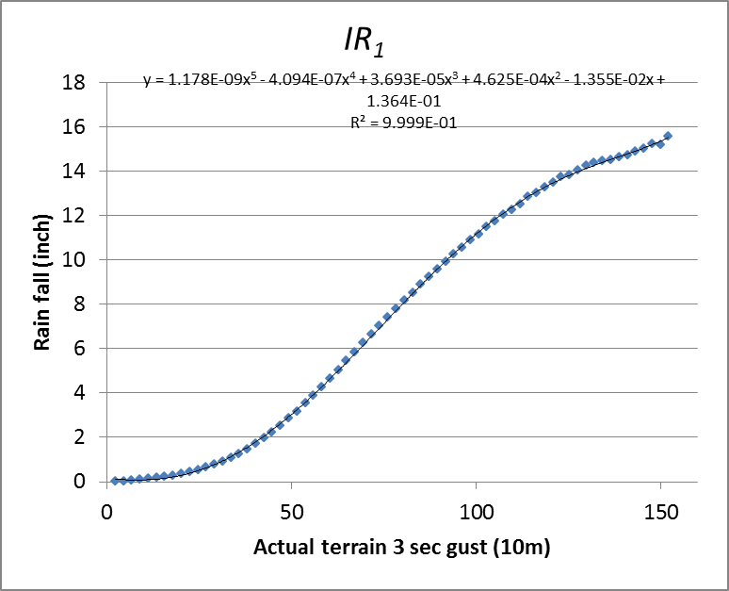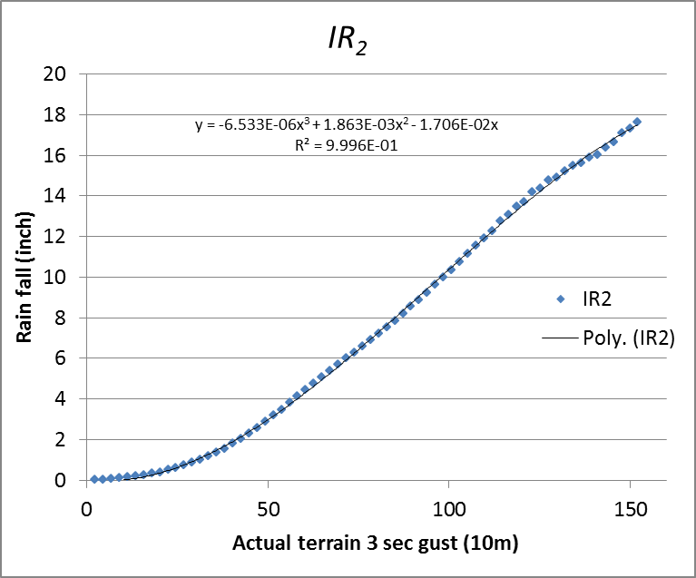
Figure 64. Mean accumulated impinging rain as a function of peak 3-second wind gust.

The adjustment factor k includes the following depending upon the portion of the structure under consideration.

Adjustment for distribution of breaches and defects in walls as a function of the wind direction, f_{sim}.

Only the windward walls are subjected to impinging rain. In other words, although positive and negative wind pressures produce damage in the whole building perimeter simultaneously, and also deficiencies are present throughout the building, impinging rain ingresses only through windward breaches. There are eight possible wind directions (four normal to a building face, four in the direction of a building corner). Each MC simulation gives an estimate of damage at a particular wind direction. But once the damage occurred, the wind will keep rotating and changing direction over the remaining duration of the storm. As a result, defects and breaches will progressively change from windward to leeward or vice-versa. Since the simulations are not time histories, it is impossible to compute exactly for how long a breach or defect will be on a windward side or on a leeward side. However, it is estimated that defects and window breaches, which are distributed on all 4 walls, have a 50% probability to be on a windward side during the duration of the storm, subjected to impinging rain. Doors and sliders defects and breaches, which are only on one wall of the building, are assigned a 25% probability of being on a windward side during the duration of the storm, subjected to impinging rain. Therefore f_{sim}=0.5 for windows defects and breaches, while f_{sim}=0.25 for doors and sliders defects and breaches.

Defects and breaches are arbitrarily distributed on the roof, and are assumed to be subjected to impinging rain regardless of their location on the roof with respect to the wind, and therefore the f_{sim} does not apply to roof.

Defects and breaches are arbitrarily distributed on the roof, and are assumed to be subjected to impinging rain regardless of their location on the roof with respect to the wind, and therefore the f_{sim} does not apply to roof.

Adjustment for projection of roof breach with respect to wind direction, f_{RedRoof}.

The above adjustment factor accounts for the probability that the wall defects and breaches will be exposed to windward wind and impinging rain. The f_{RedRoof} adjustment factor accounts for the orientation of the exposed roof openings relative to the wind (see Figure 48). If the wind is normal to the ridge, f_{RedRoof} =1.0 (the vertically projected surface area of the breach exposed to impinging rain is maximum). If the wind is parallel to the ridge, f_{RedRoof} is estimated to be 0.6 or 0.8 (for gable and hip respectively), based on engineering judgment since the vertically projected surface area of the breach exposed to impinging rain is minimum in this case. If the wind is at an angle with the ridge, f_{RedRoof} is assumed to be the average value between the two previous cases, f_{RedRoof} =0.8 or 0.9 (for gable and hip respectively). Since the roof defects and breaches can be distributed anywhere on the roof, and average value for the eight directions is adopted resulting in f_{RedRoof} =0.8 or 0.9 (for gable and hip respectively).

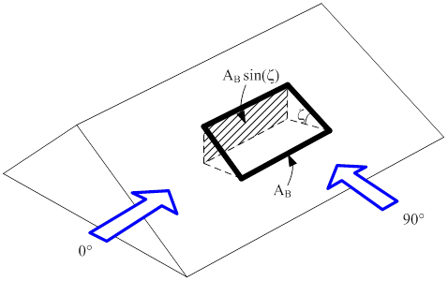
Figure 65. f_{RedRoof} represents the breached roof area that is exposed to impinging rain as a function of wind angle of attack.

Adjustment factor for gable-ends, f_{RedGbl}.

In the model, impinging rainwater ingresses the building defects or breaches through gable-ends only when the wind-driven rain is parallel to or at least 45 from the ridge. As the wind rotates, the f_{RedGbl} factor is zero for 5 of the 8 directions, and the value of f_{RedGbl} is averaged to 0.6.

Adjustment factor for runoff water,f_{RunWat}.

Some of the water that drains on the external surfaces of the building will ingress through the defects and breaches and into the building. For this purpose a factor f_{RunWat} for walls and roof, based on engineering judgment, is applied (Table 20). For wall openings and pre-existing deficiencies, the water entry increases due to runoff from story to story by 20%. Thus, in a 3-story building, the third-story factor is 1.0 (i.e. no running water is considered), the second-story factor is 1.2, and finally the first-story water intrusion is calculated using a factor of 1.4. In roofs, this factor accounts for the amount of water that falls upstream of the breach on a sloped roof but nevertheless ingresses in the building. The drain factor f_{runoff} in roofs increases the water intrusion by 20%. More research is needed to validate the adopted values through either laboratory tests or CFD. Recent efforts on modeling and measuring runoff water have been done by Blocken and Carmeliet, (2012).

Table 25. Value of f_{RunWat} for low-rise buildings walls
Number of Stories | 1 | 2 | 3
Roof | 1.2 | 1.2 | 1.2
3rd story | 1.0 | 1.0 | 1.0
2nd story |  | 1.2 | 1.2
1st story |  |  | 1.4

Water percolation

In multi-story low-rise buildings, a portion of the ingressed water percolates downward from story to story. The interior damage model assumes the percolation ρ to be 12% of the ingressed water at each story for low rise building (plywood floors) and 10 % for mid/high rise building (concrete slabs). These values of percolation are based on engineering judgment, supported by calibration of the model with the insurance claim data, and thus can be updated when new research becomes available.

Figure 49 illustrates the percolation mechanism, for water ingressing at a given story from pre-existing deficiencies and breaches in any component C_{i}. Upper story "j" gets rain from the pre-existing deficiencies and the breached openings, which is converted into the heights of ingressed water, and, respectively. A fraction of these water heights percolates down as and. Rain also enters in the second story "k" through pre-existing deficiencies and the openings as and, respectively.

Figure 66. Diagram of water intrusion through breaches, deficiencies and percolation in a 3-story building.

The total amount of water in story k of Figure 49 is thus:

Likewise, the total water height at the first story "l" of a 3-story building is:

Thus in 2-stories and 3-stories buildings, the first story gets the percolated water from the second story by adding a or to the water coming from deficiencies and breaches respectively. The amount of water percolating downward is not subtracted from the total amount of water at the story where it originated. It is assumed that even if water percolates downward, it still has the potential to produce damage before leaking downward.

In conclusion, this approach estimates the amount of water that enters through each component of the envelope. The total amount of water is calculated by adding the contributions of all components for a given wind speed, including percolation. The final step maps water inside the building to interior damage with a bilinear relationship, where total interior damage is achieved for a certain threshold of height of accumulated water (currently set at 1 inch).

- Describe the categories of the different building vulnerability functions. Specifically, include descriptions of the building types and characteristics, building height, number of stories, regions within the state of Florida, year of construction, and occupancy types in which a unique building vulnerability function is used. Provide the total number of building vulnerability functions available for use in the model for personal and commercial residential classifications.

Vulnerability functions were derived for manufactured and site-built homes, for low-rise commercial residential buildings (one to three stories), and for openings of apartment units of mid-/high-rise commercial residential buildings (four stories and higher).

A total of 17424 un-weighted vulnerability matrices were developed for site-built homes for building, contents, and ALE. The matrices correspond to different combinations of wall type (frame or masonry), region (north, central, south), subregion (high velocity hurricane zone, wind-borne debris region, inland), roof type (gable or hip), roof cover (metal, tile or shingle), window protection (shuttered or not shuttered), number of stories (one or two), and strength (weak, modified weak, retrofitted weak; medium, modified medium, retrofitted medium; strong for inland and WBDR, strong for HVHZ—see Tables 1a and 1b in the General Standards).

These 17424 un-weighted matrices were then combined to produce 20904 weighted matrices, and 1164 age weighted matrices for site-built homes for building, contents, and ALE, for each county. Many of the matrices are repeated because many of the counties use the same regional statistics for the weighting.

A total of 1296 un-weighted vulnerability matrices were developed for low-rise, commercial residential buildings for building, and interior. They correspond to different combinations of wall type (frame or masonry), sub-region (high velocity hurricane zone, wind-borne debris region, inland), roof shape (gable or hip), roof cover (metal, tile or shingle), window protection (shuttered or not shuttered), number of stories (one, two, or three), and strength (weak, medium, or strong).

These 1296 matrices were then combined to produce 144 weighted curves for low-rise, commercial residential buildings for building, and interior.

An interior vulnerability curve corresponds to each structure vulnerability curve. The contents and time-related expenses vulnerabilities are proportional to the interior vulnerabilities.

Finally, one appurtenant structure vulnerability matrix was derived for all site-built homes, all low-rise, commercial residential buildings, and all manufactured homes.

180 opening vulnerability curves and 180 associated breach curves were developed for openings of apartment units of mid-/high-rise commercial residential buildings. They correspond to different combinations of building layout (open or closed), unit floor location (corner or middle unit), impact debris zone (high density impact for stories 1 to 3, medium density impact for stories 4 to 7, and low density impact for stories 8 and higher), balconies (with or without sliders) and opening protection (none, impact resistant glass, or shutters).

12 un-weighted vulnerability matrices were developed for manufactured homes for building, contents, and ALE. They correspond to four manufactured home types: (1) pre-1994—fully tied down, (2) pre-1994—not tied down, (3) post-1994—Housing and Urban Development (HUD) Zone II, and (4) post-1994—HUD Zone III. The partially tied-down homes are assumed to have a vulnerability that is an average of the vulnerabilities of fully tied-down and not tied-down homes. Because little information is available regarding the distribution of manufactured home types by size or geometry, it is assumed that all model types are single-wide manufactured homes. The modeled single-wide manufactured homes are 56 ft x 13 ft, have gable roofs, eight windows, a front entrance door, and a sliding-glass back door. The un-weighted matrices are combined into 18 weighted matrices for building, contents, and ALE for pre-1994 (4 regions: North, Central, South, Key) and post-1994 (2 zones: II and III) manufactured homes.

- Describe the process by which local construction practices and building code adoption and enforcement are considered in the model.

In addition to a classification of building by structural types (wood or masonry walls, hip or gable roof), the buildings are classified by relative strength. Residential construction methods have evolved in Florida as experience with severe winds drives the need to reduce vulnerability.

To address this, the vulnerability team has developed strong, medium, and weak models for each site-built home and low-rise, commercial residential building structural type to represent relative quality of original construction as well as post-construction mitigation. In each region of Florida, local construction and building code criteria are reflected in the mix of weak, medium, and strong buildings.

In the case of site-built single-family homes, the models are further refined with a modified weak to reflect pre-1960s decking practices, a retrofitted weak to model weak (older) buildings that have been reroofed and decking re-nailed, a modified medium to reflect loss of quality in the construction process in the high velocity hurricane zone before Andrew, a retrofitted medium to model medium buildings that have been reroofed and decking re-nailed, a strong model to reflect modern code requirements for inland structures and those in the WBDR but outside the HVHZ, and a strong model to reflect modern code requirements for structures within the HVHZ . A discussion of these models are provided in the standard G-1 in the section describing the building models, and Tables 1a and 1b (also in G-1) provide an overview of the relative strength among the models stratified by the exterior components included in the models. These additions to the model inventory were prompted by detailed interviews with several experts on the evolution of construction practice (common practice, codes and enforcement) in Florida. Details of this interview process and its outcomes are addressed in the next section, and in the section of Standard G-1 on “Models’ Distribution in Time.”

On the basis of the exposure study, it was also decided to model four manufactured home (MH) types. These types include pre-1994—fully tied down, pre-1994—not tied down, post-1994—HUD Zone II, and post-1994—HUD Zone III, where 1994 delineates older, much weaker styles of manufactured home construction than the post-1994 homes that meet minimum federal construction standards established by HUD.

Models’ Distribution in Time

Over time, engineers and builders learned more about the interaction between wind and structures. More stringent building codes were enacted, which, when properly enforced, resulted in stronger structures. The weak, medium, and strong models, developed by the vulnerability team, represent this evolution of relative quality of construction in Florida. Each set of models is representative of the prevalent wind vulnerability of buildings for a certain historical period. It is therefore important to define the cut-off dates between the different periods since the overall aggregate losses in any region are determined as a mixture of homes of various strengths (ages). The cut-off dates do not depend only on the evolution of the building code but also on the prevailing local builder/community code enforcement standards in each era.

This issue of code enforcement has also evolved over time, and it is relatively recently that the State of Florida took an active role in uniform enforcement. Thus, a given county may have built to standards that were worse than or better than the code in place at the time. After consulting with building code development experts, the team concluded that the load provisions have had some wind provisions since at least the 1970s, and the issue is not only the code but also the enforcement of the code. The classifications shown in Table 21 were adopted for characterizing the regions by age and model. The specific building eras and classifications per region are based on the evolution of the building codes in Florida and the opinions of the experts consulted. The strength descriptions within Table 21 are provided at the bottom of Table 21 in terms of the nomenclature used in Tables 1a and 1b.

Table 26. Age classification of the models per region.
 | Pre-1960 | 1960-1970 | 1971-1980 | 1981-1993 | 1994-2001 | 2002-pres.
HVHZ | ⅔ modified Weak,  ⅓ Medium | ⅔ Weak,  ⅓ Medium | ½ Weak,  ½ modified Medium | ⅔ Weak,  ⅓ modified Medium | Modified Strong | Modified Strong
Keys | ½ modified Weak,  ½ Medium | Medium | Medium | Medium | ⅓ Medium  ⅔ Strong_OP | Strong_OP
WBDR | modified Weak | ⅔ Weak,  ⅓ Medium | ⅓ Weak,  ⅔ Medium | ⅓ Weak,  ⅔ Medium | ½ Medium,  ½ Strong_OP | Strong_OP
Inland | modified Weak | ⅔ Weak,  ⅓ Medium | ½ Weak,  ½ Medium | ½ Weak,  ½ Medium | ½ Medium,  ½ Strong | Strong
Table 21 Nomenclature with respect to Tables 1a and 1b
Strong: S00
Strong_OP: S00-OP
Modified Strong: S01
Medium: M00
Modified Medium: M10
Weak: W00
Modified Weak: W10

Note: HVHZ is high velocity hurricane zone; WBDR is wind-borne debris region.

- Describe the development of the vulnerability functions for appurtenant structures.

Appurtenant vulnerability functions

Since the appurtenant structures damage is not derived from the building damage, only one vulnerability matrix is developed for appurtenant structures. To model appurtenant structure damage, three equations were developed. Each determines the appurtenant structure insured damage ratio as a function of wind speed. One equation predicts damage for structures highly susceptible to wind damage, the second predicts damage for structures moderately susceptible to wind damage, and the third predicts damage for structures that are affected only slightly by wind. Because a typical insurance portfolio file gives no indication of the type of appurtenant structure covered under a particular policy, a distribution of the three types (slightly vulnerable, moderately vulnerable, and highly vulnerable) must be assumed and is validated against the claim data.

For commercial residential structures, appurtenant structures might include a clubhouse or administration building, which are treated like additional buildings. For other structures such as pools, etc., the appurtenant structures model developed for residential buildings is applicable.

Interior damage, contents and time element vulnerability functions

The computation of damage is a 3 stage process as described in Figure 50. The first stage corresponds to the external damage assessment through Monte Carlo simulations as discussed above. In the personal residential model, this is complemented by an empirical estimate of water penetration from wind driven rain due to exterior breaches or leakage paths in undamaged structures. The second stage corresponds to the computation of internal and utilities damage. Damage to the interior and utilities occurs when the building envelope is breached, allowing wind and rain to ingress. The cost of repairing this damage is highly variable. Damage to roof sheathing, roof cover, walls, windows, doors, and gable ends present the possible threat of cascading interior damage. Interior damage equations are derived as functions of each of these modeled components. These relationships are developed primarily on the basis of experience and engineering judgment. Observations of homes damaged during the 2004 hurricane season (Gurley, 2006) helped to validate the predictions. Utilities damage is then extrapolated from interior damage.

Figure 67. Components of the vulnerability model. Arrows indicate empirical relationships.

The third stage in the damage estimation (Figure 50) extrapolates the damage to contents and additional living expenses (ALE) from the interior damage. Contents include anything in the home that is not attached to the structure itself. Like the interior and utilities, the contents of the home are not modeled in the exterior damage Monte Carlo simulations. Contents damage is assumed to be a function of the interior damage caused by each exterior component failure that causes a breach of the building envelope. The functions are based on engineering judgment and validated using claims data.

Additional Living Expense (ALE) is coverage for expenses that arise when an individual must live away from the damaged home. ALE coverage comprises expenses actually paid by the insured. This coverage does not pay all living expenses, only the increase in living expense that results from the covered damage. The value of an ALE claim is dependent on the time needed to repair a damaged home as well as the utilities and infrastructure. Time element or Additional Living Expenses (ALE) are modeled as a function of interior damage. The equations and methods used for manufactured and residential homes are identical. However, it seems logical to reduce the manufactured home ALE predictions because typically a faster repair or replacement time may be expected for these home types. Therefore, an ALE multiplier factor of 0.75 was introduced into the manufactured home model.

In the case of commercial residential model, the development of interior damage vulnerabilities is described in detail the disclosure 5 of this standard. Contents and time element vulnerability functions are then assume to be proportional to the interior vulnerability. In the case of mid/high rise condominium association policies no time element coverage is assumed, so it is not modeled.

- Describe the relationship between building structure and appurtenant structure vulnerability functions.

Appurtenant structures are not attached to the dwelling or main residence of the home, but are located on the insured property. These types of structures could include detached garages, guesthouses, pool houses, sheds, gazebos, patio covers, patio decks, swimming pools, spas, etc. Insurance claims data reveal no obvious relationship between building damage and appurtenant structure claims. The variability of the structures covered by an appurtenant structure policy may be responsible for this result. Consequently, building structures and appurtenant structures vulnerability functions were developed independently from each other.

- Describe the assumptions, data, methods, and processes used to develop building vulnerability functions for unknown residential construction types.

The engineering team designed a mapping tool that can be used to read a policy and assign building characteristics, if unknown or other, on the basis of building population statistics and year built, where the year built serves as a proxy for the strength of the building. The process is summarized in Table 22. Once all the unknown parameters in the policy have been defined, an unweighted vulnerability matrix based on the corresponding combination of parameters can then be assigned. If the number of unknown parameters exceeds a certain threshold defined by the user of the program, he or she always has the choice of using a weighted matrix or age-weighted matrix instead.

In the few cases in which a policy in a portfolio has a combination of parameters that would result in a vulnerability matrix different than any of the existing matrices in the library of the FPHLM, the program assigns to the policy a so-called “other” weighted matrix (see Table 22 below). The “other” matrices are an average of timber and masonry matrices.

Table 27. Assignment of vulnerability matrix depending on data availability in insurance portfolios.
Data in Insurance Portfolio | Year Built | Exterior Wall | No. of Story | Roof Shape | Roof Cover | Opening Protection | Vulnerability Matrix
Case 1 | known | known | known | known | known | known | Use unweighted vulnerability matrix
Case 2 | known | known or unknown | Any combination of the four parameters is either unknown or other |  |  |  | use weighted matrix  or  replace all unknown and others randomly based on stats and use unweighted vulnerability matrix
Case 3 | known | other | Any combination of the four parameters is either unknown or other |  |  |  | use the “other” weighted matrix
Case 4 | unknown | known | Any combination of the four parameters is either unknown or other |  |  |  | use age weighted matrix  or  replace all unknown and others randomly based on stats and use unweighted vulnerability matrix
Case 5 | unknown | other | Any combination of the four parameters is either unknown or other |  |  |  | Use age weighted matrices for “other”

- Describe the assumptions, data, methods, and processes used to develop building vulnerability functions when some primary characteristics are unknown.

A detailed discussion of the assumptions used to develop the vulnerability functions for commercial residential construction types is contained within Standard G.1 and other disclosure items in Standard V1.

- Describe the assumptions, data, methods, and processes used to develop building vulnerability functions for various construction types for renters and condo-unit owners.

The implicit assumptions are that such practices are stable over time and do not vary by company.

- Describe any assumptions, data, methods, and processes used to develop and validate building vulnerability functions concerning insurance company claims.

The structure loss consists of external and internal losses. Contents and additional living expense losses are a function of the interior structure loss. Appurtenant structure losses are derived independently. All the losses are based on a combination of engineering principles, empirical equations, and engineering judgment. They were validated against claim data from several hurricane described above. The results are shown in Figures 51 through 54 below. Each dot represents an insurance portfolio.

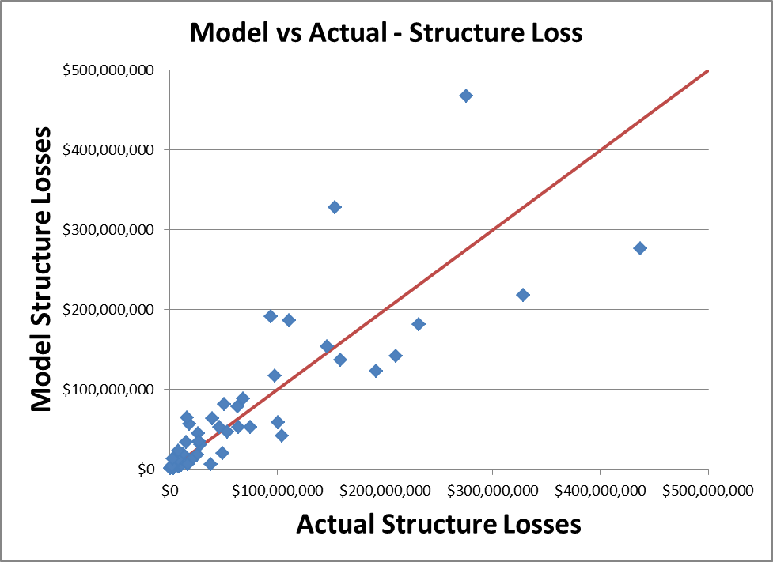
Figure 68. Model vs. Actual-Structural Loss.

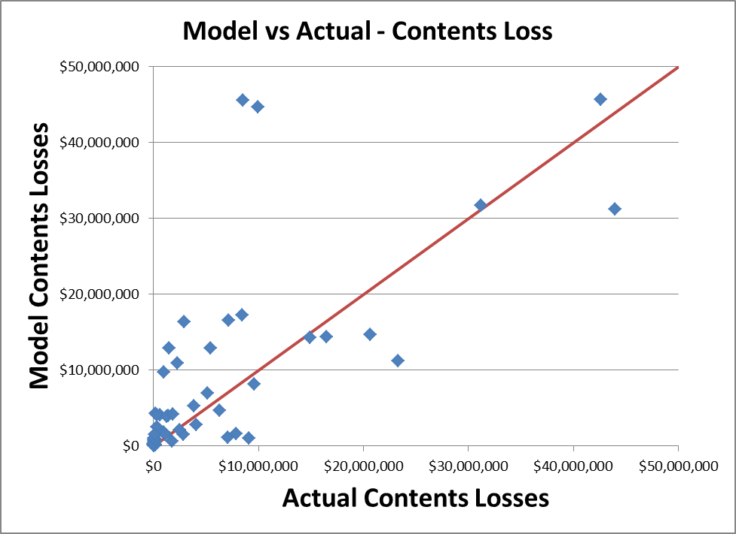
Figure 69. Model vs. Actual-Contents Loss.

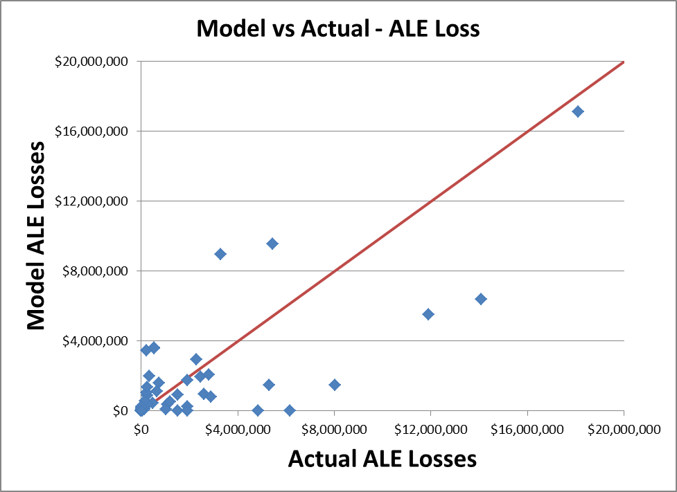
Figure 70. Model vs. Actual-ALE Loss.

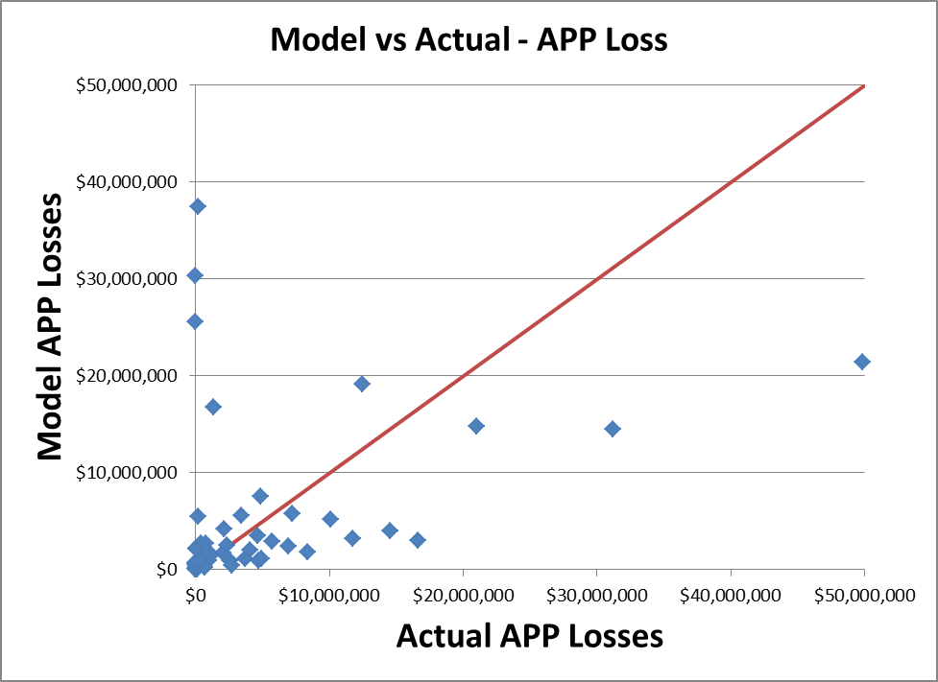
Figure 71. Model vs. Actual-APP Loss.

- Demonstrate that building vulnerability function relationships (building structures and appurtenant structures) are consistent with insurance claims data.

The validation studies described above were performed for a mix of masonry and frame structures for each portfolio. In addition, portfolios of manufactured homes were validated separately. In general, loss costs for masonry are lower than for frame, which are lower than for mobile homes. A comparison of modeled versus historical loss follows.

Table 28. Modeled vs. historical loss by construction type.
Hurricane Charley
Construction | Company | Company Actual | Modeled | Difference
Construction | Company | Loss/Exposure | Loss/Exposure | Difference
Frame | C | 0.01363 | 0.01694 | -0.00331
Masonry | C | 0.01584 | 0.01685 | -0.00101
Manufactured | M | 0.05476 | 0.03724 | 0.01752
Other | Y | 0.01803 | 0.01448 | 0.00355

Also see Standard S-5 and Form S-4.

- Identify the one-minute average sustained windspeed and the windspeed reference height at which the model begins to estimate damage.

The wind speeds used in the damage model are three-second gusts. The lowest three-second gust is 50 mph. The minimum one-minute sustained wind is approximately 40 mph.

- Describe how the duration of windspeeds at a particular location over the life of a hurricane is considered.

Duration of the storm is not explicitly modeled. The damage accumulation procedures assume sufficient duration of peak loads to account for duration dependent failures.

- Describe how the model addresses wind borne missile impact damage and waterinfiltration.

See attached form.

The model computes the damage based on actual terrain three-second gust winds that are obtained from the given open terrain one-minute sustained winds, and the losses are aggregated twice: once among the ZIP Codes with the same actual terrain three-second gust wind and once among the ZIP Codes with the same open terrain one-minute sustained wind. Because all the ZIP Codes do not have the same roughness, identical open terrain one-minute sustained winds result in different actual terrain three-second gust winds. Occasional bumps in the one-minute sustained winds plot are due to this process of conversion and re-aggregation. The modelers do confirm that the structures used in completing the form are identical to those in the table provided in the Standard.
The insured value for the condo association of the 20 story concrete structure with 8 apartments per story was changed from $100,000 to $15,000,000 since this is a more realistic insured value for a condo association for a building of these characteristics. The change was necessary since the value of the external damage in the model is computed on the basis of the actual replacement value of the damage openings. The actual value of these repairs can be disproportionally high if compared to an arbitrarily low and unrealistic insured value.
The adjustment in the insured value of the 20 story concrete structure then provides more realistic damage ratios. The resulting large discrepancies in damage ratios vs. wind speed between the personal residential reference structures in Form V-1 (i.e. timber, masonry, and manufactured home) and the engineered commercial residential reference structure are due to the fact that they correspond to widely different types of structures. Therefore, it is informative to report them separately, which is done in the last two tables of Part A of the form.
- Provide a completed Form V-1, One Hypothetical Event. Provide a link to the location of the form here.

V-2 Derivation of Contents and Time Element Vulnerability Functions

- Development of the contents and time element vulnerability functions shall be based on at least one of the following: (1) historical data, (2) tests, (3) rational structural analysis, and (4) site inspections. Any development of the contents and time element vulnerability functions based on rational structural analysis, site inspections, and tests shall be supported by historical data.

The development of the vulnerabilities is based on a component approach that combines engineering modeling, simulations with engineering judgment, and observed (historical) data. The content and time element vulnerabilities are extrapolated from the building damage on the basis of expert opinion and site inspections of areas impacted by recent hurricanes and are confirmed using historical claims data.

- The relationship between the modeled building and contents vulnerability functions and historical building and contents losses shall be reasonable.

The relationship between the modeled structure and the contents vulnerability functions is reasonable, on the basis of the relationship between historical structure and contents losses.

- Time element vulnerability function derivations shall consider the estimated time required to repair or replace the property.

Time element vulnerability function derivations consider the estimated time required to repair or replace the property.

- The relationship between the modeled building and time element vulnerability functions and historical building and time element losses shall be reasonable.

For Personal Residential risks the model uses time element vulnerability functions derived from the relationship between building damage and additional living expense. The vulnerability functions have been calibrated using historical claims data on building and additional living expense.

For Commercial Residential risks the relationship between modeled structure and time element loss costs is reasonable. Since no historical loss data were available for calibration, the relationship combines engineering and actuarial judgment.

- Time element vulnerability functions used by the model shall include time element coverage claims associated with wind, flood, and storm surge damage to the infrastructure caused by a hurricane.

The time element vulnerability functions produced by the model consider time element claims arising from wind, flood, and storm surge damage to the infrastructure. The model does not distinguish explicitly between direct and indirect loss. For Personal Residential risks the time element vulnerability functions were calibrated against claims data that include both types of losses. For Commercial Residential risks the recognition of claims due to indirect loss is based on judgment since no historical loss data were available for calibration.

Disclosures

- Describe any modifications to the contents and time element vulnerability component in the model since the previously accepted model.

- No change to report for Personal Residential home owners.
- For Commercial Residential, the contents damage is now assumed to be equal to 100% of the interior damage, instead of 50%.
- For condo unit owners and apartment unit renters, the contents damage is now assumed to be equal to 100% of the interior damage, instead of 50%; and, the time element vulnerability functions are assumed to be the same than for low-rise commercial residential, instead of 50% of the interior damage.

- Describe Provide a flow chart documenting the process by which the contents vulnerability functions are derived and implemented.

Personal Residential model

Contents include anything in the home that is not attached to the structure itself. Like the interior and utilities, the contents of the home are not modeled in the exterior damage Monte Carlo simulations. Contents damage is modeled as a function of the interior damage caused by each exterior component failure that causes a breach of the building envelope. The function is based on engineering judgment and validated using claims data. The resulting computation of contents vulnerability functions is a 3 stage process as described in Figure 72, and discussed in disclosure 3 below.

Figure 72. Derivation of contents and additional living expenses vulnerabilities for PR.

Commercial Residential model

The process by which the contents vulnerability functions are derived and implemented for commercial residential structures follows the process for interior damage described in disclosure 18 of standard V-1, and it is represented by Figure 72b below. In other words, the interior and contents vulnerability functions are set to be identical.

Figure 72b 1. Derivation of contents vulnerabilities for CR.

- Describe the data and methods used to develop vulnerability functions for contents coverage associated with personal and commercial residential buildings.

Personal Residential model

For each building model, the first stage in the development of contents vulnerability functions corresponds to the external damage assessment through Monte Carlo simulations as discussed in standards G-1 and V-1. In the personal residential model, this is complemented by an empirical estimate of water penetration from wind driven rain due to exterior breaches or leakage paths in undamaged structures (see disclosure 18 of standard V-1). The second stage corresponds to the computation of internal damage. Damage to the interior occurs when the building envelope is breached, allowing wind and rain to ingress. Damage to roof sheathing, roof cover, walls, windows, doors, and gable ends present the possible sources of water ingress. Interior damage equations are derived as heuristic functions of each of these components failure. These relationships are developed primarily on the basis of experience and engineering judgment. Observations of homes damaged during the 2004 hurricane season (Gurley, 2006) helped to validate the predictions. The third stage in the damage estimation (Figure 72) extrapolates the damage to contents from the interior damage, based on a heuristic function. This empirical function is based on engineering judgment and was validated against claims data for Hurricanes Andrew, Charley, and Frances, among others.

Commercial Residential model

The methods used to develop vulnerability functions for contents coverage associated with commercial residential structures are the same as the methods used for interior damage vulnerability functions. The contents damage is determined by vulnerability functions which correspond to different combinations of wall type (frame or masonry), sub-region (high velocity hurricane zone, wind-borne debris region, inland), roof shape (gable or hip), roof cover (metal, tile or shingle), window protection (shuttered or not shuttered), number of stories (one, two, or three), and strength (weak, medium, or strong).

Based on engineering judgment, contents damage ratio in mid/high-rise buildings (more than three stories) is also estimated as equal to the total estimated interior damage ratio for the building.

- Describe the number of contents vulnerability functions and whether different contents vulnerability relationships are used for personal residential, commercial residential, mobile home, condo unit owners, apartment renter unit location, and other similar building classes for wind related damage.

Contents vulnerability functions were derived for manufactured and site-built homes, and for low-rise commercial residential buildings (one to three stories).

A total of 4356 un-weighted contents vulnerability matrices were developed for site-built homes for building. The matrices correspond to different combinations of wall type (frame or masonry), region (north, central, south), subregion (high velocity hurricane zone, wind-borne debris region, inland), roof type (gable or hip), roof cover (metal, tile or shingle), window protection (shuttered or not shuttered), number of stories (one or two), and strength (weak, modified weak, retrofitted weak; medium, modified medium, retrofitted medium; strong for inland and WBDR, strong for HVHZ—see Tables 1a and 1b in the General Standards).

These 4356 building un-weighted matrices were then combined to produce 5226 weighted matrices, and 291 age weighted matrices for site-built homes for building, for each county. Many of the matrices are repeated because many of the counties use the same regional statistics for the weighting.

A total of 648 un-weighted contents vulnerability matrices were developed for low-rise, commercial residential buildings for building. They correspond to different combinations of wall type (frame or masonry), sub-region (high velocity hurricane zone, wind-borne debris region, inland), roof shape (gable or hip), roof cover (metal, tile or shingle), window protection (shuttered or not shuttered), number of stories (one, two, or three), and strength (weak, medium, or strong).

These 648 matrices were then combined to produce 144 weighted curves for low-rise, commercial residential buildings for building.

The contents vulnerability functions used for condo unit owners and apartment unit renters are the contents vulnerability functions for commercial residential buildings.

4 un-weighted contents vulnerability matrices were developed for manufactured homes for building. They correspond to four manufactured home types: (1) pre-1994—fully tied down, (2) pre-1994—not tied down, (3) post-1994—Housing and Urban Development (HUD) Zone II, and (4) post-1994—HUD Zone III. The partially tied-down homes are assumed to have a vulnerability that is an average of the vulnerabilities of fully tied-down and not tied-down homes. The un-weighted matrices are combined into 6 weighted matrices for building, for pre-1994 (4 regions: North, Central, South, Key) and post-1994 (2 zones: II and III) manufactured homes.

- Provide a flow chart documenting the process by which the time element vulnerability functions are derived and implemented.

Personal residential model

Additional living expenses are assumed to be a function of the interior damage caused by each exterior component failure that causes a breach of the building envelope. The function is based on engineering judgment and validated using claims data. The resulting computation of additional living expenses vulnerability functions is a 3 stage process as described in Figure 72 of disclosure 1, and discussed in disclosure 4 below.

Commercial Residential

The process by which the time element expenses vulnerability functions are derived and implemented for commercial residential structures is similar to the process for interior damage already described in disclosure 18 of standard V-1, and is represented in Figure 72c.

Figure 72c 1. Derivation of time related expenses vulnerabilities for CR.

- Describe the data and methods used to develop vulnerability functions for time element coverage associated with personal and commercial residential buildings. State whether the model considers both direct and indirect loss to the insured property. For example, direct loss could be for expenses paid to house policyholders in an apartment while their home is being repaired. Indirect loss could be for expenses incurred for loss of power (e.g., food spoilage).

Personal Residential

Additional Living Expense (ALE) is coverage for expenses that arise when an individual must live away from the damaged home. ALE coverage comprises expenses actually paid by the insured. This coverage does not pay all living expenses, only the increase in living expense that results from the covered damage. The value of an ALE claim is dependent on the time needed to repair a damaged home as well as the utilities and infrastructure. Time element or Additional Living Expenses (ALE) are modeled as a function of interior damage. The equations and methods used for manufactured and residential homes are identical. However, it seems logical to reduce the manufactured home ALE predictions because typically a faster repair or replacement time may be expected for these home types. Therefore, an ALE multiplier factor of 0.75 was introduced into the manufactured home model.

Commercial Residential

Owners of apartment buildings may purchase Time Element coverage in addition to wind coverage on the structure and contents. For commercial properties Time Element is an optional coverage and is therefore not purchased by all insured. It is generally a relatively expensive coverage. Some insurance carriers may not even offer Time Element coverage on commercial properties. The coverage will reimburse the owner of the building for business income lost or extra expenses incurred after a hurricane. Both “business income” and “extra expense” are subject to specific definitions and limitations within the coverage form.

We estimate Time Element (TE) losses as a heuristic function of interior damage (ID) as follows:

TE = 2ID² + ID

We do not allocate any portion of the structure deductible to the Time Element loss. We are assuming that Time Element Limits will be exhausted once interior damage reaches approximately 50%. From an underwriting perspective, it is necessary to restrict Time Element coverage limits in order to avoid any disincentive to rapid repairs.

In the case of mid/high rise condominium association policies no time element coverage is assumed, so it is not modeled.

Direct vs. Indirect Loss

The time element losses are based on empirical functions relating those losses to the interior damage to the structure. The model does not distinguish explicitly between direct and indirect losses to the structure. However, the functions are calibrated against claims data that include both types of losses.

- State the minimum threshold at which time element loss is calculated (e.g., loss is estimated for building damage greater than 20% or only for category 3, 4, 5 events). Provide documentation of validation test results to verify the approach used.

Time element losses for Personal Residential and low-rise Commercial Residential buildings are calculated as a function of interior damage. There is no minimum threshold at which time element loss is calculated since it is believed that even with minimum interior damage, some time element losses might exist, e.g., when residents are subject to a mandatory evacuation. The approach was validated against claims data as reported in disclosure 12.

- Describe how modeled time element loss costs take into consideration the damage (including damage due to storm surge, flood, and wind) to local and regional infrastructure.

Time element losses for Personal Residential and low-rise Commercial Residential buildings are calculated as a function of interior damage to the structure. They do not explicitly consider the degree of flood or storm surge damage to the infrastructure. For Personal Residential losses there is potentially some influence of such damage injected through the validation process. For low-rise Commercial Residential losses, however, there were no historical time element losses available for validation.

- Describe the relationship between building structure and contents vulnerability functions.

The contents vulnerability is a function of the interior damage, which is a main contributor to the building vulnerability. Consequently, the relationship between contents vulnerability and structure vulnerability follows the relationship between overall building structure vulnerability and interior vulnerability.

- Describe the relationship between building structure and time element vulnerability functions.

The time element vulnerability is a function of the interior damage, which is a main contributor to the building vulnerability. Consequently, the relationship between time element vulnerability and structure vulnerability follows the relationship between overall building structure vulnerability and interior vulnerability.

- Describe the assumptions, data, methods, and processes used to develop contents and time element vulnerability functions for unknown residential construction types.

Disclosures 9 and 10 are addressed together below.

- Describe the assumptions, data, methods, and processes used to develop contents and time element vulnerability functions when some of the primary characteristics are unknown.

The development of contents and time element vulnerability functions for unknown residential construction types, or when some of the primary characteristics are unknown, follows the process described in disclosures 11 and 12 of standard V-1.

- Describe any assumptions, data, methods, and processes used to develop and validate contents and time element vulnerability functions concerning insurance company claims.

The assumption is that company claim payment practices including the effects of contractual obligations on the claim payment process are stable over time and do not vary by company.

- Demonstrate that contents and time element vulnerability function relationships are consistent with insurance claims data.

The building loss consists of external and internal losses. Contents and time element losses are a function of the interior structure loss. All the losses are based on a combination of engineering principles, empirical equations, and engineering judgment. They were validated against claim data from several hurricanes as described above. The results are shown in Figures 73 and 74 below. Each dot represents an insurance portfolio. The figures include a total ?? hurricanes and ?? portfolios.
Figure 73. Model vs. Actual-Contents Loss.
Figure 74. Model vs. Actual-ALE Loss.

V-3 Mitigation Measures

- Modeling of mitigation measures to improve a building’s wind resistance and the corresponding effects on vulnerability shall be theoretically sound and consistent with fundamental engineering principles. These measures shall include fixtures or construction techniques that enhance the performance of the building and its contents and shall consider:

- Roof strength
- Roof covering performance
- Roof-to-wall strength
- Wall-to-floor-to-foundation strength
- Opening protection
- Window, door, and skylight strength.

Modeling of mitigation measures to improve a structure’s wind resistance is theoretically sound and includes the fixtures mentioned above. The following structures were modeled:

Base case as defined by Commission
Mitigated case as defined by Commission
Base plus one mitigation at a time

The mitigations included gable bracing, rated shingles, metal roof, stronger sheathing capacity, stronger roof-to-wall connections, stronger wall-to-sill connections, masonry reinforced walls, multiple opening protection options, and wind/missile resistant glass.

- Application of mitigation measures that enhance the performance of the building and its contents shall be justified as to the impact on reducing damage whether done individually or in combination.

The base cases are very weak cases, where the interior damage is governed by the sheathing loss at low to moderate wind speeds. The application of mitigation measures is justified and the results show the following.

Bracing the gable end, using rated shingles, using a membrane, or using a metal roof alone does not provide any benefit when all other components remain weak, as required by Form V-2. For example, regardless of the type of roof cover used, if the home loses its weak sheathing panels, there will be little benefit in mitigating the roof cover or gable end alone. Combining mitigation measures, however, does indeed reduce the vulnerability of the home, as demonstrated in the bottom section of Form V-2. The observed negative values in Form V-2 corresponding to the braced gable end mitigation are from round off of smaller values within the uncertainty scatter of the model and indicate zero change.

The hip roof has a greater impact in reducing the losses, especially in the case of frame structures. Because the base frame structure is inherently weaker, there is comparatively a higher gain with the hip timber structure than with the hip masonry structure. For example, a weak home with a hip roof is not vulnerable to gable end collapse.

Improving the roof sheathing capacity (8d nails) alone reduces the damage at wind speeds up to 100 mph and 120 mph sustained winds for wood and masonry structures, respectively, but at higher wind speeds the mitigation becomes counter-effective (Figure 81, Figure 82, Figure 83 and Figure 84). The behavior of the damage curve with mitigated sheathing after 100 (wood) and 120 (masonry) mph sustained winds is due to the still very weak roof-to-wall connections. Loss of sheathing reduces the uplift on the roof-to-wall connections. Thus, the stronger deck results in higher loads on the connections, which the connections are not prepared to absorb. This effect was recently experimentally identified through destructive testing of real structures with toe-nail connections and strong decking attachment (Shanmugam et al., 2009).

Clips and straps are very effective for frame structures, less so for masonry structures. The model emphasizes interior damage due to loss of sheathing, roof cover, or gable end, which are all independent of the roof-to-wall connection strength. If the strength of the plywood deck and roof cover is not increased, increasing the roof-to-wall connections alone will do little good at low to moderate wind speeds. At higher wind speeds, the integrity of the box system in the frame structure is improved by the stronger roof-to-wall connection, hence the more pronounced benefit for the frame structure than for masonry.

Clips and straps for wall-to-sill plate connections are very effective at high wind speeds for frame structures because they improve the integrity of the box system. Similarly, the reinforcing of the walls for masonry structures is more effective at high wind speeds when unreinforced walls become vulnerable.

Opening protections are effective, and more so at higher wind speeds. This follows logically, as the internal pressurization caused by an opening breach is critical to the failure of other components only at higher wind speeds.

A mitigated structure with a combination of individual mitigations (as per standards definition) shows improved performance over the base structure and each of the individual mitigations.

The nonzero damage between 40 and 60 mph sustained winds, the convergence of the base, and all mitigation cases in this wind speed range reflect the incorporation of nonexterior damage-related losses in the model. Water penetration through windows and doors is possible even without window or door breach (Salzano et al., 2010). This portion of the model is not dependent upon mitigations, thus the convergence of curves in Figure 81, Figure 82, Figure 83 and Figure 84 in that wind speed range.

Disclosures

- Describe any modifications to mitigation measures in the model since the previously accepted model.

None to be reported.

- Provide a completed Form V-2, Mitigation Measures – Range of Changes in Damage. Provide a link to the location of the form here.

See Form V-2. Notice that there are no entries for the Wall-Foundation Strength rows for timber structures because the model does not have the capability to model wall-to-foundation anchors or straps for timber structures. The model does account for wall-to-sill plate connections, but not the sill plate-to-foundation connections. There are no field data to indicate that this is a significant failure mode. The connection to the foundation can be weak and is reflected in the wall-to-sill capacity (toe-nails, clips, straps).

- Provide a description of the mitigation measures used by the model that are not listed in Form V-2, Mitigation Measures – Range of Changes in Damage.

None to be reported.

- Describe how mitigation is implemented in the model. Identify any assumptions.

The various mitigation options delineated in Forms V-2 and V-3 are implemented in the model by varying the capacity statistics (mean and coefficient of variation) to reflect the strength of a given component. For example, weak (base model) roof covering is represented by a random value for each shingle, with the specific capacity values for a given Monte Carlo simulation randomly assigned on the basis of a specified probability density function, mean, and coefficient of variation assigned to weak shingles. If the strong roof cover mitigation option is chosen, a different mean and coefficient of variation, reflecting higher capacity and less variability, are used to randomly assign capacities to the shingles. This same approach is used for every component for which a mitigation option is modeled. One or any combination of mitigation measures may be selected prior to running the Monte Carlo simulation. The stronger resistances of the mitigated components are directly reflected in the randomly assigned capacities of those components, and the unmitigated components are assigned capacities using distributions with parameters reflecting weaker resistance.

In the case of membrane, the mitigation is modeled through a reduction of the interior damage due to loss of roof cover and subsequent water penetration.

- Describe the process used to ensure that multiple mitigation factors are correctly combined in the model.

Each mitigation option (e.g., sheathing, roof cover, membrane, roof-to-wall connections) is modeled and accounted for independently, allowing any combination to be chosen. As reflected in the results in Figure 81, Figure 82, Figure 83 and Figure 84, it is assumed that the effect of mitigating one component can change the vulnerability but not the capacity of other components via the influence that mitigation has on loading or load sharing. It is also assumed that any given mitigation does not necessarily produce improved overall performance for all wind speeds. An example already discussed is the influence of the roof sheathing strength on the vulnerability of roof-to-wall connections, caused by the influence of intact strong roof sheathing on the uplift acting on weak roof-to-wall connections. Another example is the influence of opening vulnerability on the performance of many other components, including walls, sheathing, and roof-to-wall connections, as the change in internal pressure resulting from opening failure changes the overall loading on these other components.

In summary, mitigation options may be selected individually or in combination, but the effects of a given mitigation on other components and on overall building vulnerability, should not be and are not isolated in the model.

Form V-1: One Hypothetical Event

- Windspeeds for 96 ZIP Codes and sample personal and commercial residential exposure data are provided in the file named “FormV1Input13.xlsx.” The windspeeds and ZIP Codes represent a hypothetical hurricane track. Model the sample personal and commercial residential exposure data provided in the file against these windspeeds at the specified ZIP Codes and provide the damage ratios summarized by windspeed (mph) and construction type.

The wind speeds provided are one-minute sustained 10-meter wind speeds. The sample personal and commercial residential exposure data provided consist of four structures (one of each construction type: wood frame, masonry, mobile home, and concrete) individually placed at the population centroid of each of the ZIP Codes provided. Each ZIP Code is subjected to a specific wind speed. For completing Part A, Estimated Damage for each individual wind speed range is the sum of ground up loss to all structures in the ZIP Codes subjected to that individual wind speed range, excluding demand surge and storm surge. Subject Exposure is all exposures in the ZIP Codes subjected to that individual wind speed range. For completing Part B, Estimated Damage is the sum of the ground up loss to all structures of a specific type (wood frame, masonry, mobile home, or concrete) in all of the wind speed ranges, excluding demand surge and storm surge. Subject Exposure is all exposures of that specific type in all of the ZIP Codes.

One reference structure for each of the construction types shall be placed at the population center of the ZIP Codes. Do not include contents, appurtenant structures, or time element coverages.

Reference Frame Structure:  One story  Unbraced gable end roof  Normal shingles (55mph)  ½” plywood deck  6d nails, deck to roof members  Toe nail truss to wall anchor  Wood framed exterior walls  5/8” diameter anchors at 48” centers for wall/floor/foundation connections  No shutters  Standard glass windows  No door covers  No skylight covers  Constructed in 1980 | Reference Masonry Structure:  One story  Unbraced gable end roof  Normal shingles (55mph)  ½” plywood deck  6d nails, deck to roof members  Toe nail truss to wall anchor  Masonry exterior walls  No vertical wall reinforcing  No shutters  Standard glass windows  No door covers  No skylight covers  Constructed in 1980
Reference Mobile Home Structure:  Tie downs  Single unit  Manufactured in 1980 | Reference Concrete Structure:  Twenty story  Eight apartment units per story  No shutters  Standard glass windows  Constructed in 1980

- Confirm that the structures used in completing the form are identical to those in the above table for the reference structures. If additional assumptions are necessary to complete this form (for example, regarding structural characteristics, duration or surface roughness), provide the reasons why the assumptions were necessary as well as a detailed description of how they were included.

The modelers do confirm that the structures used in completing the form are identical to those in the table provided in the standard.

- Provide a plot of the Form V-1 (One Hypothetical Event), Part A data.

See Figures 75 through 80 in Part C of Form V-1.

Form V-1: One Hypothetical Event

Part A

All reference structures combined.

Wind Speed (mph )  1 min sustained Wind | Estimated Damage/  Subject Exposure
41-50 | 0.00%
51-60 | 0.05%
61-70 | 0.37%
71-80 | 1.08%
81-90 | 3.26%
91-100 | 7.17%
101-110 | 10.72%
111-120 | 15.68%
121-130 | 21.46%
131-140 | 23.47%
141-150 | 27.92%
151-160 | 29.46%
161-170 | 31.61%

Only personal residential reference structures combined (Timber + Masonry + MH).

Wind Speed (mph )  1 min sustained Wind | Estimated Damage/  Subject Exposure
41-50 | 0.00%
51-60 | 0.05%
61-70 | 0.37%
71-80 | 1.08%
81-90 | 3.26%
91-100 | 7.17%
101-110 | 10.72%
111-120 | 15.68%
121-130 | 21.46%
131-140 | 23.47%
141-150 | 27.92%
151-160 | 29.46%
161-170 | 31.61%

Only commercial residential reference structures (Concrete).

Wind Speed (mph )  1 min sustained Wind | Estimated Damage/  Subject Exposure
41-50 | 0.00%
51-60 | 0.03%
61-70 | 0.32%
71-80 | 1.03%
81-90 | 3.20%
91-100 | 7.10%
101-110 | 10.65%
111-120 | 15.59%
121-130 | 21.21%
131-140 | 23.19%
141-150 | 27.45%
151-160 | 28.92%
161-170 | 30.85%

Part B
Construction Type | Estimated Damage/  Subject Exposure
Wood Frame | 3.84%
Masonry | 3.30%
Mobile Home | 10.47%
Concrete | 3.06%

The structures used in completing the form are identical to those in the table provided.

Part C

All reference structures combined.

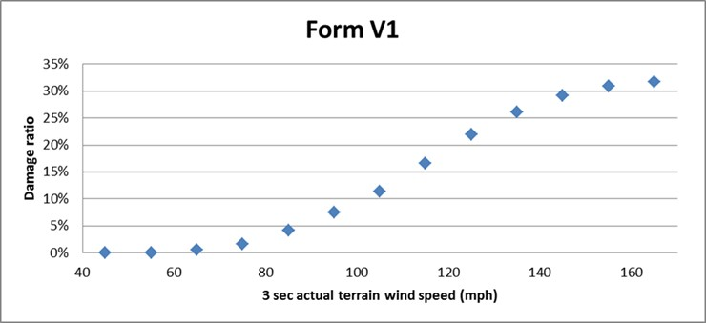
Figure 75. Structure damage vs. 3 sec actual terrain wind speed.

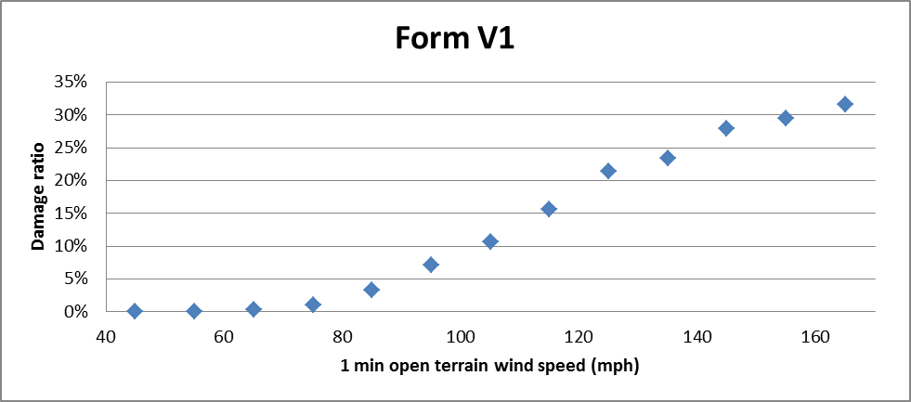
Figure 76. Structure damage vs. 1 minute sustained wind speed.

Only personal residential reference structures combined (Timber + Masonry + MH).

Figure 77. Structure damage vs. 3 sec actual terrain wind speed.

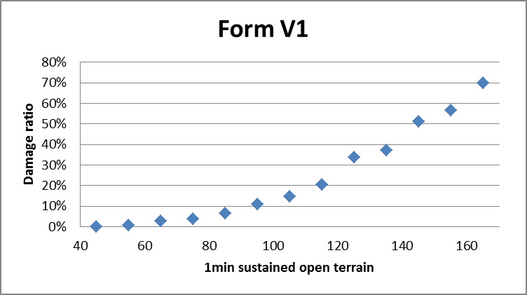
Figure 78. Structure damage vs. 1 minute sustained wind speed.

Only commercial residential reference structures (Concrete).

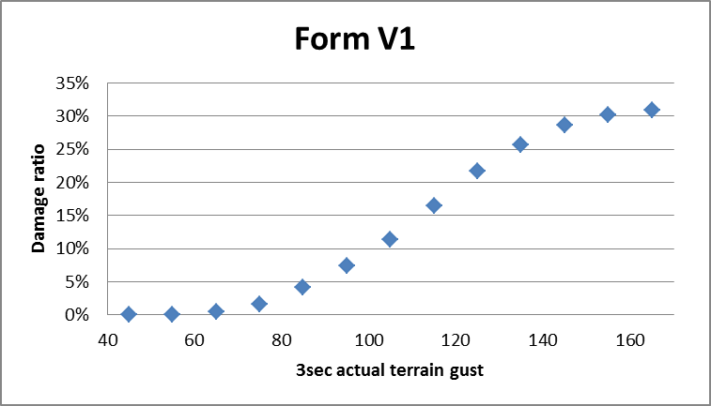
Figure 79. Structure damage vs. 3 sec actual terrain wind speed.

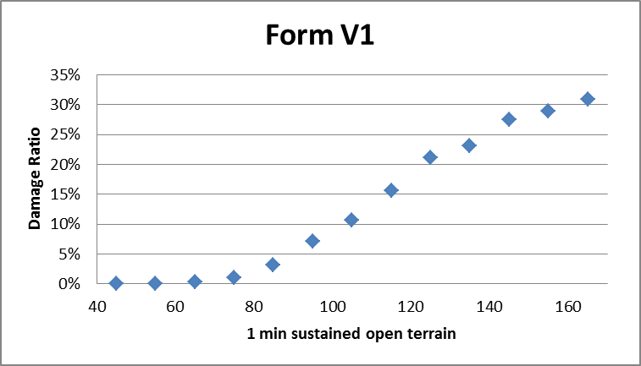
Figure 80. Structure damage vs. 1 minute sustained wind speed.

Form V-2: Mitigation Measures – Range of Changes in Damage

- Provide the change in the zero deductible personal residential reference building damage rate (not loss cost) for each individual mitigation measure listed in Form V-2 (Mitigation Measures – Range of Changes in Damage) as well as for the combination of the four mitigation measures provided for the Mitigated Frame Building and the Mitigated Masonry Building below.

See Form V-2 below.

- If additional assumptions are necessary to complete this Form (for example, regarding duration or surface roughness), provide the rationale for the assumptions as well as a detailed description of how they are included.

- Provide this form in Excel format without truncation. The file name shall include the abbreviated name of the modeling organization, the standards year, and the form name. Form V-2 (Mitigation Measures – Range of Changes in Damage) shall also be included in a submission appendix.

Reference Frame Building:  One story  Unbraced gable end roof  Normal shingles (55mph)  ½” plywood deck  6d nails, deck to roof members  Toe nail truss to wall anchor  Wood framed exterior walls  5/8” diameter anchors at 48” centers for wall/floor/foundation connections  No shutters  Standard glass windows  No door covers  No skylight covers  Constructed in 1980  Mitigated Frame Building:  Rated shingles (110mph)  8d nails, deck to roof members  Truss straps at roof  Plywood Shutters | Reference Masonry Building:  One story  Unbraced gable end roof  Normal shingles (55mph)  ½” plywood deck  6d nails, deck to roof members  Toe nail truss to wall anchor  Masonry exterior walls  No vertical wall reinforcing  No shutters  Standard glass windows  No door covers  No skylight covers  Constructed in 1980  Mitigated Masonry Building:  Rated shingles (110mph)  8d nails, deck to roof members  Truss straps at roof  Plywood Shutters

Reference and mitigated buildings are fully insured buildings with a zero deductible building only policy.

Place the reference building at the population centroid for ZIP Code 33921.

Wind speeds used in the form are one-minute sustained 10-meter wind speeds.

Form V-2: Mitigation Measures – Range of Changes in Damage (1 min)
INDIVIDUAL  MITIGATION MEASURES |  |  | PERCENTAGE CHANGES IN DAMAGE
 |  |  | (REFERENCE DAMAGE RATE - MITIGATED DAMAGE RATE)/(REFERENCE DAMAGE RATE)*100
 |  |  | FRAME BUILDING |  |  |  |  | MASONRY BUILDING
 |  |  | WIND SPEED (MPH) |  |  |  |  | WIND SPEED (MPH)
 |  |  | 60 | 85 | 110 | 135 | 160 | 60 | 85 | 110 | 135 | 160
 | REFERENCE BUILDING |  | - | - | - | - | - | - | - | - | - | -
ROOF
STRENGTH
ROOF  STRENGTH | BRACED GABLE ENDS |  | 0% | 0% | 0% | 0% | 1% | 0% | 0% | 0% | 0% | 1%
ROOF  STRENGTH | HIP ROOF |  | 1% | 6% | 5% | 11% | 4% | 1% | 6% | 1% | 7% | 5%
ROOF
COVERING
ROOF  COVERING | METAL |  | 0% | 1% | 0% | 0% | 0% | 0% | 1% | 0% | 0% | 0%
ROOF  COVERING | RATED SHINGLES (110 MPH) |  | 0% | 1% | 0% | 0% | 0% | 0% | 1% | 0% | 0% | 0%
ROOF  COVERING | MEMBRANE |  | 0% | 0% | 0% | 0% | 0% | 0% | 0% | 0% | 0% | 0%
ROOF  COVERING | NAILING OF DECK 8d |  | 2% | 37% | 0% | -7% | -1% | 3% | 38% | 13% | -4% | -1%
ROOF-WALL
STRENGTH
ROOF-WALL  STRENGTH | CLIPS |  | 0% | 0% | 5% | 14% | 11% | 0% | -1% | 0% | 7% | 12%
ROOF-WALL  STRENGTH | STRAPS |  | 0% | 0% | 5% | 18% | 23% | 0% | -1% | 0% | 8% | 15%
WALL-
FLOOR
STRENGTH
WALL-  FLOOR  STRENGTH | TIES OR CLIPS |  | 0% | 0% | 4% | 6% | 4% | - | - | - | - | -
WALL-  FLOOR  STRENGTH | STRAPS |  | 0% | 0% | 4% | 6% | 4% | - | - | - | - | -
WALL FOUNDATION
STRENGTH
WALL FOUNDATION  STRENGTH | LARGER ANCHORS  OR CLOSER SPACING |  | - | - | - | - | - | - | - | - | - | -
WALL FOUNDATION  STRENGTH | STRAPS |  | - | - | - | - | - | - | - | - | - | -
WALL FOUNDATION  STRENGTH | VERTICAL REINFORCING |  | - | - | - | - | - | 0% | -1% | 0% | 10% | 22%
OPENING
PROTECTION
OPENING  PROTECTION | WINDOW  SHUTTERS | PLYWOOD | 0% | 2% | 6% | 2% | 0% | 0% | 2% | 7% | 3% | 0%
OPENING  PROTECTION | WINDOW  SHUTTERS | STEEL | 0% | 4% | 10% | 4% | 1% | 0% | 3% | 11% | 6% | 1%
OPENING  PROTECTION | WINDOW  SHUTTERS | ENGINEERED | 0% | 4% | 13% | 8% | 3% | 0% | 4% | 15% | 9% | 3%
OPENING  PROTECTION | DOOR AND SKYLIGHT COVERS |  | 0% | 0% | 1% | 1% | 0% | 0% | 0% | 1% | 1% | 1%
WINDOW DOOR,  SKYLIGHT STRENGTH | WINDOWS
WINDOW DOOR,  SKYLIGHT STRENGTH | WINDOWS | LAMINATED | 0% | 3% | 11% | 7% | 2% | 0% | 3% | 12% | 8% | 3%
WINDOW DOOR,  SKYLIGHT STRENGTH | WINDOWS | IMPACT GLASS | 0% | 4% | 13% | 10% | 5% | 0% | 3% | 14% | 12% | 6%
WINDOW DOOR,  SKYLIGHT STRENGTH | ENTRY DOORS | HIGH STRENGTH | 0% | 0% | 0% | 1% | 1% | 0% | 0% | 0% | 1% | 1%
WINDOW DOOR,  SKYLIGHT STRENGTH | GARAGE DOORS | HIGH STRENGTH | 0% | 16% | 3% | 1% | 0% | 0% | 16% | 5% | 1% | 0%
WINDOW DOOR,  SKYLIGHT STRENGTH | SLIDING GLASS DOORS | HIGH STRENGTH | 0% | 0% | 1% | 1% | 1% | 0% | 0% | 1% | 1% | 1%
MITIGATION MEASURES IN  COMBINATION |  |  | PERCENTAGE CHANGES IN DAMAGE  (REFERENCE DAMAGE RATE - MITIGATED DAMAGE RATE)/(REFERENCE DAMAGE RATE)*100
 |  |  | FRAME BUILDING |  |  |  |  | MASONRY BUILDING
 |  |  | WIND SPEED (MPH) |  |  |  |  | WIND SPEED (MPH)
 |  |  | 60 | 85 | 110 | 135 | 160 | 60 | 85 | 110 | 135 | 160
BUILDING
BUILDING | MITIGATED BUILDING |  | 2% | 40% | 27% | 26% | 25% | 3% | 40% | 24% | 16% | 16%

Form V-3: Mitigation Measures – Mean Damage Ratios and Loss Costs (Trade Secret Item)

- Provide the mean damage ratio (prior to any insurance considerations) to the reference building for each individual mitigation measure listed in Form V-3 (Mitigation Measures – Mean Damage Ratios and Loss Costs, Trade Secret item) as well as the percent damage for the combination of the four mitigation measures provided for the Mitigated Frame Building and the Mitigated Masonry Building below.

See Form V-3 below. Notice that for the 60 mph column all the vulnerabilities coincide at 6%. This is because at these low wind speeds, no significant damage is activated to trigger any significant difference between the different cases.

- Provide the loss cost rounded to three decimal places, for the reference building and for each individual mitigation measure listed in Form V-3 (Mitigation Measurers – Mean Damage Ratios and Loss Costs, Trade Secret item) as well as the loss cost for the combination of the four mitigation measures provided for the Mitigated Frame Building and the Mitigated Masonry Building below.

See Form V-3 below.

- If additional assumptions are necessary to complete this form (for example, regarding duration or surface roughness), provide the rationale for the assumptions as well as a detailed description of how they are included.

- Provide a graphical representation of the vulnerability curves for the reference and the fully mitigated building.

See Figure 81, Figure 82, Figure 83 and Figure 84. Because there are too many vulnerability curves to plot in one figure, for the sake of clarity, the mitigations were divided in four sets for both masonry and frame structures. In each figure, there are two horizontal axes: the upper axis represents the actual terrain three-second gust winds; the lower axis represents the actual terrain one-minute sustained winds. The conversion between three-second gust and one-minute sustained winds depends on the roughness of the terrain. Therefore, on each plot, the value of the roughness parameter for Lee County is indicated. Finally, please note that, as explained in the previous section, mitigating the roof shingles alone, or the metal roof alone, or the membrane alone without mitigating the roof deck (upgrading nail size and or spacing) or the roof-to-wall connections does not improve the overall vulnerability of the structure. Consequently, in Figure 81, Figure 82, Figure 83 and Figure 84, the curves for the base case and the rated shingle, metal roof, and membrane cases are superimposed on each other. This result is dependent on the base case weak sheathing connection and should not be interpreted to imply that reroofing is not an effective mitigation. Reroofing is only ineffective for the case of a very weak roof deck. The combination of re-nailing the decking and reroofing (now required practice) is an effective mitigation.

Reference Frame Structure:  One story  Unbraced gable end roof  Normal shingles (55mph)  ½” plywood deck  6d nails, deck to roof members  Toe nail truss to wall anchor  Wood framed exterior walls  5/8” diameter anchors at 48” centers for wall/floor/foundation connections  No shutters  Standard glass windows  No door covers  No skylight covers  Constructed in 1980  Mitigated Frame Structure:  Rated shingles (110mph)  8d nails, deck to roof members  Truss straps at roof  Plywood Shutters | Reference Masonry Structure:  One story  Unbraced gable end roof  Normal shingles (55mph)  ½” plywood deck  6d nails, deck to roof members  Toe nail truss to wall anchor  Masonry exterior walls  No vertical wall reinforcing  No shutters  Standard glass windows  No door covers  No skylight covers  Constructed in 1980  Mitigated Masonry Structure:  Rated shingles (110mph)  8d nails, deck to roof members  Truss straps at roof  Plywood Shutters

Reference and mitigated buildings are fully insured building structures with a zero deductible building only policy.

Place the reference building at the population centroid for ZIP Code.

Wind speeds used in the form are one-minute sustained 10-meter wind speeds.

Form V-3: Mitigation Measures – Mean Damage Ratio (1 min)
INDIVIDUAL  MITIGATION MEASURES |  |  | MEAN DAMAGE RATIO |  |  |  |  |  |  |  |  |  | LOSS COSTS
 |  |  | FRAME BUILDING |  |  |  |  | MASONRY BUILDING |  |  |  |  | FRAME BUILDING | MASONRY BUILDING
 |  |  | WIND SPEED (MPH) |  |  |  |  | WIND SPEED (MPH) |  |  |  |  | ACROSS ALL WINDSPEEDS
 |  |  | 60 | 85 | 110 | 135 | 160 | 60 | 85 | 110 | 135 | 160
 | REFERENCE BUILDING |  | 6% | 14% | 40% | 56% | 67% | 6% | 14% | 36% | 47% | 62% | $5.544 | $5.414
ROOF
STRENGTH
ROOF  STRENGTH | BRACED GABLE ENDS |  | 6% | 14% | 40% | 55% | 66% | 6% | 14% | 36% | 47% | 61% | $5.544 | $5.414
ROOF  STRENGTH | HIP ROOF |  | 6% | 13% | 38% | 50% | 64% | 6% | 13% | 35% | 43% | 59% | $5.415 | $5.287
ROOF
COVERING
ROOF  COVERING | METAL |  | 6% | 14% | 40% | 56% | 67% | 6% | 14% | 36% | 47% | 62% | $5.538 | $5.409
ROOF  COVERING | RATED SHINGLES (110 MPH) |  | 6% | 14% | 40% | 56% | 67% | 6% | 14% | 36% | 47% | 62% | $5.538 | $5.409
ROOF  COVERING | MEMBRANE |  | 6% | 14% | 40% | 56% | 67% | 6% | 14% | 36% | 47% | 62% | $5.544 | $5.414
ROOF  COVERING | NAILING OF DECK 8d |  | 6% | 9% | 40% | 60% | 67% | 6% | 8% | 31% | 48% | 63% | $5.115 | $4.985
ROOF-WALL
STRENGTH
ROOF-WALL  STRENGTH | CLIPS |  | 6% | 14% | 38% | 48% | 59% | 6% | 14% | 35% | 43% | 54% | $5.541 | $5.412
ROOF-WALL  STRENGTH | STRAPS |  | 6% | 14% | 38% | 46% | 51% | 6% | 14% | 35% | 43% | 53% | $5.541 | $5.412
WALL-
FLOOR
STRENGTH
WALL-  FLOOR  STRENGTH | TIES OR CLIPS |  | 6% | 14% | 38% | 52% | 64% | - | - | - | - | - | $5.541 | -
WALL-  FLOOR  STRENGTH | STRAPS |  | 6% | 14% | 38% | 52% | 64% | - | - | - | - | - | $5.541 | -
WALL FOUNDATION
STRENGTH
WALL FOUNDATION  STRENGTH | LARGER ANCHORS  OR CLOSER SPACING |  | - | - | - | - | - | - | - | - | - | - | - | -
WALL FOUNDATION  STRENGTH | STRAPS |  | - | - | - | - | - | - | - | - | - | - | - | -
WALL FOUNDATION  STRENGTH | VERTICAL REINFORCING |  | - | - | - | - | - | 6% | 14% | 35% | 42% | 48% | - | $5.409
OPENING
PROTECTION
OPENING  PROTECTION | WINDOW  SHUTTERS | PLYWOOD | 6% | 14% | 37% | 54% | 67% | 6% | 13% | 33% | 45% | 62% | $5.533 | $5.399
OPENING  PROTECTION | WINDOW  SHUTTERS | STEEL | 6% | 14% | 36% | 53% | 66% | 6% | 13% | 31% | 44% | 61% | $5.527 | $5.399
OPENING  PROTECTION | WINDOW  SHUTTERS | ENGINEERED | 6% | 13% | 34% | 51% | 65% | 6% | 13% | 30% | 42% | 60% | $5.523 | $5.396
OPENING  PROTECTION | DOOR AND SKYLIGHT COVERS |  | 6% | 14% | 39% | 55% | 66% | 6% | 14% | 35% | 46% | 61% | $5.541 | $5.412
WINDOW DOOR,  SKYLIGHT STRENGTH |  | LAMINATED | 6% | 14% | 35% | 52% | 65% | 6% | 13% | 31% | 43% | 60% | $5.528 | $5.400
WINDOW DOOR,  SKYLIGHT STRENGTH |  | IMPACT GLASS | 6% | 14% | 34% | 50% | 63% | 6% | 13% | 30% | 41% | 58% | $5.526 | $5.399
WINDOW DOOR,  SKYLIGHT STRENGTH | ENTRY DOORS | HIGH STRENGTH | 6% | 14% | 39% | 55% | 66% | 6% | 14% | 35% | 46% | 61% | $5.543 | $5.414
WINDOW DOOR,  SKYLIGHT STRENGTH | GARAGE DOORS | HIGH STRENGTH | 6% | 12% | 38% | 55% | 67% | 6% | 11% | 34% | 46% | 62% | $5.409 | $5.287
WINDOW DOOR,  SKYLIGHT STRENGTH | SLIDING GLASS DOORS | HIGH STRENGTH | 6% | 14% | 39% | 55% | 66% | 6% | 14% | 35% | 46% | 61% | $5.540 | $5.412
MITIGATION MEASURES IN  COMBINATION |  |  | MEAN DAMAGE RATIO |  |  |  |  |  |  |  |  |  | LOSS COSTS
 |  |  | FRAME BUILDING |  |  |  |  | MASONRY BUILDING |  |  |  |  | FRAME BUILDING | MASONRY BUILDING
 |  |  | WIND SPEED (MPH) |  |  |  |  | WIND SPEED (MPH) |  |  |  |  | ACROSS ALL WINDSPEEDS
 |  |  | 60 | 85 | 110 | 135 | 160 | 60 | 85 | 110 | 135 | 160
MITIGATED BUILDING |  |  | 6% | 8% | 29% | 41% | 50% | 6% | 8% | 27% | 39% | 52% | $5.099 | $4.973

Figure 81. Mitigation measures for masonry homes.

(d)
Figure 82. Mitigation measures for masonry homes.

Figure 83. Mitigation measures for frame homes.

Figure 84. Mitigation measures for frame homes.

ACTUARIAL STANDARDS

A-1 Modeling Input Data

- When used in the modeling process or for verification purposes, adjustments, edits, inclusions, or deletions to insurance company input data used by the modeling organization shall be based upon accepted actuarial, underwriting, and statistical procedures.

- All modifications, adjustments, assumptions, inputs and input file identification, and defaults necessary to use the model shall be actuarially sound and shall be included with the model output report. Treatment of missing values for user inputs required to run the model shall be actuarially sound and described with the model output report.

Disclosures

- Identify depreciation assumptions and describe the methods and assumptions used to reduce insured losses on account of depreciation. Provide a sample calculation for determining the amount of depreciation and the actual cash value (ACV) losses.

For both replacement cost and ACV policies, the value of structures and contents are generally assumed to equal the insured limit. In the rare case where data on property value are available from the insurance company and that value exceeds the limit, the value provided is used to estimate the ground-up damages.

Depreciation is considered in the model, but not explicitly. The damage ratios were calibrated to insured losses that contained a mix of replacement cost and ACV policies but primarily replacement cost. Consequently there is an implicit allowance for depreciation (of an unknown degree) built into the modeled losses.

- Identify insurance-to-value assumptions and describe the methods and assumptions used to determine the true property value and associated losses. Provide a sample calculation for determining the property value and guaranteed replacement cost losses.

The model assumes that the insured value is the true value of the property except in rare cases when the insurance company provides a separate property value that is higher than the insured value.

- Describe the methods used to distinguish among policy form types (e.g., homeowners, dwelling property, mobile home, tenants, condo unit owners).

The input record provided by the company includes a “policy form” code. If there is any ambiguity, the company is contacted for clarification.

- Disclose, in a model output report, the specific type of input that is required to use the model or model output in a residential property insurance rate filing. Such input includes, but is not limited to, optional features of the model, type of data to be supplied by the model user and needed to derive loss projections from the model, and any variables that a model user is authorized to set in using the model. Include the model name and version identification on the model output report. All items included in the output form submitted to the Commission shall be clearly labeled and defined.

A model output report follows.

Table 29. Output report for OIR data processing.
Output Report for OIR Data Processing

Florida Public Hurricane Loss Model: Release 5.0

OIR Data Processing Results: <Company Name: OIR Filing Number>

Report Content:
- Original Number of the policies in data set
- Process steps to formalize the data set
- Numbers of policies which are excluded due to certain reason, e.g. invalid ZIP Codes, invalid format, etc.
- Numbers of: Construction Types, Territory Codes, Policy Forms, Program Codes, etc.

- Coverage limits for building, appurtenant structure, content, additional living expense
- Distribution of deductibles
- Number of records that change values for different types of roof shape, roof cover, roof membrane, roof to wall connection, nailing of deck, garage door, opening protection, due to missing or illogical values
-Number of records for a county whose name is changed due to inconsistencies with the zip codes

- Number of policies to generate the estimated losses
- Number of files in the report

The results are aggregated by different combinations of counties, ZIP Codes, policy forms, program codes, and territory codes as applicable.

In case if there are:
- more than 1 construction type
- more than 1 policy form
- more than 1 program code
- more than 1 territory code

There will be 40 files in the report for personal residential policies with names as below:

<CompanyName>_PERSONAL_Loss_ConstType.xls
<CompanyName>_PERSONAL_Loss_County.xls
<CompanyName>_PERSONAL_Loss_PolicyForm.xls
<CompanyName>_PERSONAL_Loss_ProgramCode.xls
<CompanyName>_PERSONAL_Loss_TerritoryCode.xls
<CompanyName>_PERSONAL_Loss_Zipcode.xls
<CompanyName>_PERSONAL_Loss_ConstType_PolicyForm.xls
<CompanyName>_PERSONAL_Loss_ConstType_ProgramCode.xls
<CompanyName>_PERSONAL_Loss_ConstType_TerritoryCode.xls
<CompanyName>_PERSONAL_Loss_County_ConstType.xls
<CompanyName>_PERSONAL_Loss_County_PolicyForm.xls
<CompanyName>_PERSONAL_Loss_Zipcode_ConstType.xls
<CompanyName>_PERSONAL_Loss_County_ProgramCode.xls
<CompanyName>_PERSONAL_Loss_County_TerritoryCode.xls
<CompanyName>_PERSONAL_Loss_Zipcode_PolicyForm.xls
<CompanyName>_PERSONAL_Loss_PolicyForm_ProgramCode.xls
<CompanyName>_PERSONAL_Loss_PolicyForm_TerritoryCode.xls
<CompanyName>_PERSONAL_Loss_TerritoryCode_ProgramCode.xls
<CompanyName>_PERSONAL_Loss_Zipcode_ProgramCode.xls
<CompanyName>_PERSONAL_Loss_Zipcode_TerritoryCode.xls
<CompanyName>_PERSONAL_Loss_ConstType_PolicyForm_ProgramCode.xls
<CompanyName>_PERSONAL_Loss_ConstType_PolicyForm_TerritoryCode.xls
<CompanyName>_PERSONAL_Loss_ConstType_TerritoryCode_ProgramCode.xls
<CompanyName>_PERSONAL_Loss_County_ConstType_PolicyForm.xls
<CompanyName>_PERSONAL_Loss_County_ConstType_ProgramCode.xls
<CompanyName>_PERSONAL_Loss_County_ConstType_TerritoryCode.xls
<CompanyName>_PERSONAL_Loss_County_PolicyForm_ProgramCode.xls
<CompanyName>_PERSONAL_Loss_County_PolicyForm_TerritoryCode.xls
<CompanyName>_PERSONAL_Loss_County_TerritoryCode_ProgramCode.xls
<CompanyName>_PERSONAL_Loss_Zipcode_ConstType_PolicyForm.xls
<CompanyName>_PERSONAL_Loss_Zipcode_ConstType_ProgramCode.xls
<CompanyName>_PERSONAL_Loss_Zipcode_PolicyForm_ProgramCode.xls
<CompanyName>_PERSONAL_Loss_ConstType_PolicyForm_TerritoryCode_ProgramCode.xls
<CompanyName>_PERSONAL_Loss_County_ConstType_PolicyForm_ProgramCode.xls
<CompanyName>_PERSONAL_Loss_County_ConstType_PolicyForm_TerritoryCode.xls
<CompanyName>_PERSONAL_Loss_County_ConstType_TerritoryCode_ProgramCode.xls
<CompanyName>_PERSONAL_Loss_County_PolicyForm_TerritoryCode_ProgramCode.xls
<CompanyName>_PERSONAL_Loss_Zipcode_ConstType_PolicyForm_ProgramCode.xls
<CompanyName>_PERSONAL_Loss_PolicyForm_TerritoryCode_ProgramCode.xls
<CompanyName>_PERSONAL_Loss_County_ConstType_PolicyForm_TerritoryCode_ProgramCode.xls

There will be 9 files in the report for commercial residential policies with names as below:

< CompanyName>_COMMERCIAL_Loss_ConstType.xls
<CompanyName>_COMMERCIAL_Loss_County.xls
<CompanyName>_COMMERCIAL_Loss_TerritoryCode.xls
<CompanyName>_COMMERCIAL_Loss_Zipcode.xls
<CompanyName>_COMMERCIAL_Loss_ConstType_TerritoryCode.xls
<CompanyName>_COMMERCIAL_Loss_County_ConstType.xls
<CompanyName>_COMMERCIAL_Loss_Zipcode_ConstType.xls
<CompanyName>_COMMERCIAL_Loss_County_TerritoryCode.xls
<CompanyName>_COMMERCIAL_Loss_County_ConstType_TerritoryCode.xls

There will be 9 files in the report for combined personal and commercial residential policies with names as below:

< CompanyName>_Loss_ConstType.xls
<CompanyName>_Loss_County.xls
<CompanyName>_Loss_TerritoryCode.xls
<CompanyName>_Loss_Zipcode.xls
<CompanyName>_Loss_ConstType_TerritoryCode.xls
<CompanyName>_Loss_County_ConstType.xls
<CompanyName>_Loss_ZIPcode_ConstType.xls
<CompanyName>_Loss_County_TerritoryCode.xls
<CompanyName>_Loss_County_ConstType_TerritoryCode.xls

- Provide a copy of the input form(s) used in the model with options chosen to reflect the Florida hurricane model under review. Describe the process followed by the user to generate the model output produced from the input form. Include the model name and version identification on the input form. All items included in the input form submitted to the Commission shall be clearly labeled and defined.

Florida Public Hurricane Loss Model: Version 5.0
Inputs for Personal Residential Policies

Provide input data only for policies that include wind coverage. The policy records should be saved in .txt files with the following format:

PolicyID,Zipcode,YearBuilt,ConstructionType,PropertyValue,StructureCoverage,AppCoverage,ContentCoverage,
ALECoverage,Deductible,HurricaneDeductible,NatureOfCoverage,County,Address,City,Form,Programcode,TerritoryCode, Year retrofitted,NumberOfStories,LocationOfUnit,NumberOfUnits,Areaof building,Roof shape,Roof cover,Roof membrane,Roof to wall connection, DeckAttachment,Garage door,Opening protection.

1. Minimum Required Attributes:

PolicyID: the unique ID for this policy
Zipcode: 5-digit ZIP Code where this building is located
YearBuilt: 4-digit year number when this building was built (if not known enter UNKNOWN)
ConstructionType: the construction type for this building, which is with one of the following types: Frame, Masonry, Manufactured, Other, or Unknown
PropertyValue: the dollar amount value for this building (if not known enter UNKNOWN)
StructureCoverage: the structure coverage amount in dollars
AppCoverage: the appurtenant structure coverage amount in dollars (enter 0 if none)
ContentCoverage: the content coverage amount in dollars (enter 0 if none)
ALECoverage: the additional living expense coverage amount in dollars (enter 0 if none)
Deductible: deductible amount in dollars for perils other than hurricane (convert percentage deductibles to dollar amount)
HurricaneDeductible: hurricane deductible amount in dollars (convert percentage deductibles to dollar amount)
NatureOfCoverage: the settlement option on the structure using one letter R or A to represent Replacement Cost or Actual Cash Value, respectively
County: the name of the county where the building is located
Address: the street address or longitude, latitude of the building in that order
City: the name of the city where the building is located
Form: Policy Form (HO-1,HO-2,HO-3,HO-5,HO-8,HO-4,HO-6 etc.)
ProgramCode: use one letter (A, B, C, etc) to represent each company program
TerritoryCode: use the territory codes reflected in your rate manual

2. Seconndary Modifier
Year retrofitted: 4 digit year when the property was retrofitted (brought up to code) if applicable. If not retrofitted enter 0000, if not known enter UNKNOWN
Number of stories: 1,2,3, etc. or UNKNOWN (Number of stories in the building)
Location of unit: 1,2,3,4, etc. or UNKNOWN (1 = first story, 2 = second story, etc) for condominium
Number of units: 1,2,3,4, etc. or UNKNOWN (Number of units in the building) for condominium
Area of building: Total number of square feet for all floors (enter 25,000 square feet as 25000)
Roof shape: unbraced gable=1, braced gable=2, gable (bracing unknown)=3, hip =4, other=5, unknown=6
Roof cover: unrated shingles=1, rated shingles(current FBC)=2, shingles(ratings unknown)=3, tiles=4, metal=5, other=6, unknown=7
Roof membrane: regular underlayment=1, secondary water resistance=2, unknown=3
Roof to wall connection: toe nails=1, clips=2, straps=3, other=4, unknown=5
Deck Attachment: planks=1, 6d@6/12”=2, 8d@6/12”=3, 8d@6/6”=4, unknown=5
Garage door: unbraced=1, braced=2, unknown=3
Opening protection plywood=1, metal=2, impact resistant glass=3, no protection=4, unknown=5

2. Examples
1,33143,1977,Masonry,162000,162000,16200,124000,0,0,250,R,Miami-Dade,1000 SW 1000 Street,Miami,HO-3,A,30,1998,2,1,3,2500, 2,3,2,3,3,3,2

Note: the attributes should be separated by comma only.

Florida Public Hurricane Loss Model: Version 5.0
Inputs for Commercial Residential Policies

Provide input data for the Florida Public Hurricane Loss Model that meets the following specifications:
The policy records should be saved in .txt files with the following format:

PolicyID,Location ID,Building ID,Zipcode,YearBuilt,ConstructionType,Number of Stories,Number of Units,Property Value,
StructureCoverage,AppCoverage,ContentCoverage,TimeElementCoverage,Deductible,HurricaneDeductible,Coinsurance,NatureOfCoverage,County,Address,City,Form,ProgramCode,TerritoryCode, Year retrofitted,Roof shape,Roof cover,Roof membrane,Roof to wall connection, DeckAttachment,Appurtenant structure,Opening protection,Building layout, AreaofBuilding, Residential Type.

1. Minimum Required Attributes:

PolicyID: the unique ID for this policy
Location ID: the unique location id for building location
Building ID: the unique ID for this building
Zipcode: 5-digit ZIP Code where this building is located
YearBuilt: 4-digit year number when this building was built. If not known, enter UNKNOWN
ConstructionType: the construction type for this building, which is with one of the following types: Frame, Masonry,Concrete,Steel,Other, or Unknown
Number of Stories: the number of floors in the building. If not known, enter UNKNOWN
Number of Units: the number of units in the building. If not known, enter UNKNOWN
PropertyValue: the dollar amount value for this building. If not known, enter UNKNOWN
StructureCoverage: the structure coverage amount in dollars
AppCoverage: the appurtenant structure coverage amount in dollars. Enter 0 if none
ContentCoverage: the content coverage amount in dollars. Enter 0 if none
TimeElementCoverage: the business income and extra expense coverage amount in dollars. Enter 0 if none
Deductible: deductible amount in dollars for perils other than hurricane (convert percentage deductibles to dollar amount)
HurricaneDeductible: hurricane deductible amount in dollars (convert percentage deductibles to dollar amount)
Coinsurance: coinsurance percentage (e.g. for 80% enter 80)
NatureOfCoverage: the settlement option on the structure using one letter R or A to represent Replacement Cost or Actual Cash Value, respectively
County: the name of the county where the building is located
Address: the street address, city, or longitude, latitude of the building in that order
City: the name of the city where the building is located
Form: Policy Form (If company offers different base forms of coverage enter company code, otherwise enter 0)
ProgramCode: use one letter (A, B, C, etc.) to represent each company program
TerritoryCode: use the territory codes reflected in your rate manual

2. Secondary Modifiers
Year retrofitted: 4 digit year when the property was retrofitted (brought up to code) if applicable. If not retrofitted enter 0000, if not known enter UNKNOWN
Roof shape: unbraced gable=1, braced gable=2, gable (bracing unknown) =3, hip =4, other=5, unknown=6
Roof cover: unrated shingles=1, rated shingles(current FBC)=2, shingles(ratings unknown)=3, tiles=4, metal=5, other=6, unknown=7
Roof membrane: regular underlayment=1, secondary water resistance=2, unknown=3
Roof to wall connection: toe nails=1, clips=2, straps=3, other=4, unknown=5
Deck Attachment: planks=1, 6d@6/12”=2, 8d@6/12”=3, 8d@6/6”=4, other=5,unknown=6
Appurtenant structure: none=1,pool=2,detached garage=3,club house=4,administration building=5, combination of any of 2,3,4,5= 6, other=7, unknown=8
Opening protection plywood=1, metal=2, impact resistant glass=3, no protection=4, unknown=5
Building Layout: open (access to units through external balcony)=1,close (access through the interior)=2
Area of building: Total number of square feet including all floor (e.g., enter 25,000 square feet as 25000)
Residential Type: Condominium=1, Apartment =2

2. Example
1,1,1,33143,1977,Reinforced Masonry,10,50,5000000,4000000,400000,2000000,1000000,5000,120000,80,R,Miami-Dade,1000SW1000Street,SouthMiami,A,A,1,1985,1,3,5,2,5,4,3,3,25000,1

Note the attributes should be separated by comma only.

- Describe actions performed to ensure the validity of insurer data used for model inputs or validation/verification.

A series of functions is executed to check and validate the data and to prepare it for processing. The checklist below outlines the initial tests that are performed. In addition the mitigation attributes are checked for valid, numeric entries, and are mapped to the code description. Pre-processing produces a summary report that identifies any major issues that require contacting the company.

Following pre-processing, a preliminary model run is performed in order to identify any inconsistencies between attributes, e.g. zip code and county. Any inconsistencies are resolved before the model is run and output produced.

Table 30. Checklist for the Pre-processing.
Note: LMs is coverage limit for building structure, LMapp is coverage limit for appurtenant structure, LMc is coverage limit for contents, and LMale is coverage limit for time element.

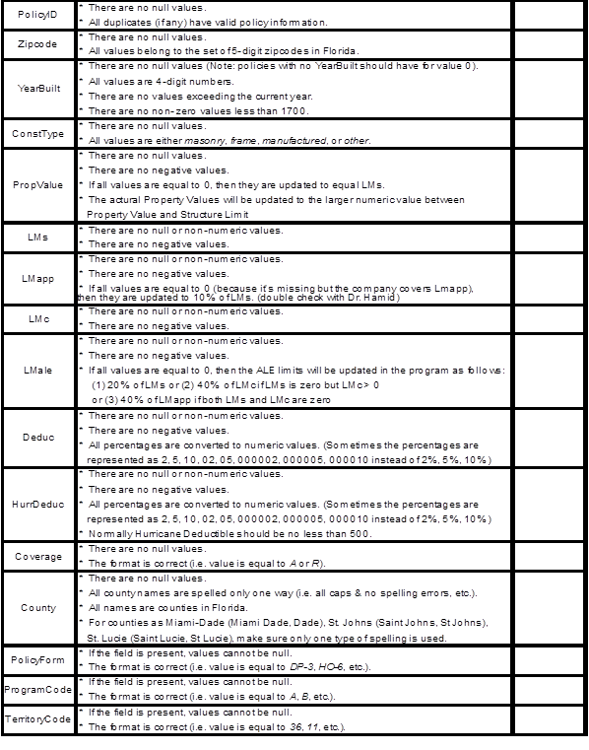
Missing attribute values | If attributes of roof shape, roof cover, opening protection, roof to wall connection are all unknown use weighted matrix. If one or more of the attributes are known, use the values  and replace the unknowns by randomly assigning values based on survey statistics and  then use unweighted matrices.

A-2 Event Definition

- Modeled loss costs and probable maximum loss levels shall reflect all insured wind related damages from storms that reach hurricane strength and produce minimum damaging windspeeds or greater on land in Florida.

- Time element loss costs shall reflect losses due to infrastructure damage caused by a hurricane.

Disclosures

- Describe how damage from model generated storms (landfalling and by-passing) is excluded or included in the calculation of loss costs and probable maximum loss levels for the state of Florida.

Damages are computed for all Florida land-falling and certain by-passing storms in the stochastic set that attain hurricane level wind speeds. The following by-passing hurricanes are included:

-Non-land-falling hurricanes with point of closest approach in region A, B, C, D, E or F and open terrain winds greater than 30 mph in at least one Florida ZIP Code.

-Land-falling hurricanes in regions E or F with open terrain winds greater than 30 mph in at least one Florida ZIP Code.

- Describe how damage resulting from concurrent or preceding flood or hurricane storm surge is treated in the calculation of loss costs and probable maximum loss levels for the state of Florida.

Damage from concurrent or preceding flood or storm surge is not considered in the calculation of loss costs and probable maximum loss. The model assumes that wind is the only cause of loss from each hurricane.

A-3 Coverages

- The methods used in the development of building loss costs shall be actuarially sound.

- The methods used in the development of appurtenant structure loss costs shall be actuarially sound.

- The methods used in the development of contents loss costs shall be actuarially sound.

- The methods used in the development of time element coverage loss costs shall be actuarially sound.

Disclosures

- Describe the methods used in the model to calculate loss costs for building coverage associated with personal and commercial residential properties.

Personal Residential Buildings

The model includes a set of vulnerability matrices for personal residential buildings. The matrices specify the probability of damage of a given magnitude at various wind speeds. For each building in the policy portfolio the applicable matrix for that building is used to determine the expected percent damage at a given wind speed. This determination is made storm by storm for every storm in the stochastic set. The resulting damages, adjusted for policy limits, deductibles and demand surge, are aggregated across all storms to calculate the loss cost per $1,000 of exposure.

Commercial Residential Buildings

For low-rise commercial residential buildings (three stories or fewer) the model includes a set of vulnerability curves. The curves specify the expected damage rate by wind speed.

For mid-/high-rise commercial residential buildings (over three stories), the model estimates exterior damage to the building by aggregating expected damage per story and interior damage as a function of the volume of water intrusion resulting from breached openings on each story.

Similar to the approach applied to personal residential buildings, expected damages for commercial residential buildings are determined for each storm, adjusted for policy provisions and demand surge, and aggregated to calculate the loss cost per $1,000 of exposure.

- Describe the methods used in the model to calculate loss costs for appurtenant structure coverage associated with personal and commercial residential properties.

Expected damages for both personal residential and commercial residential appurtenant structures are determined by policy for each storm in the stochastic set, adjusted for policy provisions and demand surge, and aggregated across all storms to calculate the loss cost per $1,000 of exposure. Expected damages are determined as follows:

Personal Residential Appurtenant Structures

Since the appurtenant structures damage is not derived from the building damage, only one vulnerability matrix is applied for appurtenant structures. The typical insurance portfolio gives no indication of the type of appurtenant structure covered under a particular policy. Therefore, a distribution of the three types (slightly vulnerable, moderately vulnerable, and highly vulnerable) was assumed in developing this matrix, and the result was then validated against claim data.

Commercial Residential Appurtenant Structures

For commercial residential exposures, appurtenant structures might include a clubhouse or administration building. These are modeled like additional buildings. For other structures such as pools, the appurtenant structures vulnerability matrix developed for residential buildings is applied.

- Describe the methods used in the model to calculate loss costs for contents coverage associated with personal and commercial residential properties.

Expected damages for both personal residential and commercial residential contents coverage are determined for each storm in the stochastic set, adjusted for policy provisions and demand surge, and aggregated across all storms to calculate the loss cost per $1,000 of exposure. Expected damages are determined as follows:

Personal Residential Contents

Contents losses are a function of the internal damage. The model applies empirical functions that are based on engineering judgment and were validated against claim data for Hurricanes Andrew, Charley, and Frances. Figure 66 shows masonry claims data from Hurricane Andrew, the cubic polynomial trend fit, and the model curve for the High Velocity Hurricane Zone (HVHZ), which consists of Miami-Dade and Broward counties. Notice that in this case the fit between model and data is reasonable where the density of data is higher. A resulting set of vulnerability matrices are applied to determine expected percent contents damage for a given wind speed.
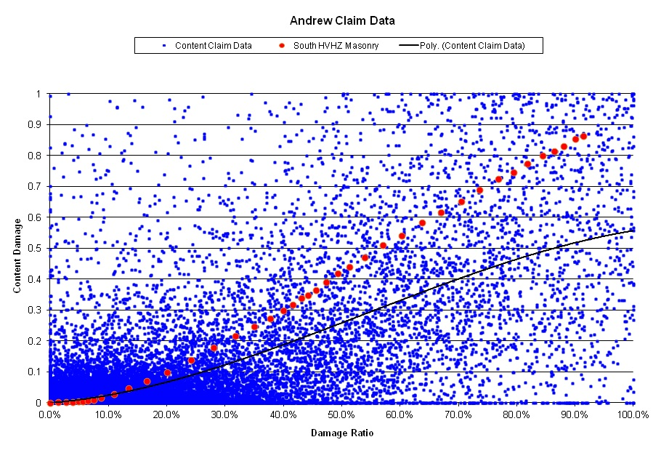
Figure 85. Modeled vs. actual relationship between structure and content damage ratios for Hurricane Andrew.

Commercial Residential Contents

Contents damage in low-rise buildings (three stories or fewer) is modeled as a proportion of interior damage. The resulting set of vulnerability curves vary by subregion and number of stories and specify expected percent damage by wind speed.

Contents damage in mid-/high-rise buildings (over three stories) is also determined as a proportion of total estimated interior damage to the building. The interior damage is estimated by determining the expected number of openings (windows, doors, sliding-glass doors) per story to be breached, and the resulting volume of water intrusion in each story.

The assumptions underlying contents damage development are based on engineering judgment.

- Describe the methods used in the model to calculate loss costs for time element coverage associated with personal and commercial residential properties.

Expected damages for both personal residential and commercial residential time element coverage are determined for each storm in the stochastic set, adjusted for policy provisions and demand surge, and aggregated across all storms to calculate the loss cost per $1,000 of exposure. Expected damages are determined as follows:

Personal Residential Time Element

Personal residential time element damages are based on an empirical function relating those damages to the interior damage to the structure. The model does not distinguish explicitly between direct and indirect loss to the structure, but the function is calibrated against claim data that include both types of losses. Vulnerability matrices specify the expected percent loss for a given wind speed.

Commercial Residential Time Element

The time element damages associated with low-rise buildings (three stories or fewer) are modeled using functions that relate those damages to interior damage to the building. The resulting set of vulnerability curves specify expected percent damage by wind speed.

Time element damages in mid-/high-rise buildings (over three stories) are not modeled.

A-4 Modeled Loss Cost and Probable Maximum Loss Considerations

- Loss cost projections and probable maximum loss levels shall not include expenses, risk load, investment income, premium reserves, taxes, assessments, or profit margin.

- Loss cost projections and probable maximum loss levels shall not make a prospective provision for economic inflation.

- Loss cost projections and probable maximum loss levels shall not include any explicit provision for direct hurricane storm surge losses.

- Loss cost projections and probable maximum loss levels shall be capable of being calculated from exposures at a geocode (latitude-longitude) level of resolution.

- Demand surge shall be included in the model’s calculation of loss costs and probably maximum loss levels using relevant data.

- The methods, data, and assumptions used in the estimation of demand surge shall be actuarially sound.

Disclosures

- Describe the method or methods used to estimate annual loss costs and probable maximum loss level. Identify any source documents used and research performed.

To estimate annual loss costs and probable maximum loss levels, losses are estimated for individual policies in the portfolio for each hurricane in a stochastic set of storms. Losses are estimated separately for structure, appurtenant structure, contents, and time element coverage.

The meteorological component of the model generates the stochastic set of hurricanes and derives an expected three-second gust wind speed, by latitude and longitude, for each hurricane in that set of storms.

The engineering component of the model consists of a set of vulnerability matrices for personal residential exposures and a set of vulnerability curves for low-rise commercial residential exposures. The matrices specify the probability of damage of a given magnitude at various wind speeds. The curves specify the expected damage rate by wind speed. For mid-rise and high-rise commercial residential exposures, the model estimates exterior damage by aggregating expected damage per story and interior damage as a function of the volume of water intrusion resulting from breached openings on each story.

The estimated damages are reduced by applicable deductibles and increased to allow for the impact of demand surge on claim costs.

The modeled insured losses can then be summed across all properties in a ZIP Code or across all ZIP Codes in a county to obtain expected aggregate loss. The losses can also be aggregated by policy form, construction type, rating territories, etc.

Finally, modeled losses are divided by the number of years in the simulation and by the total amount of insurance to estimate annual loss costs.

Modeled losses for storms occurring in the same year of the simulation are summed to produce annual storm losses. Probable maximum loss levels are calculated from the ordered set of annual losses as described in Standard A-6, Disclosure # 11.

The following sources were used in the research:

Hogg, R. V., & Klugman, S. (1984). Loss Distributions. New York: Wiley.

Klugman, S., Panjer, H., & Willmot, G. (1998). Loss Models: From Data to Decisions. New York: Wiley.

Wilkinson, M. E. (1982). Estimating Probable Maximum Loss with Order Statistics. Casualty Actuarial Society, LXIX, pp. 195-209.

- Identify the highest level of resolution for which loss costs and probable maximum loss levels can be provided. Identify all possible resolutions available for the reported output ranges.

Losses are calculated at the policy/coverage level for each storm in the stochastic set. When the street address of the exposures is available for input, each policy is associated with a latitude and longitude. In that case loss costs and probable maximum loss levels can be provided by latitude and longitude.

Losses can be summarized across any policy characteristic provided in the exposures. Therefore, loss costs and probable maximum loss levels can be aggregated by characteristics such as policy form, coverage, construction, deductible, latitude-longitude, ZIP Code, county, rating territory, roof shape, or whatever is provided for input.

For the reported output ranges, the resolutions available are defined by the policy characteristics provided in the exposures, namely, policy form, ZIP Code, construction and deductible. ZIP Codes can be aggregated to the county, region, or statewide level.

- Describe how the model incorporates demand surge in the calculation of loss costs and probable maximum loss levels.

Demand surge factors by coverage are calculated for each storm in the stochastic set and are applied to the estimated losses for that storm. For each storm, demand surge is assumed to be a function of coverage, region, and the storm’s estimated statewide losses before consideration of demand surge.

General Form of the Demand Surge Functions

The functions applied to determine the demand surge for each storm are of the form

Structure: Surge Factor = c + p1 x ln (statewide storm losses) + p2,

where c is a constant,
p1 is a constant for all regions except Monroe County,
p2 varies by region, and “statewide storm losses” are the estimated losses, before demand surge, for the storm under consideration.

Appurtenant Structures: Surge Factor = Structure Factor.

Contents: Surge Factor = [ (Structure Factor – 1) x 30% ] + 1.

Additional Living Expenses: Surge Factor = 1.5 x Structure Factor - .5.

Development of the Demand Surge Function for Structure

To estimate the impact of demand surge on the settlement cost of structural claims following a hurricane we used a quarterly construction cost index produced by Marshall & Swift/Boeckh. We considered the history of the index from first quarter 1992 through second quarter 2007. There is an index for each of 52 ZIP Codes in Florida representing 42 counties. We grouped the indices to produce a set of regional indices, weighting each ZIP Code index with population.

The approach to estimating structural demand surge was to examine the index for specific regions impacted by one or more hurricanes since 1992. From the history of the index, we projected what the index would have been in the period following the storm had no storm occurred. Any gap between the predicted and actual index was assumed to be due to demand surge. In total we examined ten storm–region combinations. From these ten observations of structural demand surge, we generalized to the functional relationship shown above.

Monroe County was treated as an exception. There were no storms of any severity striking Monroe during the period of our observations. We believe, though, that the location of and limited access to the Keys will result in an unusually high surge in reconstruction costs after a storm, particularly since the Overseas Highway could be damaged by storm surge or seriously blocked by debris. We have therefore judgmentally selected demand surge parameters for Monroe in excess of those indicated for the remainder of South Florida

Development of the Contents Demand Surge Function

The approach to determining the contents demand surge function was to relate any surge in consumer prices in Southeast Florida following hurricanes Katrina and Wilma to the estimated structure demand surge following those storms. We used a sub-index of the Miami-Ft. Lauderdale Consumer Price Index for this purpose and compared the projected and actual indices after the storms. Since the surge in consumer prices was roughly 30% of the surge in construction costs, we selected that percentage as the relationship between structure and contents demand surge.

Development of Time Element (TE) Demand Surge Function

To estimate TE demand surge we first examined the relationship between structure losses and TE losses in the validation dataset. This dataset includes losses from three storms (Andrew, Charley, and Frances) and eleven insurance companies. We then compared the predicted increase in TE losses associated with various increases in structure losses. That generalized relationship is the TE demand surge function shown above.

TE demand surge is related to structure demand surge in the following sense: structure surge is caused by an inability of the local construction industry to meet the sudden demand for materials and labor following a storm. A high surge in construction costs suggests a more serious mismatch between the demand for repairs and the supply of materials and labor. This mismatch translates into longer delays in the completion of repairs and rebuilding, which in turn implies a higher surge in TE costs.

Because the model’s TE surge is determined as a function of structure surge, Monroe County TE surge factors are higher than those for the remainder of South Florida. We believe this is reasonable because of the unusual delays in repair and rebuilding that are likely to occur following a major storm in the Keys, especially if there is damage to US 1 or to bridges connecting the islands.

Treatment of Demand Surge for Storms Impacting both the Florida Panhandle and Alabama

The Northwest region is segregated from the remainder of the North to allow for demand surge that is a function of combined Florida–Alabama losses from storms impacting both states. The Northwest region consists of all Panhandle counties west of Leon and Wakulla. The definition of this region was selected by considering which counties experienced losses from Hurricanes Ivan, Frederic, and Elena, i.e., from storms that impacted both states. Not all counties in the Northwest region experienced losses from these three specific storms, but losses in neighboring counties suggest that that they are nevertheless at risk for inclusion in a combined Florida–Alabama event.

Demand surge factors for the Northwest region are determined as an upward adjustment to the factors for the Northeast–North Central region. The purpose of this adjustment is to correct for an understatement of the model’s demand surge that occurs when only the Florida losses from a combined Florida–Alabama event are used to determine the level of demand surge from a storm.

- Provide citations to published papers, if any, that were used to develop how the model estimates demand surge.

No published papers were used in the demand surge development.

A-5 Policy Conditions

- The methods used in the development of mathematical distributions to reflect the effects of deductibles and policy limits shall be actuarially sounds.

- The relationship among the modeled deductible loss costs shall be reasonable.

- Deductible loss costs shall be calculated in accordance with s.627.701(5)(a), F.S.

Disclosures

- Describe the methods used in the model to treat deductibles (both flat and percentage), policy limits, replacement costs, and insurance-to-value when projecting loss costs.

In practice the insurance companies often allocate deductibles to structure, content, AP, and ALE on a pro-rata loss basis. Thus, if for example, structure and content damages before deductible are $20,000 and $6,000 respectively, and the deductible is $3,000, then (20,000/26,000)(3,000) = $2,308 is allocated to structure and (6,000/26,000)(3,000) = $692 is allocated to contents. This means that the various damages have to be considered and deductibles applied simultaneously. The deductibles must be allocated among the different losses and the truncation applied to each loss separately on a pro-rata basis.

For the pro-rata deductible method to work optimally, the functional relationships between structure damage and others should be estimated, and for each interval or class of structural damage, the corresponding mean and variance of the C, AP, and ALE damages should be specified. The conditional probabilities for C, AP, and ALE will then be the same as those for structural damage. An independent content matrix is somewhat problematic and may create biases in estimates of net of deductible losses. For structures we are likely to have damage ratio ranges or intervals of 0 to 2%, 2% to 4%, 4% to 6%, etc. For each interval (and its midpoint), ideally we may want to use the mean and variance of the corresponding damage ratios for contents, AP, and ALE. In practice, since the damage matrix for different types of losses are not directly related, we need to use the mean of the content, or AP, or ALE damage vector conditional on windspeeds since the windspeed is the only common frame of reference to the various types of damages.
L+D_{S}
Expected Structure Loss = E(L_{s}) = ∑ (DM_{i} - D_{s} ) p_{S} (x_{i}w) + ∑ LM_{S} p_{S} (x_{i}w)
D_{S}

L+C_{S}
Expected Content Loss = E(L_{C}) = ∑ (f(X_{i}) - D_{c}) p_{C} (x_{i}w) + ∑ LM_{C} p_{C} (x_{i}w)
C_{S}

Expected Appurtenant Loss = E(L_{AP}) = ∑ (g(X_{i}) - D_{AP}) p_{S} (x_{i}w) + ∑ LM_{AP} p_{S} (x_{i}w)

Expected ALE Loss = E(L_{ALE}) = ∑ (h(X_{i}) - D_{ALE}) p_{S} (x_{i}w) + ∑ LM_{ALE} p_{S} (x_{i}w)

Expected Loss = E (L) = E(L_{S}) + E(L_{C}) + E(L_{AP}) + E(L_{ALE})

where each of the losses net of deductible is ≥ 0 and where the deductibles DS, DC, DAP, DALE are applied on a pro-rata basis to the respective damages as follows:

D_{S} = [DM_{S} /(DM_{S} + C + AP + ALE)] * D
D_{C} = [C /(DM_{S} + C + AP + ALE)] * D
D_{AP} = [AP /(DM_{S} + C + AP + ALE)] * D
D_{ALE} = [ALE /(DM_{S} + C + AP + ALE)] * D

For this method to work, ideally, the joint probabilities of the losses must be estimated and used. In practice such joint probabilities are hard to estimate and validate. Thus, the engineering component should ideally provide for each structural damage interval, and given a wind speed, the mean and variance of damage ratio for content, AP, and ALE. The model uses the mean C, AP, and ALE for the given wind speed to determine the allocation of deductible to the various coverages.

Personal Residential

In the damage matrices, each wind speed interval is associated with a distribution of possible damage ratios. Each damage ratio is multiplied by insured value to determine dollar damages, the deductible is deducted, and net of deductible loss is estimated, subject to the constraints that net loss is ≥ 0 and ≤ limit – deductible.

Commercial Residential

The deductible is deducted from expected loss for each building.

Personal and Commercial Residential

The deductible is allocated to coverage by first calculating expected losses for each coverage, assuming zero deductible, and then allocating the deductible to coverage based on those losses.

Percentage deductibles are converted into dollar amounts.

Both the replacement cost and property value are assumed to equal the coverage limit unless the property value is provided as an input.

- Provide an example of how insurer loss (loss net of deductibles) is calculated. Discuss data or documentation used to confirm or validate the method used by the model.

Personal Residential

For each damage ratio:
Loss net of deductible = (Damage Ratio x Bldg Value) – Deductible, but not less than zero or greater than limit – deductible.

Example
Bldg value = $200,000. Limit = $180,000. Deductible = $3,000. J^{th} Damage ratio = 5%.
Loss net of deductible = .05 x 200,000 - 3,000 = $7,000. If the J^{th} Damage ratio = 1%, then loss net of deductible = 0. If the damage ratio is 95%, then the loss net of deductible = $180,000 - $3,000 = $177,000.

The deductible method used by model is based on Hogg and Klugman (1984). Modeled losses net of deductible were validated against insurance company losses for Hurricanes Andrew, Charley, and Frances.

Commercial Residential

The deductible is deducted from the expected damage for each building.

Example
Building Limit = $1,000,000. Deductible = 3 % or $30,000. Expected Damage Ratio = 10%.
Expected Damage = $1,000,000 x 10% = $100,000.
Loss net of deductible = $100,000 - $30,000 = $70,000.

- Describe how the model calculates annual deductibles.

If there are multiple Hurricanes in a year in the stochastic set, the wind deductibles are applied to the first hurricane, and any remaining amount is then applied to the second hurricane. If none of the wind deductible remains, then the general peril deductible is applied. This is the case for both personal and commercial residential policies.

A-6 Loss Output

- The methods, data, and assumptions used in the estimation of probable maximum loss levels shall be actuarially sound.

- Loss costs shall not exhibit an illogical relation to risk, nor shall loss costs exhibit a significant change when the underlying risk does not change significantly.

- Loss costs produced by the model shall be positive and non-zero for all valid Florida ZIP Codes.

- Loss costs cannot increase as the quality of construction type, materials and workmanship increases, all other factors held constant.

- Loss costs cannot increase as the presence of fixtures or construction techniques designed for hazard mitigation increases, all other factors held constant.

- Loss costs cannot increase as the quality of building codes and enforcement increases, all other factors held constant.

- Loss costs shall decrease as deductibles increase, all other factors held constant.

- The relationship of loss costs for individual coverages, (e.g., buildings and appurtenant structures, contents, and time element shall be consistent with the coverages provided.

- Output ranges shall be logical for the type of risk being modeled and deviations supported.

- All other factors held constant, output ranges produced by the model shall in general reflect lower loss costs for:

  - masonry construction versus frame construction,

  - personal residential risk exposure versus mobile home risk exposure,

  - inland counties versus coastal counties, and

  - northern counties versus southern counties.

- For loss cost and probable maximum loss level estimates derived from or validated with historical insured hurricane losses, the assumptions in the derivations concerning (1) construction characteristics, (2) policy provisions, (3) coinsurance, (4) contractual provisions, and (5) relevant underwriting practices underlying those losses, as well as any actuarial modifications, shall be appropriate based on the type of risk being modeled.

Disclosures

- Provide a completed Form A-1, Zero Deductible Personal Residential Loss Costs by ZIP Code. Provide a link to the location of the form here.

See Form A-1

- Provide a completed Form A-2, Base Hurricane Storm Set Statewide Losses. Provide a link to the location of the form here.

See Form A-2

- Provide a completed Form A- 3A, 2004 Hurricane Season Losses, using the 2007 Florida Hurricane Catastrophe Fund aggregate personal and commercial residential exposure data. Provide a link to the location of the form here.

See Form A-3

- Provide a completed Form A-3B, 2004 Hurricane Season Losses, using the 2012 Florida Hurricane Catastrophe Fund aggregate personal and commercial residential exposure data. Provide a link to the location of the form here.

- Provide a completed Form A-4A, Output Ranges, using the 2007 Florida Hurricane Catastrophe Fund aggregate personal and commercial residential exposure data. Provide a link to the location of the form here.

See Form A-4

- Provide a completed Form A-4B, Output Ranges, using the 2012 Florida Hurricane Catastrophe Fund aggregate personal and commercial residential exposure data. Provide a link to the location of the form here.

- Provide a completed Form A-5, Percentage Change in Output Ranges, using the 2007 Florida Hurricane Catastrophe Fund aggregate personal and commercial residential exposure data. Provide a link to the location of the form here.

See Form A-5

- A completed Form A-6, Logical Relationship to Risk (Trade Secret item) shall be provided during the closed meeting portion of the Commission meeting to review the model for acceptability.

See Form A-6

- Provide a completed Form A-7, Percentage Change in Logical Relationship to Risk. Provide a link to the location of the form here.

See Form A-7

- Provide a completed Form A-8, Probable Maximum Loss for Florida. Provide a link to the location of the form here.

See Form A-8

- Describe how the model produces probable maximum loss levels.

Probable maximum loss is produced nonparametrically using order statistics of simulated annual losses.

The model produces N simulated annual losses, represented by X₁, X₂, …, X_{N}. The data are ordered so that X₍₁₎ ≤ X₍₂₎ ≤ . . . ≤ X_{(N)}.

For a return period of Y years, let p = 1-1/Y. The corresponding PML for the return period Y is the pth quantile of the ordered losses.

Let k = (N)*p. If k is an integer, then the estimate of the PML is the kth order statistic, X_{(k)}, of the simulated losses. If k is not an integer, then let k* = the smallest integer greater than k, and the estimate of the pth quantile is given by X_{(k*)}.

- Provide citations to published papers, if any, that were used to estimate probable maximum loss levels.

Wilkinson, M. E. (1982). Estimating Probable Maximum Loss with Order Statistics. Casualty Actuarial Society, LXIX, pp. 195-209.

- Describe how the probable maximum loss levels produced by the model include the effects of personal and commercial residential insurance coverage.

The model can produce probable maximum loss levels separately for personal and commercial residential exposures or on a combined basis. To produce the probable maximum loss on a combined basis, modeled losses for both personal and commercial exposures are aggregated for each year in the simulation before the years are ordered. Because modeled losses are used as the basis for the probable maximum loss level, the effects of policy limits, deductibles, etc. are reflected in the probable maximum loss estimates.

- Explain any difference between the values provided on Form A-8 (Probable Maximum Loss for Florida) and those provided on Form S-2B (Examples of Loss Exceedance Estimates, 2012 FHCF Exposure Data).

The values on Form A-8 and Form S-2 are the same.

- Provide an explanation for all anomalies in the loss costs that are not consistent with the requirements of this standard.

Form A-4: In Form A-4 the county weighted average loss cost for masonry sometimes exceeds frame because the masonry weights are greater in ZIP Codes with higher loss costs.

Form A-6: There are anomalies in the Building Code and Building Strength tests in Form A-6. The anomalies are the result of the following model assumptions:

- The model assumes no difference in structure strength between the 1998, 2004 and 2007 Building Codes in the HVHZ.

- The model assumes no difference in structure strength between 1974 and 1992 Mobile Homes and does vary damages based on tie-downs.

- The model assumes no difference in structure strength between the 1980 and 1998 Building Codes as they apply to Commercial Residential construction, except in the HVHZ where metal shutters were required after 1994.

- Provide an explanation of the differences in output ranges between the previously accepted submission and the current submission.

Both the meteorology and vulnerability components of the model changed as described in Standard G-1. In general loss costs were reduced by these changes.

- Identify the assumptions used to account for the effects of coinsurance on commercial residential loss costs.

The model assumes properties are insured to value and makes no adjustment to losses for coinsurance penalties.

- Describe how loss adjustment expenses are considered within the loss cost and probable maximum loss level estimates.

No provision for loss adjustment expense is included in the loss cost or probable maximum loss level estimates.

Form A-1: Zero Deductible Personal Residential Loss Costs by ZIP Code

- Provide three maps, color-coded by ZIP Code (with a minimum of 6 value ranges), displaying zero deductible personal residential loss costs per $1,000 of exposure for frame, masonry, and mobile home.

- Create exposure sets for these exhibits by modeling all of the buildings from Notional Set described in the file “NotionalInput13.xlsx” geocoded to each ZIP Code centroid in the state, as provided in the model. Provide the predominant County name and the Federal Information Processing Standards (FIPS) Code associated with each ZIP Code centroid. Refer to the Notional Policy Specification below for additional modeling information. Explain any assumptions, deviations, and differences from the prescribed exposure information.

- Provide, in the format given in the file named “2013FormA1.xlsx,” the underlying loss cost data rounded to 3 decimal places used for A. above in both Excel and PDF format. The file name shall include the abbreviated name of the modeling organization, the standards year, and the form name.

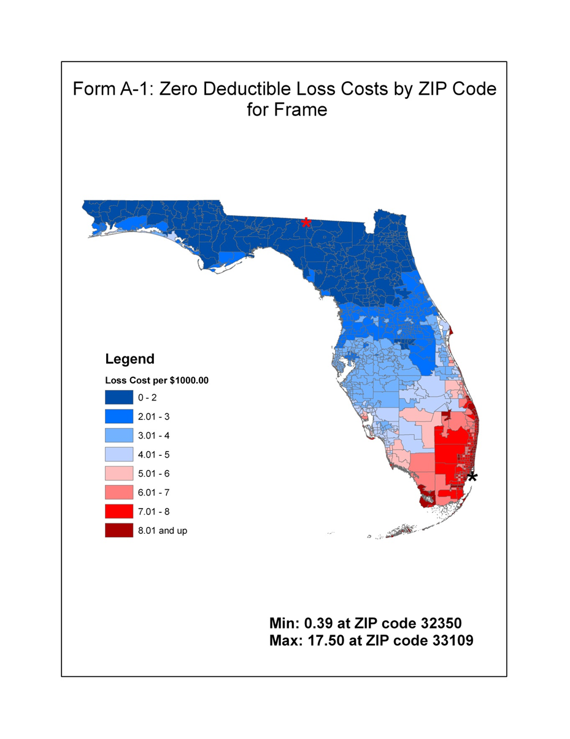
Figure 86. Zero deductible loss costs by ZIP code for frame.

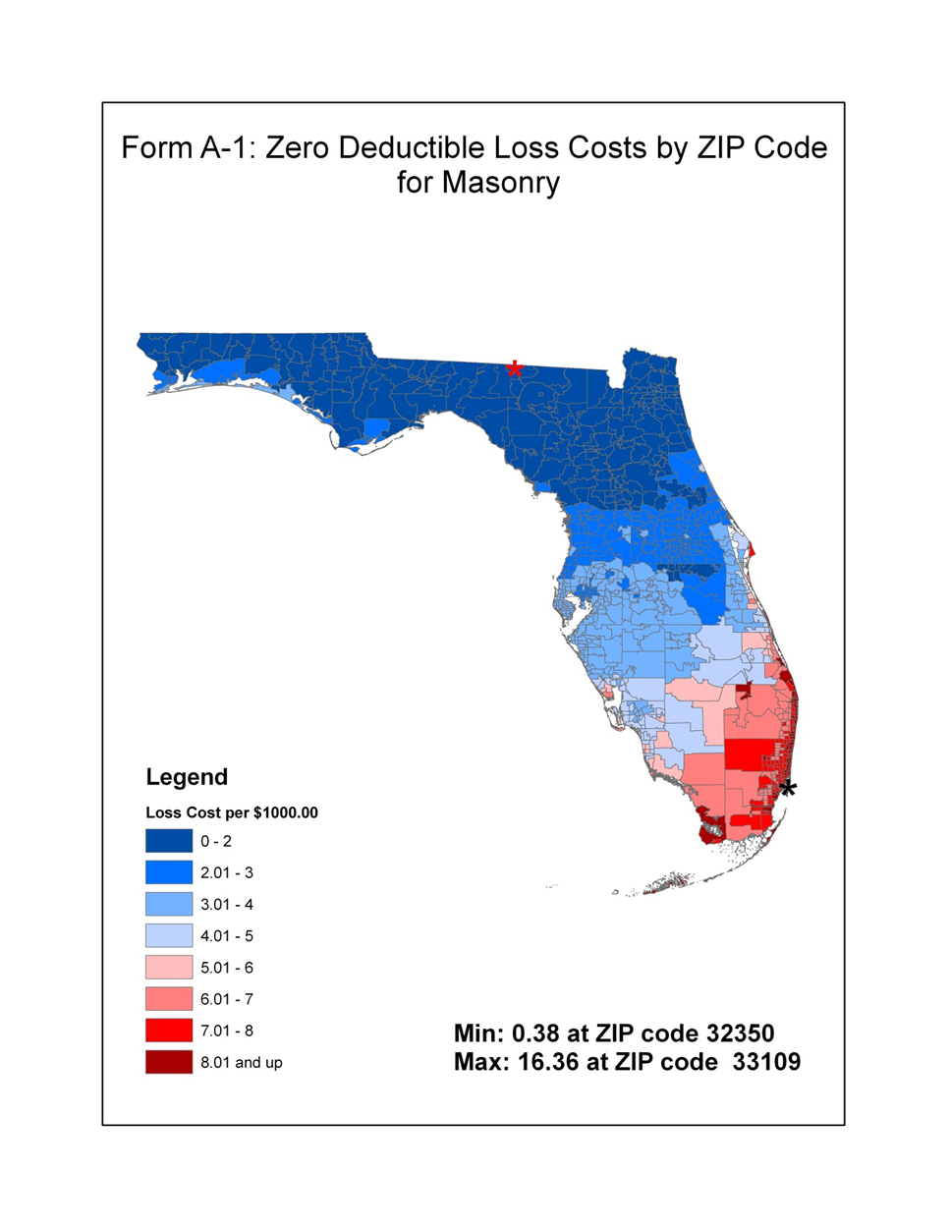
Figure 87. Zero deductible loss costs by ZIP code for masonry.

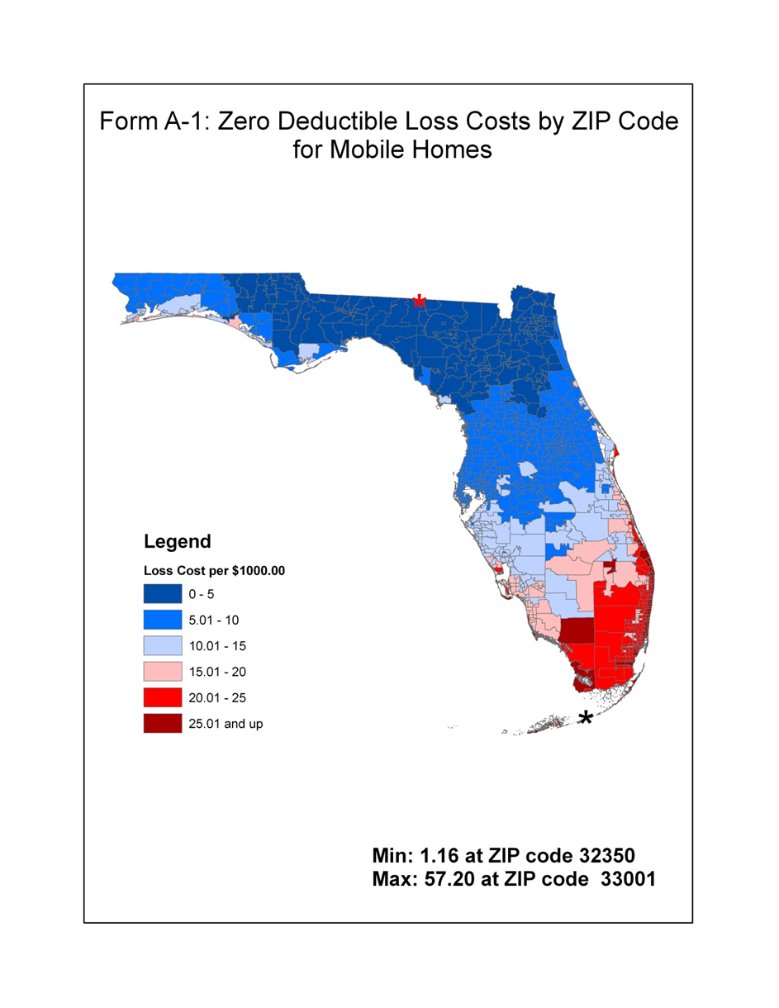
Figure 88. Zero deductible loss costs by ZIP code for mobile homes.

Form A-2: Base Hurricane Storm Set Statewide Losses

- Provide the total insured loss and the dollar contribution to the average annual loss assuming zero deductible policies for individual historical hurricanes using the Florida Hurricane Catastrophe Fund’s aggregate personal and commercial residential exposure data found in the files named “hlpm2007c.exe” and “hlpm2012c.exe.” The list of hurricanes in this form should include all Florida and by-passing hurricanes in the modeling organization Base Hurricane Storm Set, as defined in Standard M-1 (Base Hurricane Storm Set).

- Provide this form in Excel format. The file name shall include the abbreviated name of the modeling organization, the standards year, and the form name. Form A-2 (Base Hurricane Storm Set Statewide Losses) shall also be included in a submission appendix.

See Appendix B.

Form A-3A: 2004 Hurricane Season Losses (2007 FHCF Exposure Data)

- Provide the percentage of residential zero deductible losses, rounded to four decimal places, and the monetary contribution from Hurricane Charley (2004), Hurricane Frances (2004), Hurricane Ivan (2004), and Hurricane Jeanne (2004) for each affected ZIP Code, individually and in total. Include all ZIP Codes where losses are equal to or greater than $500,000.

Use the 2007 Florida Hurricane Catastrophe Fund’s aggregate personal and commercial residential exposure data found in the file named “hlpm2007c.exe.”

Rather than using directly a specified published windfield, the winds underlying the loss cost calculations must be produced by the model being evaluated and should be the same hurricane parameters as used in completing Form A-2 (Base Hurricane Storm Set Statewide Losses).

- Provide maps color-coded by ZIP Code depicting the percentage of total residential losses from each hurricane, Hurricane Charley (2004), Hurricane Frances (2004), Hurricane Ivan (2004), and Hurricane Jeanne (2004) and for the cumulative losses using the following interval coding:

Red Over 5%
Light Red 2% to 5%
Pink 1% to 2%
Light Pink 0.5% to 1%
Light Blue 0.2% to 0.5%
Medium Blue 0.1% to 0.2%
Blue Below 0.1%

The relevant storm track should be plotted on each map.

- Provide this form in Excel format. The file name shall include the abbreviated name of the modeling organization, the standards year, and the form name. Form A-3A (2004 Hurricane Season Losses, 2007 FHCF Exposure Data) shall also be included in a submission appendix.

See Appendix C.
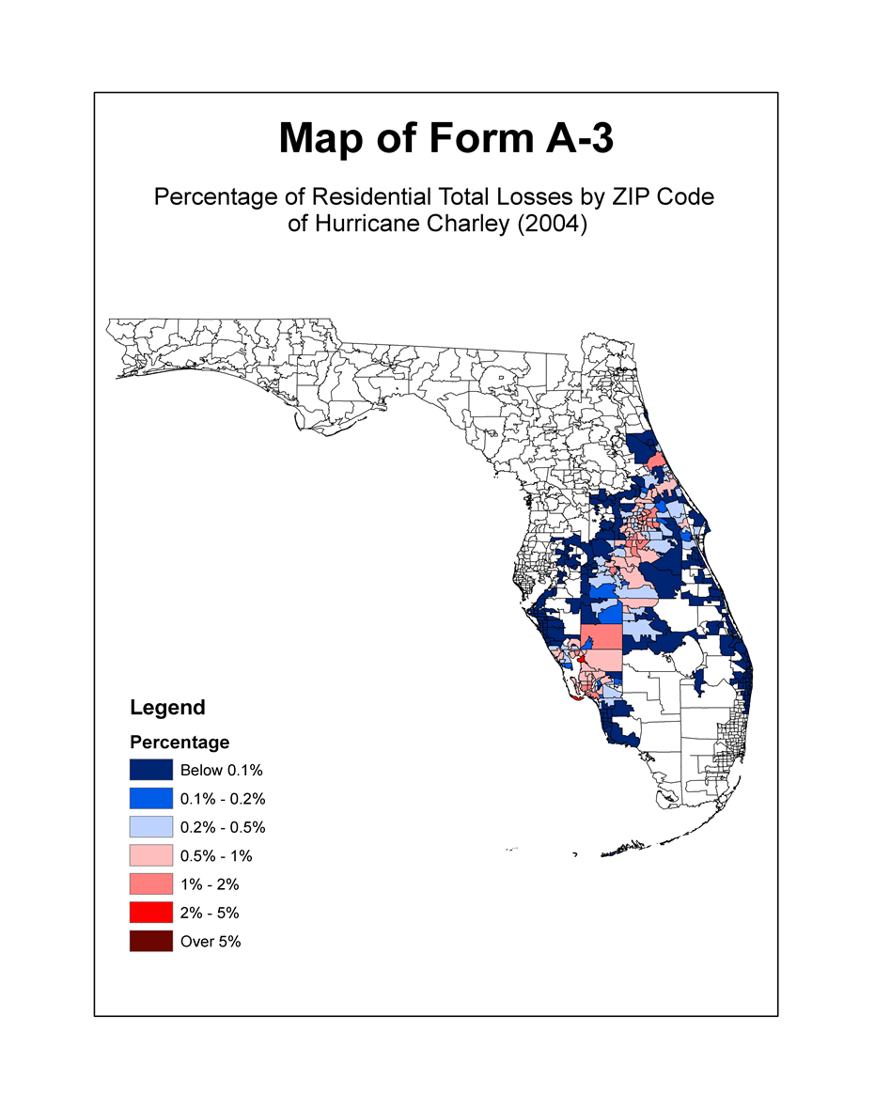
Figure 89. Percentage of residential total losses by ZIP code of Hurricane Charley (2004).
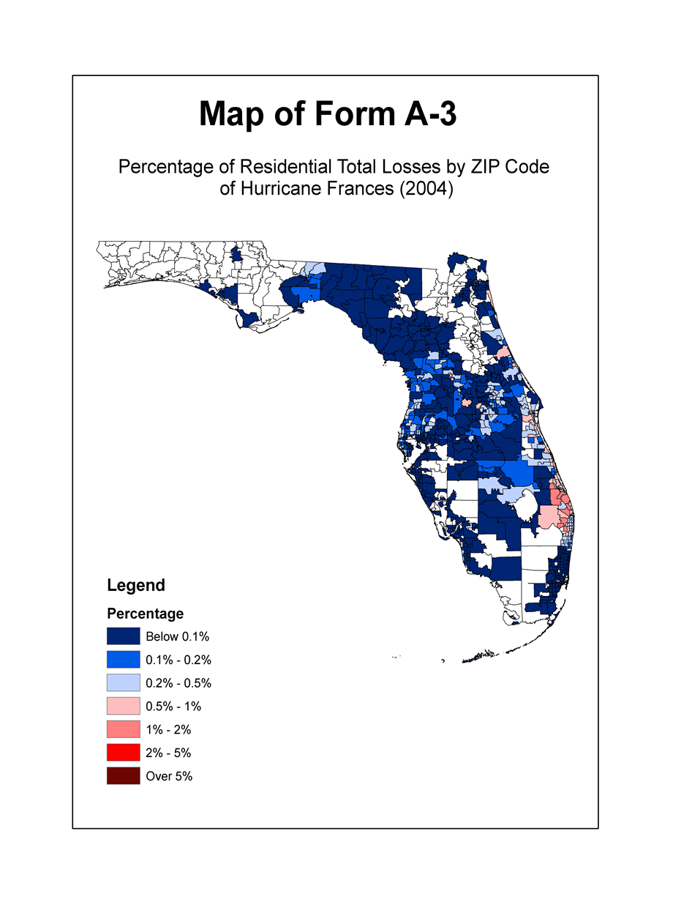
Figure 90. Percentage of residential total losses by ZIP code of Hurricane Frances (2004).
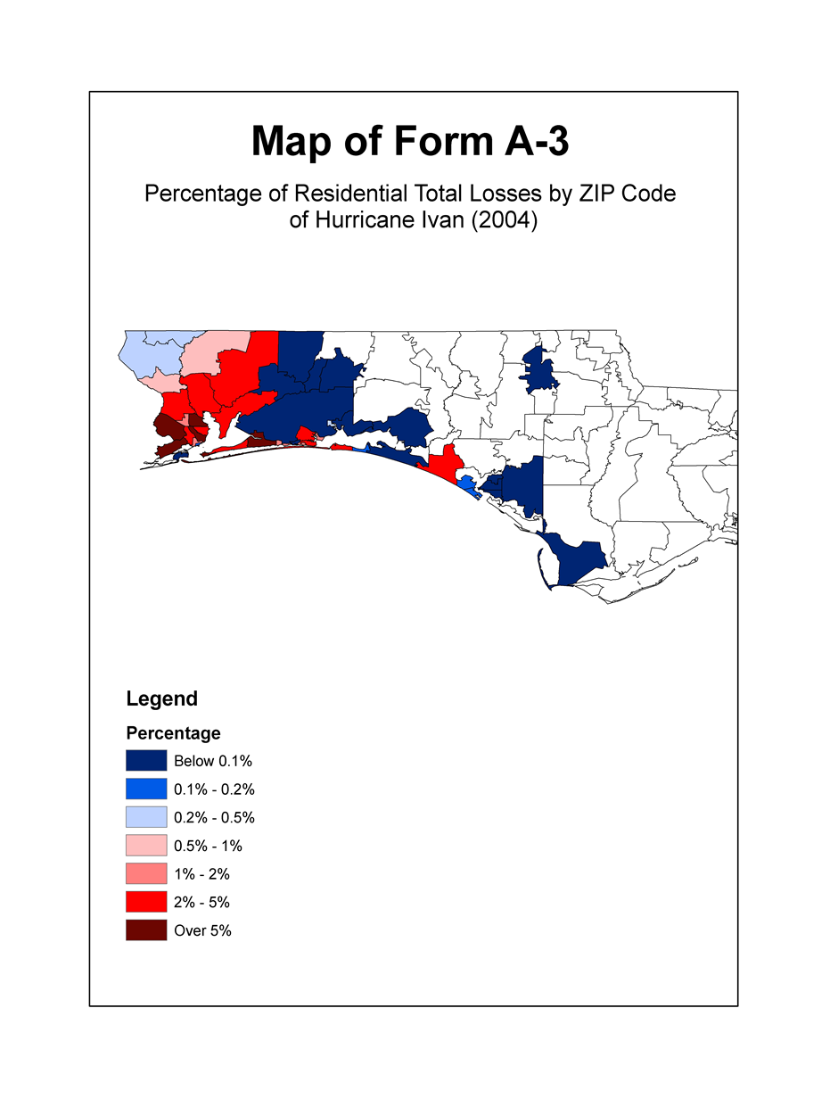
Figure 91. Percentage of residential total losses by ZIP code of Hurricane Ivan (2004).
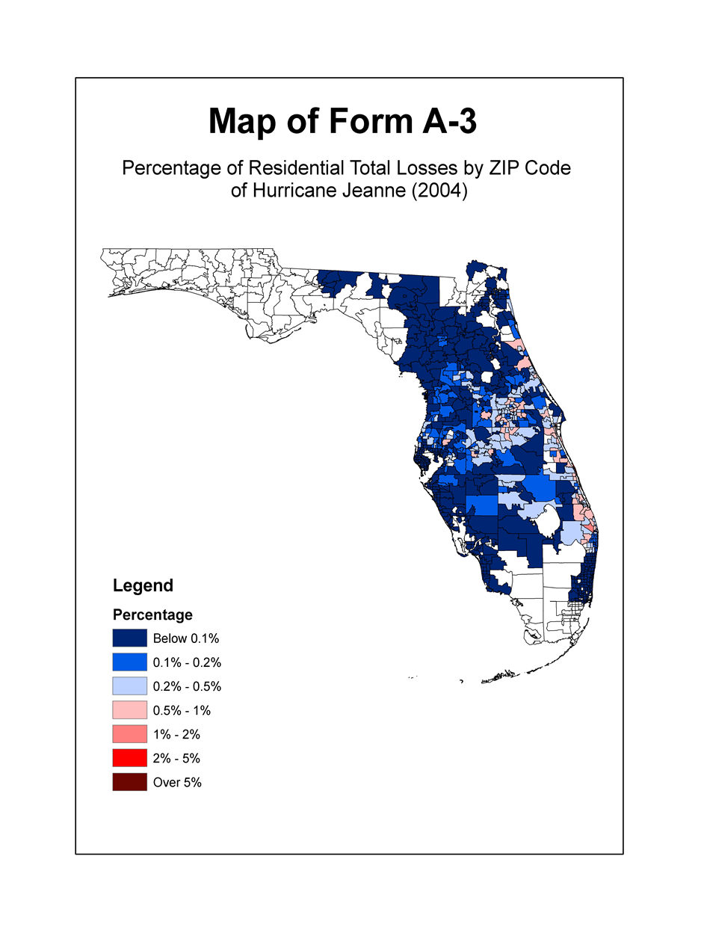
Figure 92. Percentage of residential total losses by ZIP code of Hurricane Jeanne (2004).
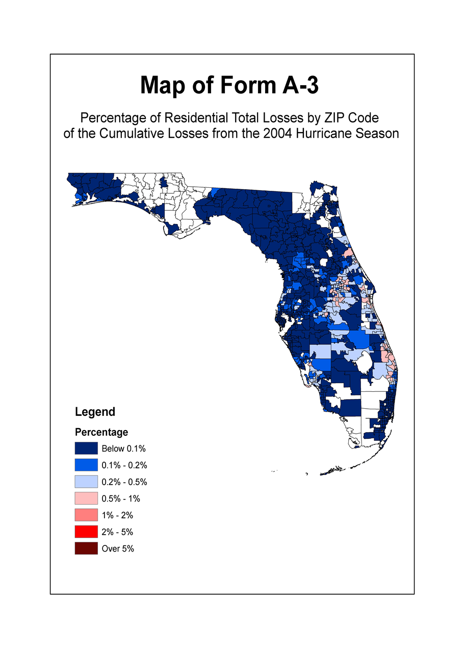
Figure 93. Percentage of residential total losses by ZIP code of the cumulative losses from the 2004 Hurricane Season.

Form A-3B: 2004 Hurricane Season Losses (2012 FHCF Exposure Data)

- Provide the percentage of residential zero deductible losses, rounded to four decimal places, and the monetary contribution from Hurricane Charley (2004), Hurricane Frances (2004), Hurricane Ivan (2004), and Hurricane Jeanne (2004) for each affected ZIP Code, individually and in total. Include all ZIP Codes where losses are equal to or greater than $500,000.

Use the 2012 Florida Hurricane Catastrophe Fund’s aggregate personal and commercial residential exposure data found in the file named “hlpm2012c.exe.”

Rather than using directly a specified published windfield, the winds underlying the loss cost calculations must be produced by the model being evaluated and should be the same hurricane parameters as used in completing Form A-2 (Base Hurricane Storm Set Statewide Losses).

- Provide maps color-coded by ZIP Code depicting the percentage of total residential losses from each hurricane, Hurricane Charley (2004), Hurricane Frances (2004), Hurricane Ivan (2004), and Hurricane Jeanne (2004) and for the cumulative losses using the following interval coding:

Red Over 5%
Light Red 2% to 5%
Pink 1% to 2%
Light Pink 0.5% to 1%
Light Blue 0.2% to 0.5%
Medium Blue 0.1% to 0.2%
Blue Below 0.1%

The relevant storm track should be plotted on each map.

- Provide this form in Excel format. The file name shall include the abbreviated name of the modeling organization, the standards year, and the form name. Form A-3B (2004 Hurricane
Season Losses, 2012 FHCF Exposure Data) shall also be included in a submission appendix.

Form A-4A: Output Ranges (2007 FHCF Exposure Data)

- Provide personal and commercial residential output ranges in the format shown in the file named “2013FormA4A.xlsx” by using an automated program or script. Provide this form in Excel format. The file name shall include the abbreviated name of the modeling organization, the standards year, and the form name. Form A-4A (Output Ranges, 2007 FHCF Exposure Data) shall also be included in a submission appendix.

- Provide loss costs rounded to three (3) decimal places by county. Within each county, loss costs shall be shown separately per $1,000 of exposure for frame owners, masonry owners, frame renters, masonry renters, frame condo unit owners, masonry condo unit owners, mobile home, and commercial residential. For each of these categories using ZIP Code centroids, the output range shall show the highest loss cost, the lowest loss cost, and the weighted average loss cost. The aggregate residential exposure data for this form shall be developed from the information in the file named “hlpm2007c.exe,” except for insured value and deductibles information. Insured values shall be based on the output range specifications below. Deductible amounts of 0% and as specified in the output range specifications will be assumed to be uniformly applied to all risks. When calculating the weighted average loss costs, weight the loss costs by the total insured value calculated above. Include the statewide range of loss costs (i.e., low, high, and weighted average).

- If a modeling organization has loss costs for a ZIP Code for which there is no exposure, give the loss costs zero weight (i.e., assume the exposure in that ZIP Code is zero). Provide a list in the submission document of those ZIP Codes where this occurs.

- If a modeling organization does not have loss costs for a ZIP Code for which there is some exposure, do not assume such loss costs are zero, but use only the exposures for which there are loss costs in calculating the weighted average loss costs. Provide a list in the submission document of the ZIP Codes where this occurs.

- All anomalies in loss costs that are not consistent with the requirements of Standard A-6 (Loss Output) and have been explained in Disclosure A-6.15 shall be shaded.

Indicate if per diem is used in producing loss costs for Coverage D (ALE) in the personal residential output ranges. If a per diem rate is used in the submission, a rate of $150.00 per day per policy shall be used.

See Appendix D.

Form A-4B: Output Ranges (2012 FHCF Exposure Data)

- Provide personal and commercial residential output ranges in the format shown in the file named “2013FormA4B.xlsx” by using an automated program or script. Provide this form in Excel format. The file name shall include the abbreviated name of the modeling organization, the standards year, and the form name. Form A-4B (Output Ranges, 2012 FHCF Exposure Data) shall also be included in a submission appendix.

- Provide loss costs rounded to three (3) decimal places by county. Within each county, loss costs shall be shown separately per $1,000 of exposure for frame owners, masonry owners, frame renters, masonry renters, frame condo unit owners, masonry condo unit owners, mobile home, and commercial residential. For each of these categories using ZIP Code centroids, the output range shall show the highest loss cost, the lowest loss cost, and the weighted average loss cost. The aggregate residential exposure data for this form shall be developed from the information in the file named “hlpm2012c.exe,” except for insured value and deductibles information. Insured values shall be based on the output range specifications below. Deductible amounts of 0% and as specified in the output range specifications will be assumed to be uniformly applied to all risks. When calculating the weighted average loss costs, weight the loss costs by the total insured value calculated above. Include the statewide range of loss costs (i.e., low, high, and weighted average).

- If a modeling organization has loss costs for a ZIP Code for which there is no exposure, give the loss costs zero weight (i.e., assume the exposure in that ZIP Code is zero). Provide a list in the submission document of those ZIP Codes where this occurs.

- If a modeling organization does not have loss costs for a ZIP Code for which there is some exposure, do not assume such loss costs are zero, but use only the exposures for which there are loss costs in calculating the weighted average loss costs. Provide a list in the submission document of the ZIP Codes where this occurs.

- All anomalies in loss costs that are not consistent with the requirements of Standard A-6 (Loss Output) and have been explained in Disclosure A-6.15 shall be shaded.

Indicate if per diem is used in producing loss costs for Coverage D (ALE) in the personal residential output ranges. If a per diem rate is used in the submission, a rate of $150.00 per day per policy shall be used.

Form A-5: Percentage Change in Output Ranges (2007 FHCF Exposure Data)

- Provide summaries of the percentage change in average loss cost output range data compiled in Form A-4A (Output Ranges, 2007 FHCF Exposure Data) relative to the equivalent data compiled from the previously accepted model in the format shown in the file named “2013FormA5.xlsx.”

For the change in output range exhibit, provide the summary by:

- Statewide (overall percentage change),
- By region, as defined in Figure 14 – North, Central and South,
- By county, as defined in Figure 15 – Coastal and Inland.

- Provide this form in Excel format. The file name shall include the abbreviated name of the modeling organization, the standards year, and the form name. All tables in Form A-5 (Percentage Change in Output Ranges, 2007 FHCF Exposure Data) shall also be included in a submission appendix.

- Provide color-coded maps by county reflecting the percentage changes in the average loss costs with specified deductibles for frame owners, masonry owners, frame renters, masonry renters, frame condo unit owners, masonry condo unit owners, mobile home, and commercial residential from the output ranges from the previously accepted model.

Counties with a negative percentage change (reduction in loss costs) shall be indicated with shades of blue; counties with a positive percentage change (increase in loss costs) shall be indicated with shades of red; and counties with no percentage change shall be white. The larger the percentage change in the county, the more intense the color-shade.

See Appendix E.

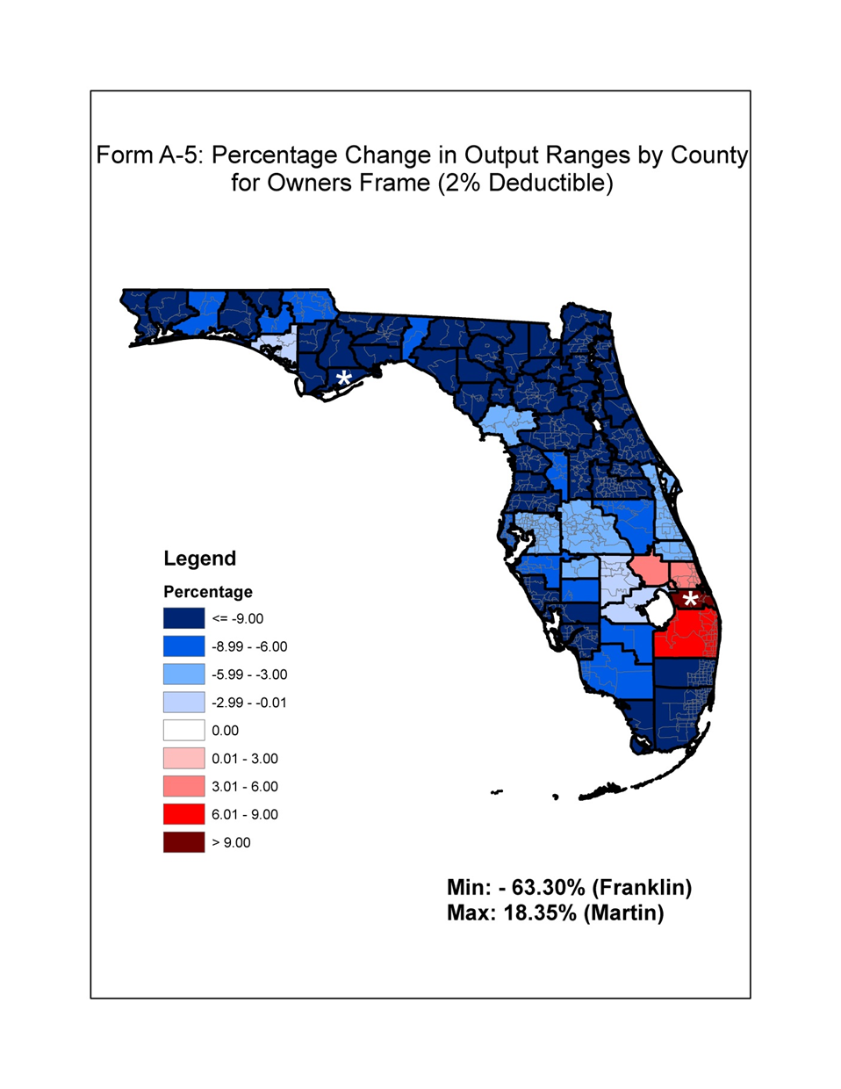
Figure 94. Percentage change in output ranges by county for owners frame (2% deductible).

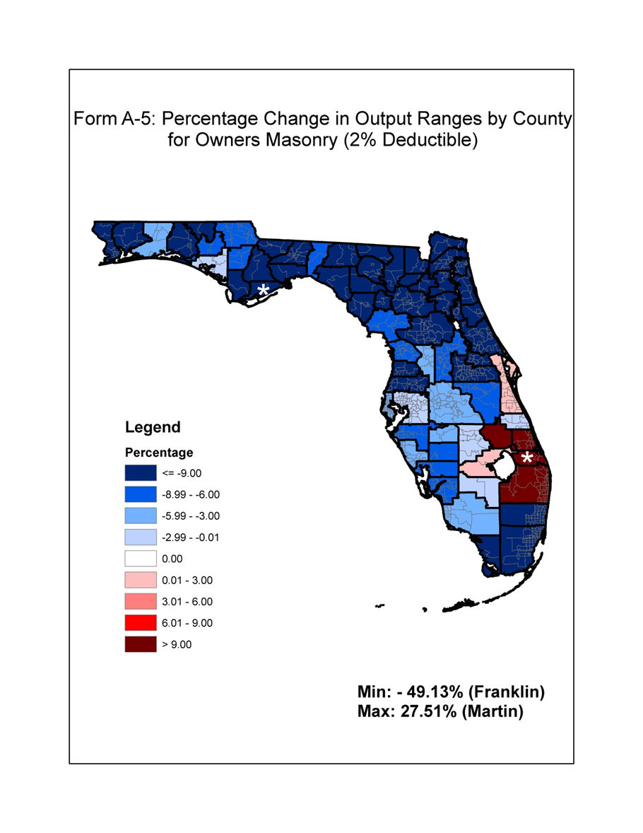
Figure 95. Percentage change in output ranges by county for owners masonry (2% deductible).
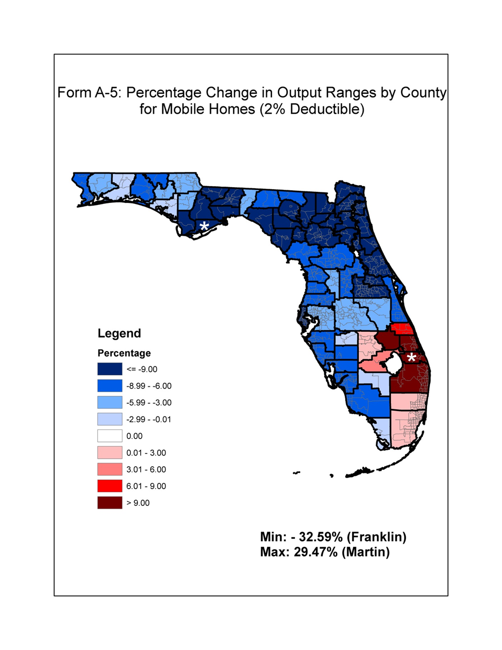
Figure 96. Percentage change in output ranges by county for mobile homes (2% deductible).

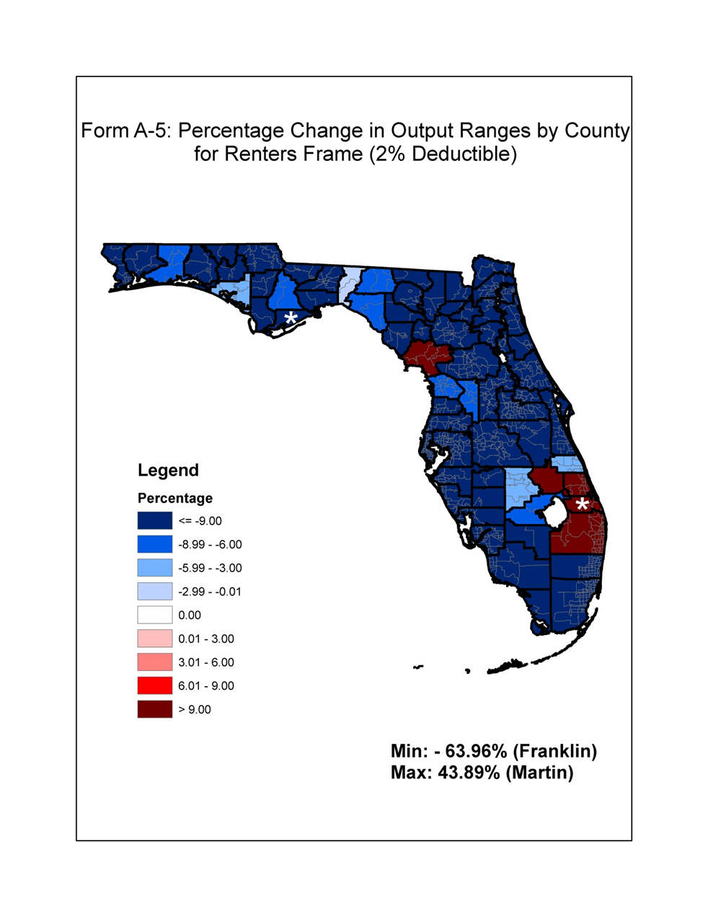
Figure 97. Percentage change in output ranges by county for renters frame (2% deductible).

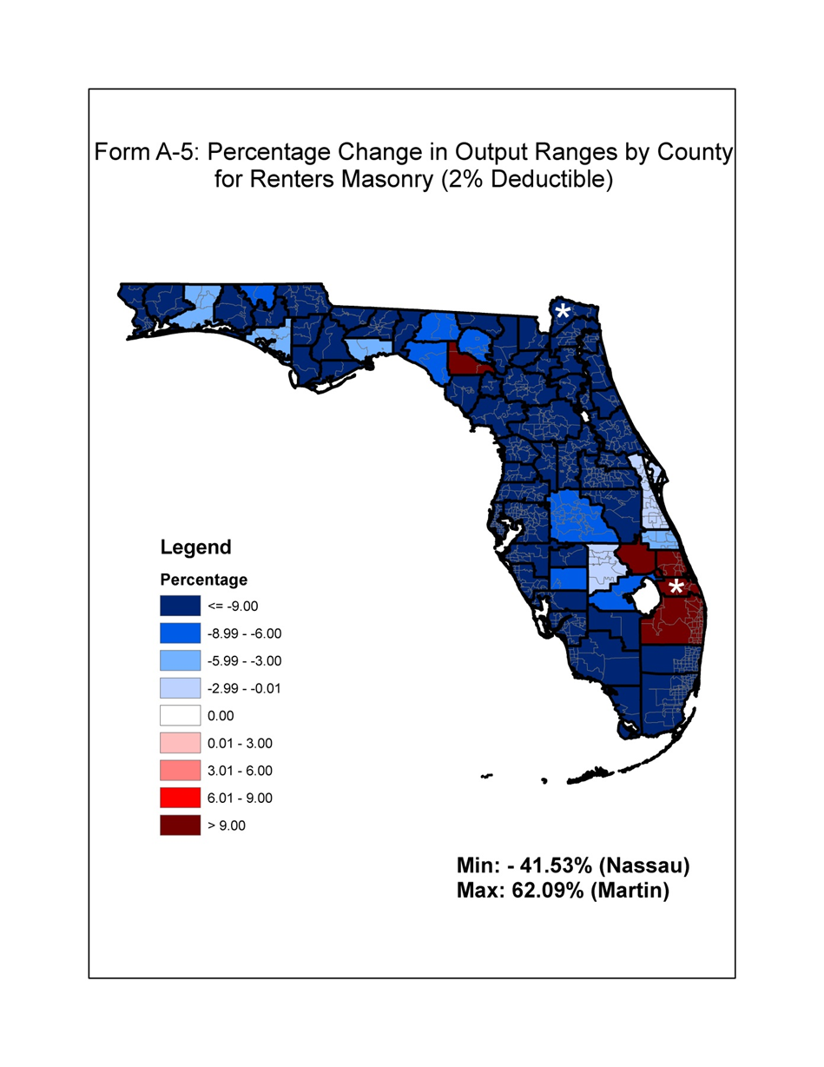
Figure 98. Percentage change in output ranges by county for renters masonry (2% deductible).

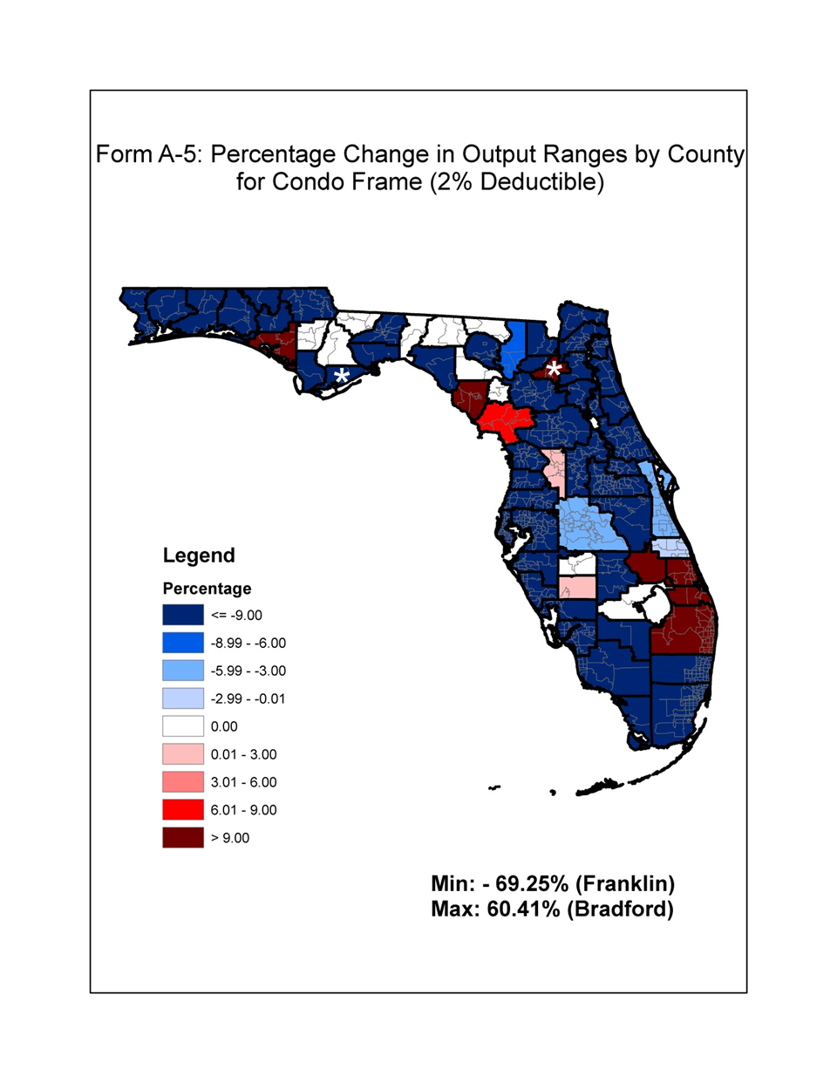
Figure 99. Percentage change in output ranges by county for condo frame (2% deductible).

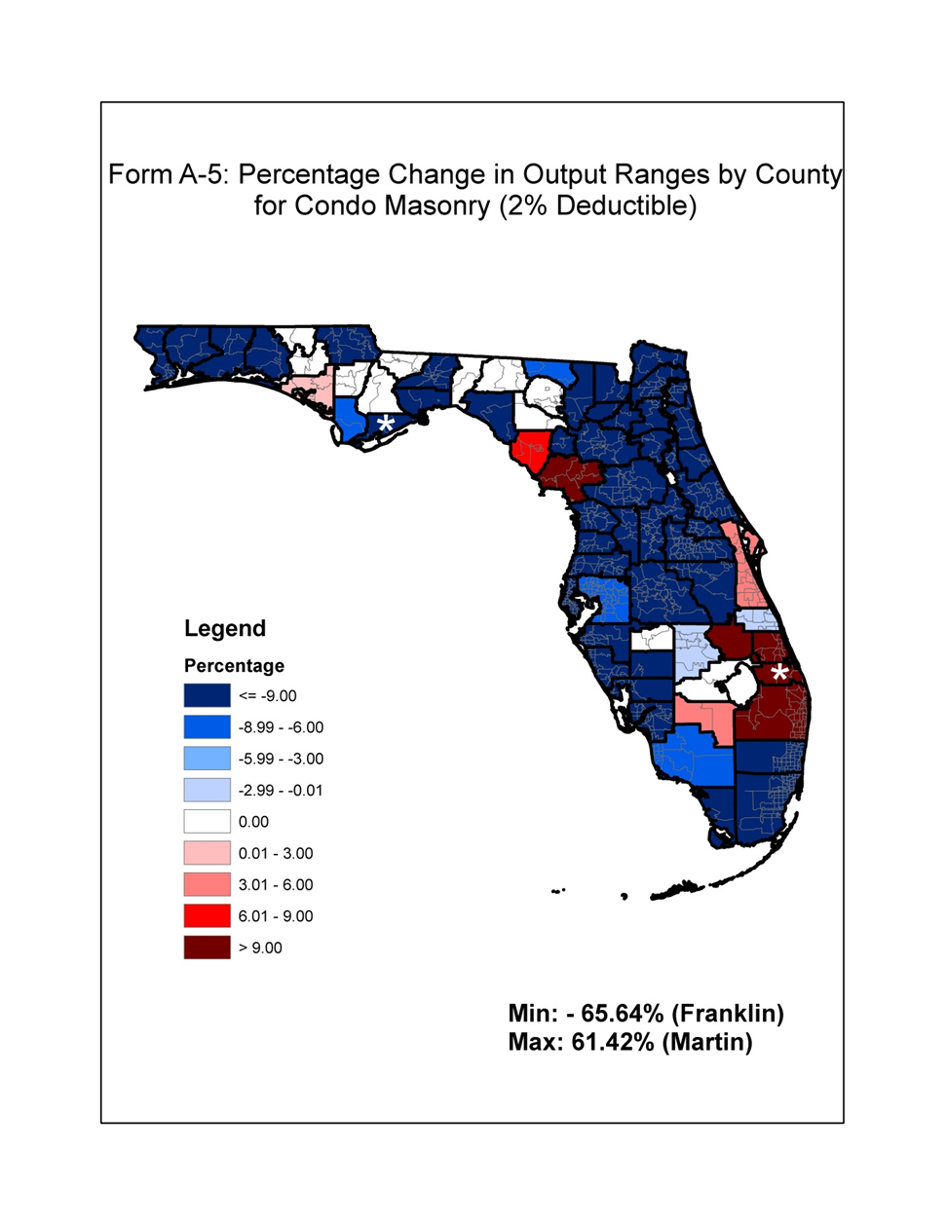
Figure 100. Percentage change in output ranges by county for condo masonry (2% deductible).

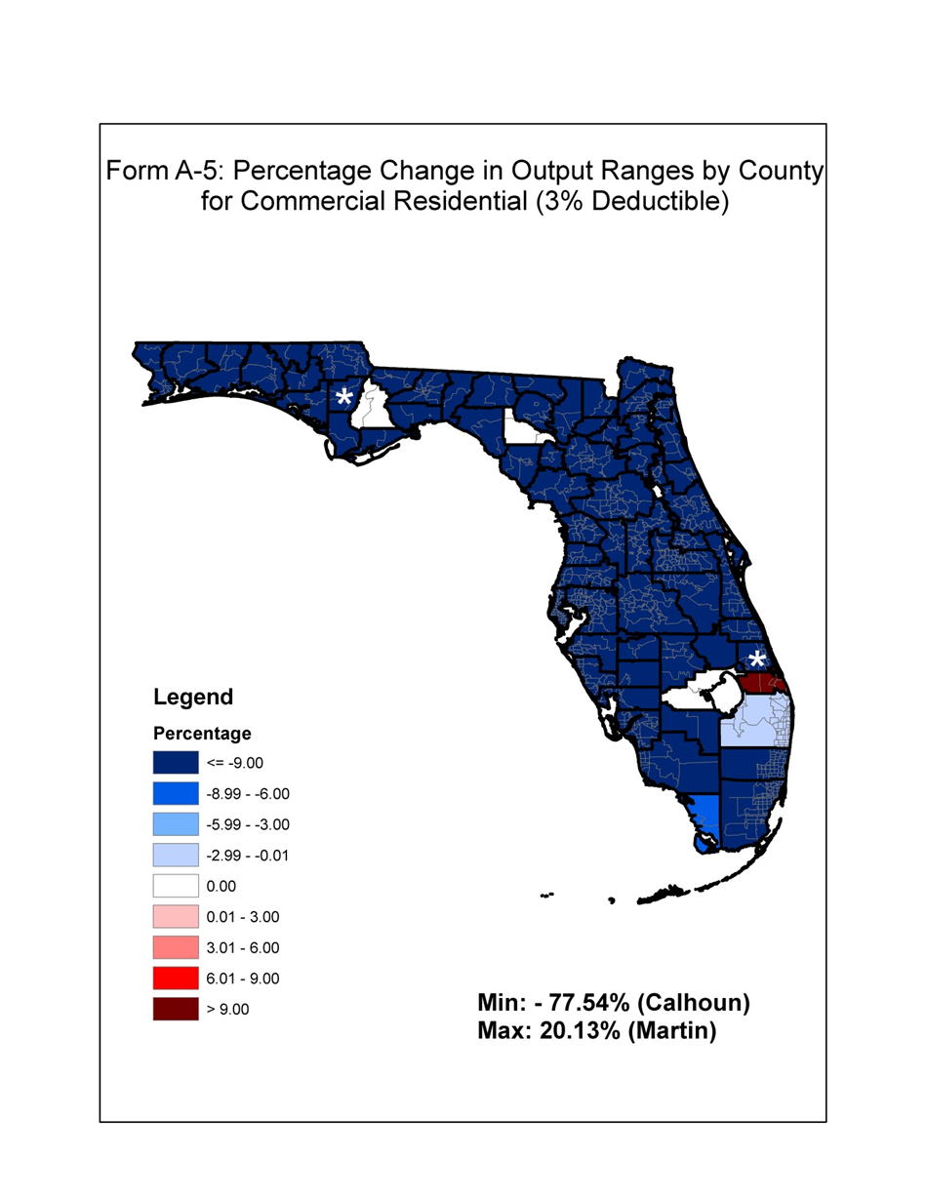
Figure 101. Percentage change in output ranges by county for commercial residential (3% deductible).

Form A-6: Personal Residential Output Ranges

- Provide the logical relationship to risk exhibits in the format shown in the file named “2013FormA6.xlsx.”

- Create exposure sets for each exhibit by modeling all of the coverages from the appropriate Notional Set listed below at each of the locations in “Location Grid A” as described in the file “NotionalInput13.xlsx.” Refer to the Notional Policy Specifications below for additional modeling information. Explain any assumptions, deviations, and differences from the prescribed exposure information.

Exhibit | Notional Set
Deductible Sensitivity | Set 1
Construction Sensitivity | Set 2
Policy Form Sensitivity | Set 3
Coverage Sensitivity | Set 4
Building Code/Enforcement (Year Built) Sensitivity | Set 5
Building Strength Sensitivity | Set 6
Condo Unit Floor Sensitivity | Set 7
Number of Stories Sensitivity | Set 8

Models shall treat points in Location Grid A as coordinates that would result from a geocoding process. Models shall treat points by simulating loss at exact location or by using the nearest modeled parcel/street/cell in the model.

Report results for each of the points in “Location Grid A” individually, unless specified. Loss cost per $1,000 of exposure shall be rounded to 3 decimal places.

- All anomalies in loss costs that are not consistent with the requirements of Standard A-6 (Loss Output) and have been explained in Disclosure A-6.15 shall be shaded.

- Create an exposure set and report loss costs results for strong owners frame buildings (Notional Set 6) for each of the points in “Location Grid B” as described in the file “NotionalInput13.xlsx.” Provide a color-coded contour map of the loss costs. Provide a scatter plot of the loss costs (y-axis) against distance to closest coast (x-axis).

See Appendix F.

Form A-7: Percentage Change in Logical Relationship to Risk

- Provide summaries of the percentage change in logical relationship to risk exhibits from the previously accepted model in the format shown in the file named “2013FormA7.xlsx.”

- Create exposure sets for each exhibit by modeling all of the coverages from the appropriate Notional Set listed below at each of the locations in “Location Grid B” as described in the file “NotionalInput13.xlsx.” Refer to the Notional Policy Specifications provided in Form A- 6 (Logical Relationship to Risk, Trade Secret item) for additional modeling information. Explain any assumptions, deviations, and differences from the prescribed exposure information.

Exhibit | Notional Set
Deductible Sensitivity | Set 1
Construction Sensitivity | Set 2
Policy Form Sensitivity | Set 3
Coverage Sensitivity | Set 4
Building Code/Enforcement (Year Built) Sensitivity | Set 5
Building Strength Sensitivity | Set 6
Condo Unit Floor Sensitivity | Set 7
Number of Stories Sensitivity | Set 8

Models shall treat points in Location Grid B as coordinates that would result from a geocoding process. Models shall treat points by simulating loss at exact location or by using the nearest modeled parcel/street/cell in the model.

Provide the results statewide (overall percentage change) and by the regions defined in Form
A-5 (Percentage Change in Output Ranges, 2007 FHCF Exposure Data).

- Provide this form in Excel format. The file name shall include the abbreviated name of the modeling organization, the standards year, and the form name. All tables in Form A-7 (Percentage Change in Logical Relationship to Risk) shall also be included in a submission appendix.

See Appendix G.

Form A-8: Probable Maximum Loss for Florida

- Provide a detailed explanation of how the Expected Annual Hurricane Losses and Return Periods are calculated.

For each range of losses:

Expected Annual Hurricane Losses = Total Loss / Number of years in the simulation,

Where:

Total Loss = Sum of losses for all simulated years with aggregate storm losses in the range.

Return Period = 1 / Probability of exceeding the average loss in the range,

Where:

Average Loss = Total Loss / Number of years with aggregate storm losses in the range,

And

Probability of exceeding the average loss in the range =

(Number of years with aggregate storm losses > Average Loss) / Number of years in the simulation.

- Complete Part A showing the personal and commercial residential probable maximum loss for Florida. For the Expected Annual Hurricane Losses column, provide personal and commercial residential, zero deductible statewide loss costs based on the 2012 Florida Hurricane Catastrophe Fund’s aggregate personal and commercial residential exposure data found in the file named “hlpm2012c.exe.”

In the column, Return Period (Years), provide the return period associated with the average loss within the ranges indicated on a cumulative basis.

For example, if the average loss is $4,705 million for the range $4,501 million to $5,000 million, provide the return period associated with a loss that is $4,705 million or greater.

For each loss range in millions ($1,001-$1,500, $1,501-$2,000, $2,001-$2,500) the average loss within that range should be identified and then the return period associated with that loss calculated. The return period is then the reciprocal of the probability of the loss equaling or exceeding this average loss size.

The probability of equaling or exceeding the average of each range should be smaller as the ranges increase (and the average losses within the ranges increase). Therefore, the return period associated with each range and average loss within that range should be larger as the ranges increase. Return periods shall be based on cumulative probabilities.

A return period for an average loss of $4,705 million within the $4,501-$5,000 million range should be lower than the return period for an average loss of $5,455 million associated with a $5,001- $6,000 million range.

- Provide a graphical comparison of the current submission Residential Return Periods loss curve to the previously accepted submission Residential Return Periods loss curve. Residential Return Period (Years) shall be shown on the y-axis on a log 10 scale with Losses in Billions shown on the x-axis. The legend shall indicate the corresponding submission with a solid line representing the current year and a dotted line representing the previously accepted submission.

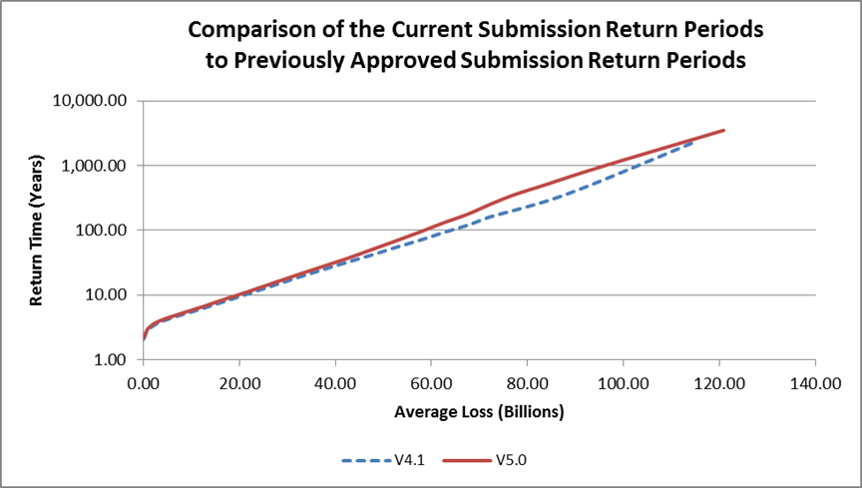
Figure 102. Comparison of return periods.

- Provide the estimated loss and uncertainty interval for each of the Personal and Commercial Residential Return Periods given in Part B. Describe how the uncertainty intervals are derived.

The uncertainty intervals (except for the top event) are approximate 95% confidence intervals.

Let X₁, X₂, . . . , X_{N} be the ordered set of annual losses produced by the simulation with X₍₁₎ ≤ X₍₂₎ ≤ . . . ≤ X_{(N).}

Since the sample is large enough to assume a normal approximation for the pth quantile of the ordered set, an approximate 95% confidence interval for the PML is given by (X_{(r)}, X_{(s)}), where

and N and p are defined as in Standard A-11, i.e.

N = number of years in the simulation
and
p = 1 – 1 / return period.

If r and/or s are not integers, let r* be the smallest integer greater than r and let s* be the smallest integer greater than or equal to s. The 95% approximate confidence interval is given by (X_{(r*)}, X_{(s*)})

The top event itself is estimated by the highest order statistic, X_{(N).} Although it is not possible to compute a confidence interval for the top event using the above methods, an upper bound can be placed on the expected top event, E(X_{(N)}).

As per Wilkinson (1982), E(X_{(N)}) ≤

where μ and σ are the mean and the standard deviation of the losses, respectively.

Thus an upper bound for the top even is computed as :

where is the sample mean of the simulated annual losses and s is the sample standard deviation.

- Provide this form in Excel format. The file name shall include the abbreviated name of the modeling organization, the standards year, and the form name. Form A-8 (Probable Maximum Loss for Florida) shall also be included in a submission appendix.

See Appendix H.

COMPUTER STANDARDS

C-1 Documentation

- Model functionality and technical descriptions shall be documented formally in an archival format separate from the use of letters, slides, and unformatted text files.

The Florida Public Hurricane Loss model formally documents the model functionality and technical descriptions in the primary document binder, an archival format separate from the use of letters, slides, and unformatted text files. The primary document binder uses standard software practices to formally describe the model’s requirements and complete software design and implementation specifications. All documentation, formal and informal, related to the model is maintained in a central location that is easily accessible.

- The modeling organization shall maintain a primary document repository, containing or referencing a complete set of documentation specifying the model structure, detailed software description, and functionality. Development of the documentation shall be indicative of accepted software engineering practices.

The Florida Public Hurricane Loss Model (FPHLM) maintains a primary document binder, in both electronic and physical formats, to satisfy the aforementioned requirements. In addition, the FPHLM maintains a user manual, designed for the end user, which provides a high-level introduction and a step-by-step guide to the whole system. All the documents are easily available for inspection and electronic copies are also available online. Accepted software engineering practices are used to render all the documents more readable, self-contained, consistent, and easy to understand. Every component of the system is documented with standard use case, class, data flow, sequence diagrams, etc. The diagrams describe in detail the structure, logic flow, information exchange among submodules, etc. of each component and increase the visibility of the system. The diagrams describing the component functionality and structure also make each component of the system reusable and easily maintainable.

- All computer software (i.e., user interface, scientific, engineering, actuarial, data preparation, and validation) relevant to the submission shall be consistently documented and dated.

The primary document binder contains all of the required documents arranged in subfolders linked to one another on the basis of their mutual relationships. Thus, the entire document can be viewed as a hierarchical referencing scheme in which each module is linked to its submodule, which ultimately refers to the corresponding codes.

- The modeling organization shall maintain (1) a table of all changes in the model from the previously accepted submission to the initial submission this year and (2) a table of all substantive changes since this year’s initial submission.

These tables are maintained and documented and will be available for review.

- Documentation shall be created separately from the source code.

Databases and formats of all the input/output data files are comprehensively documented. All source code is properly documented in terms of both in-line detailed comments and external higher-level documentation, and they are maintained under version control systems. Source-code documentation has been created separately from the source code.

C-2 Requirements

The modeling organization shall maintain a complete set of requirements for each software component as well as for each database or data file accessed by a component. Requirements shall be updated whenever changes are made to the model.

The FPHLM is divided into several major modules, each of them providing one or more inputs to other modules. Requirements of each of the modules, including input/output formats, are precisely documented. Apart from maintaining a detailed documentation of each module of the system using standard software practices, several other documents are maintained as part of a large-scale project management requirement, including a quality assurance document, a system hardware and software specification document, a training document, a model maintenance document, a testing document, a user manual, etc. Moreover, detailed documentation has been developed for the database consisting of the schema and information about each table. Additionally, information about the format for each data file (in the form of an Excel or text file) accessed by different programs is documented. Whenever changes are made to a model, the corresponding requirements documentation is updated to reflect such changes.

Disclosure

1. Provide a description of the documentation for interface, human factors, functionality, documentation, data, human and material resources, security, and quality assurance.

The user interface, functionality requirements, and material resources of each of the modules are described in the relevant module documentation. Database schemata and table formats are separately documented for the whole system and attached to the primary document binder. A separate software testing and quality assurance document describes the system quality, performance, and stability concerns. Additionally, a user manual and a human resource management document are maintained. Additionally, security, software and hardware specifications for the system as well as training plans are documented.

C-3 Model Architecture and Component Design

The modeling organization shall maintain and document (1) detailed control and data flow diagrams and interface specifications for each software component, (2) schema definitions for each database and data file, and (3) diagrams illustrating model-related flow of information and its processing by modeling organization personnel or team. Documentation shall be to the level of components that make significant contributions to the model output.

Interface specifications for each of the modules are included in the module documentation. In addition, the user manual provides further information about the user interface specification. Control and data flow diagrams are presented at various levels of the model documentation. High-level flow diagrams are used to illustrate the flow of the whole system and the interactions among modules. More technical and detailed diagrams are used in module-level descriptions.

The database schema are documented and attached as part of the document binder. A detailed schema representation of the active database is documented with additional information such as database maintenance, tuning, data loading methodologies, etc. to provide a complete picture of the database maintained for the project.

These documents will be made available to the professional team during the site visit.

C-4 Implementation

- The modeling organization shall maintain a complete procedure of coding guidelines consistent with accepted software engineering practices.

The FPHLM has developed and followed a set of coding guidelines that is consistent with accepted software practices. These documents include guidelines for version control, code revision history maintenance, etc. All the developers involved in the system development adhere to the instructions in these documents.

- The modeling organization shall maintain a complete procedure used in creating, deriving, or procuring and verifying databases or data files accessed by components.

The FPHLM uses an Oracle database to store the related data necessary for the model. The database documentation includes the procedures for creating and deriving the database. Data files are generated by different modules and used as interfaces between modules. Several data verification techniques are undertaken to ensure the correctness. Details about these are included in the module documentation.

- All components shall be traceable, through explicit component identification in the flow diagrams, down to the code level.

Traceability, from requirements to the code level and vice versa, is maintained throughout the system documentation.

- The modeling organization shall maintain a table of all software components affecting loss costs, with the following table columns: (1) Component name, (2) Number of lines of code, minus blank and comment lines; and (3) Number of explanatory comment lines.

The FPHLM primary document binder includes a table that gives the above-requested information. The table is available for review by the professional team.

- Each component shall be sufficiently and consistently commented so that a software engineer unfamiliar with the code shall be able to comprehend the component logic at a reasonable level of abstraction.

All the software codes are properly provided with code-level comments, and a consistent format is maintained throughout the software modules. These code-level comments include a summary of important changes, names of developers involved in each modification, function headers, and in-line comments to explain potentially ambiguous software code.

- The modeling organization shall maintain the following documentation for all components or data modified by items identified in Standard G-1 (Scope of the Computer Model and Its Implementation), Disclosure 5:

- A list of all equations and formulas used in documentation of the model with definitions of all terms and variables.

- A cross-referenced list of implementation source code terms and variable names to items within F.1.

Tables that map the equations and formulas used in documentation of the model implementation source code terms and variable names were added as glossaries to the model’s documentation, thus combining F.1 and F.2 into the same table. These tables enhance the model’s documentation and include the equations and formulas for each module (not just the modified ones from the prior year’s submission).

Disclosure

1. Specify the hardware, operating system, other software, and all computer languages required to use the model.

The system is mainly a web-based application that is hosted over an Oracle 9i web application server. The backend server environment is Linux and the server side scripts are written in Java Server Pages (JSP) and Java beans. Many backend calculations are coded in C++ using the IMSL library and called through Java Native Interface (JNI). The system uses an Oracle database running on a Sun workstation. Server side software requirements are IMSL library CNL 5.0, OC4J 9.0.2.0.0, Oracle 9iAS 9.0.2.0.0, JNI 1.3.1, and JDK 1.3.1.

The end-user workstation requirements are minimal. The recommended web browsers are Internet Explorer 8.0 running on Windows XP or Internet Explorer 9.0 running on Windows 7. However, other modern web browsers such as Mozilla Firefox running on either Windows or Linux should also deliver optimal user experience. Typically, the manufacturer’s minimal set of features for a given web browser and operating system combination is sufficient for an optimal operation of the application.

C-5 Verification

- General

For each component, the modeling organization shall maintain procedures for verification, such as code inspections, reviews, calculation crosschecks, and walkthroughs, sufficient to demonstrate code correctness. Verification procedures shall include tests performed by modeling organization personnel other than the original component developers.

FPHLM software verification is done in three stages.

1. Code inspection and verification by the code developer.
2. Inspection of the input and validation of the output by the system modeler.
3. Review and extensive testing of the code by modeler personnel who are not part of the original component development.

The first level of verification includes code-level debugging, walking through the code to ensure a proper flow, inspection of internal variables through intermediate output printing and error logging, use of exception handling mechanisms, calculation crosschecks, and verification of the output against sample calculations provided by the system modeler.

In the second level of the verification, the modeler is provided with sample inputs and corresponding outputs. The modeler then conducts black-box testing to verify the results against his or her model. Finally, each component is rigorously tested by modeler personnel not responsible for original component development.

- Component Testing

1. The modeling organization shall use testing software to assist in documenting and analyzing all components.

Component testing (C-5.B) and data testing (C-5.C) are done in the third level of verification. The system is rigorously checked for the correctness, precision, robustness, and stability of the whole system. Calculations are performed outside the system and compared against the system- generated results to ensure the system correctness. Extreme and unexpected inputs are given to the system to check the robustness. Wide series of test cases are developed to check the stability and the consistency of the system.

2. Unit tests shall be performed and documented for each component.
Unit testing is done at the first and third levels of verification. The developer tests all the units as the unit is developed and modified. Then all the units are tested again by the external testing team. Both “black-box” and “white-box” tests are performed and documented in a separate testing document.

3. Regression tests shall be performed and documented on incremental builds.

Regression testing is performed for each module. In this kind of testing methodology, the modules that have undergone some changes and revisions are retested to ensure that the changes have not affected the entire system in any undesired manner.

4. Aggregation tests shall be performed and documented to ensure the correctness of all model components. Sufficient testing shall be performed to ensure that all components have been executed at least once.

Aggregation testing is performed at all three levels of verification. Aggregation testing is performed by running each major module as a complete package. It is ensured that all components have been executed at least once during the testing procedure. All the test cases executed are described in the software testing and verification documentation.

C. Data Testing

1. The modeling organization shall use testing software to assist in documenting and analyzing all databases and data files accessed by components.

The FPHLM uses an Oracle database to store the required data. Data integrity and consistency are maintained by the database itself. Moreover, different queries are issued and PL/SQL is implemented to check the database. Oracle 9i has a very robust loader, which is used to load the data into the database. The loader maintains a log that depicts if the loading procedure has taken place properly and completely without any discrepancy. Data files are manually tested using commercial data manipulation software such as Excel and Access.

2. The modeling organization shall perform and document integrity, consistency, and correctness checks on all databases and data files accessed by the components.

All the tests are well documented in a separate testing document.

Disclosures

- State whether any two executions of the model with no changes in input data, parameters, code, and seeds of random number generators produce the same loss costs and probable maximum loss levels.

The model produces the same loss costs and probable maximum loss levels if it is executed more than once with no changes in input data, parameters, code, and seeds of random number generators.

- Provide an overview of the component testing procedures.

FPHLM software testing and verification is done in three stages.

[A] Code inspection and the verification by the code developer

The code developer performs a sufficient amount of testing on the code and does not deliver the code until he or she is convinced of the proper functionality and robustness of the code.

The first level of verification includes code-level debugging, walking through the code to ensure proper flow, inspection of internal variables through intermediate output printing and error logging, use of exception handling mechanisms, calculation crosschecks, and verification of the output against sample calculations provided by the system modeler.

[B] Verification of results by the person who developed the system model

Once the first level of testing is done, the developer sends the sample inputs and the generated results back to the modeler. Then the system modeler double-checks the results against his or her model. The code is not used in the production environment unless approved by the modeler.

[C] Review and extensive testing of the code by modeler personnel other than the original component developers.

The system is rigorously checked by modeler personnel (testers) other than the original component developers for the correctness, precision, robustness, and stability of the whole system. Calculations are performed outside the system and compared against the system generated results to ensure the system correctness. Extreme and unexpected inputs are given to the system to check the robustness. Wide series of test cases are developed to check the stability and the consistency of the system.

Unit testing, regression testing, and aggregation testing (both white-box and black-box) are performed and documented.

Any flaw in the code is reported to the developer, and the bug-corrected code is again sent to the tester. The tester then performs unit testing again on the modified units. Additionally, regression testing is performed to determine if the modification affects any other parts of the code.

Different testing tools and software packages are used to test different components of the system. The detailed list of the various testing tools and/or techniques used for different components of the system is provided in the main document and will be available for audit.

- Provide a description of verification approaches used for externally acquired data, software, and models.

C-6 Model Maintenance and Revision

- The modeling organization shall maintain a clearly written policy for model revision, including verification and validation of revised components, databases, and data files.

The FPHLM is periodically enhanced to reflect new knowledge acquired about hurricanes and Florida ZIP Code information. A clearly written policy for model revision is maintained in the primary document binder.

- A revision to any portion of the model that results in a change in any Florida residential hurricane loss cost or probable maximum loss level shall result in a new model version identification.

Whenever a revision results in a change in any Florida residential hurricane loss cost, a new model version number will be assigned to the revision. Verification and validation of the revised units are repeated according to the above-mentioned “software verification procedures” document.

- The modeling organization shall use tracking software to identify and describe all errors, as well as modifications to code, data, and documentation.

The FPHLM uses Subversion for version control. Subversion is a revision control system widely used in recent years by important projects and has been termed the successor of CVS (Concurrent Versions System). We can record the history of source files and documents by using Subversion.

- The modeling organization shall maintain a list of all model versions since the initial submission for this year. Each model description shall have unique version identification, and a list of additions, deletions, and changes that define that version.

A list of all model versions since the initial submission will be maintained. Each model revision will have a unique model version number (i.e., unique version identification) and a list of additions, deletions, and changes that define that version. The unique model version will consist of the scheme “V[major].[minor].” The terms “[major]” and “[minor]” are positive numeric numbers that correspond to substantial and minor changes in the model, respectively. A minor change in the model would cause the minor number to be incremented by one, and similarly, a major change in the model would cause the major number to be incremented by one with the minor reset to zero. The rules that prompt changes in the major and minor numbers are described in Disclosure 2.
Disclosures

1. Identify procedures used to maintain code, data, and documentation.

The FPHLM’s software development team employs source revision and control software for all software development. In particular, the FPHLM employs Subversion, an accepted and effective system for managing simultaneous development of files. Recently, it has been used in large programming projects both in the open-source community and in the corporate world to track modifications to source code and documentation files. Subversion maintains a record of the changes to each file and allows the user to revert to a previous version, merge versions, and track changes. This software is able to record the information for each file, the date of each change, the author of each change, the file version, and the comparison of the file before and after the changes. The detailed information will be made available to the professional team during its site visit.

2. Describe the rules underlying the model and code revision identification systems.

The model numbering system consists of the scheme “V[major].[minor].” The terms "[major]" and "[minor]" are positive numeric numbers that correspond to major and minor changes in the model, respectively; a minor change causes the minor number to be incremented by one, and similarly, a major change causes the major number to be incremented by one with the minor number reset to zero. The rules that prompt major or minor changes in the model are the following:

Rules that trigger a change in the major number:

- Updates in any of the main modules of the FPHLM: any change resulting in the partial or total modification of the algorithm/model of the Storm Generation, Wind Field, Damage Estimation, and/or Insurance Loss models.

Rules that trigger a change in the minor number:

- Slight changes to the Storm Generation, Wind Field, and/or Damage Estimation modules: small updates such as a change in the Holland B parameter or any change to correct deficiencies that do not result in a new algorithm for the component.

- Updates to correct errors in the computer code: modifications in the code to correct deficiencies or errors such as a code bug in the computer program.

- Changes in the probability distribution functions using updated or corrected historical data, such as the updates of the HURDAT database: each year the model updates its HURDAT database with the latest HURDAT data released by the National Hurricane Center, which is used as the input in the Storm Generation Model.

- Updates of the ZIP Code list: every two years the ZIP Codes used in the model must be updated according to information originating from the United States Postal Service.

- Updates in the validation of the vulnerability matrices: the incorporation of new data, such as updated winds and insurance data, may trigger a tune-up of the vulnerability matrices used in the Insurance Loss Model.

If any change results in a change in loss costs estimates, there will be at least a change in the minor revision number.

Consequently, for the submission of November 1, 2012, the Florida Public Hurricane Loss Model changed its version number from 4.1 to 5.0 because of the incorporation of the most recent HURDAT database, the updated ZIP Code list, and the changes in the meteorological and vulnerability models. For a detailed description of the aforementioned changes, please refer to Standard G-1, Disclosure 5.

C-7 Security

The modeling organization shall have implemented and fully documented security procedures for: (1) secure access to individual computers where the software components or data can be created or modified, (2) secure operation of the model by clients, if relevant, to ensure that the correct software operation cannot be compromised, (3) anti-virus software installation for all machines where all components and data are being accessed, and (4) secure access to documentation, software, and data in the event of a catastrophe.

The FPHLM maintains a set of security procedures to protect data and documents from deliberate and inadvertent changes. These procedures include both physical and electronic measures. A set of policies identifies different security issues and addresses each of them. All the security measures are properly documented and attached to the primary document binder.

Disclosure

1. Describe methods used to ensure the security and integrity of the code, data, and documentation.

Electronic measures include the use of different authorization levels, special network security enforcements, and regular backups. Each developer is given a separate username and password and assigned a level of authorization so that even a developer cannot change another developer’s code. The users of the system are given usernames and passwords so that unauthorized users cannot use the system. External users are not allowed direct access to any of the data sources of the system. The network is extensively monitored for any unauthorized actions using standard industry practices. Since the system runs on a Linux sever environment, minimal virus attacks are expected.

Any sensitive or confidential data (insurance data, for example) are kept on an unshared disk on a system that has user access control and requires a login. Screen locks are enforced whenever the machine is left unattended. In addition, for system security and reliability purposes, we also deploy a development environment besides the production environment. Modifications to the code and data are done in the development environment and tested by in-house developers. The final production code and data can only be checked into the production environment by the authorized personnel. The models resulting from the FPHLM project can only be used by the authorized users. Authorized user accounts are created by the project manager. Regular backups of the server are taken and stored in two ways: physically and electronically. Backups are performed daily and are kept for six weeks. Nightly backups of all UNIX data disks and selected Windows data disks (at user requests) are performed over the network onto LT02 and LT03 tapes. The tape drives have built-in diagnostics and verification to ensure that the data is written correctly to the tapes. This ensures that if the tape is written successfully, it will be readable, provided no physical damage occurred to the tape. A copy of each backup is placed in a secure and hurricane-protected building. Additionally, the application server and the database server are physically secured in a secure server room with alarm systems. In case of disasters, we have implemented a set of preparation procedures and recovery plans as outlined in “FIU SCIS Hurricane Preparation Procedures.”

Appendix A - Expert Review Letters
Assessment of the meteorological portion of the State of Florida Public Hurricane Model

February 15, 2007
Gary M. Barnes
Professor, Department of Meteorology
School of Ocean and Earth Science and Technology
University of Hawaii at Manoa

Introduction
My review of the State of Florida Public Hurricane Model is based on a three day visit to Florida International University in December, and an examination of the submission draft provided to me in February. I have had full access to the meteorological portion of the model, access to the draft for the Florida commission, and access to prior submittals to the commission from several other groups in order to establish a sense of what is desired by the commission. I am pleased to report that the issues that I have raised have received their attention and I believe that the model meets all the standards set forth by the commission. Ultimately this model, when linked to engineering and actuarial components, will provide objective guidance for the estimation of wind losses from hurricanes for the state of Florida. It does not address losses from other aspects of a tropical cyclone such as storm surge, or fresh water flooding. I now offer specific comments on each of the six meteorological standards established by the commission to ascertain this model’s suitability.

M-1 Official Hurricane Set
The consortium of scientists working on the Public model have adopted HURDAT (1900- 2006) to determine landfall frequency and intensity at landfall. The NWS report by Ho et al. (1987), DeMaria’s extension of the best track, H*Wind analyses (Powell & Houston, 1996, 1998; Powell et al. 1996, 1998) and NOAA Hurricane Research Division aircraft data are used to estimate the radius of maximum winds (RMW) at landfall. The strength of HURDAT is that it is the most complete and accessible historical record for hurricanes making landfall or passing closely by Florida. HURDAT weaknesses include the abbreviated record and questionable intensity estimates for those hurricanes early in the record, especially those that remain offshore. Evidence for the shortness of record is the impact of the last few hurricane seasons on landfall return frequency. The meteorological team has scrutinized the base set developed by the commission and made a number of adjustments to the dataset based on refereed literature and the HURDAT record. I have looked at several of these adjustments in detail and find the corrections to be an improvement over the initial base set.

M-2 Hurricane Characteristics
The model has two main components. The track portion of the model produces a storm with either an initial location or genesis point and an intensity that is derived from an empirical distribution derived from HURDAT (2006). Storm motion and intensity is then initialized by using a Monte Carlo approach, drawing from probability density functions (PDFs) based on the historical dataset to create a life for a bogus hurricane. Examination of the PDFs reveals that they are faithful to the observed patterns for storms nearing Florida, and the evolution of any particular hurricane appears realistic.

The second component of the meteorological model is the wind field generated for a given hurricane, which only comes into play when the hurricane comes close enough to place high winds over any given ZIP Code of Florida. To generate a wind field the minimum sea-level pressure (MSLP) found in the eye, the RMW at landfall, and a distant environmental pressure (1013 mb) are entered into the Holland (1980) B model for the axisymmetric pressure distribution around the hurricane. The behavior of the RMW is based on a variety of sources that include Ho et al. (1987), DeMaria’s extension of the best track data, H*wind analyses, and aircraft reconnaissance radial wind profiles. The B coefficient is based on the extensive aircraft dataset acquired in reconnaissance and research flights over the last few decades. RMW and B use a random or error term to introduce variety into the model. The Holland pressure field is used to produce a gradient wind at the top of the boundary layer. The winds in the boundary layer are estimated following the work proposed by Ooyama (1969) and later utilized by Shapiro (1983) which includes friction and advection effects. These boundary layer winds are reduced to surface winds (10 m) using reduction factors based on the work of Powell et al. (2003). Maximum sustained winds and 3 second gusts are estimated using the guidance of Vickery and Skerlj (2005). Once the hurricane winds come ashore there are further adjustments to the wind to account for local roughness as well as the roughness of the terrain found upstream of the location under scrutiny. The pressure decay of the hurricane is modeled to fit the observations presented by Vickery (2005).

Gradient balance has been demonstrated to be an accurate representation for vortex scale winds above the boundary layer by Willoughby (1990) and is a fine initial condition. The slab boundary layer concept of Ooyama and Shapiro has been shown to produce wind fields much like observed once storm translation and surface friction come into play. The reduction to 10 m altitude is based on Powell et al. (2003); they use the state of the art Global Positioning System sondes to compare surface and boundary layer winds.

Perhaps the most questionable part of the wind portion of the model is the reliance on the estimates of the RMW at landfall. The scatter in RMW for a given MSLP is large; larger RMWs coupled with the B parameter control the size of the annulus of the damaging winds. The typical length of an aircraft leg from the eye is about 150 km so the choice of the B parameter is based on a small radial distance in the majority of hurricanes. The collection of quality wind observations over land in hurricanes remains a daunting task; therefore the actual response of the hurricane winds to variations in roughness is less certain. Applying roughness as a function of ZIP Code is a coarse approximation to reality. However, this is the approach chosen by the commission, and given the data limitations, a reasonable course to take.

M-3 Landfall Intensity
The model uses one minute winds at 10 m elevation to determine intensity at landfall and categorizes each hurricane according to the Saffir-Simpson classification. The model considers any hurricane that makes landfall or comes close enough to place high winds over Florida. Multiple landfalls are accounted for, and decay over land between these landfalls is also estimated. Maximum wind speeds for each category of the Saffir-Simpson scheme are reasonable as is the worst possible hurricane the model generates. Simulations are conducted for a hypothetical 60,000 years. Any real climate change would alter results, but maybe not as much as have an actual record of order of 1,000 years to base the PDFs on.

M-4 Hurricane Probabilities
Form M-1 demonstrates that the model is simulating the landfalls very well for the entire state, region A (NW Florida) and region B (SW Florida). There are subsections of the state where the historical and the simulated landfalls have a discrepancy. In region C (SE Florida) the observations show an unrealistic bias toward Category 3 storms. This is likely due to an overestimate of intensity for the hurricanes prior to the advent of aircraft sampling or advanced satellite techniques. The historical distribution for region C also does not fit any accepted distributions that we typically see for atmospheric phenomena. This discrepancy is probably due to the shortness of the historical record. I note that other models also have difficulty with this portion of the coast. I believe the modeled distribution, based on tens of thousands of years, is more defensible than the purported standard. Regions D (NE Florida) and E (Georgia) have virtually no distribution to simulate, again pointing to a very short historical record. There is no documented physical reason why these two regions have escaped landfall events. Perhaps a preferred shape of the Bermuda High may bias the situation, but this remains speculative.

M-5 Land Friction and Weakening
Land use and land cover are based on high resolution satellite imagery. Roughness for a particular location is then based on HAZUS tables that assign a roughness to a particular land use. There are newer assessments from other groups but the techniques were not consistently applied throughout the state, nor are the updated HAZUS maps for 2000 available yet. Winds at a particular location are a function of the roughness at that point and conditions upwind. A pressure decay model based on the work of Vickery (2005) produces weakening winds that are reasonable approximations of the observed decay rates of several hurricanes that made landfall in Florida in 2004 and 2005.

The maps (Form M-2) of the 100 year return period maximum sustained winds shows the following trends: (1) a reduction in the sustained winds from south to north, (2) a reduction of winds from coastal to inland ZIP Codes, and (3) the highest winds in the Keys and along the SE and SW coasts. The plotting thresholds requested by the commission partially obfuscate the gradients in wind speed, but Form M-2 produced with finer contours highlights the above trends clearly. The open terrain maps look logical; the actual terrain maps are perhaps overly sensitive to the local roughness. Convective scale motions, which cannot be resolved in this type of model, would probably be responsible for making the winds closer to the open terrain results.

M-6 Logical Relationships of Hurricane Characteristics
The RMW is a crucial but poorly measured variable. Making RMW a function of intensity and latitude explains only a small portion of the variance (~20%). Examination of aircraft reconnaissance radial profiles shows that RMW is highly variable. Currently there are no other schemes available to explain more of the variance. Form M-3 reflects the large range of RMW. Note that only the more intense hurricanes (MSLP < 940 mb) show a trend, and only with the upper part of the range. Even open ocean studies of the RMW show such large scatter.

Tests done during my visits show that wind speed decreases as a function of roughness, all other variables being held constant. The evolution of the wind field as a hurricane comes ashore is logical.

Summary
The consortium that has assembled the meteorological portion of the Public Model for Hurricane Wind Losses for the State of Florida is using the HURDAT with corrections based on other refereed literature. These data yield a series of probability density functions that describe frequency, location, and intensity at landfall. Once a hurricane reaches close enough to the coast the gradient winds are estimated using the equations by Holland (1980), then a sophisticated wind model (Ooyama 1969, Shapiro 1983) is applied to calculate the boundary layer winds. Reduction of this wind to a surface value is based on recent boundary layer theory and observations. Here the consortium has exploited other sources of data (e.g., NOAA/AOML/HRD aircraft wind profiles and GPS sondes) to produce a surface wind field. As the wind field transitions from marine to land exposure changes in roughness are taken into account. Form M-1 (frequency and category at landfall as a function of coastal segment) and Form M-2 (100 year return maximum sustained winds for Florida) highlight the good performance of the model.

I suspect that the differences between the historical record and the simulation are largely due to the shortness and uncertainty of the record. If the consortium had the luxury of 1000 years of observations agreement between the record and the simulation would be improved. I believe that the meteorological portion of the model is meeting all the standards established by the commission. Tests of the model against H*Wind analyses and the production of wind speed swaths go beyond the typical quality controls of prior models and demonstrate that this model is worthy of consideration by the commission.

Appendix B – Form A-2: Base Hurricane Storm Set Statewide Loss Costs

Appendix C – Form A-3: Cumulative Losses from the 2004 Hurricane Season

Appendix D – Form A-4: Output Ranges

Appendix E – Form A-5: Percentage Change in Output Ranges

Appendix F – Form A-6: Logical Relationship to Risk

Appendix G - Form A-7: Percentage Change in Logical Relationship to Risk

Appendix H – Form A-8: Probable Maximum Loss for Florida

