Florida Commission on
Hurricane Loss Projection Methodology

Flood Model Identification

Name of Flood Model:

Flood Model Version Identification:

Interim Flood Model Update Version Identification:

Flood Model Platform Name and Identifications:

Interim Data Update Designation:

Name of Modeling Organization:

Street Address:

City, State, ZIP Code:

Mailing Address, if different from above:

Contact Person:

Phone Number: Fax Number:

E-mail Address:

Date:

Flood Model Submission Data

The following input data have been provided to the modeling organization on the enclosed CD.

Input Data
Name | Description
NotionalInput17_Flood.xlsx | Notional structures and location grids for Form AF-1, Zero Deductible Personal Residential Standard Flood Loss Costs and Form AF-5, Logical Relationship to Flood Risk (Trade Secret Item)
VFEventFormsInput17.xlsx | Sample personal residential exposure data for 26 flood depths and 8 reference structures defined in Forms VF-1, Coastal Flood with Damaging Wave Action and VF-2, Inland Flood by Flood Depth
2017FormAF1.xlsx | Standard flood loss cost data format for Form AF-1, Zero Deductible Personal Residential Standard Flood Loss Costs
2017FormAF3.xlsx | Standard flood loss costs data format for Form AF-3, Personal Residential Standard Flood Loss Costs by ZIP Code
2017FormAF4.xlsx | Flood output ranges format for Form AF-4, Flood Output Ranges
2017FormAF5.xlsx | Logical relationship to flood risk exhibits format for Form AF-5, Logical Relationship to Flood Risk (Trade Secret Item)

Output shall be provided in specified output files as listed below. XXX denotes the abbreviated name of the modeling organization.

Output Data
Name | Description
XXX17FormVF3.xlsx | Output data from Form VF-3, Flood Mitigation Measures Range of Changes in Flood Damage
XXX17FormVF4.xlsx | Output data from Form VF-4, Coastal Flood Mitigation Measures, Mean Coastal Flood Damage Ratios and Coastal Flood Damage/$1,000 (Trade Secret Item)
XXX17FormVF5.xlsx | Output data from Form VF-5, Inland Flood Mitigation Measures, Mean Inland Flood Damage Ratios and Inland Flood Damage/$1,000 (Trade Secret Item)
XXX17FormAF1.xlsx and  XXX17FormAF1.pdf | Underlying flood loss cost data from Form AF-1, Zero Deductible Personal Residential Standard Flood Loss Costs
XXX17FormAF2.xlsx | Output data from Form AF-2, Total Flood Statewide Loss Costs
XXX17FormAF3.xlsx | Output data from Form AF-3, Personal Residential Standard Flood Loss Costs by ZIP Code
XXX17FormAF4.xlsx | Flood output range exhibits from Form AF-4, Flood Output Ranges
XXX17FormAF5.xlsx | Output data from Form AF-5, Logical Relationship to Flood Risk (Trade Secret Item)
Name | Description
XXX17FormAF6.xlsx | Output data from Form AF-6, Flood Probable Maximum Loss for Florida

The modeling organization shall run various scenario flood events through the flood model on the input exposure data. The referenced output forms shall be completed and flood loss files provided in Excel and PDF format as specified. Forms designated as a Trade Secret Item are to be provided if not considered as trade secret. The file names shall include the abbreviated name of the modeling organization, the flood standards year, and the form name. Revised files shall also include the revision date.

Notional Set 1 – Deductible Sensitivity

Notional Set 2 – Policy Form Sensitivity

Notional Set 3 – Policy Form/Construction Sensitivity

Notional Set 4 – Coverage Sensitivity

Notional Set 5 – Year Built Sensitivity

Notional Set 6 – Foundation Type Sensitivity

Notional Set 7 – Condo Unit Floor Sensitivity

Notional Set 8 – Number of Stories Sensitivity

Notional Set 9 – Lowest Floor Elevation of Residential Structure Sensitivity

Figure 2

Florida County Codes

County | County |  | County | County |  | County | County
Code | Name |  | Code | Name |  | Code | Name
001 | Alachua |  | 049 | Hardee |  | 093 | Okeechobee
003 | Baker |  | 051 | Hendry |  | 095 | Orange
005 | Bay |  | 053 | Hernando |  | 097 | Osceola
007 | Bradford |  | 055 | Highlands |  | 099 | Palm Beach
009 | Brevard |  | 057 | Hillsborough |  | 101 | Pasco
011 | Broward |  | 059 | Holmes |  | 103 | Pinellas
013 | Calhoun |  | 061 | Indian River |  | 105 | Polk
015 | Charlotte |  | 063 | Jackson |  | 107 | Putnam
017 | Citrus |  | 065 | Jefferson |  | 109 | St. Johns
019 | Clay |  | 067 | Lafayette |  | 111 | St. Lucie
021 | Collier |  | 069 | Lake |  | 113 | Santa Rosa
023 | Columbia |  | 071 | Lee |  | 115 | Sarasota
027 | De Soto |  | 073 | Leon |  | 117 | Seminole
029 | Dixie |  | 075 | Levy |  | 119 | Sumter
031 | Duval |  | 077 | Liberty |  | 121 | Suwannee
033 | Escambia |  | 079 | Madison |  | 123 | Taylor
035 | Flagler |  | 081 | Manatee |  | 125 | Union
037 | Franklin |  | 083 | Marion |  | 127 | Volusia
039 | Gadsden |  | 085 | Martin |  | 129 | Wakulla
041 | Gilchrist |  | 086 | Miami-Dade |  | 131 | Walton
043 | Glades |  | 087 | Monroe |  | 133 | Washington
045 | Gulf |  | 089 | Nassau
047 | Hamilton |  | 091 | Okaloosa

Note: These codes are derived from the Federal Information Processing Standards (FIPS) Codes.

Figure 3

State of Florida
By County

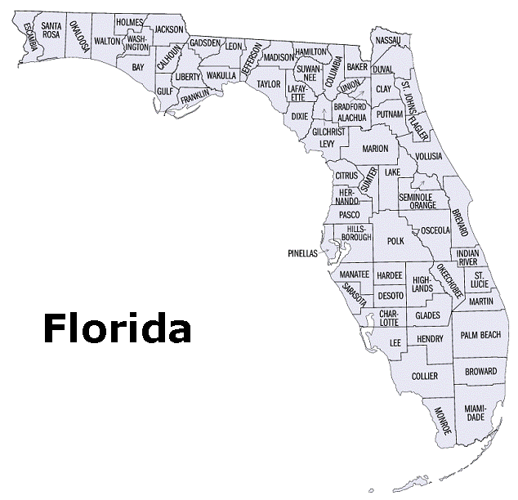

Figure 4

State of Florida and Neighboring States
By Region

F

(Alabama/
Mississippi)
E

(Georgia))

